Gene expression meta-analysis of Parkinson’s disease and its relationship with Alzheimer’s disease
Additional file 1

Table S1: Information about each study used in our meta-analysis

GEO Accession number | Platform name | Platform ID |  | Male | Female | All | Age range (average)
GSE7621 | Affymetrix Human Genome U133 Plus 2.0 Array | GPL570 | PD | 13 | 3 | 16 | N/A
 |  |  | Control | 4 | 5 | 9 | N/A
GSE20141 | Affymetrix Human Genome U133 Plus 2.0 Array | GPL570 | PD | N/A | N/A | 9 | N/A
 |  |  | Control | N/A | N/A | 6 | N/A
GSE8397 | Affymetrix Human Genome U133A Array | GPL96 | PD | 9 | 6 | 15 | 68-89 (80)
 |  |  | Control | 5 | 1 | 6 | 46-81 (68.2)
GSE20292 | Affymetrix Human Genome U133A Array | GPL96 | PD | 6 | 5 | 11 | 67-84 (75.5)
 |  |  | Control | 13 | 5 | 18 | 41-94 (66.8)
GSE20163 | Affymetrix Human Genome U133A Array | GPL96 | PD | N/A | N/A | 8 | N/A
 |  |  | Control | N/A | N/A | 9 | N/A
GSE20164 | Affymetrix Human Genome U133A Array | GPL96 | PD | N/A | N/A | 6 | N/A
 |  |  | Control | N/A | N/A | 3 | N/A
GSE20333 | Affymetrix Human HG-Focus Target Array | GPL201 | PD | 1 | 3 | 4 | 70-87 (77.3)
 |  |  | Control | 5 | 1 | 6 | 68-88 (79)

Table S1. Information about each study used in our meta-analysis after removal of outlier samples.

Table S2: DEGs that have been previously identified as PD risk genes by GWAS

Gene name | Entrez ID | Average FC | metaZscore | FDR corrected Pval
SNCA | 6622 | 0.57 | -6.00 | 1.03E-05
ANK2 | 287 | 0.61 | -4.21 | 2.33E-03
ALAS1 | 211 | 0.76 | -3.52 | 1.12E-02
SH3GL2 | 6456 | 0.64 | -3.46 | 1.31E-02
DLG2 | 1740 | 0.79 | -3.34 | 1.68E-02
SCN3A | 6328 | 0.56 | -3.30 | 1.79E-02
MAPT | 4137 | 1.23 | 3.15 | 2.45E-02
ATP6V0A1 | 535 | 0.85 | -3.03 | 3.15E-02
VPS13C | 54832 | 1.17 | 2.85 | 4.61E-02

Table S2: Differentially expressed genes identified in our meta-analysis that have been identified as PD risk genes in a recent GWAS meta-analysis [33].

Table S3
Ingenuity Canonical Pathways | DEGs | Genes in Pathway | Ratio | adjPval | AD DEGs | AD Ratio | AD adjPval
Breast Cancer Regulation by Stathmin1 | 33 | 204 | 0.162 | 2.40E-06 | 47 | 0.23 | 8.51E-03
Sirtuin Signaling Pathway | 40 | 284 | 0.141 | 2.40E-06 | 70 | 0.247 | 3.39E-04
14-3-3-mediated Signaling | 24 | 130 | 0.185 | 9.55E-06 | 34 | 0.262 | 5.13E-03
Phagosome Maturation | 23 | 138 | 0.167 | 9.12E-05 | 34 | 0.246 | 1.15E-02
Remodeling of Epithelial Adherens Junctions | 15 | 67 | 0.227 | 1.12E-04
Mitochondrial Dysfunction | 24 | 166 | 0.145 | 4.27E-04 | 41 | 0.248 | 4.79E-03
Oxidative Phosphorylation | 18 | 105 | 0.173 | 4.68E-04
CDK5 Signaling | 17 | 99 | 0.173 | 7.24E-04 | 27 | 0.276 | 7.08E-03
Huntington's Disease Signaling | 30 | 248 | 0.121 | 7.59E-04
B Cell Receptor Signaling | 25 | 188 | 0.133 | 7.59E-04 | 50 | 0.266 | 6.92E-04
Epithelial Adherens Junction Signaling | 21 | 143 | 0.147 | 7.59E-04
Gap Junction Signaling | 24 | 191 | 0.126 | 2.51E-03
Germ Cell-Sertoli Cell Junction Signaling | 22 | 170 | 0.130 | 2.69E-03 | 41 | 0.243 | 7.08E-03
Axonal Guidance Signaling | 43 | 447 | 0.096 | 2.95E-03 | 94 | 0.211 | 2.09E-03
Sertoli Cell-Sertoli Cell Junction Signaling | 22 | 174 | 0.127 | 3.31E-03 | 38 | 0.22 | 3.72E-02
Rac Signaling | 17 | 116 | 0.147 | 3.31E-03 | 29 | 0.25 | 1.70E-02
Synaptic Long Term Potentiation | 17 | 119 | 0.143 | 4.17E-03 | 29 | 0.244 | 2.34E-02
AMPK Signaling | 25 | 216 | 0.116 | 4.17E-03
Glycolysis I | 7 | 24 | 0.292 | 4.27E-03
PI3K/AKT Signaling | 17 | 124 | 0.138 | 5.50E-03 | 34 | 0.276 | 2.09E-03
ERK/MAPK Signaling | 23 | 199 | 0.116 | 7.08E-03 | 51 | 0.256 | 9.55E-04
Iron homeostasis signaling pathway | 17 | 127 | 0.134 | 7.41E-03
Clathrin-mediated Endocytosis Signaling | 23 | 206 | 0.112 | 1.05E-02
Gαi Signaling | 16 | 121 | 0.133 | 1.05E-02
Signaling by Rho Family GTPases | 26 | 250 | 0.104 | 1.38E-02 | 61 | 0.243 | 9.55E-04
Neuropathic Pain Signaling In Dorsal Horn Neurons | 15 | 114 | 0.132 | 1.62E-02
G Protein Signaling Mediated by Tubby | 7 | 31 | 0.226 | 1.62E-02
Role of NFAT in Cardiac Hypertrophy | 23 | 217 | 0.106 | 1.62E-02 | 47 | 0.218 | 2.19E-02
Reelin Signaling in Neurons | 13 | 93 | 0.141 | 1.62E-02
Amyloid Processing | 9 | 50 | 0.180 | 1.62E-02
Cardiac β-adrenergic Signaling | 17 | 141 | 0.121 | 1.62E-02
TCA Cycle II (Eukaryotic) | 6 | 24 | 0.250 | 1.82E-02
p70S6K Signaling | 16 | 132 | 0.122 | 1.95E-02
PTEN Signaling | 15 | 120 | 0.126 | 1.95E-02 | 31 | 0.261 | 7.94E-03
Sumoylation Pathway | 13 | 97 | 0.135 | 2.00E-02 | 30 | 0.312 | 9.33E-04
Protein Ubiquitination Pathway | 26 | 264 | 0.099 | 2.00E-02
Gluconeogenesis I | 6 | 25 | 0.240 | 2.00E-02
STAT3 Pathway | 13 | 98 | 0.134 | 2.04E-02 | 20 | 0.27 | 2.63E-02
HIPPO signaling | 12 | 86 | 0.140 | 2.09E-02 | 32 | 0.372 | 4.17E-05
fMLP Signaling in Neutrophils | 15 | 122 | 0.123 | 2.14E-02 | 33 | 0.27 | 3.47E-03
Dopamine-DARPP32 Feedback in cAMP Signaling | 18 | 161 | 0.112 | 2.14E-02
D-myo-inositol (1,4,5)-trisphosphate Degradation | 5 | 18 | 0.278 | 2.14E-02
Dopamine Receptor Signaling | 11 | 76 | 0.145 | 2.14E-02
GNRH Signaling | 18 | 163 | 0.111 | 2.29E-02 | 38 | 0.235 | 1.45E-02
Insulin Receptor Signaling | 16 | 137 | 0.117 | 2.34E-02
Cardiac Hypertrophy Signaling | 23 | 233 | 0.099 | 2.63E-02 | 51 | 0.219 | 1.45E-02
Cyclins and Cell Cycle Regulation | 11 | 80 | 0.138 | 3.02E-02 | 20 | 0.253 | 4.79E-02
IGF-1 Signaling | 13 | 106 | 0.123 | 3.55E-02
Protein Kinase A Signaling | 33 | 386 | 0.086 | 3.72E-02 | 82 | 0.214 | 3.24E-03
Gαq Signaling | 17 | 159 | 0.107 | 3.89E-02 | 42 | 0.264 | 1.58E-03
Aspartate Degradation II | 3 | 7 | 0.429 | 3.98E-02 | 5 | 0.714 | 9.55E-03
Renin-Angiotensin Signaling | 14 | 121 | 0.116 | 3.98E-02
ATM Signaling | 12 | 97 | 0.124 | 4.27E-02
BMP signaling pathway | 10 | 75 | 0.135 | 4.47E-02

Table S3: IPA canonical pathway analysis for significant pathways identified using all PD DEGs, included with the information for pathways shared with those identified as significant using all AD DEGs.

Table S4: IPA canonical pathway analysis for significant pathways identified using down-regulated PD DEGs.
Ingenuity Canonical Pathways | DEGs | Genes in Pathway | Ratio | Adj. Pval
Breast Cancer Regulation by Stathmin1 | 32 | 204 | 0.157 | 1.86E-09
Phagosome Maturation | 23 | 138 | 0.167 | 2.19E-07
Sirtuin Signaling Pathway | 34 | 284 | 0.120 | 2.19E-07
Mitochondrial Dysfunction | 24 | 166 | 0.145 | 9.55E-07
14-3-3-mediated Signaling | 21 | 130 | 0.162 | 9.55E-07
Remodeling of Epithelial Adherens Junctions | 15 | 67 | 0.227 | 9.55E-07
Oxidative Phosphorylation | 18 | 105 | 0.173 | 2.82E-06
Axonal Guidance Signaling | 39 | 447 | 0.087 | 3.39E-05
Gap Junction Signaling | 22 | 192 | 0.115 | 1.17E-04
CDK5 Signaling | 15 | 99 | 0.153 | 1.32E-04
Huntington's Disease Signaling | 25 | 248 | 0.101 | 2.14E-04
Sertoli Cell-Sertoli Cell Junction Signaling | 20 | 173 | 0.116 | 2.34E-04
Germ Cell-Sertoli Cell Junction Signaling | 19 | 170 | 0.112 | 5.13E-04
Cardiac β-adrenergic Signaling | 17 | 141 | 0.121 | 5.13E-04
Glycolysis I | 7 | 24 | 0.292 | 5.37E-04
Epithelial Adherens Junction Signaling | 17 | 143 | 0.119 | 6.03E-04
Synaptic Long Term Potentiation | 15 | 120 | 0.126 | 8.51E-04
PI3K/AKT Signaling | 15 | 123 | 0.122 | 1.17E-03
Iron homeostasis signaling pathway | 15 | 128 | 0.118 | 1.62E-03
Neuropathic Pain Signaling In Dorsal Horn Neurons | 14 | 114 | 0.123 | 1.74E-03
Dopamine-DARPP32 Feedback in cAMP Signaling | 17 | 161 | 0.106 | 1.91E-03
Rac Signaling | 14 | 116 | 0.121 | 1.95E-03
Dopamine Receptor Signaling | 11 | 76 | 0.145 | 1.99E-03
Role of NFAT in Cardiac Hypertrophy | 20 | 216 | 0.093 | 2.88E-03
Signaling by Rho Family GTPases | 22 | 252 | 0.088 | 2.95E-03
TCA Cycle II (Eukaryotic) | 6 | 24 | 0.250 | 3.24E-03
Protein Kinase A Signaling | 29 | 386 | 0.075 | 3.80E-03
Gluconeogenesis I | 6 | 25 | 0.240 | 3.80E-03
HIPPO signaling | 11 | 86 | 0.128 | 4.79E-03
GNRH Signaling | 16 | 162 | 0.099 | 5.01E-03
p70S6K Signaling | 14 | 131 | 0.107 | 5.01E-03
AMPK Signaling | 19 | 215 | 0.088 | 5.62E-03
ERK/MAPK Signaling | 18 | 199 | 0.091 | 5.89E-03
Amyloid Processing | 8 | 50 | 0.160 | 5.89E-03
Gαi Signaling | 13 | 121 | 0.108 | 6.17E-03
Opioid Signaling Pathway | 20 | 237 | 0.084 | 6.46E-03
fMLP Signaling in Neutrophils | 13 | 122 | 0.107 | 6.92E-03
Clathrin-mediated Endocytosis Signaling | 18 | 206 | 0.087 | 7.59E-03
CREB Signaling in Neurons | 18 | 211 | 0.086 | 8.91E-03
Gαq Signaling | 15 | 160 | 0.094 | 8.91E-03
Protein Ubiquitination Pathway | 21 | 265 | 0.080 | 8.91E-03
RhoGDI Signaling | 16 | 177 | 0.091 | 8.91E-03
Melatonin Signaling | 9 | 70 | 0.129 | 1.10E-02
Calcium Signaling | 17 | 198 | 0.086 | 1.12E-02
α-Adrenergic Signaling | 10 | 85 | 0.118 | 1.12E-02
Synaptic Long Term Depression | 15 | 168 | 0.089 | 1.38E-02
Actin Cytoskeleton Signaling | 18 | 222 | 0.081 | 1.38E-02
BMP signaling pathway | 9 | 74 | 0.122 | 1.41E-02
Aspartate Degradation II | 3 | 7 | 0.429 | 1.41E-02
B Cell Receptor Signaling | 16 | 189 | 0.085 | 1.48E-02
Insulin Receptor Signaling | 13 | 137 | 0.095 | 1.48E-02
Regulation of eIF4 and p70S6K Signaling | 14 | 155 | 0.091 | 1.48E-02
IGF-1 Signaling | 11 | 106 | 0.104 | 1.55E-02
Reelin Signaling in Neurons | 10 | 92 | 0.109 | 1.70E-02
Fcγ Receptor-mediated Phagocytosis in Macrophages and Monocytes | 10 | 93 | 0.108 | 1.82E-02
Parkinson's Signaling | 4 | 16 | 0.250 | 1.86E-02
Pyridoxal 5'-phosphate Salvage Pathway | 8 | 64 | 0.125 | 1.86E-02
CCR3 Signaling in Eosinophils | 12 | 127 | 0.095 | 1.86E-02
Cardiac Hypertrophy Signaling | 18 | 232 | 0.078 | 1.86E-02
Phototransduction Pathway | 7 | 52 | 0.137 | 1.91E-02
Salvage Pathways of Pyrimidine Ribonucleotides | 10 | 96 | 0.105 | 1.91E-02
D-myo-inositol (1,4,5)-Trisphosphate Biosynthesis | 5 | 28 | 0.185 | 2.00E-02
Cdc42 Signaling | 12 | 130 | 0.093 | 2.08E-02
Tight Junction Signaling | 14 | 167 | 0.084 | 2.40E-02
Chemokine Signaling | 8 | 68 | 0.118 | 2.40E-02
Aldosterone Signaling in Epithelial Cells | 14 | 168 | 0.084 | 2.45E-02
D-myo-inositol (1,4,5)-trisphosphate Degradation | 4 | 19 | 0.222 | 2.45E-02
P2Y Purigenic Receptor Signaling Pathway | 12 | 134 | 0.090 | 2.45E-02
PAK Signaling | 10 | 100 | 0.100 | 2.45E-02
Role of CHK Proteins in Cell Cycle Checkpoint Control | 7 | 57 | 0.123 | 3.09E-02
G Protein Signaling Mediated by Tubby | 5 | 32 | 0.161 | 3.16E-02
Renin-Angiotensin Signaling | 11 | 122 | 0.091 | 3.16E-02
Inhibition of Angiogenesis by TSP1 | 5 | 33 | 0.156 | 3.63E-02
Xenobiotic Metabolism Signaling | 19 | 273 | 0.070 | 3.80E-02
G-Protein Coupled Receptor Signaling | 19 | 275 | 0.069 | 3.98E-02
GDNF Family Ligand-Receptor Interactions | 8 | 77 | 0.105 | 3.98E-02
IL-1 Signaling | 9 | 93 | 0.098 | 3.98E-02
Ceramide Signaling | 9 | 93 | 0.097 | 4.17E-02
Arsenate Detoxification I (Glutaredoxin) | 2 | 4 | 0.500 | 4.37E-02
CXCR4 Signaling | 13 | 164 | 0.079 | 4.37E-02
Mevalonate Pathway I | 3 | 12 | 0.250 | 4.68E-02

Table S4: IPA canonical pathway analysis for significant pathways identified using down-regulated PD DEGs.

Table S5: IPA upstream regulator analysis for up and down regulated PD DEGs analysed separately.
Upstream Regulator | Molecule type | p-value | Number of target molecules
Upstream regulators for Down-regulated DEGs
Lh | complex | 1.21E-08 | 27
FSH | complex | 7.25E-07 | 28
HSP90B1 | other | 8.38E-05 | 7
CUL4B | other | 2.03E-04 | 5
SBDS | other | 2.67E-04 | 11
REST | transcription regulator | 2.91E-04 | 6
SUZ12 | enzyme | 4.01E-04 | 11
LONP1 | peptidase | 6.46E-04 | 9
MMP12 | peptidase | 1.51E-03 | 7
INHBA | growth factor | 3.64E-03 | 10
NMNAT1 | enzyme | 4.84E-03 | 3
PRKAR1A | kinase | 4.84E-03 | 3
RBM5 | other | 5.10E-03 | 6
IL15 | cytokine | 5.16E-03 | 10
HNRNPA2B1 | other | 5.42E-03 | 12
CCND1 | transcription regulator | 5.87E-03 | 16
TP53 | transcription regulator | 7.91E-03 | 37
Upstream regulators for Up-regulated DEGs
HSF1 | transcription regulator | 1.57E-04 | 8
TGFBR2 | kinase | 5.16E-04 | 6
miR-346 (and other miRNAs w/seed GUCUGCC) | mature microrna | 6.73E-04 | 2
TP73 | transcription regulator | 8.09E-04 | 9
SP4 | transcription regulator | 1.09E-03 | 3
MTOR | kinase | 1.20E-03 | 5
NPAT | transcription regulator | 1.33E-03 | 2
AREG | growth factor | 2.60E-03 | 5
COL18A1 | other | 3.18E-03 | 5
ZBTB10 | other | 3.27E-03 | 2
MYC | transcription regulator | 4.07E-03 | 10
miR-22-3p (miRNAs w/seed AGCUGCC) | mature microrna | 4.23E-03 | 3
CD24 | other | 4.50E-03 | 6
ZNF652 | other | 4.53E-03 | 2
CCND1 | transcription regulator | 5.50E-03 | 9
GATA6 | transcription regulator | 5.86E-03 | 4
Cdk | group | 6.11E-03 | 3
SAFB | other | 7.26E-03 | 4
mir-122 | microrna | 8.41E-03 | 5
miR-155-5p (miRNAs w/seed UAAUGCU) | mature microrna | 8.42E-03 | 3
E2F1 | transcription regulator | 8.87E-03 | 8
KITLG | growth factor | 9.28E-03 | 3
CASP8 | peptidase | 9.42E-03 | 2
DDIT3 | transcription regulator | 9.42E-03 | 2
CBL | transcription regulator | 9.42E-03 | 2

Table S5: IPA upstream regulator analysis for up and down regulated PD DEGs analyzed separately.

Table S6: Top 10 hubs found in the PPIN subnetwork created using the top 30 PD DEGs

Gene name | Number of First neighbour nodes
YWHAZ | 122
YWHAB | 62
YWHAG | 62
YWHAE | 42
YWHAQ | 39
SNCA | 38
YWHAH | 32
TP53 | 25
AKT1 | 22
ABL1 | 19

Table S6: Top 10 hubs found in the protein-protein interaction network (PPIN) analysis subnetwork created using the top 30 PD DEGs.

Table S7: The direction of differential expression between the common DEGs of AD and PD.
 | PD upregulated | PD downregulated | Total
AD upregulated | 114 | 3 | 117
AD downregulated | 1 | 318 | 319
Total | 115 | 321 | 436

Table S7: The direction of differential expression between the common DEGs found between AD and PD.

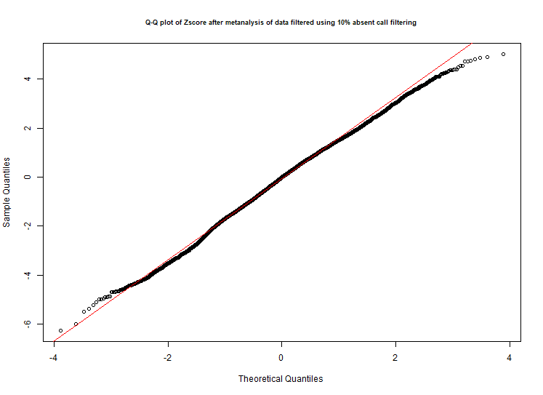
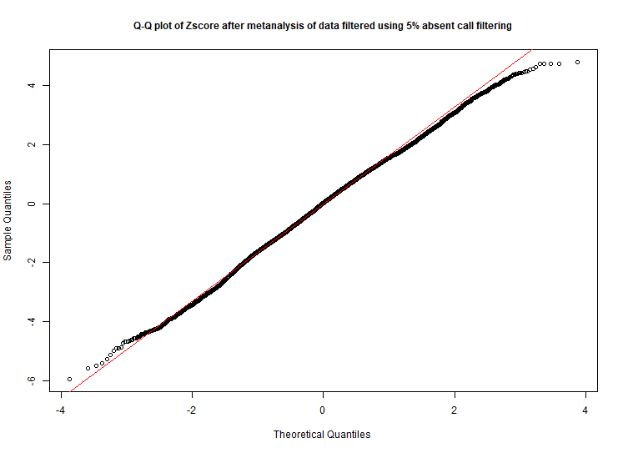
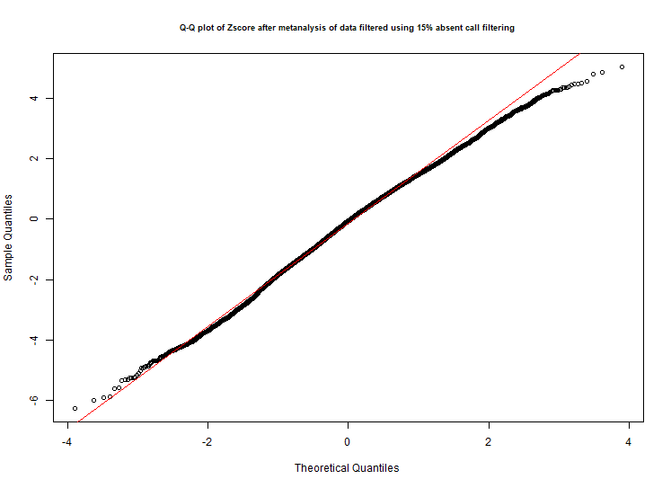
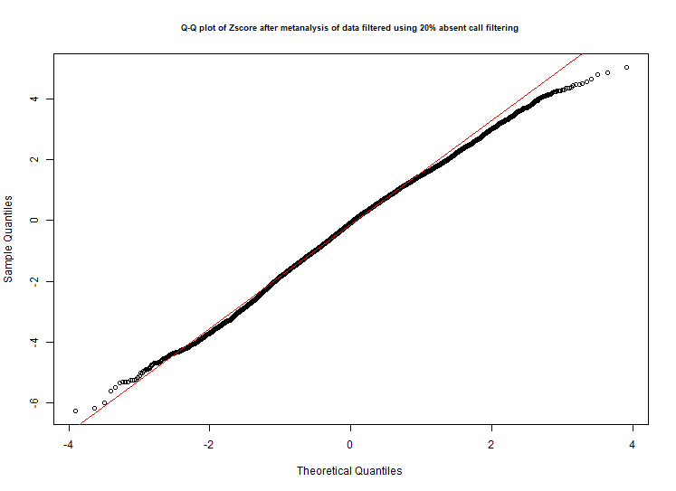
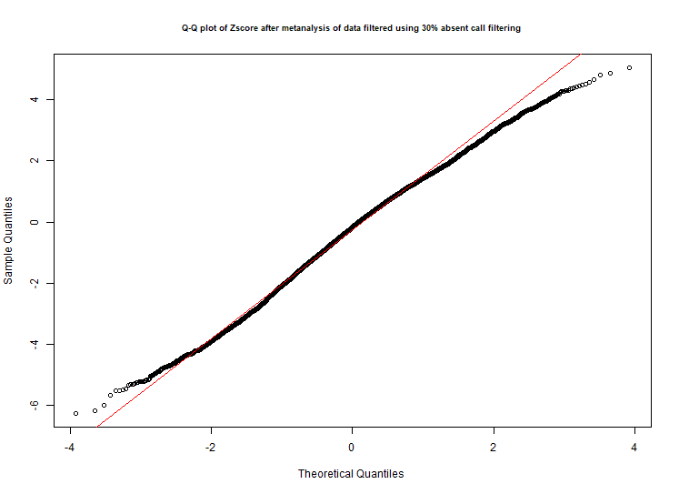
A
B
D
C
E
F

Figure S1: Selecting filtering threshold for microarray data. The percentage of studies called absent in a mas5 present absent call for each probe was calculated, and threshold determined by minimizing Anderson-Darling normality tests and giving optimal Q-Q plot of the Z-scores after meta-analysis. The Q-Q plot for (A) 5%, (B) 10%, (C) 15%, (D) 20% and (E) 30% filtering. After 15% filtering A-D p-values were minimized (F) and the 15% Q-Q plot gave closest values to normality. A-D is Anderson-Darling normality test.

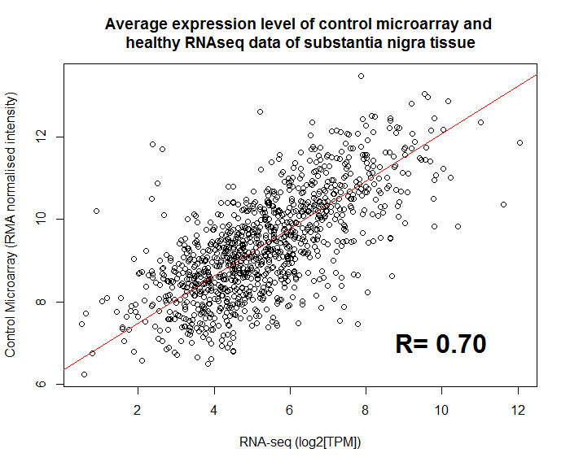
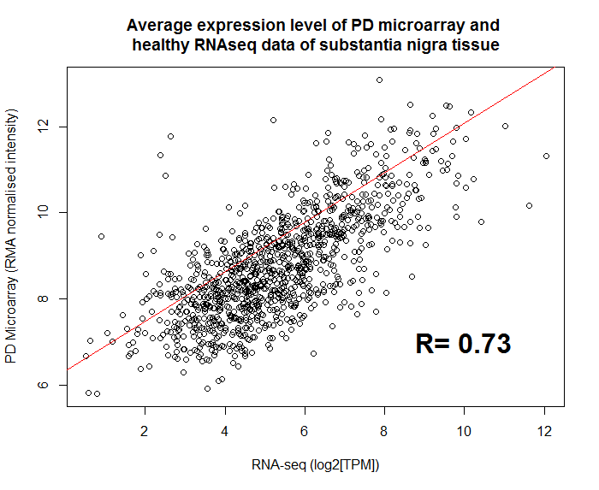
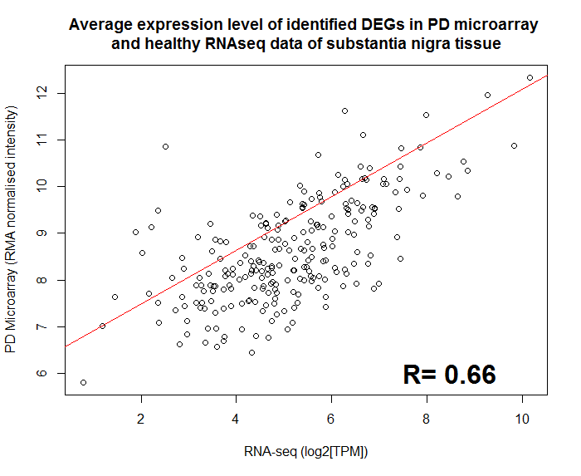
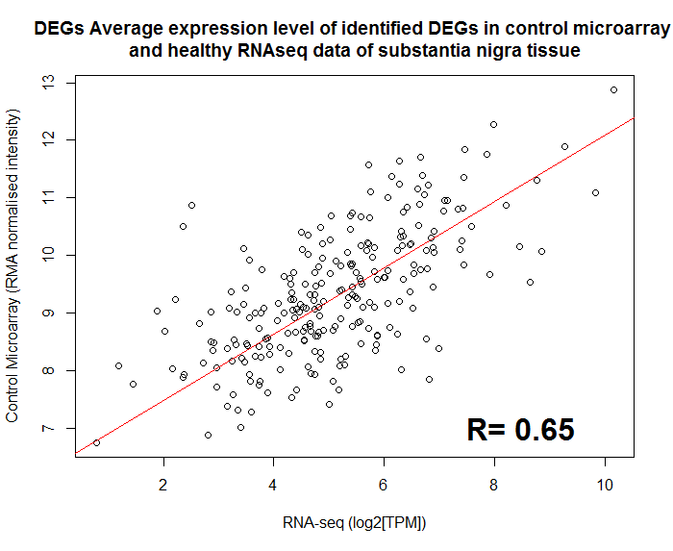
A
D
B
C

Figure S2. RNA-seq vs microarray. Average absolute expression level of RNA-seq log2(TPM) of SN tissue from GTEx database plotted against RMA normalised and filtered intensity of microarray control and PD data used in this meta-analysis. The Pearson correlation coefficient between the control microarray data and healthy RNA-seq data (A) is 0.70 (pvalue < 2.2e-16) showing that the expression values of genes between microarray and RNA-seq are correlated and expression data distribution is similar. The Pearson correlation between the healthy RNA-seq and PD microarray data (B) is actually higher than between RNA-seq and control microarray at 0.73 (pvalue < 2.2e-16), when it would be expected to be lower due to some genes being differentially expressed. When using only DEGs, correlation between healthy RNA-seq and control microarray (C) and PD microarray (D) data this difference in correlation is minimised to 0.65 (pvalue < 2.2e-16) and 0.66 (pvalue < 2.2e-16) respectively, suggesting that the difference in correlation could be due to the larger sample size of the PD data.

