Supplemental information
Patient number 5, four years after having completed the follow-up, consulted due to severe low-back pain of a mechanical nature. The neurological examination was normal. Image through x-ray and MRI studies confirmed the existence of a deterioration of a contiguous disc level. In the absence of response to the conservative treatment, surgery for fusion with extension to the adjacent level was performed. Posterolateral bone fusion of the index procedure was evidenced during the procedure. A sample from both sides was collected and histological study was performed. The findings were similar on both sides, showing mature bone (Additional Image 1).
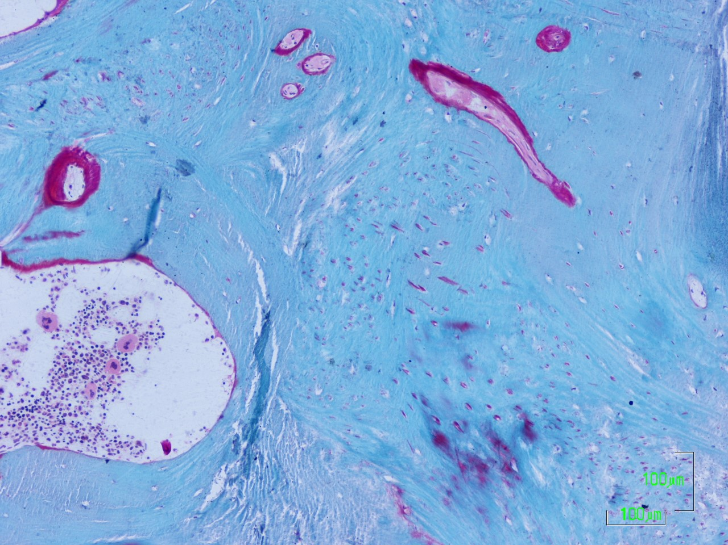
Additional Image 1. Histological Image from Patient #5 demonstrating mature bone formation.

