Additional files

Intravenous Pulse Methylprednisolone For Induction Of Remission In Severe ANCA Associated Vasculitis: A Multi-Center Retrospective Cohort Study

Dimitrios Chanouzas PhD^{1,2}, JulieAnne G. McGregor MD³, Peter Nightingale PhD², Alan D. Salama PhD⁴, Wladimir M. Szpirt MD⁵, Neil Basu PhD⁶, Matthew David Morgan PhD^{1,2}, Caroline J. Poulton MSW³, Juliana Bordignon Draibe MD⁴, Elizabeth Krarup MD⁵, Paula Dospinescu MBChB⁶, Jessica Anne Dale MBChB², William Franklin Pendergraft PhD³, Keegan Lee MBChB⁴, Martin Egfjord PhD⁵, Susan L. Hogan PhD³ and Lorraine Harper PhD^{1,2}.

Additional file Table S1 Intravenous pulse methylprednisolone use and dosage
 | MP use | MP dose (g)*
Birmingham | 9/23 | 1.00 (0.50-1.75)
Chapel Hill | 30/32 | 1.50 (1.50-2.19)
London | 9/10 | 1.50 (1.50-1.50)
Copenhagen | 3/36 | 1.50 (1.50-1.50)
Aberdeen | 1/13 | 3.00 (3.00-3.00)
* Median (IQR) in patients that received intravenous pulse methylprednisolone (MP)

Additional file Table S2 Cyclophosphamide and oral prednisolone dose in intravenous pulse methylprednisolone (MP) and non-MP treated patients
 | MP | Non-MP
Cyclophosphamide (g)
2 weeks | 1.0 (0.8 – 1.2) | 1.4 (0.8 – 1.5)
1 month | 1.4 (1.0 – 1.8) | 2.7 (1.5 – 3.0)
3 months | 4.5 (3.1 – 4.9) | 6.5 (4.5 – 9.0)
6 months | 5.2 (3.6 – 9.4) | 8.6 (6.4 – 10.5)
Oral prednisolone (g)
1 week | 0.4 (0.4 – 0.4) | 0.4 (0.4 – 0.4)
2 weeks | 0.8 (0.8 – 0.8) | 0.8 (0.8 – 0.8)
1 month | 1.8 (1.4 – 1.8) | 1.6 (1.4 – 1.7)
3 months | 3.8 (2.9 – 3.8) | 3.9 (3.0 – 4.1)
6 months | 4.0 (3.9 – 4.0) | 5.6 (4.4 – 6.3)
12 months | 4.0 (3.9 – 5.3) | 6.8 (5.5 – 7.0)
Median (IQR) shown
Cumulative dose up to the respective time point is shown

Additional file Table S3 Factors associated with infection at 3 months on univariable and multivariable proportional hazards analysis
 | Univariable |  | Multivariable
 | HR (95% CI) | p value | HR (95% CI) | p value
(A) Time to infection at 3 months
MP dose (per gram) | 1.4 (1.1 – 1.9) | 0.017 | 1.5 (1.1 – 1.9) | 0.010
Leukopenia preceding infection | 3.6 (1.6 – 8.0) | 0.001 | 3.9 (1.8 – 8.6) | 0.001
Dose of oral prednisolone, g | 5.4 (1.1 – 27.3) | 0.043 | 7.2 (1.2 – 44.7) | 0.035
(B) Time to severe infection at 3 months
MP dose (per gram) | 1.5 (1.1 – 2.1) | 0.016 | 1.44 (1.03 – 2.00) | 0.034
Leukopenia preceding infection | 4.8 (2.1 – 10.9) | < 0.001 | 5.35 (2.34 – 12.23) | < 0.001
Dose of oral prednisolone, g | 9.2 (1.5 – 54.7) | 0.015 | 15.20 (1.71 – 134.99) | 0.015
BVAS score | 1.1 (1.0 – 1.2) | 0.005 | 1.08 (0.97 – 1.20) | 0.169
Lung involvement | 1.9 (0.9 – 3.9) | 0.096 | 0.93 (0.37 – 2.38) | 0.884
Dose of oral prednisolone was entered as a segmented time dependent variable as follows: dose at 1 week, 2 weeks, 1 month and 3 months.
HR = hazard ratio, CI = confidence intervals

The differences in infection and severe infection between MP treated patients and patients that did not receive MP were confined to the first 3 months. As shown in Additional file Figure S1, there is a clear difference in infection between the 2 groups at 3 months. There is no difference in the occurrence of new infections from 3 to 12 months between MP and non-MP treated patients.

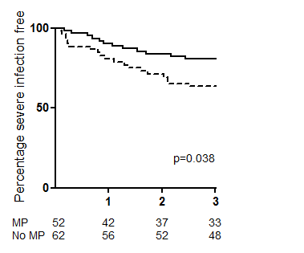
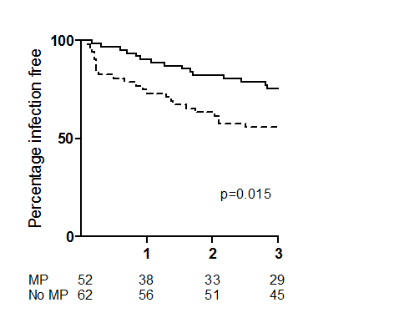
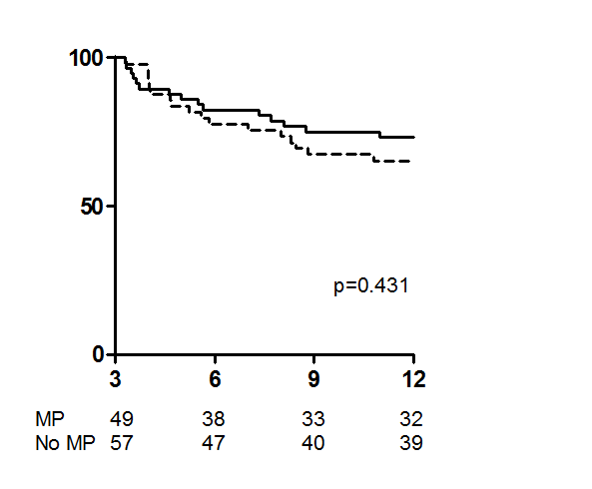
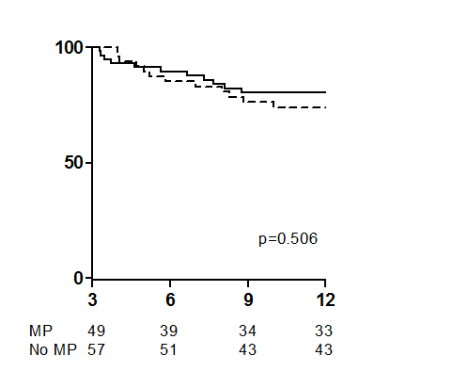
A
B
C
D

Additional file Figure S1 Time to infection by 3 months (A) and from 3 to 12 months (B) and time to severe infection by 3 months (C) and from 3 to 12 months (D) was examined by Kaplan-Meier curve analysis. Time for infection for patients that received MP is shown in the dashed line and that for non-MP treated patients in the solid line.

