Additional file
Zinc phosphate-based nanoparticles as a novel antibacterial agent: In vivo study on rats after dietary exposure
Pavel Horkyª, Sylvie Skalickovaª, Lenka Urbankovaª, Daria Baholetª, Silvia Kociova^{b}, Zuzana Bytesnikova^{b}, Eliska Kabourkova^{b}, Zuzana Lackova^{b,c}, Natalia Cernei^{b,c}, Milica Gagic^{b}, Vedran Milosavljevic^{b,c}, Vendula Smolikova^{b,c}, Eva Vaclavkova^{d}, Pavel Nevrkla^{e}, Pavel Knotª, Olga Krystofova^{b,c}, David Hynek^{b,c}, Pavel Kopel^{b,c}, Jiri Skladankaª, Vojtech Adam^{b,c}, Kristyna Smerkova^{b,c*}

ªDepartment of Animal Nutrition and Forage Production, Mendel University in Brno, Zemedelska 1, CZ-613 00 Brno, Czech Republic; pavel.horky@mendelu.cz, sylvie.skalickova@gmail.com, lenka.urbankova@mendelu.cz, xbaholet@mendelu.cz, pavel.knot@mendelu.cz, jiri.skladanka@mendelu.cz
^{b}Department of Chemistry and Biochemistry, Mendel University in Brno, Zemedelska 1, CZ-613 00 Brno, Czech Republic; skociova@gmail.com, zuzka.bytesnikova@gmail.com, eliska.kabourkova404@gmail.com, Lackova14@seznam.cz, cernei.natalia3@gmail.com, gagic.milica@gmail.com, grizlidripac@gmail.com, VendulaSmolikova@seznam.cz, olga.krystofova@seznam.cz, d.hynek@email.cz, paulko@centrum.cz, vojtech.adam@mendelu.cz, kristyna.smerkova@mendelu.cz
^{c}Central European Institute of Technology, Brno University of Technology, Purkynova 123, CZ-612 00 Brno, Czech Republic
^{d}Institute of Animal Science, Komenskeho 1239, CZ-517 41 Kostelec nad Orlici, Czech Republic; vaclavkova.eva@vuzv.cz
^{e}Department of Animal Breeding, Mendel University in Brno, Zemedelska 1, CZ-613 00 Brno, Czech Republic; nevrkla.uchhz@mendelu.cz

*Corresponding author: Kristyna Smerkova, Department of Chemistry and Biochemistry, Mendel University in Brno, Zemedelska 1, CZ-613 00 Brno, Czech Republic, E-mail: kristyna.smerkova@mendelu.cz; Phone: +420 545 133 290

Figure S1 TEM image of commercial ZnO-N
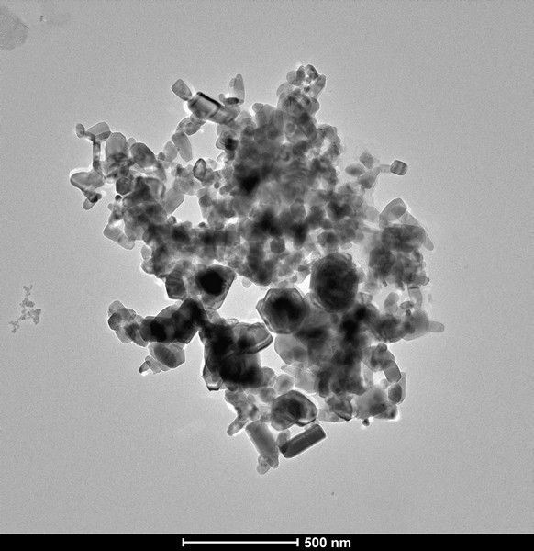

Figure S2 Histological analysis of liver (1) and duodenum (2) of the groups rats ZnA (A, B); ZnB (C, D); ZnC (E, F); ZnD (G, H); ZnO-N (I, J); ZnO (K, L) and control group (M, N).
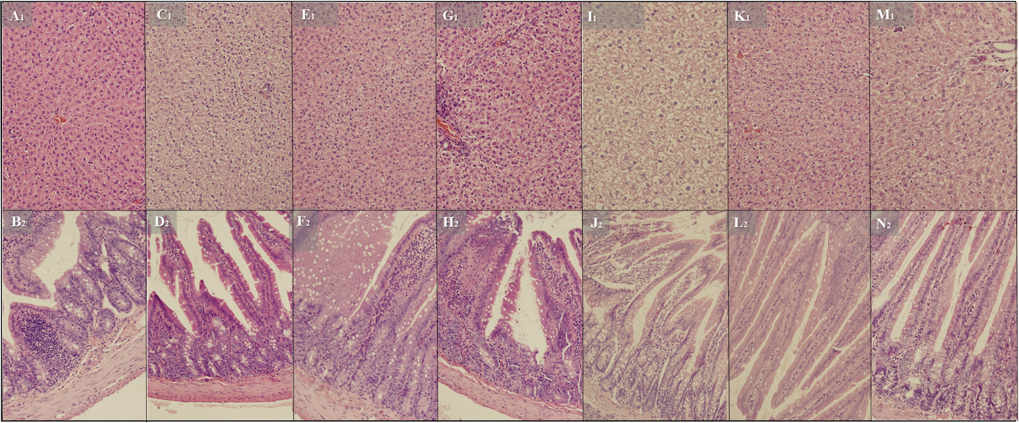

Table S1 The weight of rats, g
Days of experiment
 | 0 | 7 | 14 | 21 | 28
ZnA | 138.2±6.8 | 149.4±5.3 | 165.6±5.3 | 190.8±6.2 | 193.8±6.2
ZnB | 137.0±4.5 | 162.8±7.2 | 194.4±8.6 | 208.0±6.6 | 218.2±6.4
ZnC | 144.0±4.8 | 156.2±4.2 | 187.4±5.3 | 194.6±6.5 | 200.4±8.8
ZnD | 130.4±5.7 | 157.2±6.1 | 185.4±9.9 | 201.0±9.9 | 200.6±8.5
ZnO-N | 155.2±5.7 | 159.6±4.7 | 178.2±8.2 | 190.2±3.5 | 198.8±3.7
ZnO  Control | 153.2±8.5  144.0±4.8 | 164.2±7.4  149.6±4.0 | 185.0±7.4  172.6±2.5 | 190.8±7.3  182.0±4.5 | 202.8±5.4  199.6±5.3

