**Supplemental Figure 1**

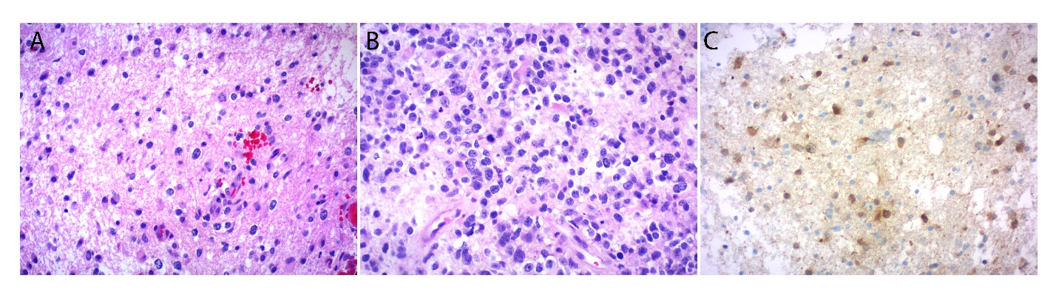

Separate and adjacent areas of lower grade (WHO grades II to III) infiltrating glioma (A, 200X; B, 200X). These areas were positive for IDH1 (R132H) mutant protein.

**Supplemental Figure 2**

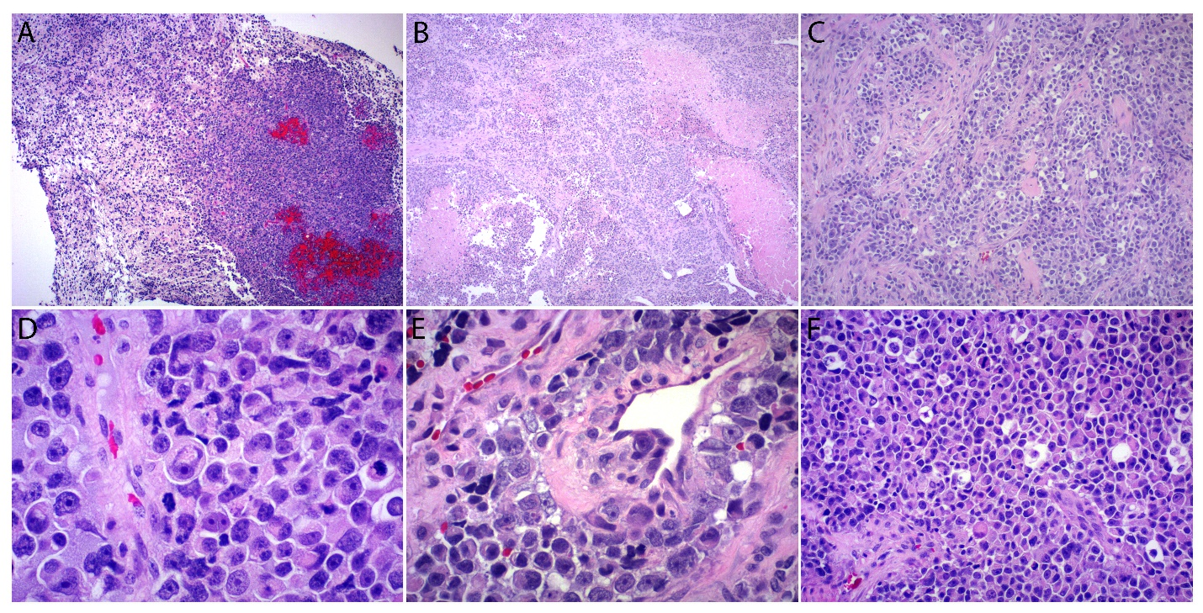

The tumor was largely composed of patternless sheets of cells (A, 100X; B, 40X; C, 200X) with rounded cytoplasmic contours, variable amounts of eosinophilic cytoplasm with minimal to no stellate cellular processes (D, 400X; E, 400X; F, 200X), large nuclei, and variably prominent nucleoli (D). Necrosis was predominantly zonal and frequently associated with sclerosed or thrombosed blood vessels (B, 40X). Rare foci suspicious for vascular invasion were also noted (E, 400X). Rare fragments showed adjacent areas of lower grade, infiltrating glioma (A).

**Supplemental Figure 3 **

**Supplemental Table**

