Additional file 2: The Endurance Shuttle Tests: materials and procedures
 | ESWT | ESBBT | ESNHPT
 | 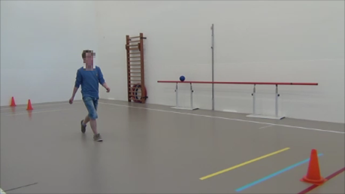 | 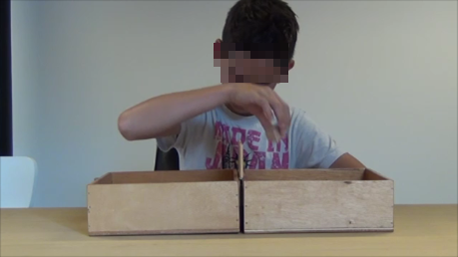
Test Material | - Straight corridor  - 10 meter walking course  - 4 cones  - Metronome | - Box and Block Test  - 200 blocks  - Adjustable table  - Metronome | - Nine Hole Peg Test  - Adjustable table  - Metronome
Maximal performance estimation | - Walk as fast as possible and turn at the line between the cones before the beep  - 5-10 trials, 30 seconds breaks  - Fastest time out of three attempts < 10% difference | - Transfer 10 blocks over the partition as fast as possible before the beep  - 5-10 trials, 30 seconds breaks  - Fastest time out of three attempts < 10% difference | - Place and return the nine pegs as fast as possible before the beep  - 5-10 trials, 30 seconds breaks  - Fastest time out of three attempts < 10% difference
Intensity level | - 75% individual intensity (s) = maximal time(s)/0.75 and then converted into the matching metronome number | - 75% individual intensity (s) = maximal time(s)/0.75 and then converted into the matching metronome number | - 75% individual intensity (s) = maximal time(s)/0.75 and then converted into the matching metronome number
Maximal duration | - 20 minutes | - 20 minutes | - 20 minutes
Instruction Assessor | - Cover each time 10 meters before the beep  - Continue as long as possible within safety margins  - Try to speed up in case of one failure | - Transport each time 10 blocks before the beep  - Continue as long as possible  - Try to speed up in case of one failure | - Place and return 9 pegs each time before the beep  - Continue as long as possible  - Try to speed up in case of one failure

