Additional file 8. KEGG pathway analysis from selected subclusters 4, 7 and 11 from gene expression cluster analysis. Using Differentially Expressed Genes (DEG; FDR<0.01) from comparisons among 150 DAFS (Days After Fruit Set) vs 240 DAFS, 240 DAFS vs 300 DAFS and 300 DAFS vs 390 DAFS.

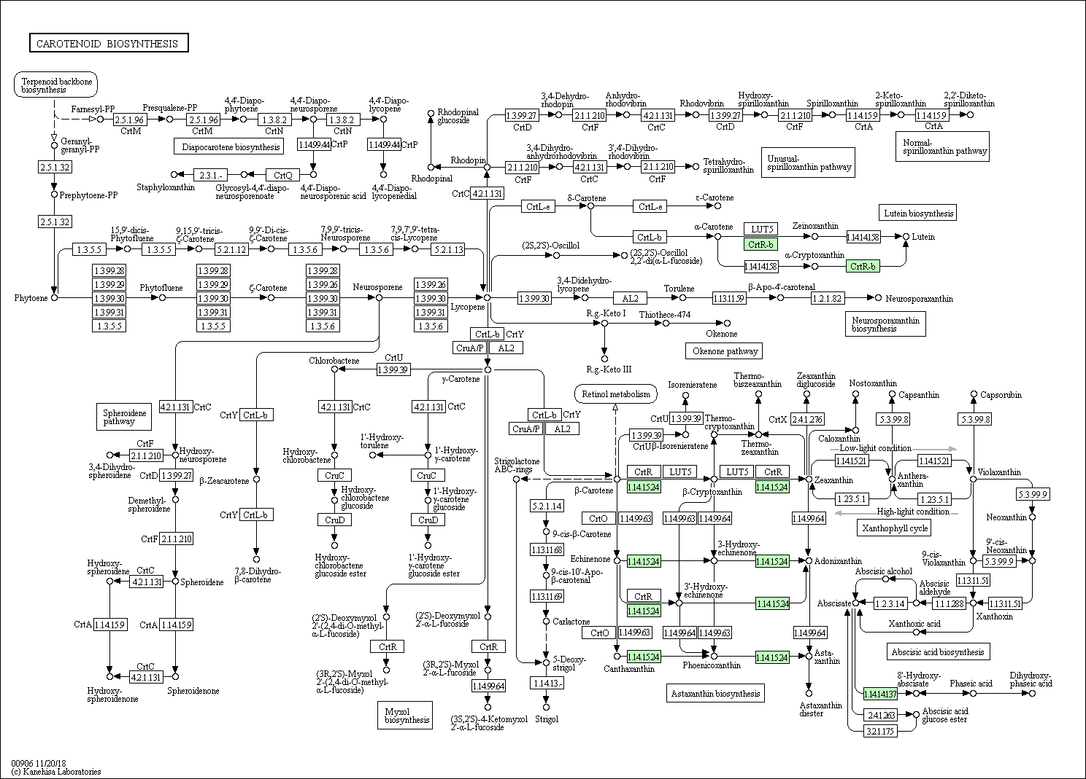

Additional file 8.1 Carotenoid biosynthesis pathway with transcripts from subcluster 4. Enzymes and products are represented as rectangles and circles, respectively. The presence of transcripts from subcluster 4 are indicated in green, where CrtR-b: beta-carotene 3-hydroxylase; 1.14.15.24: beta-carotene 3-hydroxylase and 1.14.14.137: (+) – abscisic acid 8’-hydroxylase.
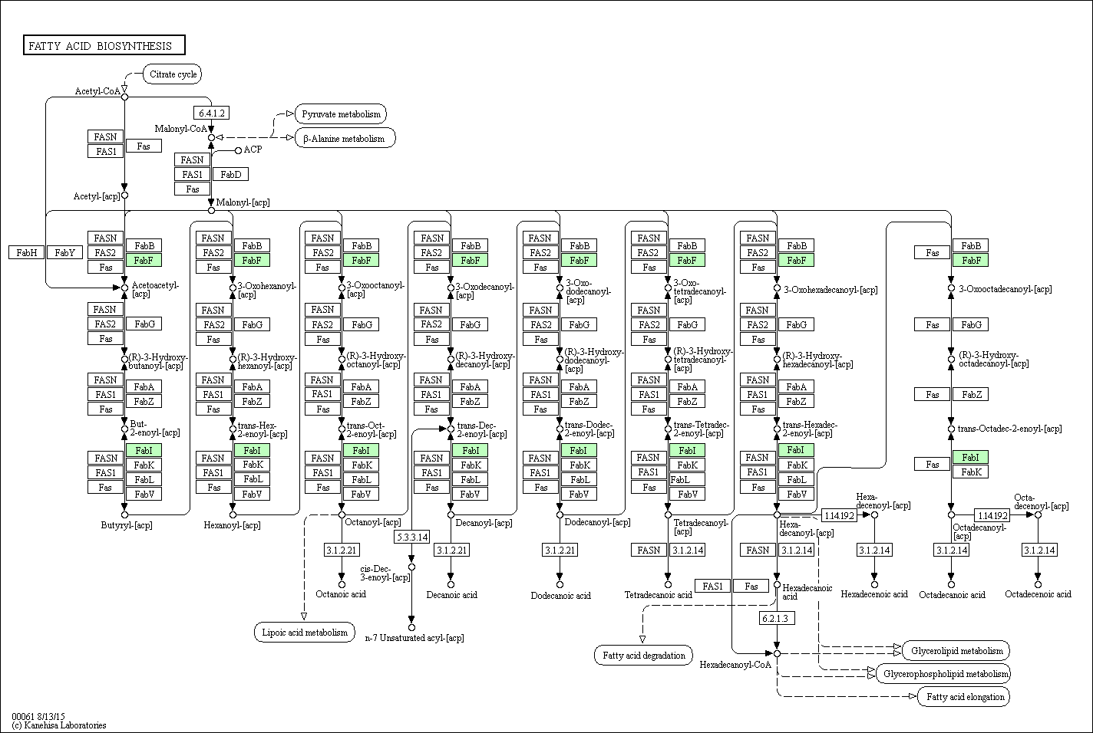

Additional file 8.2. Fatty acid biosynthesis pathway with transcripts from subcluster 4. Enzymes and products are represented as rectangles and circles, respectively. The presence of transcripts from subcluster 4 are indicated in green, where FabF: 3-oxoacyl-[acyl-carrier protein] synthase II and FabI: enoyl-[acyl-carrier protein] reductase I.
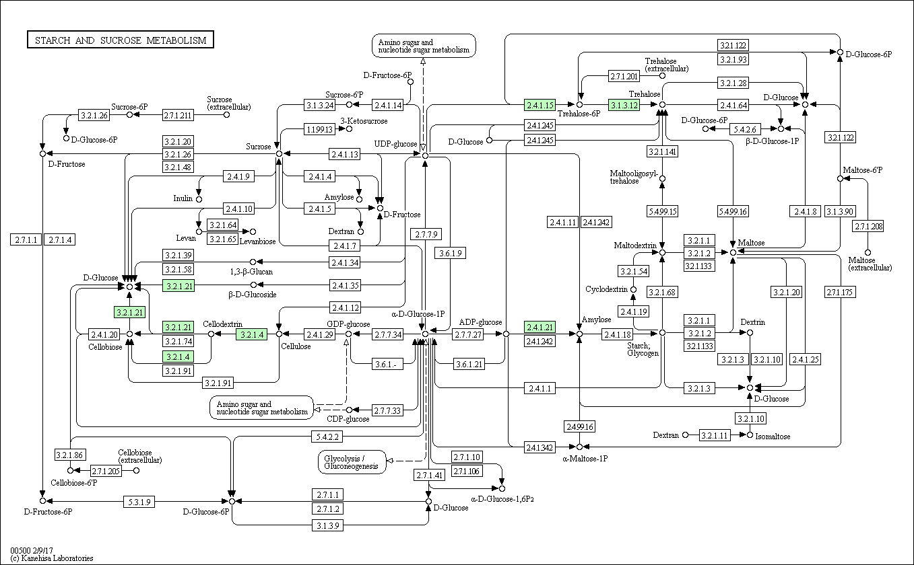

Additional file 8.3. Starch and sucrose metabolism pathway with transcripts from subcluster 4. Enzymes and products are represented as rectangles and circles, respectively. The presence of transcripts from subcluster 4 are indicated in green, where 2.4.1.15: trehalose 6-phosphate synthase; 3.1.3.12: trehalose 6-phosphate phosphatase; 3.2.1.21: beta-glucosidase; 3.2.1.4: endoglucanase and 2.4.1.21: starch synthase.
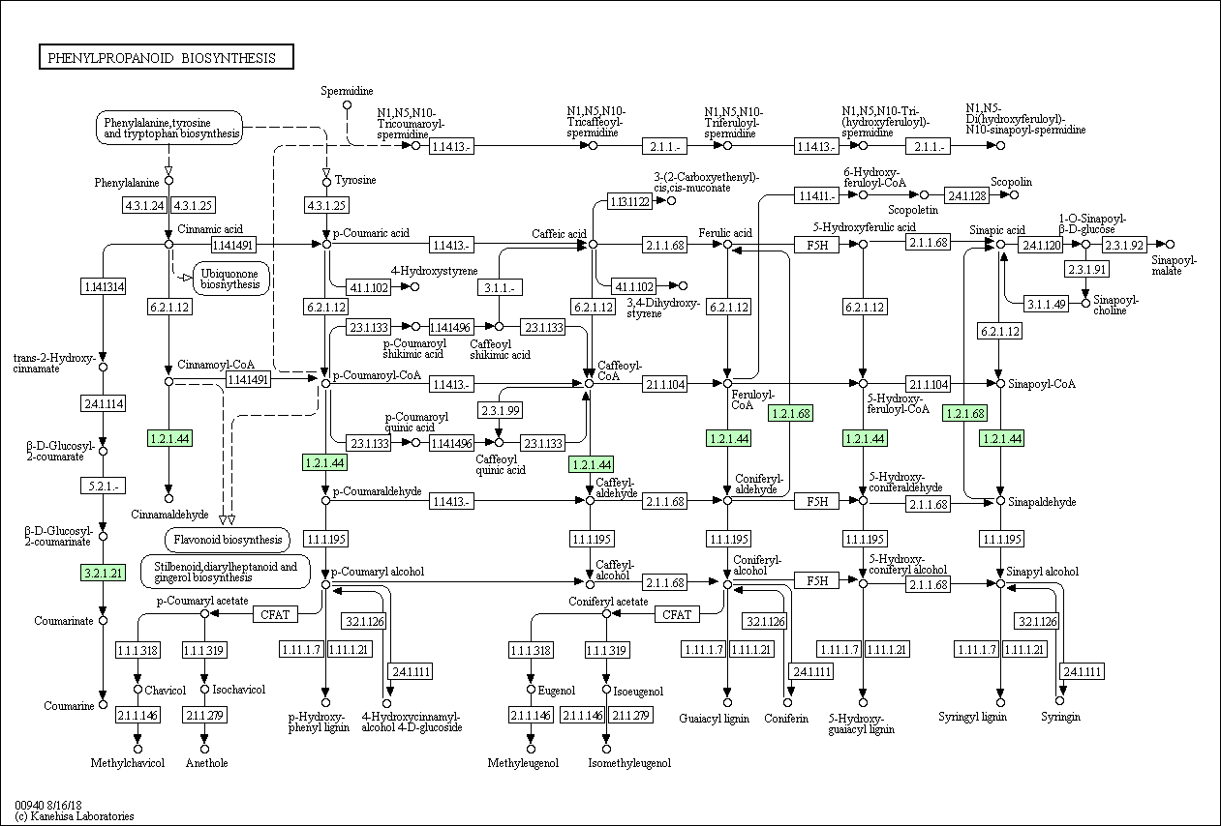

Additional file 8.4. Phenylpropanoid biosynthesis pathway with transcripts from subcluster 4. Enzymes and products are represented as rectangles and circles, respectively. The presence of transcripts from subcluster 4 are indicated in green, where 3.2.1.21: beta-glucosidase; 1.2.1.44: cinnamoyl-CoA reductase and 1.2.1.68: coniferyl-aldehyde dehydrogenase.

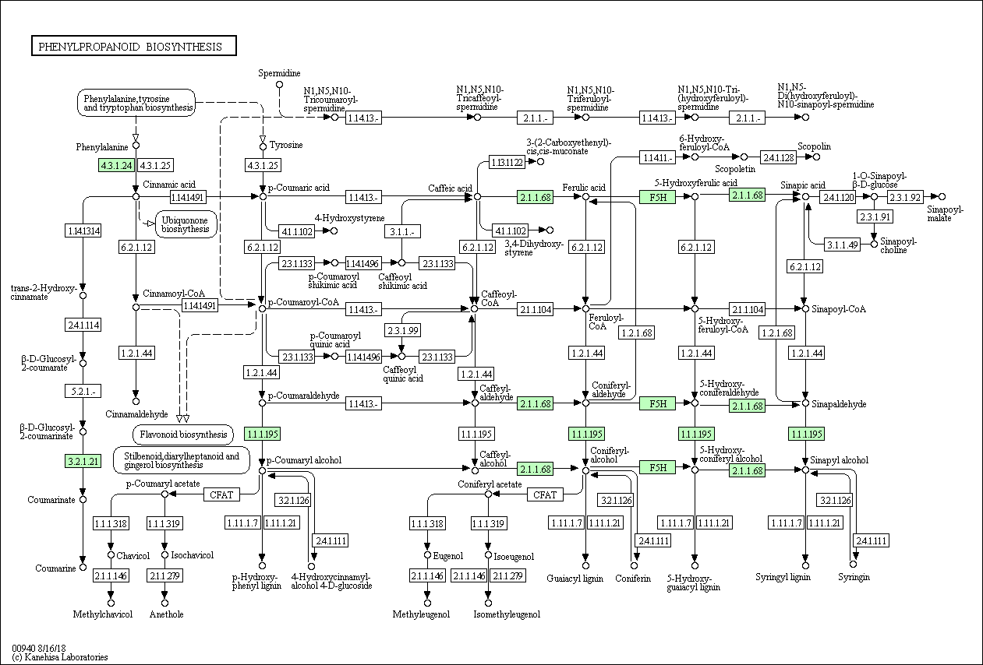

Additional file 8.5. Phenylpropanoid biosynthesis pathway with transcripts from subcluster 7. Enzymes and products are represented as rectangles and circles, respectively. The presence of transcripts from subcluster 7 are indicated in green, where 4.3.1.24: phenylalanine ammonia-lyase; 3.2.1.21: beta-glucosidase; 1.1.1.195: cinnamyl-alcohol dehydrogenase; 2.1.1.68: caffeic acid 3-0-methyltransferase and F5H: ferulate-5-hydroxylase.
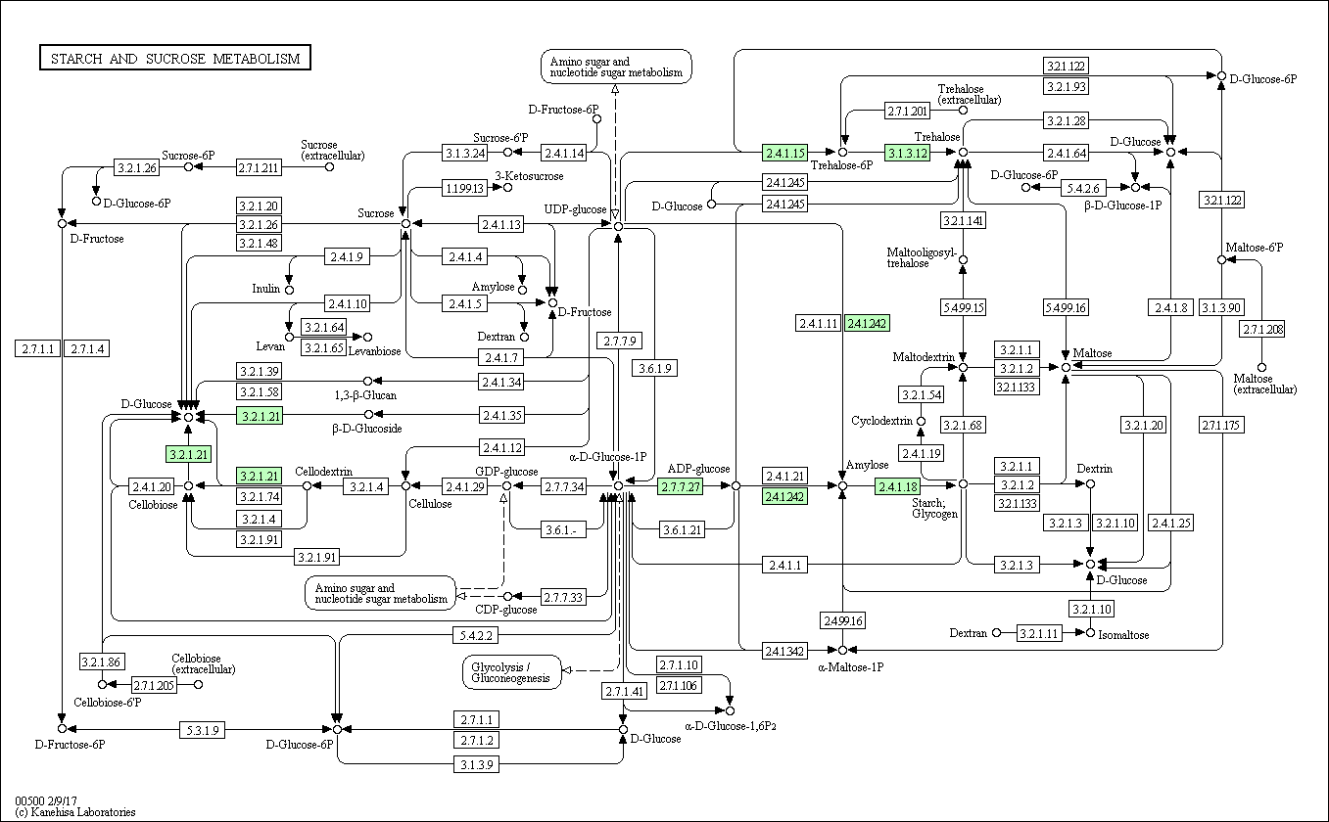

Additional file 8.6. Starch and sucrose metabolism pathway with transcripts from subcluster 7. Enzymes and products are represented as rectangles and circles, respectively. The presence of transcripts from subcluster 7 are indicated in green, where 3.2.1.21: beta-glucosidase; 2.7.7.27: glucose-1-phosphate adenylyltransferase; 2.4.1.242: granule-bound starch synthase and 2.4.1.18: 1,4-alpha-glucan branching enzyme.

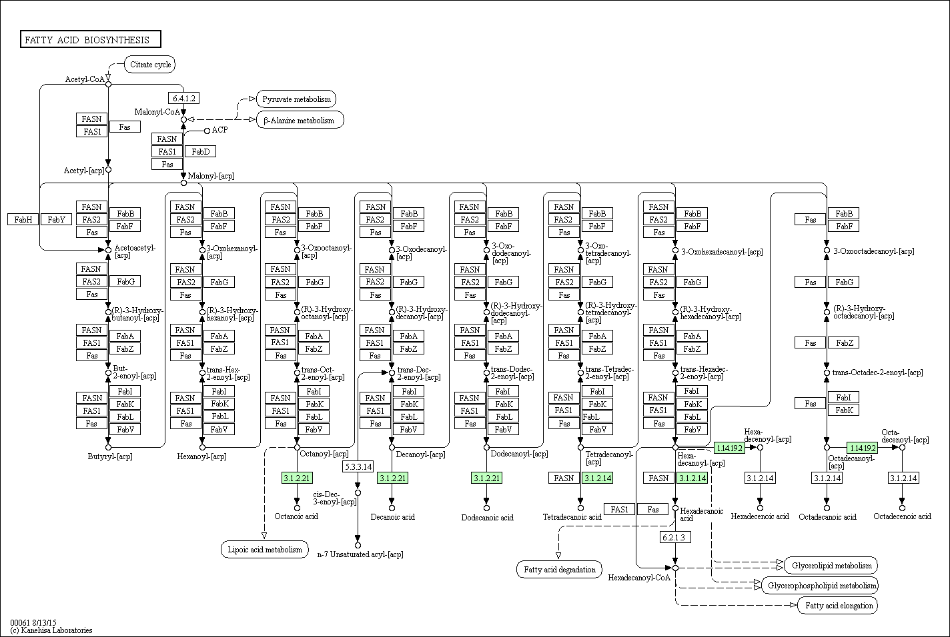

Additional file 8.7. Fatty acid biosynthesis pathway with transcripts from subcluster 11. Enzymes and products are represented as rectangles and circles, respectively. The presence of transcripts from subcluster 11 are indicated in green, where 3.1.2.21: medium.chain acyl-[acyl-carrier-protein] hydrolase; 3.1.2.14: fatty acyl-ACP thioesterase B and 1.14.19.2: acyl-[acyl-carrier-protein] desaturase.

