Additional file 3. Sequences analysis of atp4 in three materials

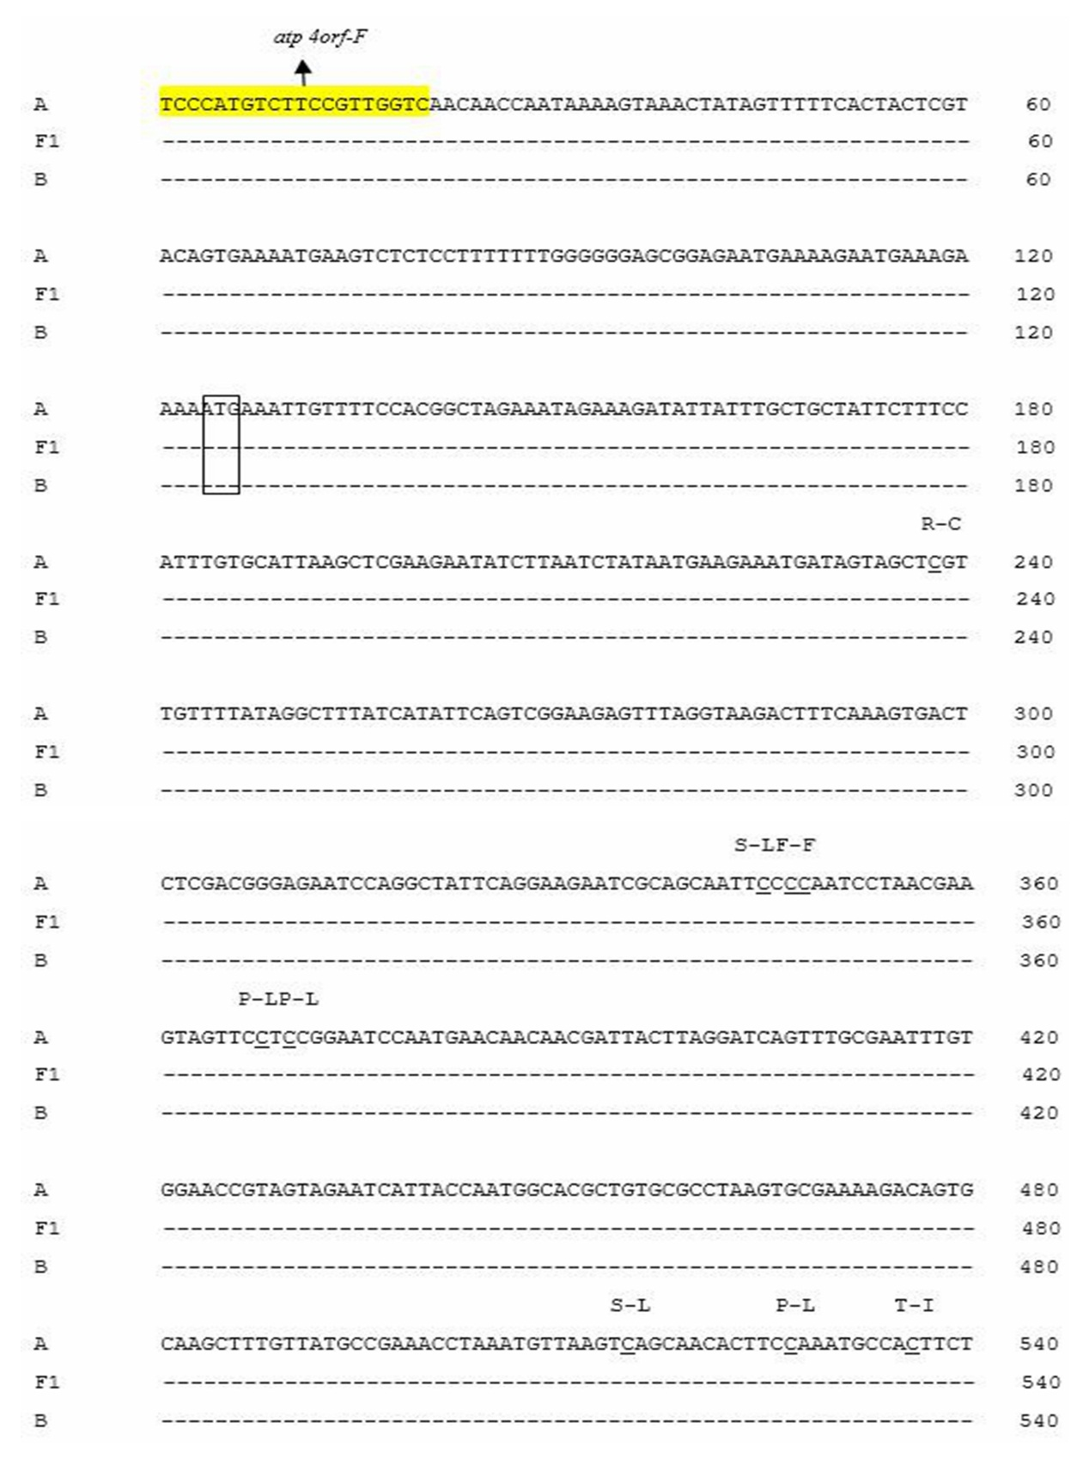

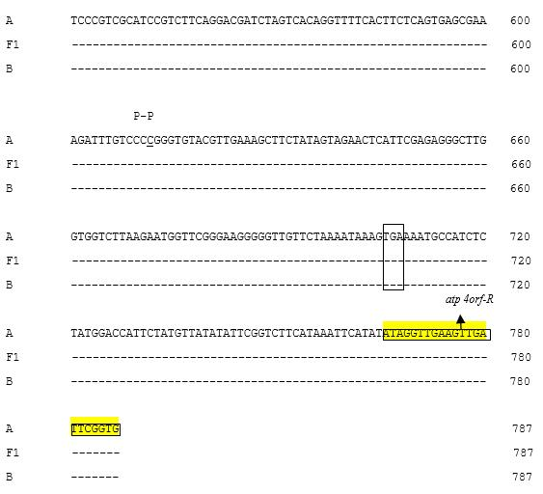
Notes: A, CMS line H276A; F1, Fertile F1 (H276A/H268); B, Maintainer line H276B.

