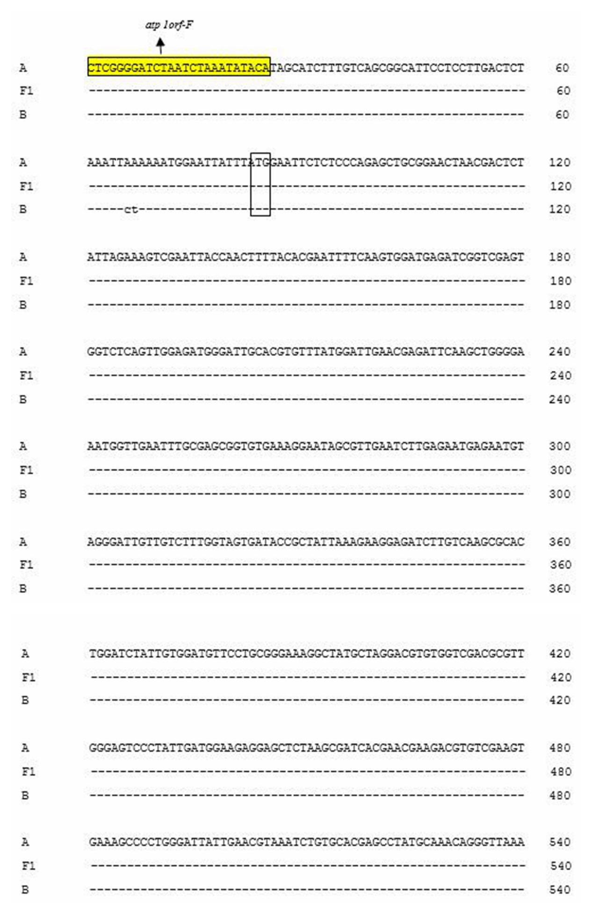
Additional file 2. Sequences analysis of atp1 in three materials

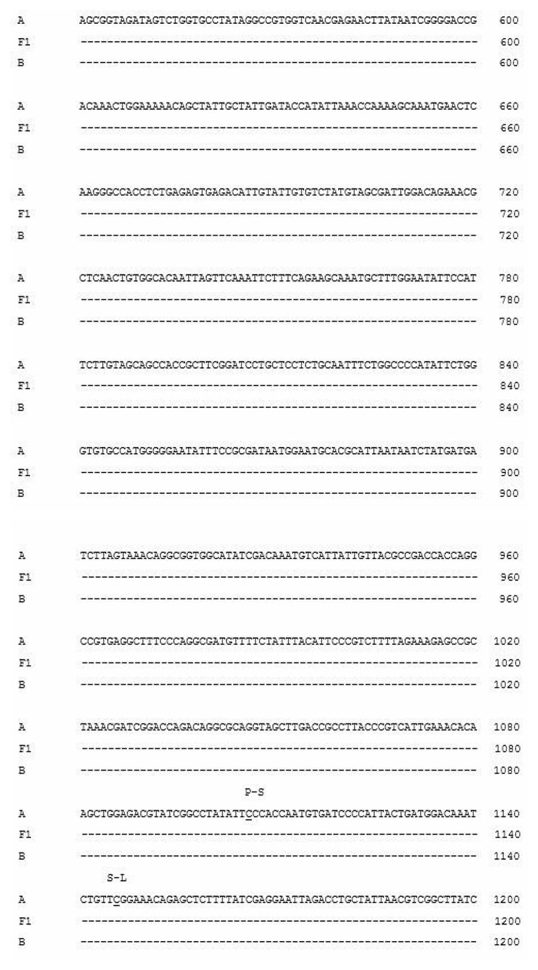
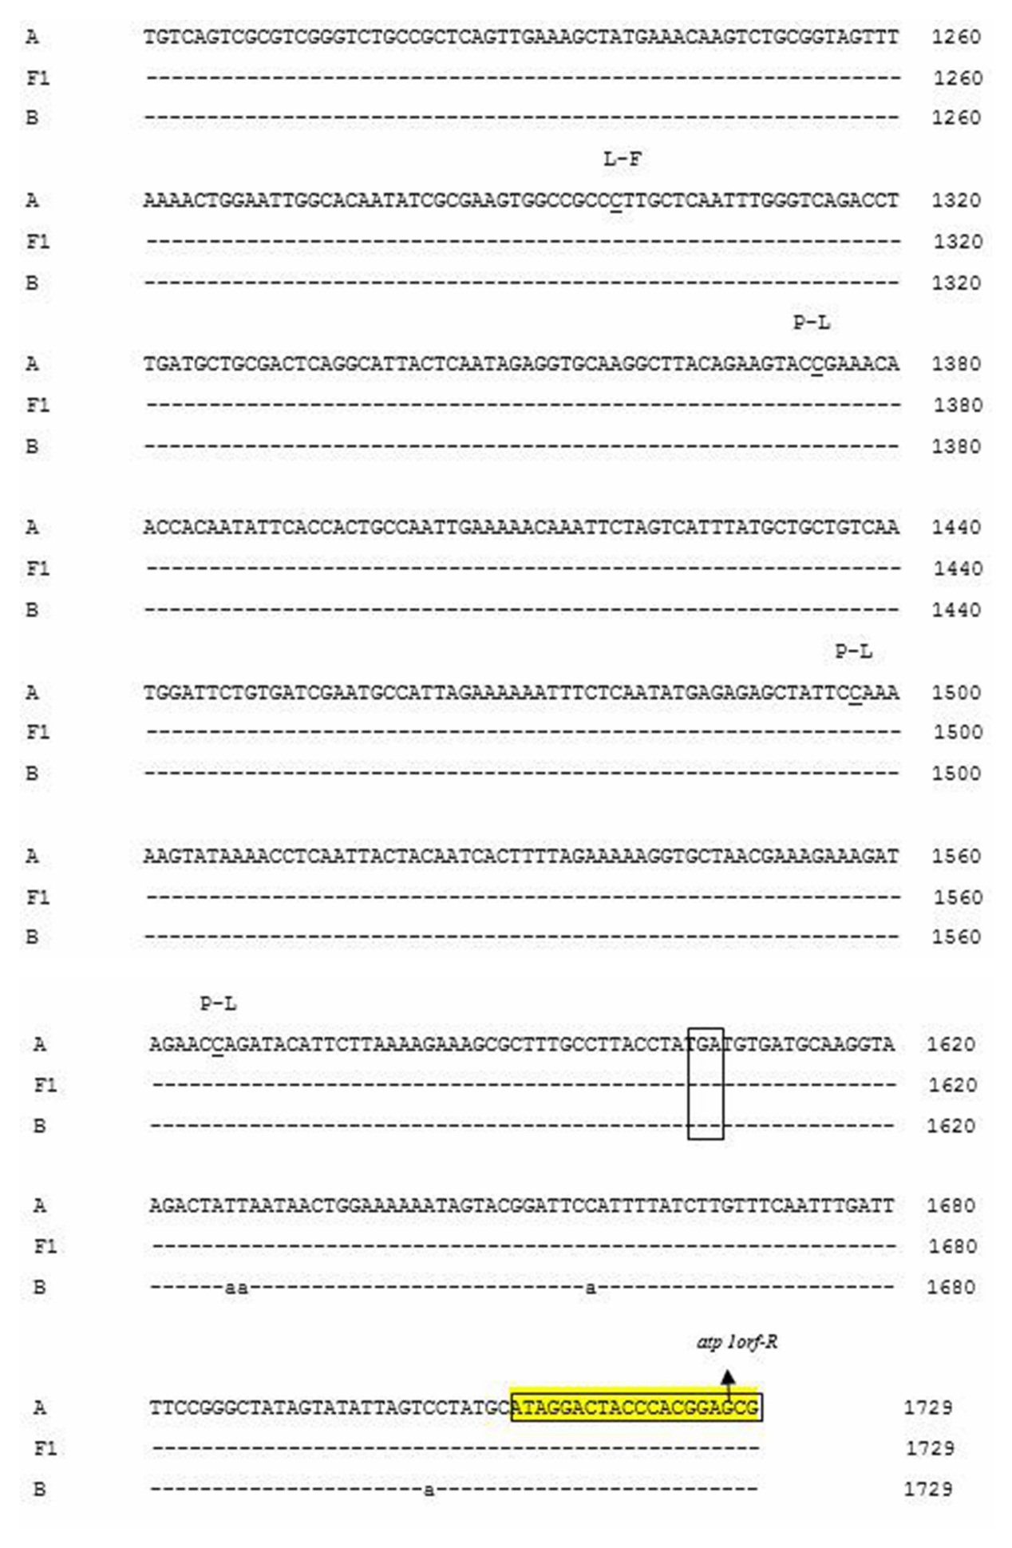
Notes: A, CMS line H276A; F1, Fertile F1 (H276A/H268); B, Maintainer line H276B.

