Additional File 4
Figure S1: The sequences and comparisons of the results of prediction techniques (biomine, PrDOS, Disopred, and the present study) with IDEAL annotations for Baculoviral IAP repeat-containing protein 5 from Homo sapiens (IDEAL-ID: IID00186), Histone H3-like centromeric protein A from Homo sapiens (IDEAL-ID: IID00272), Microtuble-associated proteins 1A/1B light chain 3B from Homo sapiens (IDEAL-ID: IID00346) and Histone H3K27 methylase from Paramecium bursaria Chlorella virus 1 (IDEAL-ID: IID90012). A segment with a red double arrow means the position of IDR annotated in IDEAL and blue double arrow means a segment predicted as IDR by biomine, PrDOS, Disopred, or the present study.

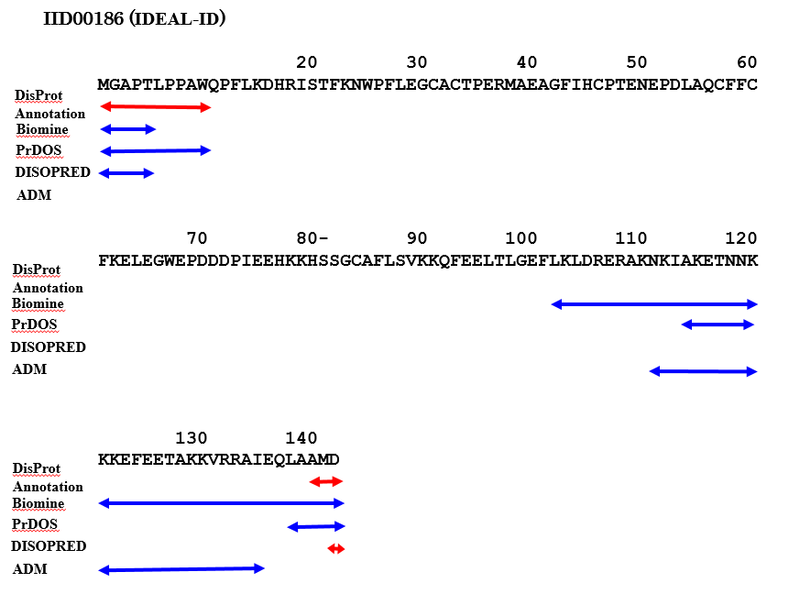
IDEAL
Annotation
IDEAL
Annotation
IDEAL
Annotation

(continued)
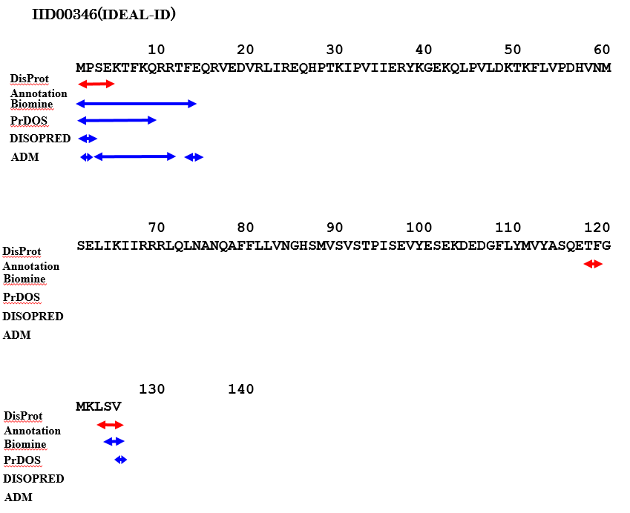
IDEAL
Annotation
IDEAL
Annotation
IDEAL
Annotation

(continued)
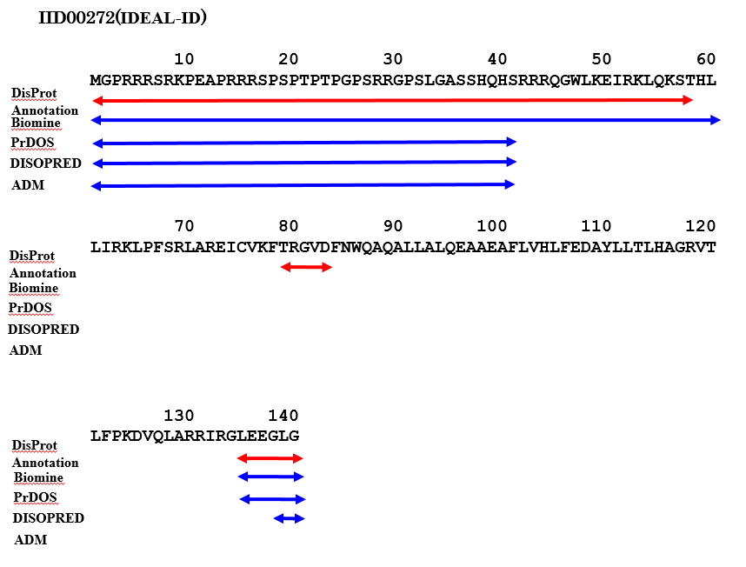
IDEAL
Annotation
IDEAL
Annotation
IDEAL
Annotation

(continued)
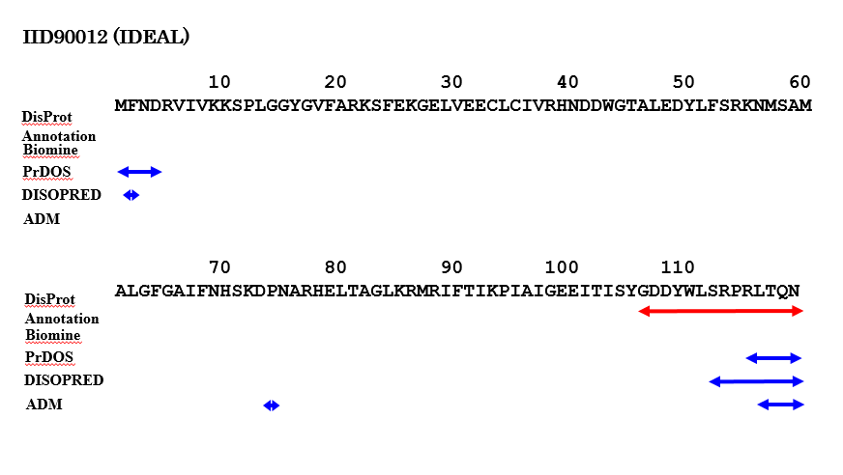
IID90012 (IDEAL-ID)
IDEAL
Annotation
IDEAL
Annotation

