Application of MALDI-TOF mass spectrometry and specific PCR for tracking of E. coli O157:H⁻ strain 431/97 in Batavia lettuce

Results of the partial amplification of the rfbE gene

Supplementary figure S17. Picture of agarose gel electrophoresis (2% (w/v)) of partially amplified rfbE genes. The expected amplicon size was 259 bp. GeneRuler™ 100 bp DNA ladder was used as a marker (M). 1: no template control; 2: E. coli O157:H7 EDL 933; 3: E. coli O157:H⁻ 431/97; 4: E. coli DH5α; 5: isolate 48; 6: isolate 180 1; 7: isolate 180 2; 8: isolate 181 1; 9: isolate 181 2; 10: isolate 181 3; 11: isolate 181 4; 12: isolate 249 a; 13: isolate 249 a1; 14: isolate 249 b1; 15: isolate 249 1b; 16: isolate 249 2b; 17: isolate 282 1; 18: isolate 282 2.
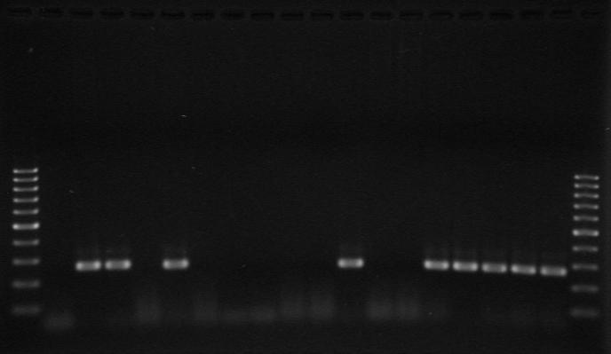
- 200 bp
- 300 bp
- 500 bp
M 1 2 3 4 5 6 7 8 9 10 11 12 13 14 15 16 17 18 M

Supplementary figure S18. Picture of agarose gel electrophoresis (2% (w/v)) of partially amplified rfbE genes. The expected amplicon size was 259 bp. GeneRuler™ 100 bp DNA ladder was used as a marker (M). 19: isolate 283; 20: isolate 284; 21: isolate 285; 22: isolate 289; 23: isolate 291 a; 24: isolate 291 1a; 25: isolate 291 b; 26: isolate 291 2b; isolate 27: 292; 28: isolate 292 2; 29: isolate 294; 30: isolate 294 1; 31: isolate 294 2; 32: isolate 295 a; 33: isolate 295 b1; 34: isolate 295 b2; 35: isolate 296.
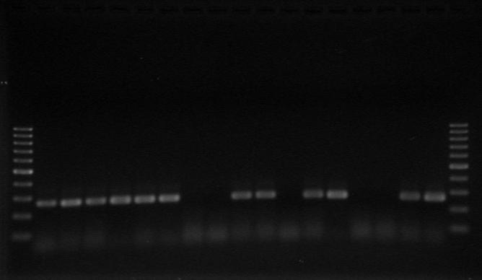
- 200 bp
- 300 bp
- 500 bp
M 19 20 21 22 23 24 25 26 27 28 29 30 31 32 33 34 35 M

Results of the amplification of the sfpA gene

Supplementary figure S19. Picture of agarose gel electrophoresis (2% (w/v)) of amplified sfpA genes. The expected amplicon size was 440 bp. GeneRuler™ 100 bp DNA ladder was used as a marker (M). 1: no template control; 2: E. coli O157:H7 EDL 933; 3: E. coli O157:H⁻ 431/97; 4: E. coli DH5α; 5: isolate 48; 6: isolate 180 1; 7: isolate 180 2; 8: isolate 181 1; 9: isolate 181 2; 10: isolate 181 3; 11: isolate 181 4; 12: isolate 249 a; 13: isolate 249 a1; 14: isolate 249 b1; 15: isolate 249 1b; 16: isolate 249 2b; 17: isolate 282 1; 18: isolate 282 2.
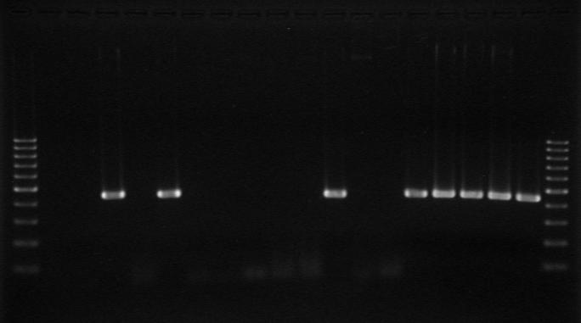
- 200 bp
- 300 bp
- 500 bp
M 1 2 3 4 5 6 7 8 9 10 11 12 13 14 15 16 17 18 M

Supplementary figure S20. Picture of agarose gel electrophoresis (2% (w/v)) of amplified sfpA genes. The expected amplicon size was 440 bp. GeneRuler™ 100 bp DNA ladder was used as a marker (M). 19: isolate 283; 20: isolate 284; 21: isolate 285; 22: isolate 289; 23: isolate 291 a; 24: isolate 291 1a; 25: isolate 291 b; 26: isolate 291 2b; 27: isolate 292; 28: isolate 292 2; 29: isolate 294; 30: isolate 294 1; 31: isolate 294 2; 32: isolate 295 a; 33: isolate 295 b1; 34: isolate 295 b2; 35: isolate 296.
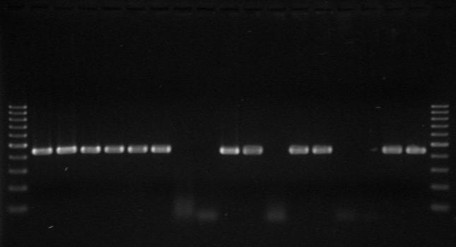
- 200 bp
- 300 bp
- 500 bp
M 19 20 21 22 23 24 25 26 27 28 29 30 31 32 33 34 35 M

Results of the amplification of the stx_{2a} gene

Supplementary figure S21. Picture of agarose gel electrophoresis (2% (w/v)) of amplified stx_{2a} genes. The expected amplicon size was 584 bp. GeneRuler™ 100 bp DNA ladder was used as a marker (M). 1: no template control; 2: E. coli O157:H7 EDL 933; 3: E. coli O157:H⁻ 431/97; 4: E. coli DH5α; 5: isolate 48; 6: isolate 180 1; 7: isolate 180 2; 8: isolate 181 1; 9: isolate 181 2; 10: isolate 181 3; 11: isolate 181 4; 12: isolate 249 a; 13: isolate 249 a1; 14: isolate 249 b1; 15: isolate 249 1b; 16: isolate 249 2b; 17: isolate 282 1; 18: isolate 282 2.
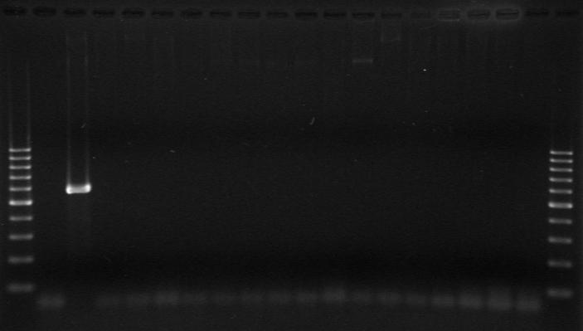
- 200 bp
- 300 bp
- 500 bp
M 1 2 3 4 5 6 7 8 9 10 11 12 13 14 15 16 17 18 M

Supplementary figure S22. Picture of agarose gel electrophoresis (2% (w/v)) of amplified stx_{2a} genes. The expected amplicon size was 584 bp. GeneRuler™ 100 bp DNA ladder was used as a marker (M). 19: isolate 283; 20: isolate 284; 21: isolate 285; 22: isolate 289; 23: isolate 291 a; 24: isolate 291 1a; 25: isolate 291 b; 26: isolate 291 2b; 27: isolate 292; 28: isolate 292 2; 29: isolate 294; 30: isolate 294 1; 31: isolate 294 2; 32: isolate 295 a; 33: isolate 295 b1; 34: isolate 295 b2; 35: isolate 296.
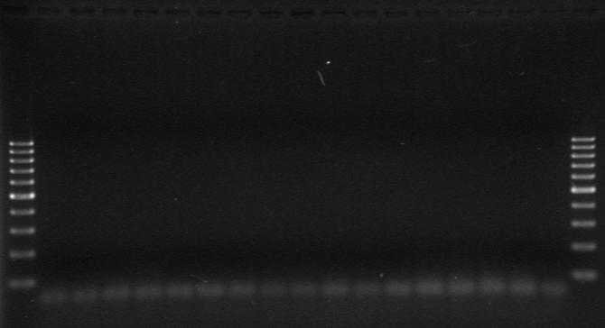
- 200 bp
- 300 bp
- 500 bp
M 19 20 21 22 23 24 25 26 27 28 29 30 31 32 33 34 35 M

