Toxicity and neurotoxicity profiling of contaminated sediments from Gulf of Bothnia (Sweden): a multi-endpoint assay with zebrafish embryos
Riccardo Massei ¹, Henner Hollert ², Martin Krauss ¹, Wolf von Tümpling⁴, Cindy Weidauer ¹, Peter Haglund ³, Eberhard Küster ⁵, Christine Gallampois ³, Mats Tysklind ³, Werner Brack ^{1,2}

¹ Helmholtz Centre for Environmental Research - UFZ, Department of Effect-Directed Analysis, Permoserstraße 15, D-04318 Leipzig, Germany

² RWTH-Aachen University, Institute for Environmental Research, Department of Ecosystem Analysis (ESA), Worringer Weg 1, D- 52074 Aachen, Germany

³ Umea University, Department of Chemistry, S-901 87 Umeå, Sweden
⁴ Helmholtz Centre for Environmental Research - UFZ. Central Laboratory for Water Analytics and Chemometrics, , Brückstraße 3a, D- 39114 Magdeburg, Germany
⁵ Helmholtz Centre for Environmental Research - UFZ, Department Bioanalytical Ecotoxicology, Permoserstraße 15, D-04318 Leipzig, Germany

Corresponding author
*Riccardo Massei
Helmholtz Centre for Environmental Research - UFZ, Department Effect-Directed Analysis, Permoserstraße 15, D-04318 Leipzig, Germany
Emails adress:
Riccardo Massei: riccardo.massei@ufz.de
Henner Hollert: henner.hollert@bio5.rwth-aachen.de
Martin Krauss: martin.krauss@ufz.de
Wolf von Tümpling:: wolf.vontuempling@ufz.de
Cindy Weidauer: cw0802@gmx.de
Peter Haglund: peter.haglund@umu.se
Eberhard Küster: eberhard.kuester@ufz.de
Christine Gallampois: christine.gallampois@umu.se
Mats Tysklind: mats.tysklind@umu.se
Werner Brack: werner.brack@ufz.de
Additional files
S.1 - Sediments extraction and clean-up
S2 - GC-HRMS and LC-HRMS methods
S3 - Trace Finder parameters
S4 - Method detection limits
S5 - Trace elements analyses
Additional Tables
Table S1 - Sediments characteristics and sampling spot information
Table S2 - GC oven program
Table S3 - Injection details for pulsed split less injection for GC-analysis
Table S4 - Parameters of the GC-QExactive HRMS method
Table S5 - LC gradient program
Table S6 - Settings of the Trace Finder software
Table S9 - Chemicals and Equipment
Additional Figures
Figure S1 – Sampling spot map
Figure S2 - Acetylcholisterase inhibition in Danio rerio embryos exposed to sediments of Gulf of Bothnia
Figure S3- Zebrafish embryos after 96 hpf exposed to sediments of Kramfors and Örnsköldsvik.

Additional material

S1- Sediments extraction and clean-up
Extraction and clean-up were performed according to Massei et al. (2017). Briefly, a total amount of 50 mg of sediment TOC equivalent (grain size ≤ 63 μm) was sequentially extracted by pressurize liquid extraction (PLE) using a mixture of ethyl acetate and acetone (EtAC, 50:50 v/v) at 100 °C. The extraction was performed with two static cycles of 5 min.
For the cleanup, deactivated silica (1.5 g) and aluminum oxide (1 g) were used. The sorbents were suspended in n-hexane and poured into a glass column with silica at the bottom and aluminum oxide on top of the silica. In a round-bottom flask, 0.75 g silica was mixed with the EtAC extract and evaporated to dryness with a rotary evaporator. This “loaded” silica was added to the column onto the aluminum oxide. This procedure allows the transfer of a broad range of organic compounds onto the column without the need to dissolve them in the first normal-phase column elution solvent (n-hexane). The analytes were eluted sequentially with n-hexane (11 mL), n-hexane–dichloromethane (3:1, 7.5 mL), dichloromethane (15 mL), and methanol (10 mL).
For LC-HRMS analyses, half of the n-hexane–dichloromethane eluate was mixed with half of the methanol eluate and evaporated to 500 μL under a gentle stream of nitrogen. The sample was evaporated close to dryness, dissolved in 1 mL of methanol.
For GC-HRMS analyses, the n-hexane–dichloromethane eluate left was mixed with half of the n-hexane eluate and evaporated to 500 μL under a gentle stream of nitrogen. The sample was evaporated close to dryness, dissolved in 1 mL of EtAc. All samples were filtered (pore size 45 μm) and stored at -20 °C until analysis.

S2 - GC-HRMS and LC-HRMS methods
For GC-HRMS analyses, a Thermo TRACE 1300 GC system WITH A DB-5MS capillary column (30 m x 250 µm x 0.25 µm) using helium as carrier gas at a flow rate of 1 mL min⁻¹. Extract aliquots of 1 µL were injected using pulse split less injection. The GC program is listed in Table S2 and injection details in Table S3.
Table S2: GC oven program
Step | Rate [°C/minute] | Temperature [°C] | Hold time [minutes]
Initial |  | 60 | 1
Ramp 1 | 5 | 300 | 15

Table S3: Injection details for pulsed split less injection for GC-analysis
Parameter | Value
Pressure [unit!] | 14.50
Inlet temperature | 200 °C, hold 1 min
Injection pulse pressure | 10.15
Purge flow to split flow | 5 mL/min
Purge temperature | 200 °C
Injection volume | 1 μL
Syringe size | 5 μL

Analyses were performed on a GC quadrupole-Orbitrap MS (GC-QExactive, Thermo) operating in electron ionization (EI) mode. MS parameters of the MS method are shown in Table S4.
Table S4: Parameters of the GC-QExactive HRMS method
Parameter | Value
Filament delay (min) | 5.0
MS transfer line temp (C⁰) | 280
Ion source temp | 250
Emission current (μA) | 50
Electron energy (eV) | 70
Resolution | 60000
Maximum IT (ms) | 200
Scan range (m/z) | 50 to 650

For LC-HRMS analyses, a Thermo Ultimate 3000 LC system with a Kinetex 2.6 μm EVO C18 (50x2.1 mm) column equipped with a pre-column (C18 EVO 5.x2.1 mm) and an inline filter was used for chromatographic separation. A water-methanol mobile phase gradient elution was used at a flow rate of 300 µL min⁻¹. Both eluents contained 0.1% formic acid (v/v). The LC gradient program is given in Table S5. The column oven was heated to 40°C and a volume of 5 μL was injected.
Table S5 – LC gradient program
Time [min] | Solvent A [%] | Solvent B [%]
0 | 90 | 10
3.2 | 90 | 10
21 | 5 | 95
42 | 5 | 95
43 | 90 | 10
50 | 90 | 10

Analyses were performed on a quadrupole-Orbitrap MS (QExactive Plus, Thermo). Analyses were conducted in separate positive and negative mode runs using electrospray ionization combining a full scan experiment (100-1000 m/z) at a nominal resolving power of 70,000 (referenced to m/z 200) and data-independent MS/MS experiments at a nominal resolving power of 35,000. For the latter, we acquired the data using broad isolation windows of about 50 (i.e., m/z ranges 97-147, 144-194, 191-241, 238-288, 285-335, 332-382, 379-429, 426-476) and 280 (i.e., m/z ranges 460-740, 730-1010), respectively.

S3 Trace Finder parameters
For data evaluation the Trace finder 3.2 Software (Thermo) and an internal, method-matched calibration were used. To this end, 7 calibration standards were processed from spiked solvents with the same procedure as the samples at 0.1, 0.5, 5, 10, 25, 50, 100 ng/mL in vial. For confirming identity of target compound peaks, accurate masses and retention times of the main adduct in the full scan runs (usually M+H⁺ or M-H⁻) were used as well as the match of experimental and theoretical isotope patterns fund the presence of one or two fragment ions from the MS/MS experiments. For quantification, the peak area of the main adduct in full scan mode was used. The settings are given in Table S6.
Table S6 – Settings of the Trace Finder software
Parameter | Settings
Parent Mass Tolerance | 5 ppm
Threshold Override | 200,000
Smoothing | 5
Area Noise factor | 20
Peak Noise Factor | 40
Baseline Window | 50
S/N | 100
Min peak width | 10
Multiple resolution | 10
Area tail extension | 5
Area Scan Volume | 0
Isotopes Fit Threshold | 70%
Isotopes Allowed Mass Deviation | 5 ppm
Isotopes Allowed Intensity Deviation | 30%
Minimum Number of Fragments | 1
Fragments Intensity Threshold | 30,000
Fragments Mass Tolerance | 7 ppm

S4 - Method detection limits for LC and GC-HRMS
Method detection limits (MDLs) for LC-HRMS were calculated according to US US EPA (2011) based on the standard deviation (STD) of the peak area from replicate analysis of samples of the same concentration using the spiking levels for the method validation which was about 5-10 times higher than the anticipated MDL. MDLs for GC-HRMS were considered to be the lowest point of the calibration curve were was still possible to distinguish the base peak from the blank. Values are given in Table S7

S5 - Trace elements analyses
The results obtained from the three-step sequential extraction help to better understand the potential mobility of the detected priority elements. As example the first fractions (F1) is characterized by the presence of compounds that are weekly associated to carbonates and may potentially harm aquatic organisms due to their high bioavailability. In all the three sites of Gulf of Bothnia , Cd and Zn were mostly associated to F1 (range from 39 to 54% of the total amount). The high affinity of Cd and Zn to F1 was already observed in previous studies (Fathollahzadeh et al. 2014). This is particularly relevant since Cd is an highly toxic element which may harm aquatic species in case of its remobilization (Qu et al. 2013). The second fraction (F2) is defined as reducible fraction and it contains elements that may be again potentially bioavailable after natural or anthropogenic perturbation of the sediments bench (i.e. dredging or remediation). In our study, Pb was mostly associated to the second fraction in all sites (72–82% of the total amount as suggested in a previous study (Fathollahzadeh et al. 2014, Gao &Li 2012, Yang et al. 2012). The third fraction (F3) contains compounds which are normally not bioavailable since they are associated to humic substances or bonded as sulfides. In our study, F3 was characterized by the presence of the trace element Cu (54–82% of the total amount). Finally, the residual fraction (RF) contains element compounds or clusters with low mobility and unlike adverse effect against aquatic organism. In sediments from GoB, the trace elements As, Cr and Ni were mostly associated to this last fraction (30–59% of the total amount).

ADDITIONAL TABLES

Table S1 – Sediments characteristics and sampling spot information. Coordinates are expressed in Degrees Decimal Minutes (DDM)*. (TC= Total carbon; TOC= Total Organic Carbon; TIC= Total inorganic carbon; TEC= Total elemental carbon).

LOCATION | % TOTAL CARBON | % TOC | % TIC | % TEC | Sampling Date | Latitude | Longitude
Sundsvall | 3.4 | 2.1 | 0.8 | 0.4 | 10-09-13 14:10 | 62°23'22.62"N | 17°21'38.77"E
 |  |  |  |  | 10-09-13 15:00 | 62°23'24.88"N | 17°21'24.58"E
 |  |  |  |  | 10-09-13 15:55 | 62°23'24.86"N | 17°21'51.79"E
Kramfors | 1.2 | 2.2 | 0.7 | 0.5 | 11-09-13 16:50 | 62°57'19.57"N | 17°46'33.37"E
 |  |  |  |  | 11-09-13 17:30 | 62°57'26.26"N | 17°46'25.07"E
 |  |  |  |  | 11-09-13 18:05 | 62°57'15.66"N | 17°46'42.70"E
Örnsköldsvik | 4.1 | 2.7 | 0.8 | 0.6 | 12-09-13 14:10 | 63°15'58.56"N | 18°43'49.56"E
 |  |  |  |  | 12-09-13 14:52 | 63°15'56.16"N | 18°43'38.52"E
 |  |  |  |  | 12-09-13 15:35 | 63°15'54.18"N | 18°43'58.68"E

Table S9 - Chemicals and Equipment
Chemical | Brand
Acetone | HPLC grade, Merck
Alumina | (0.063-0.200 mm) for column chromatography, Merck
Ammonia solution | 7N in Methanol, Sigma-Aldrich
Double Distilled Water
Dichloromethane | HPLC grade, Merck
Ethyl acetate | HPLC grade, Merck
Formic Acid | 98-100%, analytical reagent grade, Merck
Hexane | LC grade, Merck
Hydromatrix | ISOLUTE HM-N; Biotage, Uppsala (SE)
Methanol LC-MS grade | Chromasolv, Sigma-Aldrich
Water LC-MS grade | Chromasolv, Sigma-Aldrich
Methanol | HPLC grade, Merck
Silica gel | (0.063-0.200 mm) for column chromatography, Macherey-Nagel, Düren (Germany)
Sodium borate | Sigma Aldrich
Aqua Regia | Suprapurgrade, Merck, Germany

Equipment | Brand
Freeze dryer | Christ Beta 1-16, Osterode am Harz (Germany)
Pressurized liquid extraction | ASE 200, Dionex
Rotary evaporator | Büchi, Flawil (CH)
pH meter | pH 526, WTW, Weilheim (Germany)
Sieving machine | Retsch AS 200 basic, Haan (Germany)
Microwave | Discover, CEM, Germany

Additional Figures
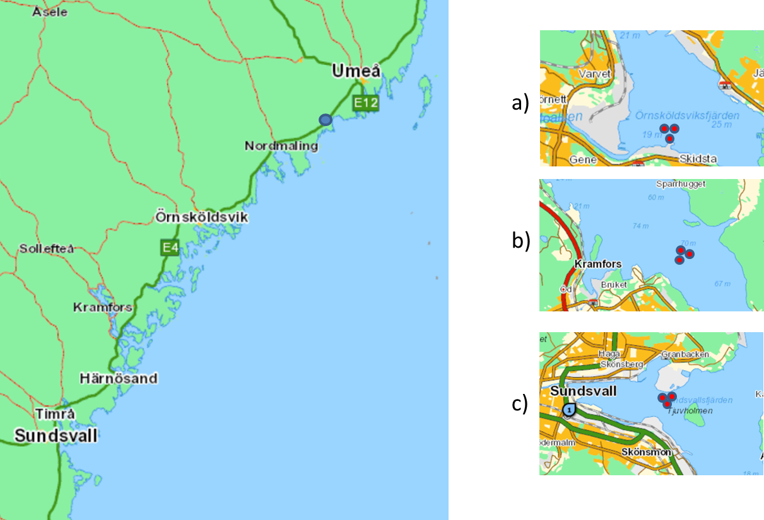
Fig S1.: Sampling spot map for a) Örnsköldsvik b) Kramfors and c) Sundsvall

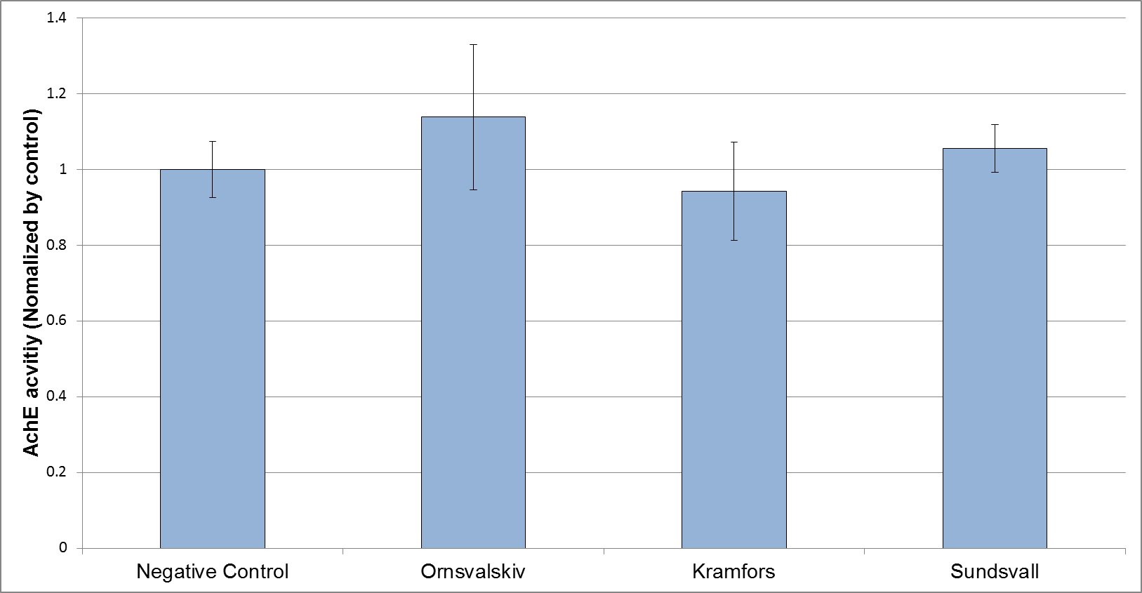
Fig S2.: Control normalized activity of AChE in Danio rerio embryos exposed for 105 hours post fertilization (hpf) to native sediments from Gulf of Bothnia. No statistical difference between treatments or between treatments and the control were observed (p ≤ 0.05)
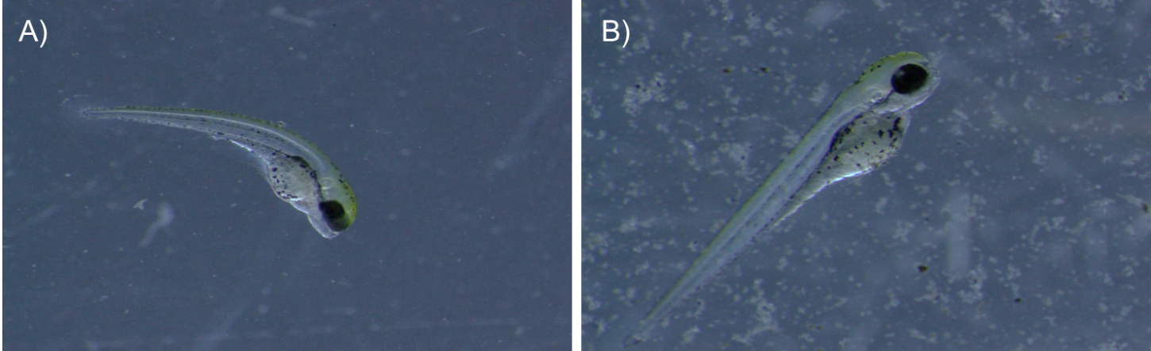
Figure S3 - Zebrafish embryos after 96 hpf exposed to sediments of A) Kramfors and B) Örnsköldsvik. All embryos exposed to Kramfors (100% effect) showed a strong spinal curvature

References
Fathollahzadeh H, Kaczala F, Bhatnagar A, Hogland W (2014): Speciation of metals in contaminated sediments from Oskarshamn Harbor, Oskarshamn, Sweden. Environmental Science and Pollution Research 21, 2455-2464
Gao X, Li P (2012): Concentration and fractionation of trace metals in surface sediments of intertidal Bohai Bay, China. Marine pollution bulletin 64, 1529-1536
Massei R, Byers H, Beckers L-M, Prothmann J, Brack W, Schulze T, Krauss M (2017): A sediment extraction and cleanup method for wide-scope multitarget screening by liquid chromatography–high-resolution mass spectrometry. Analytical and Bioanalytical Chemistry, 1-12
Qu RJ, Wang XH, Feng MB, Li Y, Liu HX, Wang LS, Wang ZY (2013): The toxicity of cadmium to three aquatic organisms (Photobacterium phosphoreum, Daphnia magna and Carassius auratus) under different pH levels. Ecotoxicology and Environmental Safety 95, 83-90
US EPA (2011): Definition and Procedure for the Determination of the Method Detection Limit. 40 CFR Part 136, Appendix B to Part 136 Revision 1.11.
Yang Y, Chen F, Zhang L, Liu J, Wu S, Kang M (2012): Comprehensive assessment of heavy metal contamination in sediment of the Pearl River Estuary and adjacent shelf. Marine Pollution Bulletin 64, 1947-1955

