Figure S1 Model-estimated cumulative events per 100 patients over five years, according to CKD stage (a–c), RAASi use (d–f) and incidence of hyperkalaemia (g–i)
CKD: chronic kidney disease; RAASi: renin-angiotensin-aldosterone system inhibitor;

To aid interpretation of the relationship between key patient characteristics and modelled event rates, the cumulative number of mortality, cardiovascular and hospitalization events estimated by the model are presented, according to initial CKD severity (eGFR (mL/min/1.73m²): 52.5 (CKD3a), 37.5 (CKD3b), and 22.5 (CKD4)), renin-angiotensin-aldosterone system inhibitor (RAASi) use and serum potassium status (normokalaemia or hyperkalaemia).
All settings were as described in the base case scenario with RAASi use, unless otherwise specified. In the normokalaemia scenario constant potassium levels of 4.5 mEq/L were modelled; while in the hyperkalaemia scenario hyperkalaemia events (potassium ≥6 mEq/L) were modelled in two months per year. Simulated patients on RAASi progress to the next CKD stage at 3.4 years; while those not on RAASi progress at 2.4 years.
Figure S2 Impact of RAASi cost and efficacy (0–100% of base case values) on discounted lifetime per-patient costs, QALYs, life years and NMB at conventional WTP thresholds
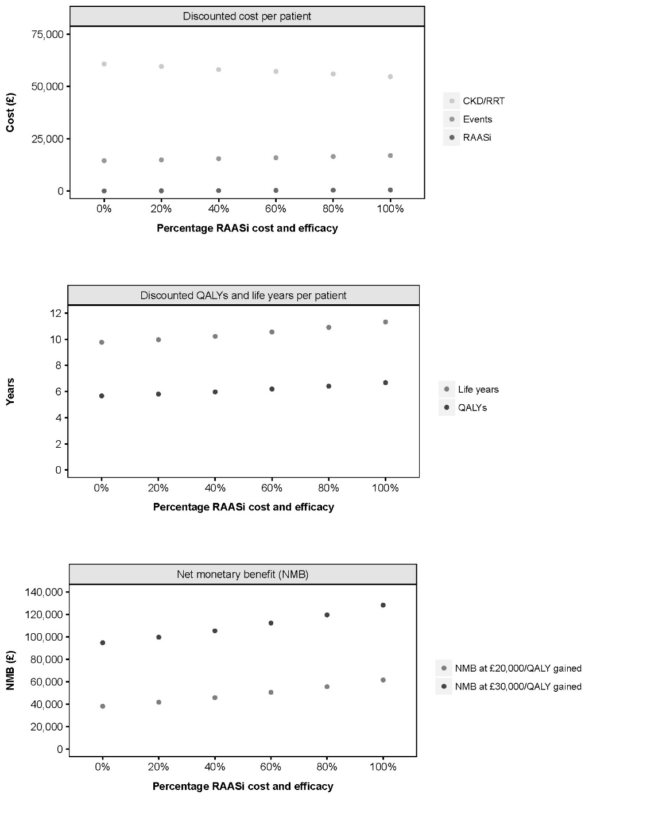
CKD: chronic kidney disease; NMB: net monetary benefit; QALY: quality-adjusted life year; RAASi: renin-angiotensin-aldosterone system inhibitor; RRT: renal replacement therapy; WTP, willingness-to-pay

