Table S1: Serum levels of AEA, OEA and PEA are independently associated with ASD status when adjusting for age, gender, BMI and ADHD (Logistic regression).

AEA
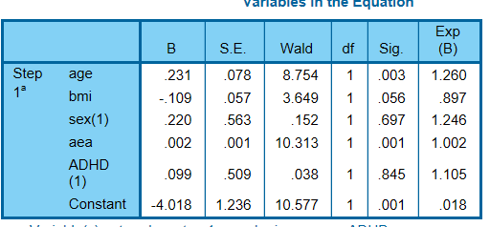

OEA
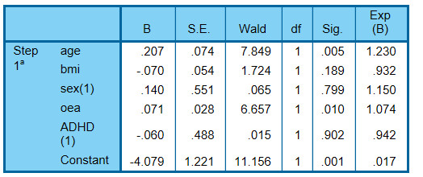

PEA
