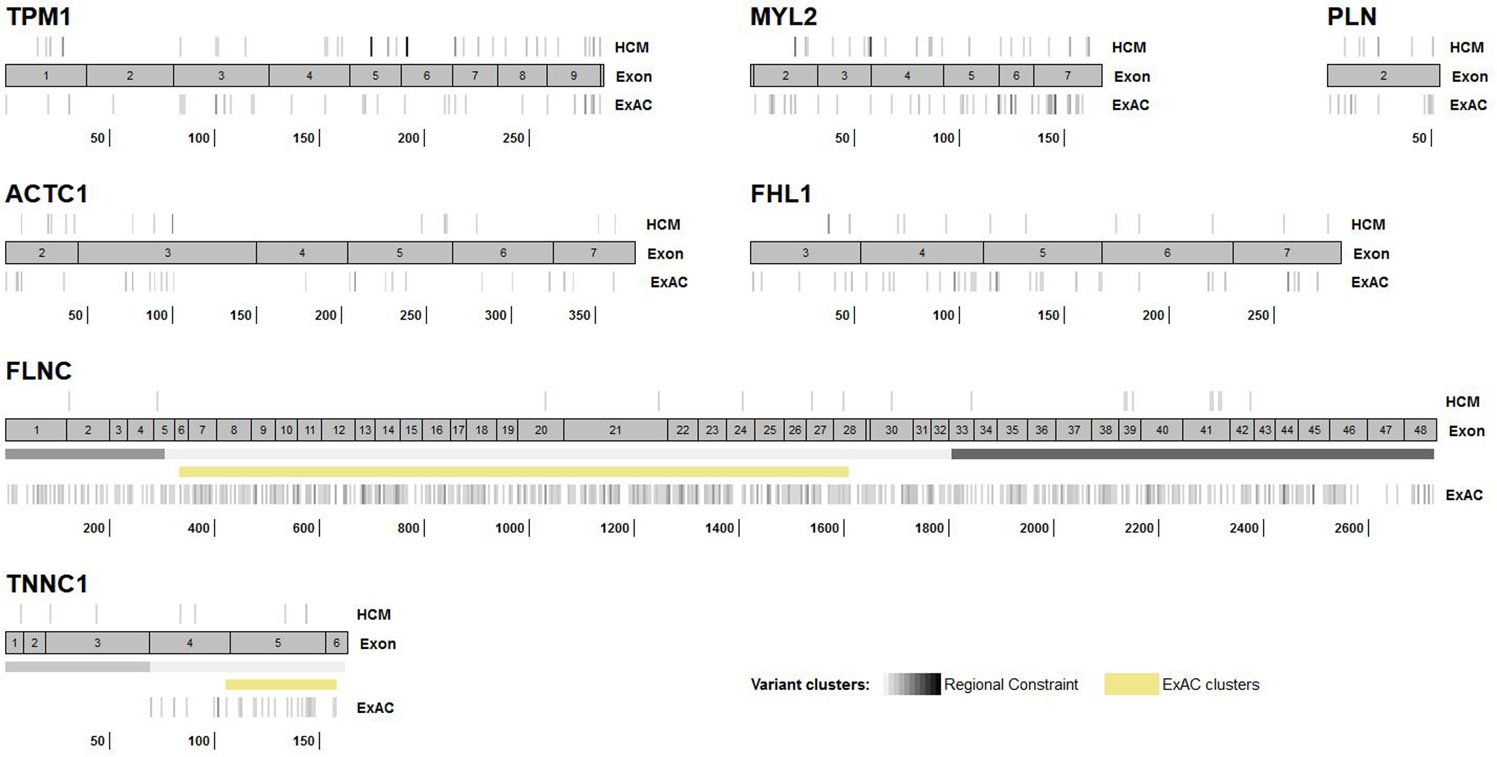

Figure S1: Distribution of rare variants in HCM and ExAC cohorts in genes without variant clustering
Figure S1: Distribution of rare, non-truncating variants in HCM cohorts and ExAC for validated genes without observed clustering of variants in cases (variant density increases with darker shades of grey). Regional constraint boundaries described by Samocha et al are also highlighted.

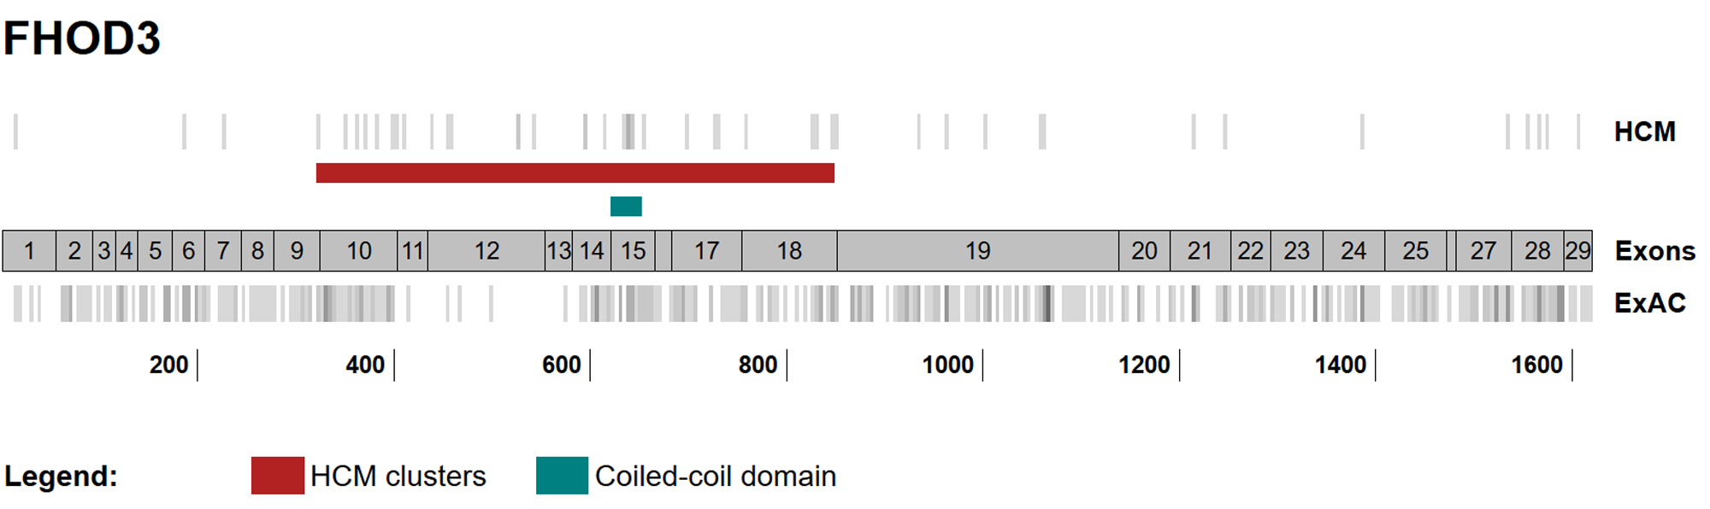

Figure S2: Distribution of rare variants in HCM and ExAC cohorts in FHOD3
Figure S1: Distribution of rare, non-truncating variants in HCM cohorts and ExAC for the recently implicated HCM gene FHOD3. An enriched case cluster was detected between residues 321 and 849. The EF for rare, non-truncating variants within this cluster is 0.786 (0.726-0.847) compared to 0.475 (0.353-0.597) for the overall gene. The coiled-coil domain (residues 622-655) is also highlighted – clustering of cases variants in this domain has been observed, with a calculated EF of 0.823 (0.709-0.937).

