Additional file 1

Supplementary data description

Identification and purity assessment of isolated 10-Hydroxy-2-decenoic acid
10-Hydroxy-2-decenoic acid (10-HDA) was obtained as white colored crystals. The ¹H NMR and ¹³C NMR were recorded for identification of the compound (Fig. 1A-B). Further identification and purity assessment was done by comparing chromatograms of the isolated compound and standard 10-hydroxy-2E-decenoic acid (Nacalai, Japan) using TLC and UPLC. In TLC the Rf-value was found to be similar for both isolated and standard compounds (Fig. 2A-3C). Furthermore, retention time of both isolated and standard compounds peak on UPLC was also found to be similar. Mass spectrometry analysis of the active isolated compound revealed an ion chromatogram ([M - H]⁺) with m/z 185.1149 Da, corresponding to the molecular formula C₁₀H₁₈O₃ (Fig. 3). Analyzing all data, it was confirmed the isolated compound was 10-Hydroxy-2-decenoic acid (10-HDA). Purity of the isolated compound was assessed using TLC and UPLC. The compound was found to be 94.97% pure.
10-Hydroxy-2-decenoic acid: ¹H NMR (500 MHz, DMSO-d6) ẟ ppm 6.80 (dt, J=15.55, 6.97 Hz, 1 H) 5.75 (dt, J=15.55, 1.39 Hz, 1 H) 3.36 (t, J=6.50 Hz, 2 H) 2.12 - 2.20 (m, 2 H) 1.25 (m, J=9.16 Hz, 10 H). ¹³C NMR (500 MHz, DMSO-d6): δ 175.08 (C-1), 149.44 (C-2), 167.71 (C-3), 33.07 (C-4), 29.12 (C-5), 29.25 (C-6), 29.53 (C-7), 25.98 (C-8), 31.91 (C-9), 61.28 (C-10).

Supplementary Figures
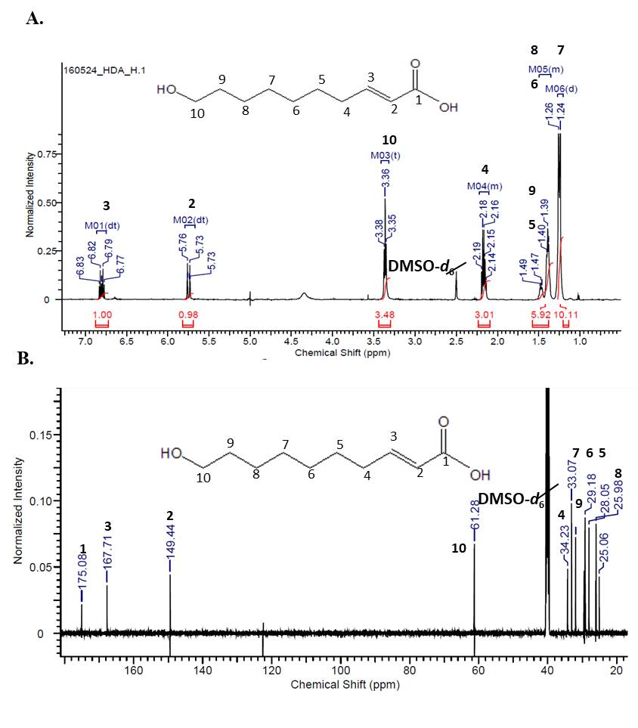
Figure S1 ¹H NMR Spectrum (A) and ¹³C NMR (500 MHz) spectra (B) of the compound isolated from ethyl acetate fraction of RJ in DMSO-d6.
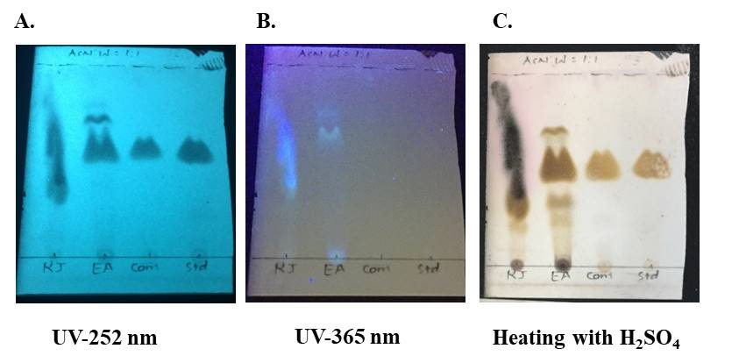
Figure S2 TLC analysis of Royal jelly (RJ), RJ-EA fraction (EA), isolated 10-HDA compound (Com) and standard 10-HDA (Std). TLC was eluted with the solvent mixture, acetonitrile: water =1: 1, v/v.

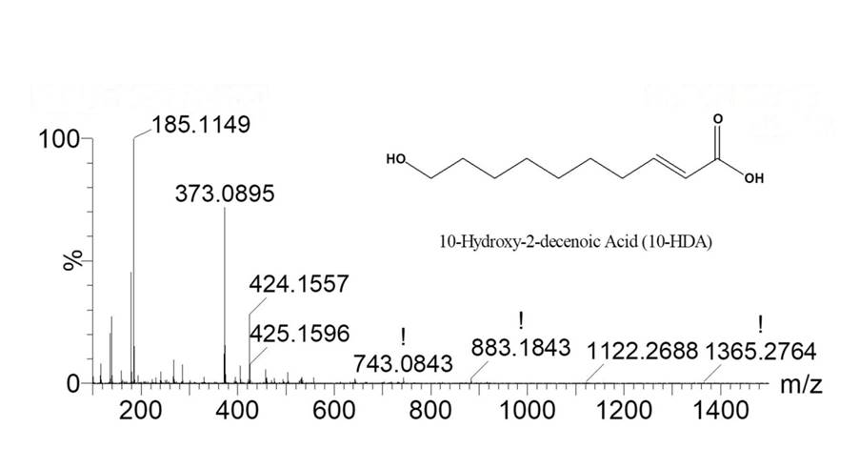
Figure S3 Mass spectrometry - structure of the 10-Hydroxy-2-decenoic acid (10-HDA)

