Supplementary Information
for
Incorporation of Cu₃BTC₂ nanocrystals to increase the permeability of polymeric membranes in O₂/N₂ separation

Chong Yang Chuah^{[a]}, Tae-Hyun Bae^{*[a,b]}

^{[a]} School of Chemical and Biomedical Engineering, Nanyang Technological University, Singapore 637459, Singapore
^{[b]} Singapore Membrane Technology Centre, Nanyang Environment and Water Research Institute, Nanyang Technological University, Singapore 637141, Singapore

* Corresponding author
Email: cchuah002@e.ntu.edu.sg, thbae@ntu.edu.sg

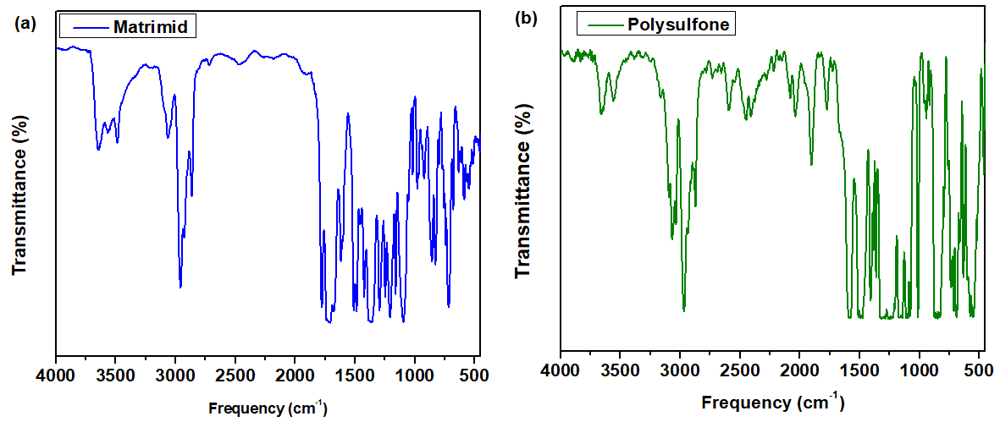
Figure S1 FTIR spectrum of (a) Matrimid 5218 and (b) Polysulfone Udel polymer

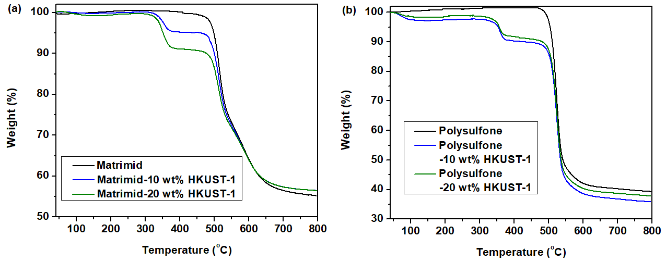
Figure S2 TGA curves of (a) Matrimid and (b) polysulfone membranes containing
10 wt% and 20 wt% Cu₃BTC₂ nanocrystals

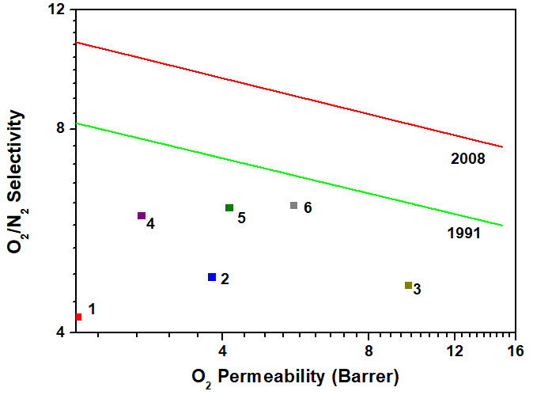
Figure S3 Comparison of the performance of the studied polymer with the Robeson Upper Bound. The label “1” to “6” is indicated in Table below.

Membrane | Label
Polysulfone | 1
Polysulfone + 10 wt% Cu₃BTC₂ | 2
Polysulfone + 20 wt% Cu₃BTC₂ | 3
Matrimid® | 4
Matrimid® + 10 wt% Cu₃BTC₂ | 5
Matrimid® + 20 wt% Cu₃BTC₂ | 6

