SUPPLEMENTARY INFORMATION

Archaea dominate the microbial community in an ecosystem with low-to-moderate temperature and extreme acidity

Aleksei A. Korzhenkov, Stepan V. Toshchakov, Rafael Bargiela, Huw Gibbard, Manuel Ferrer, Alina V. Teplyuk, David L. Jones, Ilya V. Kublanov, Peter N. Golyshin and Olga V. Golyshina

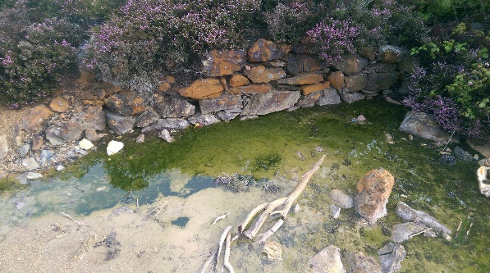
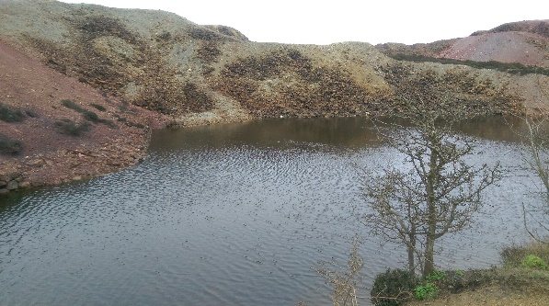
Figure S1 (A-C). The pit pond (A) and mine water flow (B) sites are separated by approximately 7-8 m of copper-containing sulfidic deposits (C). The acidic water from the pond (pH 1.74, Eh +581 mV) flows through these deposits and emerges as surface water flow. Samples were taken from the water (SW) and sediment (SS) of the stream.
Pit pond
Mine water flow
= Copper containing sulfidic deposits
C.
A.
B.
LW
SW
SS
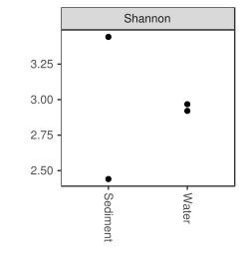
Figure S2. Shannon index for the sediment and water microbial communities,
calculated with Phyloseq package (McMurdie & Holmes, 2013).

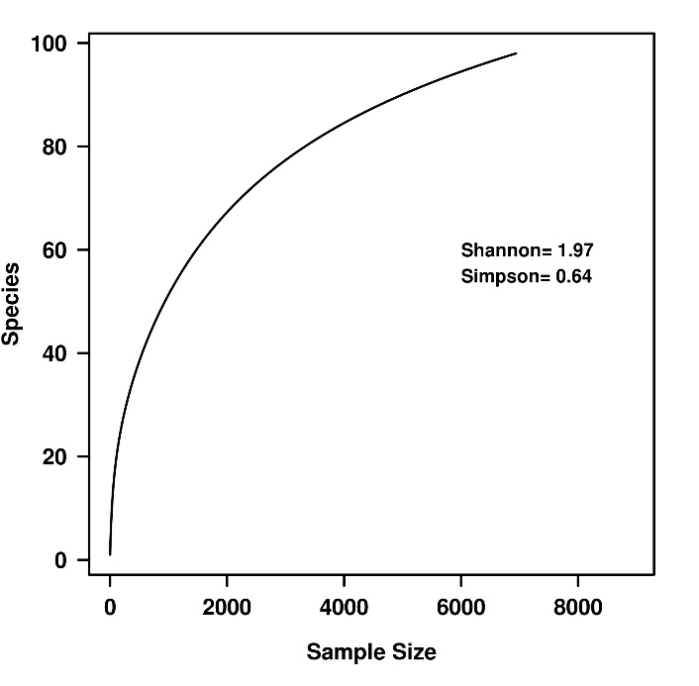

Figure S3. Rarefaction plot and species richness calculated in GraftM from the taxonomic annotation of the Parys Mountain metagenome sequencing data. Alpha-diversity Shannon and Simpson’s indices are shown in the figure. Both, rarefaction and diversity indexes were calculated under R environment using vegan package.

Table S1. Soil pore water chemistry for the sediment and for the overlying surface water for the acidic stream of Parys Mt. All values are expressed in mg l⁻¹ and represent means ± SEM (n = 3).

 | Surface water |  |  | Sediment pore water
Ca | 100.9 | ± 1.2 |  | 105.4 | ± 3.7
Na | 37.0 | ± 0.2 |  | 99.8 | ± 14.0
K | 4.9 | ± 0.3 |  | 44.0 | ± 41.2
Mg | 93.0 | ± 18.6 |  | 121.1 | ± 6.3
Fe | 1328 | ± 1 |  | 1863 | ± 36
Cu | 90.4 | ± 0.2 |  | 49.7 | ± 2.4
Zn | 94.7 | ± 0.1 |  | 105.7 | ± 6.7
Pb | 5.7 | ± 0.1 |  | 12.1 | ± 0.5
Ni | 0.24 | ± 0.00 |  | 0.43 | ± 0.05

References

McMurdie PJ, Holmes S. phyloseq: an R package for reproducible interactive analysis and graphics of microbiome census data. PLoS One.2013;8(4):e61217.

