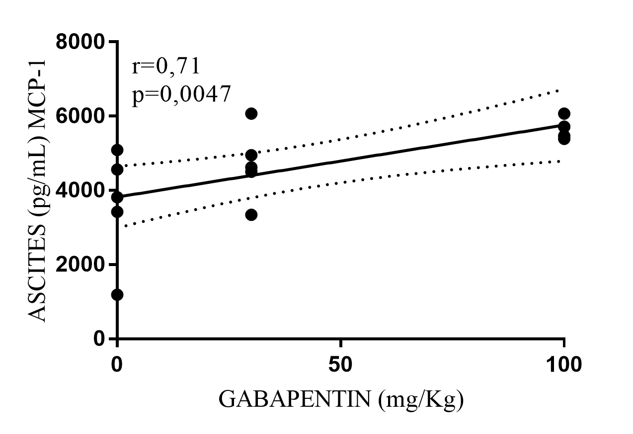
Additional file 6 Fig S3. MCP-1 level in ascites according to gabapentin dose. MCP-1 level increased with higher gabapentin dose.

