Additional File 1: Caries Risk assessment

Patient name: __________________________ Date: ________________________________

- Fluoride tooth paste exposure
Did the patient FAIL to brush their teeth with a fluoride toothpaste last night?
Y / N

- Diet assessment
  - Did the patient drink ANY of the following yesterday: fruit juice; cordial; fizzy drinks; energy drinks?
Y / N

  - Did the patient eat ANY of the following yesterday: biscuits; cakes; chocolates; lollies?
Y / N

- Plaque assessment
Criteria for plaque assessment (Silness & Loe, 1964)

3 = thick plaque is visible along gingival margin (no need to probe)
2 = plaque is visible along gingival margin, with or without air drying (no need to probe)
1 = plaque is not visible but can be wiped off with an explorer
0 = plaque is not visible not cannot be wiped off with an explorer
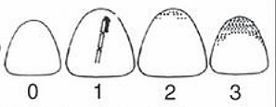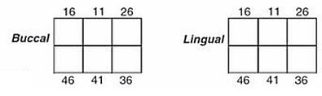
Notes:
- If an index tooth is missing, score the nearest tooth in that sextant. If there are no teeth in the sextant, enter X
- If plaque thickness varies along the gingival margin, score according to the worst situation

Was a score of 3 recorded for any site?
Y/N

- Caries diagnosis and history
  - Are there any sites demonstrating dentine shadowing?
Y / N

  - Are there any sites demonstrating cavitation?
Y / N

  - Are there any sites exhibiting a restoration?
Y / N

Caries risk categorisation and study inclusion:
If any of the above questions were answered Yes – the patient is at risk of developing caries and should be included in the study following gingival assessment.

Gingival assessment: Absence of ulcerative gingivitis or stomatitis? Y / N

Child eligible for fluoride varnish application: Y / N

Signed: _________________________

