Validation of Core and Salinispora models

Table S1: Simulations of Core model under different growth conditions.

 | Medium | Growth rate | Growth rate | References
 |  | in silico | in vivo
 |  | 1/h
1 | Medium without Carbon source | 0.000 | no growth | Contador et al 2015
2 | Medium without Nitrogen source | 0.000 | no growth | Contador et al 2015
3 | Medium without Sulfur source | 0.000 | no growth | Contador et al 2015
4 | Medium without Phosphate source | 0.000 | no growth | Contador et al 2015
5 | Glucose-Minimal Media Anaerobic | 0.000 | no growth | Ahmed et al 2013, Maldonado et al 2005
6 | Glucose-Minimal Media Aerobic | growth | growth | Ahmed et al 2013, Maldonado et al 2005
7 | Starch-A1 medium | 0.1346 | growth | This work
8 | ISP2 (glucose-malt-yeast extract agar) | growth |  | Ahmed et al 2013
9 | ISP5 (glycerol-asparagine agar) | growth |  | Ahmed et al 2013
10 | ISP4 (inorganic salts-starch agar) | growth |  | Ahmed et al 2013
11 | ISP3 (oatmeal agar) | growth |  | Ahmed et al 2013
12 | ISP6 (peptone-yeast extract-iron agar) | growth |  | Ahmed et al 2013
13 | ISP1 (tryptone yeast extract agar) | growth |  | Ahmed et al 2013
14 | ISP7 (tyrosine agar) | growth |  | Ahmed et al 2013

Table S2: Predicted growth rates by iCC926 under different growth conditions.

 | Medium | Growth rate | Growth rate | References
 |  | in silico | in vivo
 |  | 1/h
1 | Glucose-Minimal Media | 0.4118 |  | Alam et al 2011
2 | Glucose-Minimal Media | 0.1489 | growth | Maldonado et al 2005
3 | Glucose-CM-SS | 0.5714 | 6 (% PCV) | Tsueng et al 2008
4 | Glucose-CM-SF1 | 0.5533 | 6 (% PCV) | Tsueng et al 2008
5 | Glucose-CM-SF2 | 0.5533 | growth | Contador et al 2015
6 | Glucose-CM-not salts | 0.5533 | no growth | Maldonado et al 2005
7 | Starch-SS | 0.9342 | growth | Lechner et al 2011
8 | Starch-SF1 | 0.9160 | +++, 5.97 mg/ml | Tsueng and Lam 2008b; Tsueng and Lam 2010
9 | Starch-SF2 | 0.9160 | 7.15 mg/ml, 6.45mg/ml | Tsueng and Lam 2008b; Tsueng and Lam 2010
10 | ISP2 (glucose-malt-yeast extract agar) | 1.288 | +++ | Ahmed et al 2013
11 | ISP5 (glycerol-asparagine agar) | 0.8571 | +++ | Ahmed et al 2013
12 | ISP4 (inorganic salts-starch agar) | 0.4467 | ++ | Ahmed et al 2013
13 | ISP3 (oatmeal agar) | 0.8809 | +++ | Ahmed et al 2013
14 | ISP6 (peptone-yeast extract-iron agar) | 0.0044 | no growth | Ahmed et al 2013
15 | ISP1 (tryptone yeast extract agar) | 0.8836 | +++ | Ahmed et al 2013
16 | ISP7 (tyrosine agar) | 1.1966 | +++ | Ahmed et al 2013
17 | Medium without Carbon source | 0.000 | no growth | Contador et al 2015
18 | Medium without Nitrogen source | 0.000 | no growth | Contador et al 2015
19 | Medium without Sulfur source | 0.000 | no growth | Contador et al 2015
20 | Medium without Phosphate source | 0.000 | no growth | Contador et al 2015
21 | Glucose-Minimal Media Anaerobic | 0.000 | no growth | Ahmed et al 2013, Maldonado et al 2005
22 | Glucose-Minimal Media Aerobic | growth | growth | Ahmed et al 2013, Maldonado et al 2005
23 | D-Glucose as carbon source | 1.95 | growth | Contador et al 2015
24 | D-Mannose as carbon source | 1.95 | growth | Contador et al 2015
25 | D-Xylose as carbon source | 1.95 | growth | Contador et al 2015
26 | Glycerol as carbon source | 1.49 | growth | Contador et al 2015
27 | Lactose as carbon source | 0 | no growth | Contador et al 2015
28 | Sucrose as carbon source | 1.95 | growth | Contador et al 2015
29 | D-Fructose as carbon source | 1.95 | growth | Contador et al 2015
30 | Mannitol as carbon source | 1.95 | growth | Contador et al 2015
31 | Maltose as carbon source | 1.95 | growth | Contador et al 2015
32 | Acetate as carbon source | 0.99 | growth | Contador et al 2015
33 | D-Sorbitol as carbon source | 1.95 | growth | Contador et al 2015
34 | L-Arabinose as carbon source | 1.95 | growth | Contador et al 2015
35 | Citrate as carbon source | 1.95 | growth | Contador et al 2015
36 | L-glutamate as carbon source | 2.48 | growth | Contador et al 2015
37 | Glycine as carbon source | 0.99 | growth | Contador et al 2015
38 | Cellobiose as carbon source | 1.95 | growth | Contador et al 2015
39 | Raffinose as carbon source | 1.95 | growth | Contador et al 2015
40 | Uracil as carbon source | 0 | no growth | Contador et al 2015
41 | Uridine as carbon source | 2.07 | growth | Contador et al 2015
42 | D-Galactose as carbon source | 1.95 | growth | Contador et al 2015
43 | Lactate as carbon source | 0 | no growth | Contador et al 2015
44 | Adenosine as carbon source | 3.49 | growth | Contador et al 2015
45 | Trehalose as carbon source | 1.95 | growth | Contador et al 2015
46 | Glycine as nitrogen source | 1.95 | growth | Contador et al 2015
47 | Ammonium as nitrogen source | 1.95 | growth | Contador et al 2015
48 | Nitrate as nitrogen source | 1.95 | growth | Contador et al 2015
49 | Urea as nitrogen source | 3.01 | growth | Contador et al 2015
50 | L-glutamate as nitrogen source | 1.95 | growth | Contador et al 2015
51 | Nitrite as nitrogen source | 1.95 | growth | Contador et al 2015
52 | Inosine as nitrogen source | 3.93 | growth | Contador et al 2015
53 | L-glutamine as nitrogen source | 3.45 | growth | Contador et al 2015
54 | Adenosine as nitrogen source | 4.01 | growth | Contador et al 2015
55 | Sulfate as sulfur source | 1.95 | growth | Contador et al 2015
56 | Sulfite as sulfur source | 1.95 | growth | Contador et al 2015
57 | L-cysteine as sulfur source | 2.97 | growth | Contador et al 2015
58 | L-methionine as sulfur source | 2.34 | growth | Contador et al 2015
59 | Pyrophosphate as phosphorous source | 0 | no growth | Contador et al 2015
60 | Orthophosphate as phosphorous source | 1.9539 | growth | Contador et al 2015
61 | β-glycerolphosphate as phosphorous source | 0 | no growth | Contador et al 2015
62 | Salicin as carbon source | 0 | no growth | Maldonado et al 2005
63 | L-proline as carbon source | 2.48 | no growth | Maldonado et al 2005
64 | L-threonine as carbon source | 1.99 | no growth | Maldonado et al 2005
65 | L-tyrosine as carbon source | 2.01 | no growth | Maldonado et al 2005
66 | D-galactose as carbon source | 1.95 | growth | Maldonado et al 2005
67 | L-alanine as nitrogen source | 1.95 | no growth | Maldonado et al 2005
PCV = packed cell volumen; SS = synthetic seawater; CM: complex media
+++ = abundant growth in agar medium; ++ = moderate growth in agar medium

Table S3: Salinosporamide predicted production rates by iCC926 under different production conditions.

 |  | Sal A | Sal B | Sal A | Sal B
 | Medium | production | production | production | production | References
 |  | in silico  [mmol/gDW h] | in silico  [mmol/gDW h] | in vivo  [mg/L] | in vivo  [mg/L]
68 | Starch-SHY production media | 1.26 | 0.13 | 100 | 13 | Tsueng and Lam, 2009
69 | Starch-A1 production medium (SS) | 1.26 | 0.13 | 82.2-63.2 |  | Lechner et al, 2011
70 | Starch-production media plus butyric acid* | 1.01 | 0.22 | 211 | 32.7 | Tsueng and Lam, 2007
*experiment with S. tropica NPS21184; SS = synthetic seawater; Sal: salinosporamide.

Table S4: Salinosporamide predicted production rates of mutant strains by iCC926.

 |  | Sal A | Sal A | Sal B | Sal B
 | Strain | production | production | production | production
 |  | in silico  [mmol/gDW h] | in vivo  % | in silico  [mmol/gDW h] | in vivo  %
71 | mutant salL- | 0 | n.d | 0.114 | yes
72 | mutant salA- | 0 | n.d | 0 | n.d
73 | mutant salT- | 0.63 | 50 | 0.117 | 91
74 | mutant salM- | 0.027 | 2.2 | 0.156 | 120
75 | mutant salH- | 0.048 | 3.8 | 0.091 | 70
76 | mutant salQ- | 0.315 | 25 | 0.127 | 98
77 | mutant salG- | 0 | n.d | 0.122 | 94
78 | mutant Strop_3612- | 1.411 | 112 | 0.067 | 52
79 | mutant salL- with 5'-ClDA in the media | 2.3 | detected | 0.13 | detected
80 | mutant salL- with 5-CIR in the media | 1.27 | detected | 0.11 | detected
81 | mutant salL- with 5-CIRL in the media | 1.27 | detected | 0.11 | detected
82 | mutant salL- with 5-CIRI in the media | 0.01 | detected | 0.126 | detected
83 | mutant salG- with 5'-ClDA in the media | 0 | n.d | 0.119 | detected
84 | mutant salG- with 5-CIR in the media | 0 | n.d | 0.119 | detected
85 | mutant salG- with 5-CIRL in the media | 0 | n.d | 0.119 | detected
86 | mutant salG- with 5-CIRI in the media | 0 | n.d | 0.119 | detected
Reference: Eustáquio et al. 2009; Sal: salinosporamide; in vivo data: % with respect to wild-type; n.d: not detected

Table S5: Sporolides predicted production rates by iCC926 assuming different production ratios.

 | Strain | Sporolide A | Sporolide B | Sporolide | Ratio
 |  | in silico  [mmol/gDW h] | in silico  [mmol/gDW h] | in vivo  [ug/L] | spo B:spo A
87 | Wild-type | 0.77 | 0.38 | 100 | 1:2
88 | Wild-type supplement with tyrosine | 0.906 | 0.453 | 100
89 | Wild-type | 0.578 | 0.578 | 100 | 1:1
90 | Wild-type supplement with tyrosine | 0.679 | 0.679 | 100
91 | Wild-type | 1.04 | 0.116 | 100 | 1:9
92 | Wild-type supplement with tyrosine | 1.22 | 0.136 | 100
Reference: McGlinchey et al 2008b; spo: sporolide

Table S6: Sioxanthin predicted production rates by iCC926.

 | Strain | Sioxanthin | Sioxanthin | Reference
 |  | in silico  [mmol/gDW h] | in vivo
93 | Wild-type | 0.221 | detected | Richter et al 2015
94 | Strop2408mt | 0 | n.d | Richter et al 2015
95 | Strop3246mt | 0 | n.d | Richter et al 2015
96 | Strop3247mt | 0 | n.d | Richter et al 2015
97 | Strop3248mt | 0 | n.d | Richter et al 2015
n.d: not detected

Table S7: Simulations of Salinispora arenicola iSACNH643 model under different growth conditions.

 | Medium | Growth rate | Growth rate | References
 |  | in silico | in vivo
 |  | 1/h
1 | Medium without Carbon source | 0.000 | no growth | Contador et al 2015
2 | Medium without Nitrogen source | 0.000 | no growth | Contador et al 2015
3 | Medium without Sulfur source | 0.000 | no growth | Contador et al 2015
4 | Medium without Phosphate source | 0.000 | no growth | Contador et al 2015
5 | Glucose-Minimal Media Anaerobic | 0.000 | no growth | Ahmed et al 2013, Maldonado et al 2005
6 | Glucose-Minimal Media Aerobic | growth | growth | Ahmed et al 2013, Maldonado et al 2005
7 | Starch-A1 medium | 1.9698 | growth | This work
8 | ISP2 (glucose-malt-yeast extract agar) | 1.0687 | +++ | Ahmed et al 2013
9 | ISP5 (glycerol-asparagine agar) | 0.9611 | +++ | Ahmed et al 2013
10 | ISP4 (inorganic salts-starch agar) | 0.5248 | ++ | Ahmed et al 2013
11 | ISP3 (oatmeal agar) | 0.6736 | +++ | Ahmed et al 2013
12 | ISP6 (peptone-yeast extract-iron agar) | 0.8502 | +++ | Ahmed et al 2013
13 | ISP1 (tryptone yeast extract agar) | 1.7004 | +++ | Ahmed et al 2013
14 | ISP7 (tyrosine agar) | 0.8822 | +++ | Ahmed et al 2013
15 | DMM | 0.1749 | growth | This work
16 | Salicin as carbon source | 2.0839 | growth | Maldonado et al 2005
17 | L-proline as carbon source | 2.5271 | growth | Maldonado et al 2005
18 | L-threonine as carbon source | 2.3325 | growth | Maldonado et al 2005
19 | L-tyrosine as carbon source | 2.3958 | growth | Maldonado et al 2005
20 | D-galactose as carbon source | 0 | no growth | Maldonado et al 2005
21 | L-alanine as nitrogen source | 2.0839 | growth | Ahmed et al 2013
22 | L-glutamate as nitrogen source | 2.0839 | no growth | Ahmed et al 2013
23 | Sioxanthin production | 0.1941 mmol/gDW h | detected | Maldonado et al 2005; this work
+++ = abundant growth in agar medium; ++ = moderate growth in agar medium

Table S8: Simulations of Salinispora pacifica iSPCNR114 model under different growth conditions.

 | Medium | Growth rate | Growth rate | References
 |  | in silico | in vivo
 |  | 1/h
1 | Medium without Carbon source | 0.000 | no growth | Contador et al 2015
2 | Medium without Nitrogen source | 0.000 | no growth | Contador et al 2015
3 | Medium without Sulfur source | 0.000 | no growth | Contador et al 2015
4 | Medium without Phosphate source | 0.000 | no growth | Contador et al 2015
5 | Glucose-Minimal Media Anaerobic | 0.000 | no growth | Ahmed et al 2013, Maldonado et al 2005
6 | Glucose-Minimal Media Aerobic | growth | growth | Ahmed et al 2013, Maldonado et al 2005
7 | Starch-A1 medium | 1.3673 | growth | Ahmed et al 2013
8 | ISP2 (glucose-malt-yeast extract agar) | 0.9013 | +++ | Ahmed et al 2013
9 | ISP5 (glycerol-asparagine agar) | 0.8426 | +++ | Ahmed et al 2013
10 | ISP4 (inorganic salts-starch agar) | 0.9306 | ++ | Ahmed et al 2013
11 | ISP3 (oatmeal agar) | 0.5690 | +++ | Ahmed et al 2013
12 | ISP6 (peptone-yeast extract-iron agar) | 0.148 | +++ | Ahmed et al 2013
13 | ISP1 (tryptone yeast extract agar) | 1.48 | +++ | Ahmed et al 2013
14 | ISP7 (tyrosine agar) | 0.9853 | +++ | Ahmed et al 2013
15 | DMM | 0.1469 | growth | This work
16 | L-alanine as nitrogen source | 1.8612 | no growth | Ahmed et al 2013
17 | L-glutamate as nitrogen source | 18612 | growth | Ahmed et al 2013
18 | Sioxanthin production | 0.1395 mmol/gDW h | detected | Ahmed et al 2013; this work
19 | Lomaiviticin A production | 0.3633 mmol/gDW h | detected | Duncan et al 2015
+++ = abundant growth in agar medium; ++ = moderate growth in agar medium

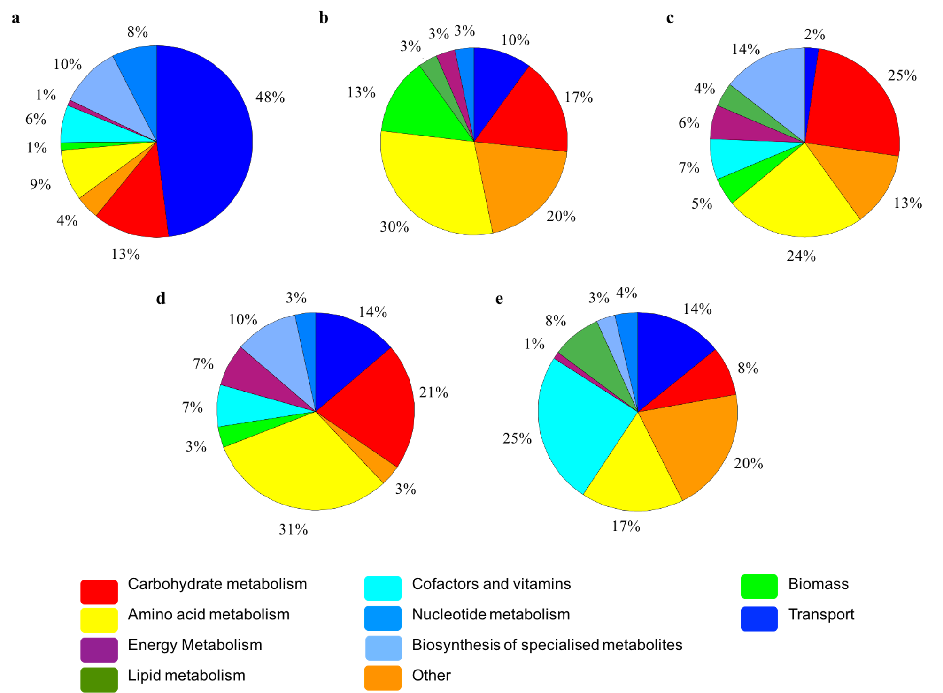

Figure S5 Distribution of unique sets of reactions by subsystems. (a) ST-CNB440; (b) SA-CNH643; (c) SP-CNR114; (d) ST-CNB440/SA-CNH643; (e) ST-CNB440/SA-CNH643. Sets with 20 or more reactions were represented.

References

- Ahmed L, Jensen PR, Freel KC, Brown R, Jones AL, Kim BY, Goodfellow M (2013). Salinispora pacifica sp. nov., an actinomycete from marine sediments. Antonie van Leeuwenhoek, Int. J. Gen. Mol. Microbiol. 103, 1069–1078.
- Alam MT, Merlo ME, Consortium TS, Hodgson DA, Wellington EMH, Takano E, Breitling R (2010). Metabolic modeling and analysis of the metabolic switch in Streptomyces coelicolor. BMC Genomics 11, 202.
- Contador CA, Rodríguez V, Andrews BA, Asenjo JA. Genome-scale reconstruction of Salinispora tropica CNB-440 metabolism to study strain-specific adaptation. Antonie van Leeuwenhoek, Int. J. Gen. Mol. Microbiol. 2015;108:1075–90.
- Eustáquio AS, McGlinchey RP, Liu Y, Hazzard C, Beer LL, Florova G, Alhamadsheh MM, Lechner A, Kale AJ, Kobayashi Y, Reynolds KA, Moore BS (2009). Biosynthesis of the salinosporamide A polyketide synthase substrate chloroethylmalonyl-coenzyme A from S-adenosyl-L-methionine. Proc. Natl. Acad. Sci. U. S. A. 106, 12295–12300.
- Lechner A, Eustáquio AS, Gulder TAM, Hafner M, Moore BS (2011). Selective overproduction of the proteasome inhibitor salinosporamide A via precursor pathway regulation. Chem. Biol. 18, 1527–1536.
- Maldonado LA, Fenical W, Jensen PR, Kauffman CA, Mincer TJ, Ward AC, Bull AT, Goodfellow M (2005). Salinispora arenicola gen. nov., sp. nov. and Salinispora tropica sp. nov., obligate marine actinomycetes belonging to the family Micromonosporaceae. Int. J. Syst. Evol. Microbiol. 55, 1759–1766
- McGlinchey RP, Nett M, Moore BS (2008b). Unraveling the biosynthesis of the sporolide cyclohexenone building block. J. Am. Chem. Soc. 130, 2406–2407.
- Tsueng G, McArthur KA, Potts BCM, Lam KS (2007). Unique butyric acid incorporation patterns for salinosporamides A and B reveal distinct biosynthetic origins. Appl. Microbiol. Biotechnol. 75, 999–1005.
- Tsueng G, Lam KS (2008b). Growth of Salinispora tropica strains CNB440, CNB476, and NPS21184 in nonsaline, low-sodium media. Appl. Microbiol. Biotechnol. 80, 873–880.
- Tsueng G, Teisan S, Lam KS (2008). Defined salt formulations for the growth of Salinispora tropica strain NPS21184 and the production of salinosporamide A (NPI-0052) and related analogs. Appl. Microbiol. Biotechnol. 78, 827–832.
- Tsueng G, Lam KS (2009). Effect of cobalt and vitamin B12 on the production of salinosporamides by Salinispora tropica. J. Antibiot. 62, 213–216.
- Tsueng G, Lam KS (2010). A preliminary investigation on the growth requirement for monovalent cations, divalent cations and medium ionic strength of marine actinomycete Salinispora. Appl. Microbiol. Biotechnol. 86, 1525–1534.
- Richter TKS, Hughes CC, Moore BS. Sioxanthin, a novel glycosylated carotenoid, reveals an unusual subclustered biosynthetic pathway. Environ. Microbiol. 2015;17:2158–71.
- Duncan KR, Crüsemann M, Lechner A, Sarkar A, Li J, Ziemert N, et al. Molecular Networking and Pattern-Based Genome Mining Improves Discovery of Biosynthetic Gene Clusters and their Products from Salinispora Species. Chem. Biol. 2015;460–71.

