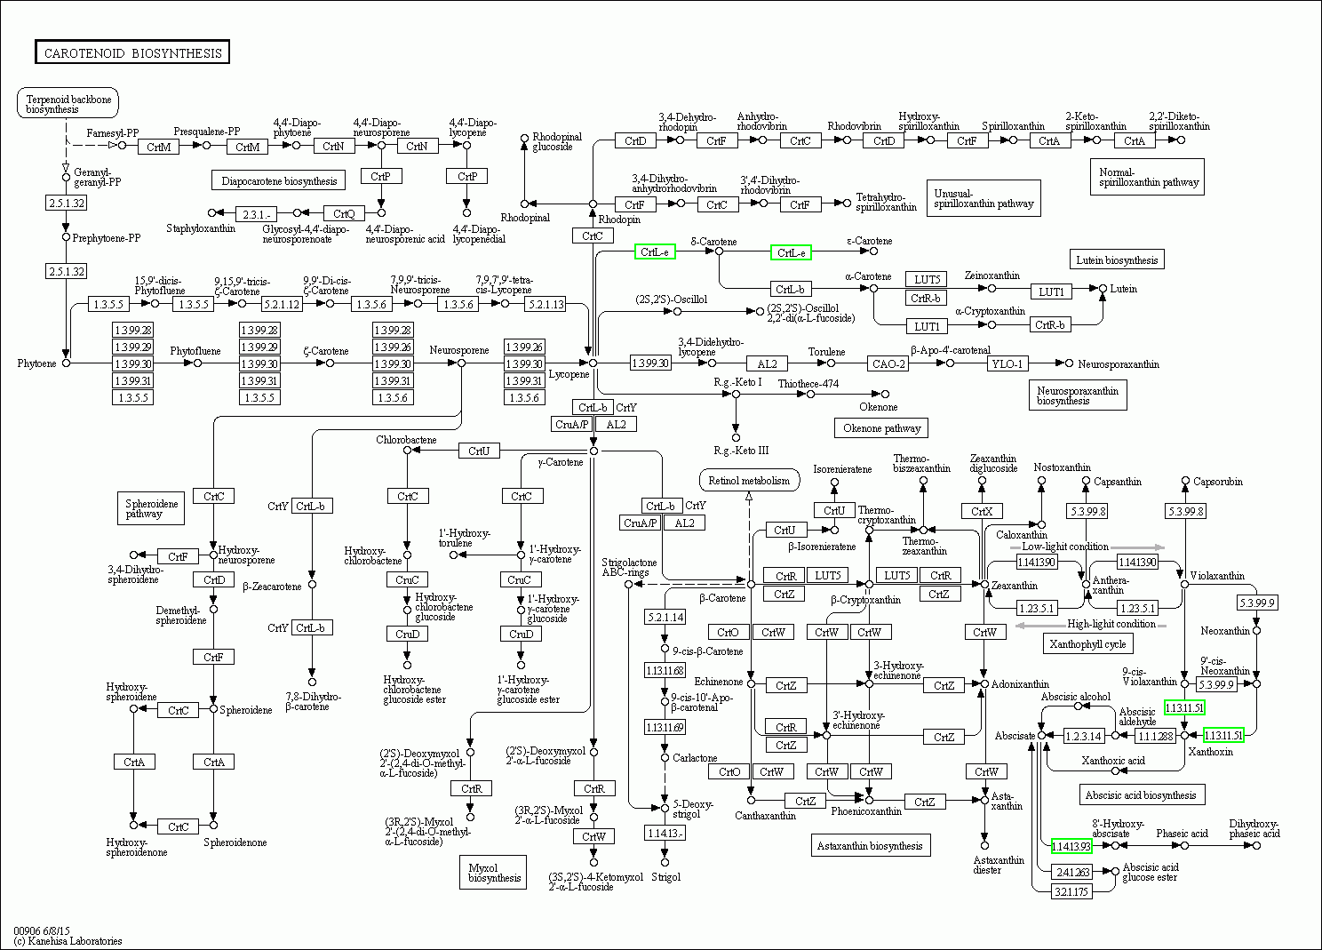
Additional figure 3 KEGG graph of carotenoid biosynthetic pathway (PE2-vs-FL2).
CrtL-e indicates LCYE ( evm.TU.supercontig_28.134, fold -3.9)

