Table S1. Constructed plasmids and strains in this study
Names | Descriptions | References
Plasmids
pYJM14 | pTrcHis2B carrying ERG12, ERG8, ERG19 and IDIsc from S. cerevisiae | [7]
pYJM20 | pACYCDuet-1 carrying mvaE and mvaS from E. faecalis, IspS_{pa} from P. alba | [7]
pT-EEE-IDI_{bl} | pTrcHis2B carrying ERG12, ERG8, ERG19 from S. cerevisiae, IDI_{bl} from B. licheniformis | This study
pT-EEE-IDI_{bl}-RBS | pTrcHis2B carrying ERG12, ERG8 and ERG19 from S. cerevisiae, IDI_{bl} with stronger RBS sequence from B. licheniformis | This study
pT-EEE-IDI_{bs} | pTrcHis2B carrying ERG12, ERG8 and ERG19 from S. cerevisiae , IDI_{bs} from B. subtilis | This study
pT-EEE-IDI_{bs}-RBS | pTrcHis2B carrying ERG12, ERG8 and ERG19 from S. cerevisiae , IDI_{bs} with stronger RBS sequence from B. subtilis | This study
pT-EEE-IDI_{mj} | pTrcHis2B carrying ERG12, ERG8 and ERG19 from S. cerevisiae , IDI_{mj} from M. jannaschii | This study
pT-EEE-IDI_{mj}-RBS | pTrcHis2B carrying ERG12, ERG8 and ERG199 from S. cerevisiae , IDI_{mj} with stronger RBS sequence from M. jannaschii | This study
pT-EEE-IDI_{sa} | pTrcHis2B carrying ERG12, ERG8 and ERG19 from S. cerevisiae , IDI_{sa} from S. aureus | This study
pT-EEE-IDI_{sa}-RBS | pTrcHis2B carrying ERG12, ERG8 and ERG19 from S. cerevisiae , IDI_{sa} with stronger RBS sequence from S. aureus | This study
pA-MM-IspS_{pa}^{MT} | pACYCDuet-1 carrying mvaE and mvaS from E. faecalis, IspS_{pa}^{MT} from P. alba | This study
pA-MM-IspS_{mp} | pACYCDuet-1 carrying mvaE and mvaS from E. faecalis, IspS_{mp} from M. pruriens | This study
pA-MM-IspS_{ib} | pACYCDuet-1 carrying mvaE and mvaS from E. faecalis, IspS_{ib} from I. batatas | This study
pT-EEI-ERG12^{MT} | pTrcHis2B carrying ERG12^{MT}, ERG8, ERG19 and IDI_{sc} from S. cerevisiae | This study
pT-EEI-MK_{cv} | pTrcHis2B carrying ERG8, ERG19 and IDI_{sc} from S. cerevisiae, MK_{cv} from C. variabile | This study
pT-EEI-MK_{cv}-RBS | pTrcHis2B carrying ERG8, ERG19 and IDI_{sc} from S. cerevisiae, MK_{cv} with stronger RBS sequence from C. variabile | This study
pT-EEI-MK_{mm} | pTrcHis2B carrying ERG8, ERG19 and IDI_{sc} from S. cerevisiae, MK_{mm} from M. mazei | This study
pT-EEI-MK_{mm}-RBS | pTrcHis2B carrying ERG8, ERG19 and IDI_{sc} from S. cerevisiae, MK_{mm} with stronger RBS sequence from M. mazei | This study
pT-EE-IDI_{sa}-MK_{mm}-RBS | pTrcHis2B carrying ERG8, ERG19 from S. cerevisiae, MK_{mm} with stronger RBS sequence from M. mazei, IDI_{sa} with stronger RBS sequence from S. aureus | This study
pT-EEI-ERG19-RBS1 | pTrcHis2B carrying ERG12, ERG8, ERG19 with attenuated RBS strength and IDI_{sc} from S. cerevisiae, | This study
pT-EEI-ERG19-RBS2 | pTrcHis2B carrying ERG12, ERG8, ERG19 with attenuated RBS strength and IDI_{sc} from S. cerevisiae, | This study
pA-M-ispS_{ib}-MvaE-RBS1 | pACYCDuet-1 carrying mvaE with attenuated RBS strength and mvaS from E. faecalis, IspS_{ib} from I. batatas | This study
pA-M-ispS_{ib}-MvaE-RBS2 | pACYCDuet-1 carrying mvaE with attenuated RBS strength and mvaS from E. faecalis, IspS_{ib} from I. batatas | This study
Strains
LMJ0 | Bl21(DE3)/pYJM14 + pYJM20 | This study
LMJ1 | Bl21(DE3)/ pT-EEE-IDI_{bl} + pYJM20 | This study
LMJ2 | Bl21(DE3)/ pT-EEE-IDI_{bl}-RBS + pYJM20 | This study
LMJ3 | Bl21(DE3)/ pT-EEE-IDI_{bs} + pYJM20 | This study
LMJ4 | Bl21(DE3)/ pT-EEE-IDI_{bs}-RBS + pYJM20 | This study
LMJ5 | Bl21(DE3)/ pT-EEE-IDI_{mj} + pYJM20 | This study
LMJ6 | Bl21(DE3)/ pT-EEE-IDI_{mj}-RBS + pYJM20 | This study
LMJ7 | Bl21(DE3)/ pT-EEE-IDI_{sa} + pYJM20 | This study
LMJ8 | Bl21(DE3)/ pT-EEE-IDI_{sa}-RBS + pYJM20 | This study
LMJ9 | Bl21(DE3)/ pYJM14 + pA-MM-ispS_{pa}^{MT} | This study
LMJ10 | Bl21(DE3)/ pYJM14 + pA-MM-ispS_{mp} | This study
LMJ11 | Bl21(DE3)/ pYJM14 + pA-MM-ispS_{ib} | This study
LMJ12 | Bl21(DE3)/ pT-EEE-IDI_{sa}-RBS + pA-MM-ispS_{ib} | This study
LMJ13 | Bl21(DE3)/ pT-EEI-ERG12^{MT} + pYJM20 | This study
LMJ14 | Bl21(DE3)/ pT-EEI-MK_{cv} +pYJM20 | This study
LMJ15 | Bl21(DE3)/ pT-EEI-MK_{cv}-RBS + pYJM20 | This study
LMJ16 | Bl21(DE3)/ pT-EEI-MK_{mm} + pYJM20 | This study
LMJ17 | Bl21(DE3)/ pT-EEI-MK_{mm}-RBS+ pYJM20 | This study
LMJ18 | Bl21(DE3)/pT-EE-IDI_{sa}-MK_{mm}-RBS + pA-MM-ispS_{ib} | This study
LMJ19 | Bl21(DE3)/pYJM14 + pA-M-ispS_{ib}-MvaE-RBS1 | This study
LMJ20 | Bl21(DE3)/pYJM14 + pA-M-ispS_{ib}-MvaE-RBS2 | This study
LMJ21 | Bl21(DE3)/pT-EEI-ERG19-RBS1 + pA-MM-ispS_{ib} | This study
LMJ22 | Bl21(DE3)/pT-EEI-ERG19-RBS2 + pA-MM-ispS_{ib} | This study
LMJ23 | Bl21(DE3)/pT-EEI-ERG19-RBS2 + pA-M-ispS_{ib}-MvaE-RBS2 | This study

Table S2. Primers used in this study
Primers | 5’-3’
IDI_{bl}-F | TAGGAGCTCAAAAAAAATGATGGTTACCCGCGCCAA
IDI_{bl}-R | CAGCTGCAGTTAGCGCTTGCTAT
IDI_{bl}-RBS-F | CGCCCTTAGGAGCTCACCCACTAGAAACGATAGAAAGAGAGAGGCAGAATGATGGTTACCCGCGCC
IDI_{bl}-RBS-R | TGGTACCAGCTGCAGTTAGCGCTTGCTATACAC
IDI_{bs}-F | TAGGAGCTCAAAAAAAATGACCCGTGCCGAGCGTAAACG
IDI_{bs}-R | CAGCTGCAGTTAGCGCACGCTAT
IDI_{bs}-RBS-F | CGCCCTTAGGAGCTCCGCACCGAACAACGAGAAAAATAAGGAGGTACCTATGACCCGTGCCGAGCGTAAACG
IDI_{bs}-RBS-R | TGGTACCAGCTGCAGTTAGCGCACGCTATAACTG
IDI_{mj}-F | TAGGAGCTCAAAAAAAATGGTGAATAATCGCAACGA
IDI_{mj}-R | CAGCTGCAGTTATTTCAGACGCT
IDI_{mj}-RBS-F | CGCCCTTAGGAGCTCAGATATTACAAAACCCAATAACGAGGAAAATATGGTGAATAATCGCAACGAG
IDI_{mj}-RBS-R | TGGTACCAGCTGCAGTTATTTCAGACGCTGGCTGATC
IDI_{sa}-F | TAGGAGCTCAAAAAAAATGAGCGATTTCCAGCGCGA
IDI_{sa}-R | CAGCTGCAGTTAACCGCGATGGA
IDI_{sa}-RBS-F | CGCCCTTAGGAGCTCAACAAGTATCAAAATAGGTAGGAGGACATTATGAGCGATTTCCAGCGCGAACAGC
IDI_{sa}-RBS-R | TGGTACCAGCTGCAGTTAACCGCGATGGATATTCAG
IspS_{ib}-F | GATATACATATGAGTAGCGCCCAG
IspS_{mp}-F | GATATACATATGAGTGCCGTTAGC
IspS-R | GCCGGCAGATCTTTA
IspS_{pa}^{MT}-F | AACTGGGTGGTAGCCCGTTCGCGAAA
IspS_{pa}^{MT}-R | GGGCTACCACCCAGTTTTTCCTTGTT
MK_{cv}-F | TGTATCGATTAAATAAGGAGGAATAAACCATGGCCCCGCATGTGGGTCA
MK_{cv}-R | TGCAGGCCTATCGCAAATTAGCTTATTGCATCACTTCACCGG
MK_{cv}-RBS-F | TATTAATGTATCGATCAATTCAAGATATAAGGAGATTAGAGAATGGCCCCGCATGTGGGTCATG
MK_{cv}-RBS-R | TAAGGGTGCAGGCCTTTATTGCATCACTTCACCGG
MK_{mm}-F | TGTATCGATTAAATAAGGAGGAATAAACCATGGTTTCTTGTTCTGCTCC
MK_{mm}-R | TGCAGGCCTATCGCAAATTAGCTTAATCCACTTTCAGGCCC
MK_{mm}-RBS-F | TATTAATGTATCGATACGCGAACGCGTACAATTAAGTTCGGAGGTTTCGTATGGTTTCTTGTTCTGCTCCTG
MK_{mm}-RBS-R | TAAGGGTGCAGGCCTTTAATCCACTTTCAGGCCC
ERG12^{MT}-1-F | GGCTCAAGCGCCTCTATGTCTGTATCAC
ERG12^{MT}-1-R | CATAGAGGCGCTTGAGCCCAACCCAGCA
ERG12^{MT}-2-F | GGCTCAAGCGCCTCTATGTCTGTATCACTGGCCTTAGCTA
ERG12^{MT}-2-R | TAGCTAAGGCCAGTGATACAGACATAGAGGCGCTTGAGCC
ERG19-RBS1-F | GATAAATAACTCGAGATCGATTATACCGGACAACAGCAAGGATATTAGG ATGACCGTTTACACAGCATC
ERG19-RBS2-F | GATAAATAACTCGAGTAACGTACGGTACCAGATTAATAGGAGGCTCGAATGACCGTTTACACAGCATC
ERG19-RBS-R | ATTTTTTTTGAGCTCCTAAGGGCG
MvaE-RBS1-F | GGAGATATACCATGGCGCCAACGAACATTTACTACAATAGAGGAGACCTAATGAAAACAGTAGTTATTATTG
MvaE -RBS2-F | GGAGATATACCATGGAACAACACGCATACAATAAAAGGAGGCAACACAAGGATGAAAACAGTAGTTATTATTG
MvaE -RBS-R | CTCGAATTCGGATCCTTATTG

Fig. S1 OD600 of strains constructed in this study. a. OD600 of strain engineered with IDI modification. b. OD600 of strain engineered with MK modification. c. OD600 of strain engineered with IspS modification. d. OD600 of strain engineered through combination of the three enzymes, IDI_{sa}, MK_{mm} and IspS_{ib}. e. OD600 of strain with modification of RBS sequence of MvaE. f. OD600 of strain with modification of RBS sequence of ERG19. The black column indicated the OD600 of original strain. The white column indicated that OD600 of strain with only enzyme substitution. The gray column indicated the OD600 of strain with RBS sequence optimization. The experiment was conducted in triplicate. Bar represents mean±s.d.

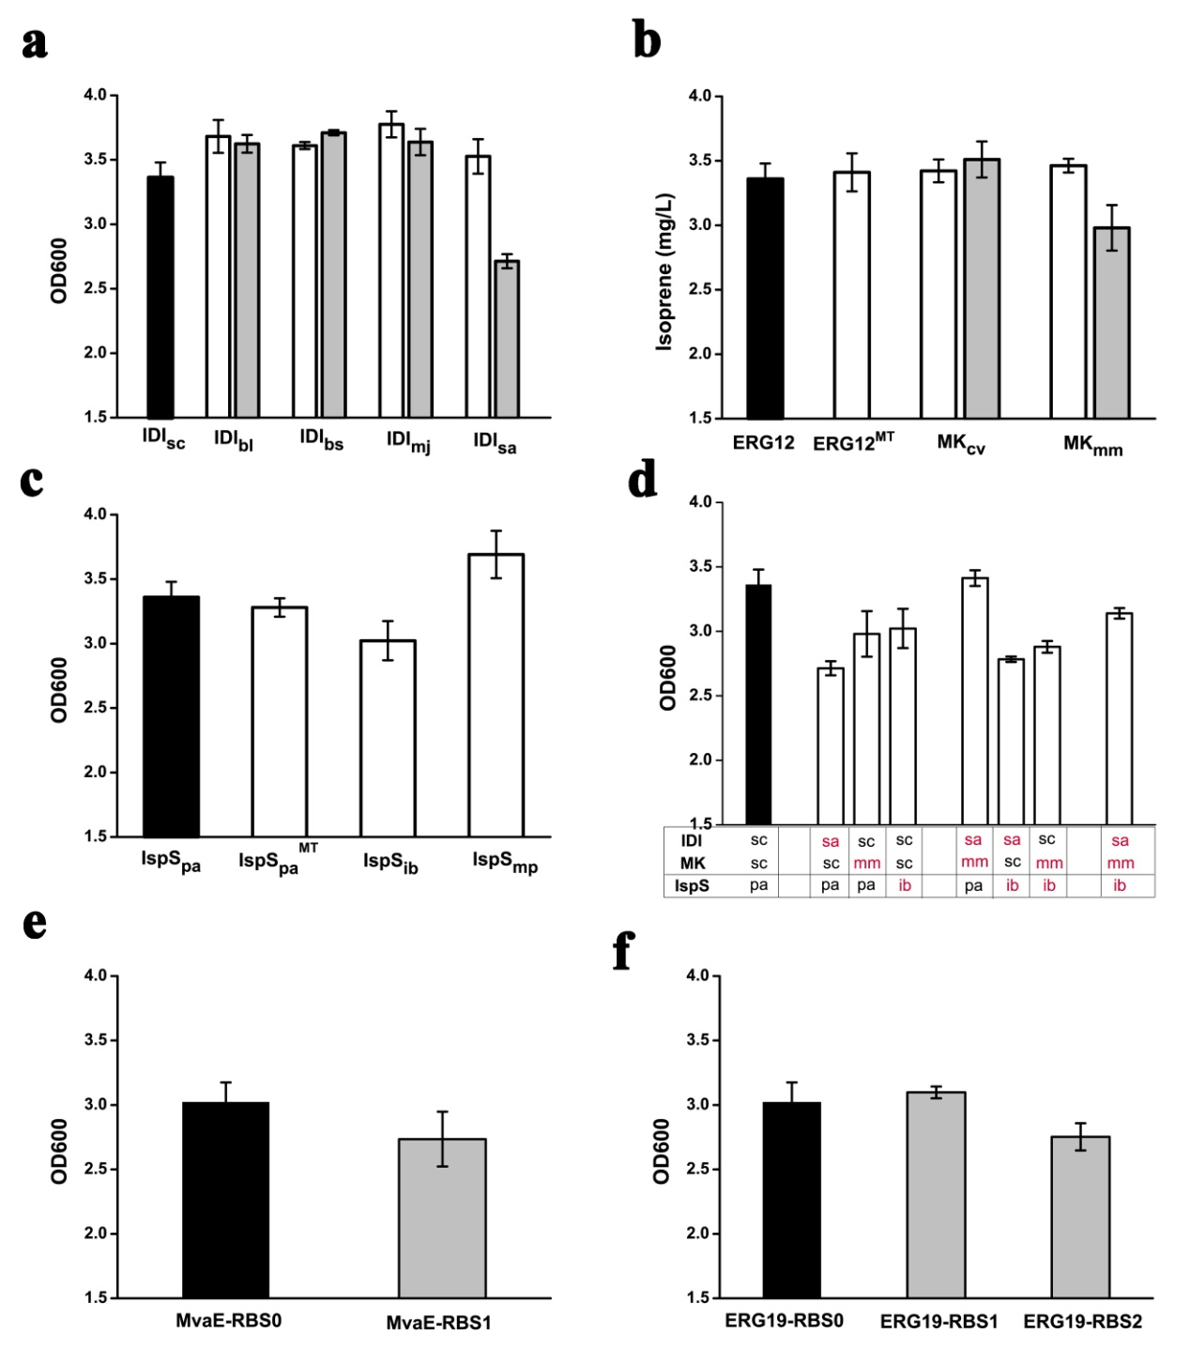

Fig. S2 Yields of strains constructed in this study. a. Yields of strain engineered with IDI modification. b. Yields of strain engineered with MK modification. c. Yields of strain engineered with IspS modification. d. Yields of strain engineered through combination of the three enzymes, IDI_{sa}, MK_{mm} and IspS_{ib}. e. Yields of strain with modification of RBS sequence of MvaE. f. Yields of strain with modification of RBS sequence of ERG19. The black column indicated the isoprene yields of original strain. The white column indicated that isoprene yields of strain with only enzyme substitution. The gray column indicated the isoprene yields of strain with RBS sequence optimization. The experiment was conducted in triplicate. Bar represents mean±s.d.
