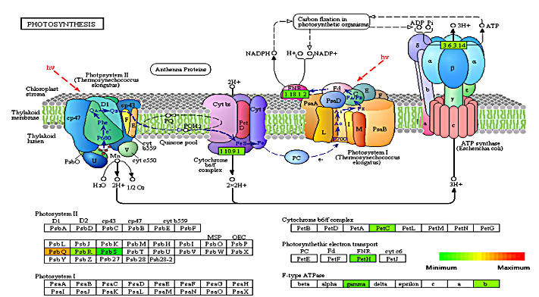

Figure S5. Changes in the reaction related to photosynthetic electron transport metabolism. The metabolism of each previously selected DEG was analyzed using the KEGG mapper.

