Supplementary file 6: Risk of Bias Figures

Risk of bias items presented as percentages across all included studies

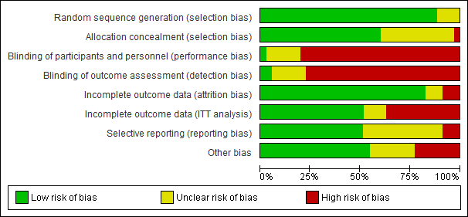

Figure 3: Risk of bias items for each included study
