Additional file 1:
Continuous monitoring of soil CO₂ flux at Aso volcano, Japan: The influence of environmental parameters on diffuse degassing
Masaaki Morita^{1*}, Toshiya Mori², Akihiko Yokoo³, Takahiro Ohkura³, Yuichi Morita⁴
Earth, Planets and Space

*Corresponding author: aki.morita@aist.go.jp
¹Geological Survey of Japan, National Institute of Advanced Industrial Science and Technology, Central 7, Higashi 1-1-1, Tsukuba, Ibaraki 305-8567, Japan
²Geochemical Research Center, Graduate School of Science, The University of Tokyo
³Aso Volcanological Laboratory, Institute for Geothermal Sciences, Kyoto University
⁴Earthquake Research Institute, The University of Tokyo

Here we present supplementary information on the continuous monitoring, supplementary figures (Figures S1, S2, and S3), and a supplementary table (Table S1) in the following sections.

Details of the continuous monitoring of soil CO₂ flux
The station performed soil CO₂ flux measurements using the accumulation chamber method (Parkinson 1981; Chiodini et al. 1998). Every hour a chamber automatically descended into the ground, and the gas-air mixture accumulated in the chamber was pumped into a non-dispersive infrared detector LI-820 (LI-COR Inc.). The detector measured the CO₂ concentration with a range from 0 to 20,000 ppm. The soil CO₂ flux (F in g m⁻² day⁻¹) was calculated based on an increase in the CO₂ concentrations during the measurement (s in ppm s⁻¹) using an air temperature (T in K) and a barometric pressure (P in hPa):
$F=s\frac{PV}{RT}\frac{44}{A}\frac{86400}{{10}^{6}}$, (1)
where R denotes the gas constant (= 8.31451 J K⁻¹ mol⁻¹), and V and A respectively correspond to the volume and the area of the chamber (V/A = 0.125 m). A typical example of the increase in the CO₂ concentrations is shown in Figure S1. Dionis et al. (2015) reported that the accuracy of soil CO₂ flux was within ±25% for the range of 22–220 g m⁻² day⁻¹ using a similar instrument. Although a typical value of soil CO₂ flux in the present study was one order of magnitude lower than the range of soil CO₂ flux for the reported accuracy, the accuracy of soil CO₂ flux in the present study unlikely deviated from the previous value, as shown in Figure S1.
The station also performed measurements of environmental parameters, such as air temperature, air relative humidity, barometric pressure, wind speed, wind direction (direction where the wind blew from), soil humidity, soil temperature, and precipitation (Table S1). The environmental parameter data, as well as the soil CO₂ flux data, were transferred to a server at Geochemical Research Center of the University of Tokyo by 3G telecommunication networks.
In the present study, the data between 8 January 2016 and 20 November 2017 were reported. During the observation, the sensor for the air temperature and the air relative humidity malfunctioned from September to December 2016 and from August 2017 to the end of the present study. The rain gauge was also out-of-order from October 2016. Therefore, for air temperature and precipitation data of the missing period, those data obtained at a weather station maintained by the JMA (200 m from the soil CO₂ flux station; Figure 1) were used. Before the analysis described in the main text, consistency between these data obtained at the soil CO₂ flux station and the weather station was checked (Figure S2). For the air temperature and the precipitation, the data of the soil CO₂ flux station were consistent with those of the weather station (Figures S2a and S2b). Thus, for these two parameters, we used the data of the weather station without any transformation only when the data of the soil CO₂ flux station were not available. For the air relative humidity data, the variability of the data between the two stations deviated from the 1:1 line (Figure S2c). Therefore, the data of the weather station were used for the whole observed period in the analysis. The environmental parameters at the weather station were also missing during October 2016–January 2017 due to damage caused by the 8 October 2016 eruption. It meant that the air temperature data between October and December 2016 were missing at both stations. We linearly interpolated data of the air temperature during this 3-month period. Furthermore, during the winter season (late December to March), our station was often covered with snow, and the accumulation chamber system often froze. Consequently, the soil CO₂ flux data in the winter season were frequently missing.

Figures and Tables
Figure S1 shows a typical slope of an increase of CO₂ concentrations in the accumulation chamber measured at the station. Figure S2 shows correlation plots of air temperature, precipitation, and air relative humidity between the soil CO₂ flux station and the weather station. Figure S3 shows a histogram of soil CO₂ flux and correlation plots of soil CO₂ flux to each environmental parameter. Table S1 presents technical characteristics of the soil CO₂ flux station such as sensor type, elevation or depth of the sensor from the ground, and measurement accuracy and range.

References
Chiodini G, Cioni R, Guidi M, Raco B, Marini L (1998) Soil CO₂ flux measurements in volcanic and geothermal areas. Appl Geochem 13:543–552. doi:10.1016/S0883-2927(97)00076-0
Dionis SM, Pérez NM, Hernández PA, Melián G, Rodríguez F, Padrón E, Sumino H, Barrancos J, Padilla GD, Fernandes P, Bandomo Z, Silva S, Pereira JM, Semedo H, Cabral J (2015) Diffuse CO₂ degassing and volcanic activity at Cape Verde islands, West Africa. Earth Planets Space 67:48. doi:10.1186/s40623-015-0219-x
Parkinson KJ (1981) An improved method for measuring soil respiration in the field. J Appl Ecol 18:221–228. doi:10.2307/2402491

Figure S1
The typical slope of an increase in CO₂ concentrations of the accumulation chamber measured at the station (18h00 local time on 24 May 2016). The blue circles are the concentrations, and the red line corresponds to the fitted slope. In this case, the slope was 0.228 ppm s⁻¹, which was converted to 3.97 g m⁻² day⁻¹.

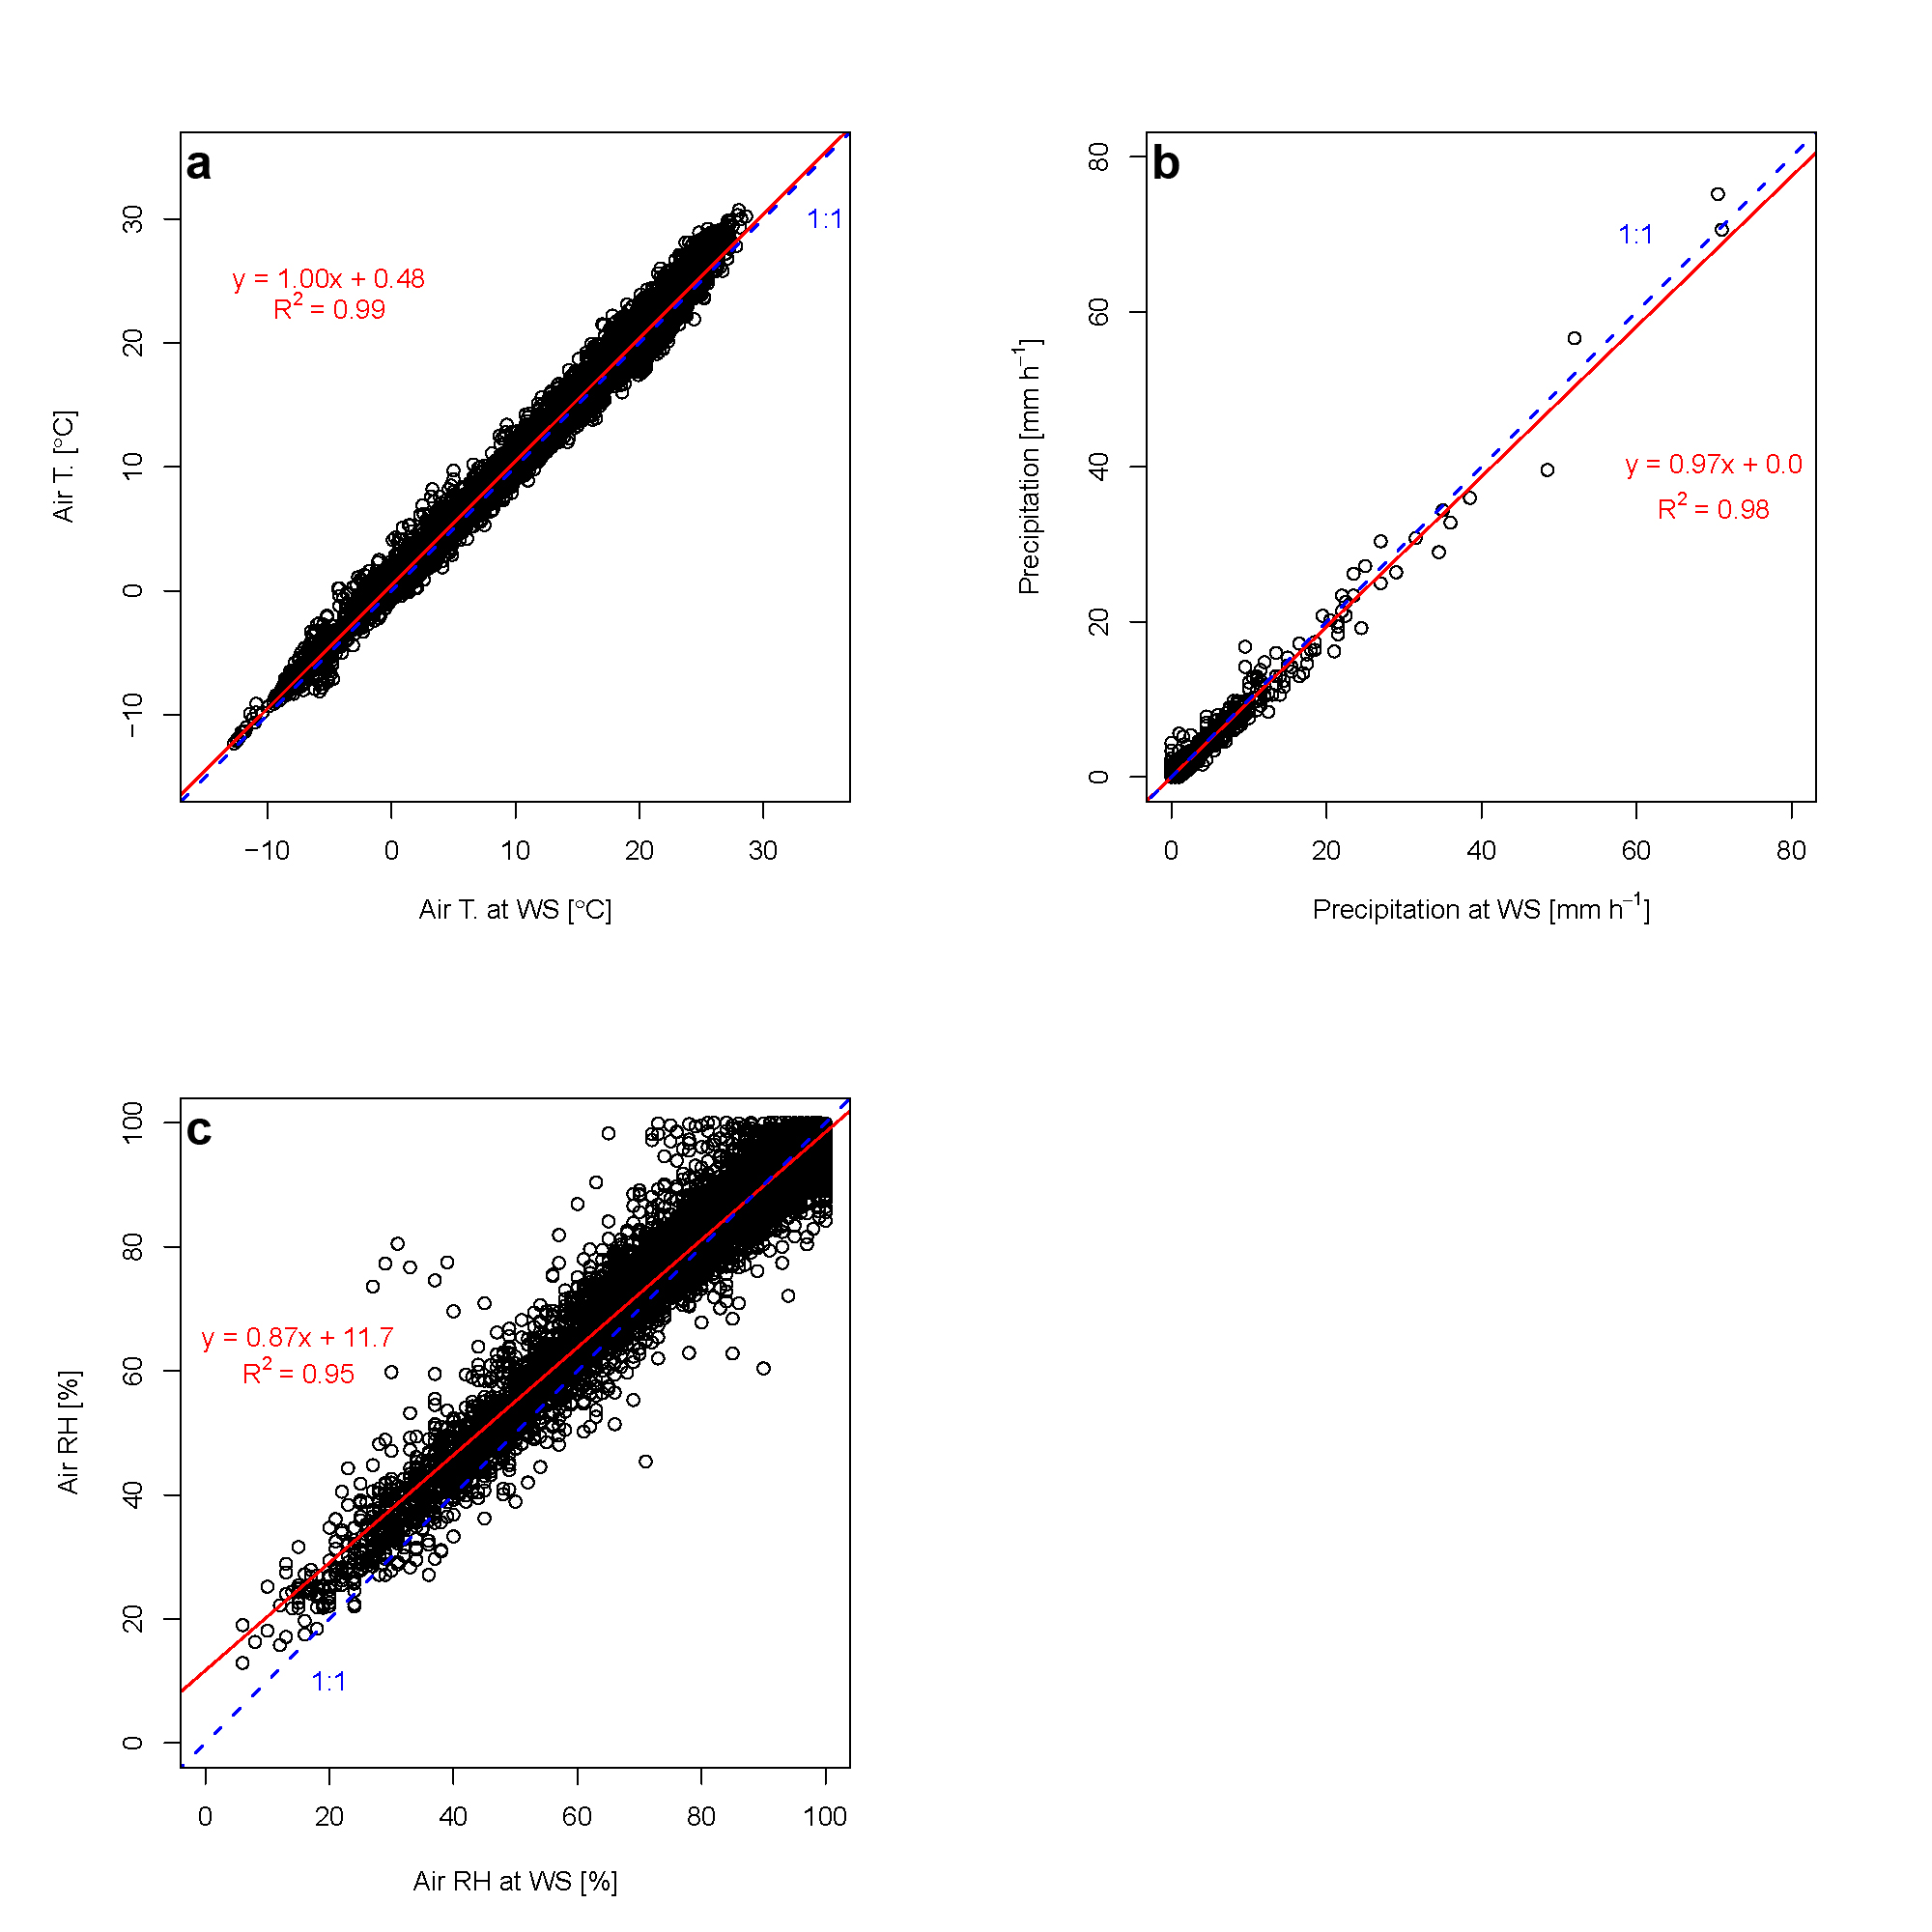
Figure S2
a) Air temperature, b) precipitation, and c) air relative humidity data at the soil CO₂ flux station (y-axis) and the weather station (x-axis). The red line shows the linear regression line, and the blue dotted line shows the 1:1 line.

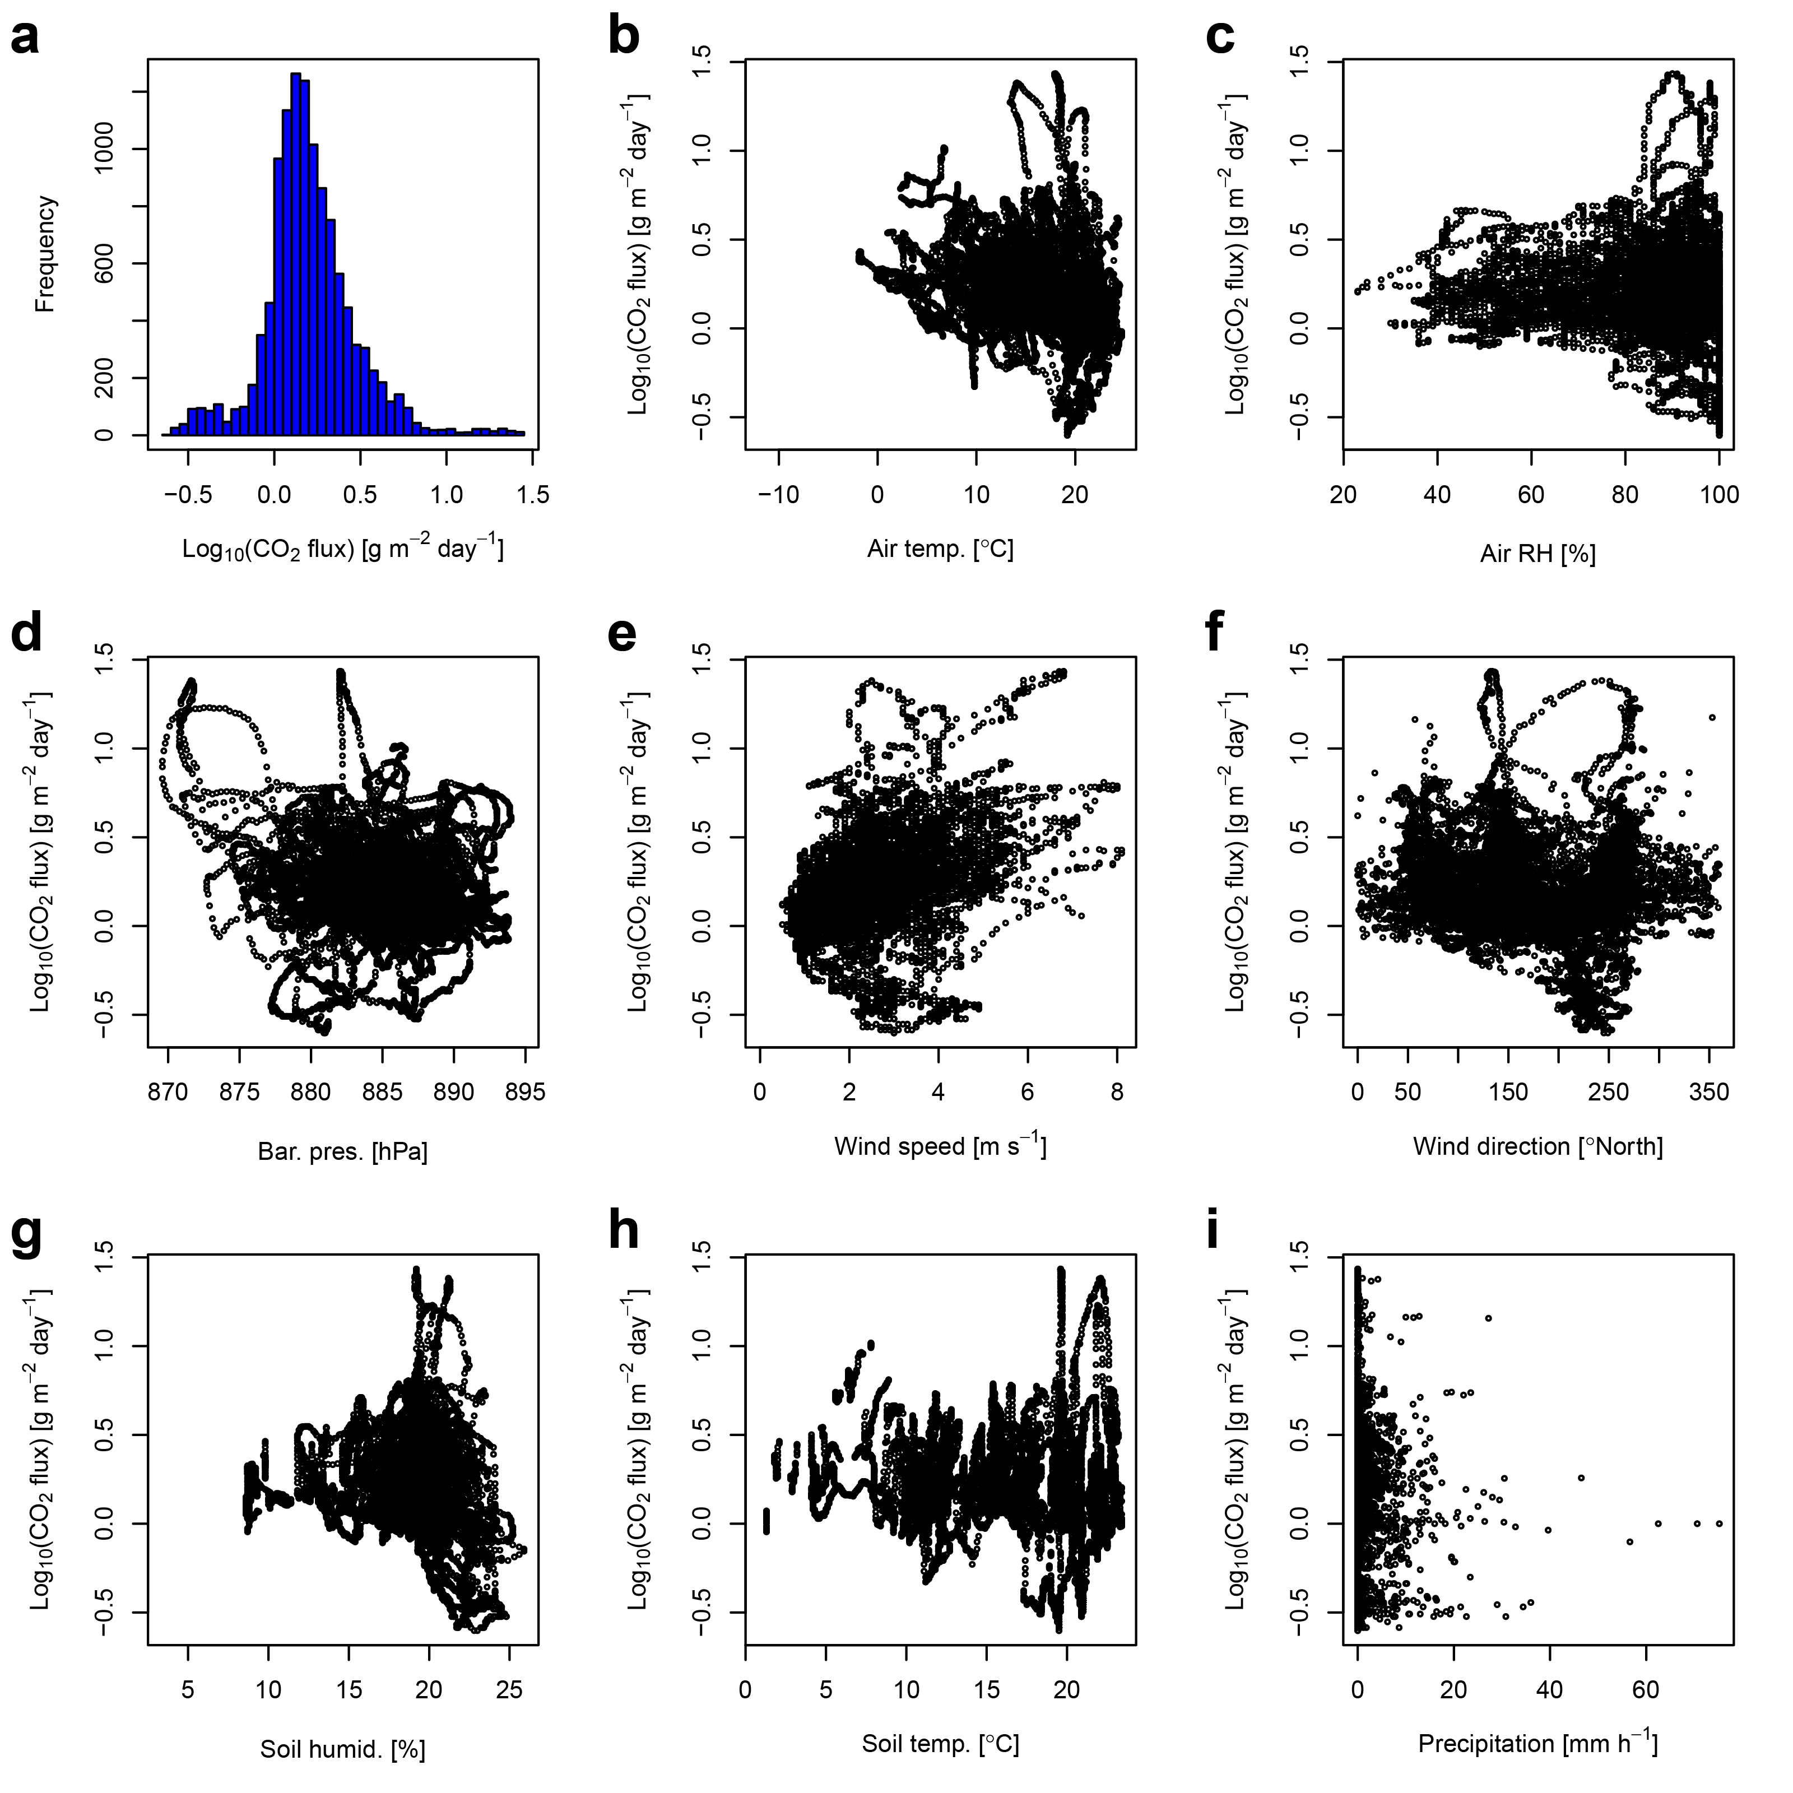
Figure S3
a) Histogram of the daily average values of soil CO₂ flux data and correlation plots of the daily average values of soil CO₂ flux to those of b) air temperature, c) air relative humidity, d) barometric pressure, e) wind speed, f) wind direction, g) soil humidity, h) soil temperature, and i) precipitation. Soil CO₂ flux values are shown in log scale.

Table S1
Technical characteristics of soil CO₂ flux station.
Parameter | Sensor | Elevation/Depth from the ground | Accuracy | Range
Soil CO₂ flux | LI-820, LI-COR | 0 m | ±25% at 22–220 g m⁻² day^{−1 a} | nd^{b}
Air temperature | Solid-state sensor | 1.5 m | ±0.4 °C at 5–40 °C | −30–70 °C
Air relative humidity | Solid-state sensor | 1.5 m | ±2% at 10–90% | 10–98%
Barometric pressure | PTB110, VAISALA | 1.5 m | ±0.3 hPa at 20 °C | 500–1100 hPa
Soil temperature | Pt100 probe, RS Components | −0.5 m | ±0.5 °C | 0–200 °C
Soil humidity | CS616, Campbell Scientific | −0.5 m | ±2.5% | 0–50%
Wind speed | Ultrasonic sensor, Gill Instruments | 1.5 m | ±2% at 12m s⁻¹ | 0–60 m s⁻¹
Wind direction | Ultrasonic sensor, Gill Instruments | 1.5 m | ±2° at 12m s⁻¹ | 0–359 °North
Precipitation | DQA130, LSI-Lastem | 1.5 m | ±1% | 0–600 mm h⁻¹
ªDionis et al. (2015), ^{b}: not determined

