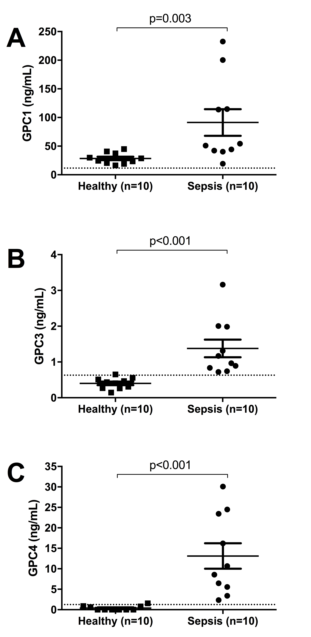

Additional file 1: Figure S1. Pilot experiment measuring Glypican levels in sepsis patients. GPC1, 3 and 4 levels were measured by ELISA in patients with sepsis and healthy controls. Differences between these groups were determined by Mann-Whitney test. The lower limit of detection of each assay is shown as a dashed line.

