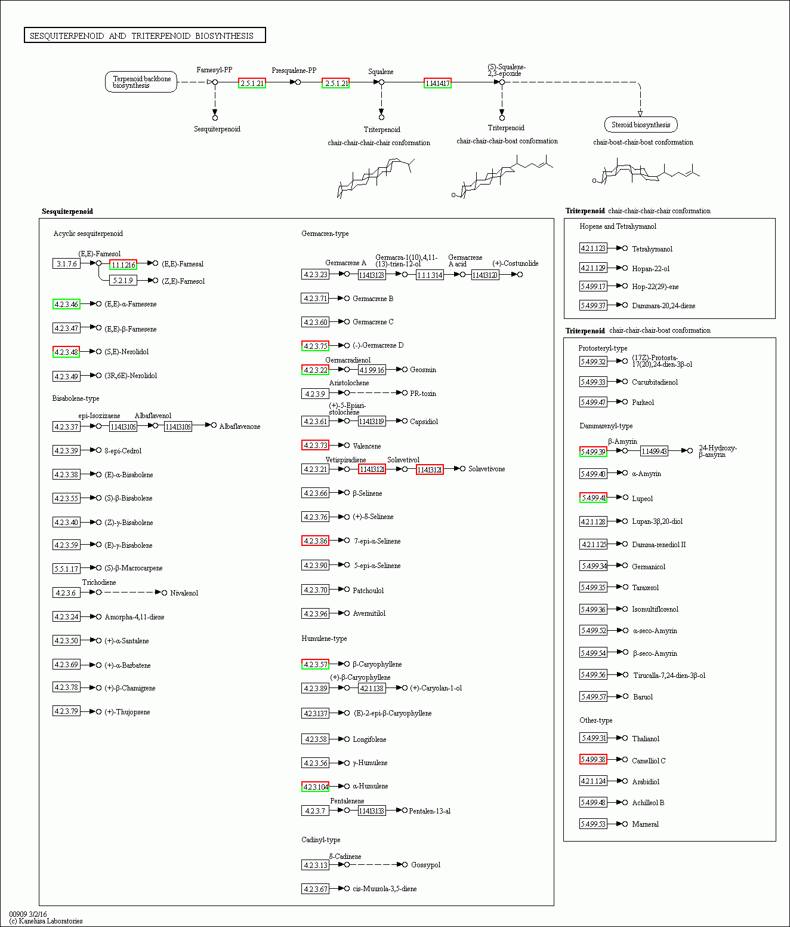
Additional file 4. Putative Sesquiterpenoid and triterpenoid biosynthesis pathway of C. angulatus. Putative Sesquiterpenoid and triterpenoid biosynthesis of C. angulatus was constructed based on KEGG annotation. A total of 75 unigenes were involved in the metabolic pathway. These unigenes were distributed in the rectangular boxes in the figure.

