Additional file
Engineered Zymomonasmobilis tolerant to acetic acid and low pH via multiplex atmospheric and room temperature plasma mutagenesis

Bo Wu^{1†}, Han Qin^{1†}, Yiwei Yang¹, Guowei Duan¹,Shihui Yang², Fengxue Xin³, Chunyan Zhao⁴, Huanhuan Shao⁴, Yanwei Wang¹, Qili Zhu¹, Furong Tan¹,Guoquan Hu¹ and Mingxiong He¹*

¹ Biomass Energy Technology Research Centre, Key Laboratory of Development and Application of Rural Renewable Energy (Ministry of Agriculture), Biogas Institute of Ministry of Agriculture, Section 4-13, Renmin Rd. South, Chengdu 610041, China
² Hubei Collaborative Innovation Center for Green Transformation of Bio-resources, Environmental Microbial Technology Center of Hubei Province, Hubei Key Laboratory of Industrial Biotechnology, College of Life Sciences, Hubei University, Wuhan, 430062, China
³ State Key Laboratory of Materials‑Oriented Chemical Engineering,College of Biotechnology and Pharmaceutical Engineering, Nanjing TechUniversity, No. 30 Puzhu Rd, Pukou District Nanjing, Nanjing 211816, China
⁴ College of Life Science, Sichuan Normal University, Section 2-1819, Chenglong Avenue, Chengdu 610101, China

Table S1 pH values of RM supplemented with acetic acid or sodium acetate
Medium | pH value
RM | 6.60
RM+ 1 g/L acetic acid | 4.90
RM+ 2 g/L acetic acid | 4.48
RM+ 3 g/L acetic acid | 4.28
RM+ 4 g/L acetic acid | 4.15
RM+ 5 g/L acetic acid | 4.05
RM+ 6 g/L acetic acid | 3.98
RM+ 7 g/L acetic acid | 3.92
RM+ 8 g/L acetic acid | 3.86
RM+ 9 g/L acetic acid | 3.81
RM+ 10 g/L acetic acid | 3.77
RM+ 11 g/L acetic acid | 3.74
RM+ 12 g/L acetic acid | 3.71
RM+ 13 g/L acetic acid | 3.67
RM+ 14 g/L acetic acid | 3.64
RM+ 15 g/L acetic acid | 3.61
RM+ 150 mM sodium acetate* | 5.97
RM+ 200mM sodium acetate* | 6.02
RM+ 250mM sodium acetate* | 6.00
*Sodium acetate trihydratewas used, equaling to 12.3 g/L, 16.4 g/L and 20.5 g/L sodium acetate, respectively.

Figure S1
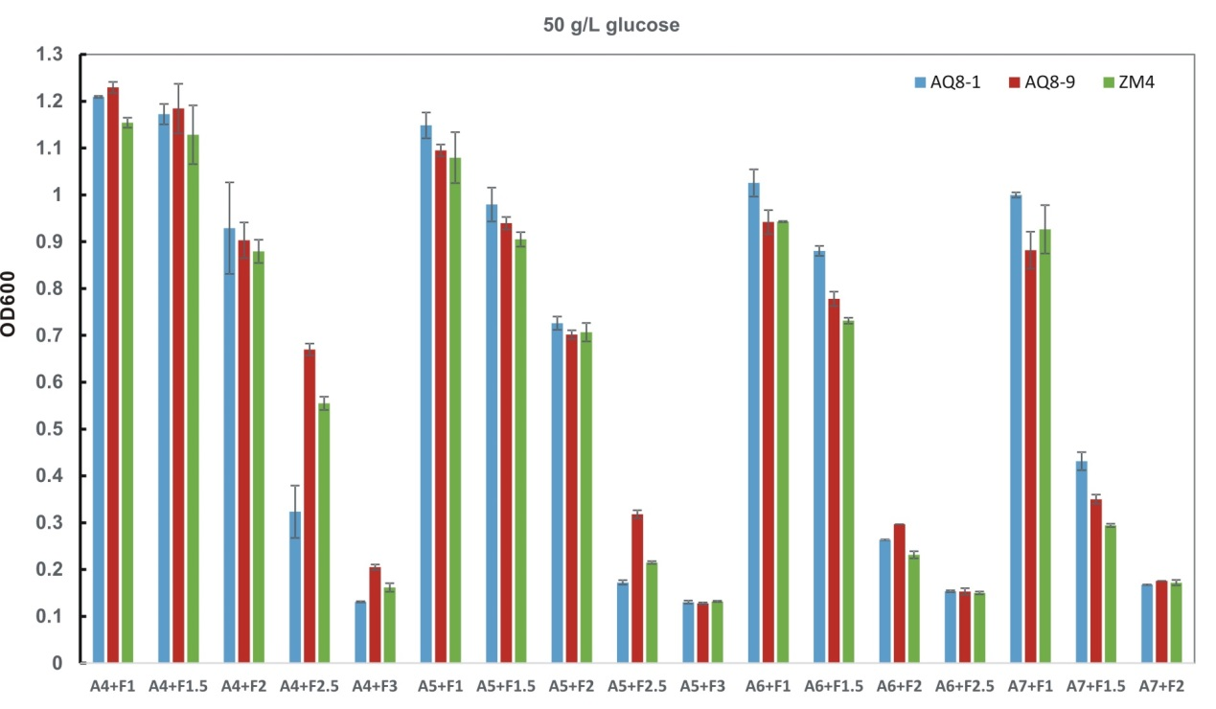

Tolerance of AQ8-1, AC8-9 and ZM4 to mixture of acetic acid and furfural. “A” indicates acetic acid and “F” indicates furfural. The number after A or F indicates the concentration of corresponding inhibitor. The concentrations of acetic acid ranged from 1.0 to 7.0 g/L, and furfural from 1.0 to 3.0 g/L in the mixture. OD_{600 nm} valueswere measuredat stationery phase.

