Table S1: Acceptance in Phase I- Individual Animal Data
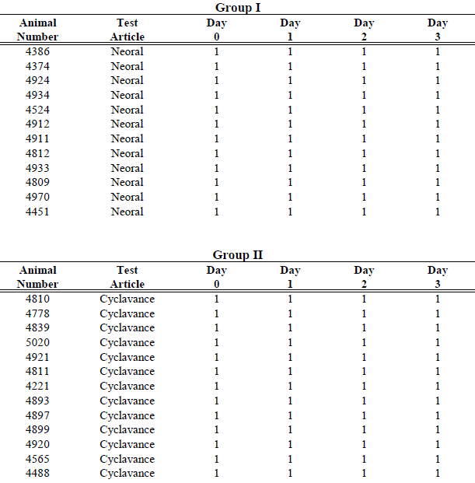
- Voluntary acceptance- Syringe is easily inserted into mouth combined with willingness to swallow
- Forced acceptance- Need for strong animal handling to insert the syringe into the dog’s mouth and administer the product at the back of the throat/into the cheek or need for restriant to ensure swallowing

Table S1: Acceptance in Phase I- Individual Animal Data (continued)
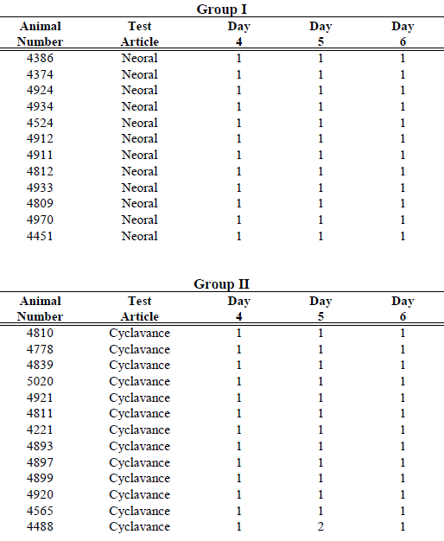

- Voluntary acceptance- Syringe is easily inserted into mouth combined with willingness to swallow
- Forced acceptance- Need for strong animal handling to insert the syringe into the dog’s mouth and administer the product at the back of the throat/into the cheek or need for restriant to ensure swallowing

Table S1: Acceptance in Phase I- Individual Animal Data (continued)
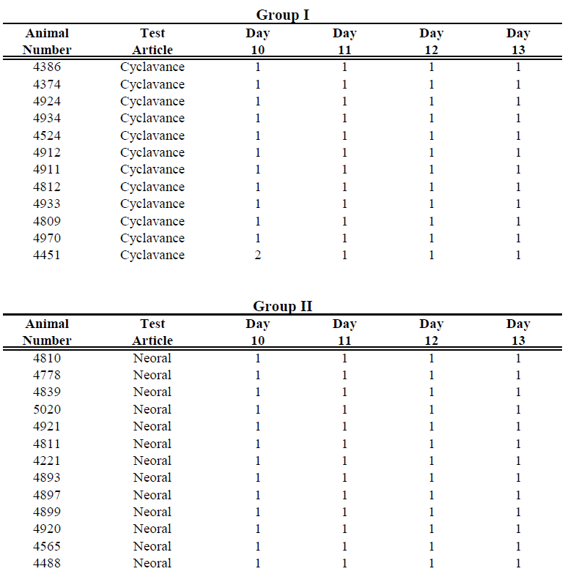

- Voluntary acceptance- Syringe is easily inserted into mouth combined with willingness to swallow
- Forced acceptance- Need for strong animal handling to insert the syringe into the dog’s mouth and administer the product at the back of the throat/into the cheek or need for restriant to ensure swallowing

Table S1: Acceptance in Phase I- Individual Animal Data (continued)
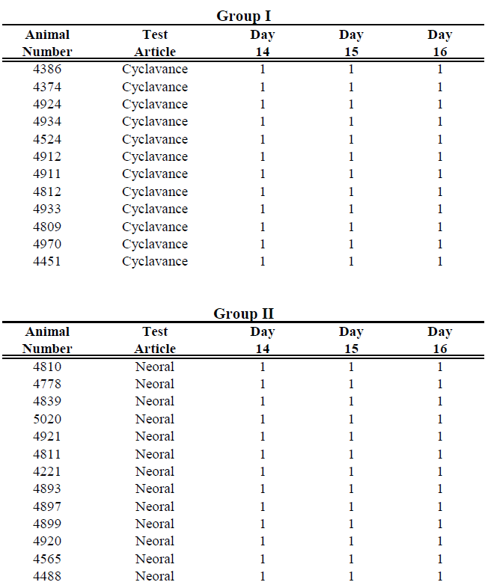
- Voluntary acceptance- Syringe is easily inserted into mouth combined with willingness to swallow
- Forced acceptance- Need for strong animal handling to insert the syringe into the dog’s mouth and administer the product at the back of the throat/into the cheek or need for restriant to ensure swallowing

Table S2: Acceptance in Phase II (Period 1)- Individual Animal Data
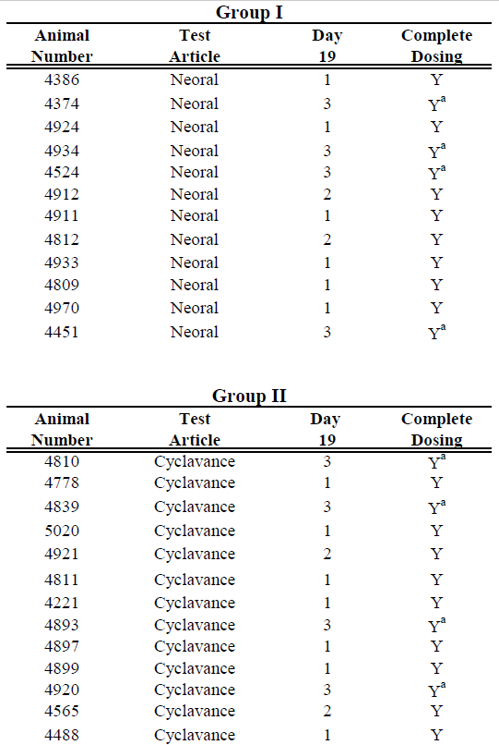
1 - Immediate Prehension - food and test article taken into the mouth within two seconds.
2 - Delayed Prehension - food and test article taken into the mouth after two seconds
3 - No Prehension - test article and food mixture remaining after one minute
Y - Yes
Ya - Yes; consumed after one minute

Table S2: Acceptance in Phase II (Perod 1)- Individual Animal Data (continued)
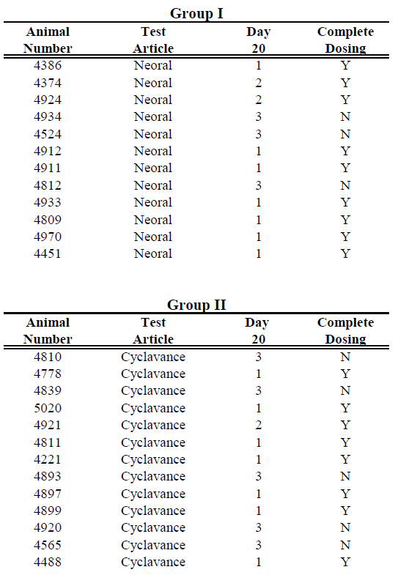
1 - Immediate Prehension - food and test article taken into the mouth within two seconds.
2 - Delayed Prehension - food and test article taken into the mouth after two seconds
3 - No Prehension - test article and food mixture remaining after one minute
Y - Yes
Ya - Yes; consumed after one minute

Table S2: Acceptance in Phase II (Perod 1)- Individual Animal Data (continued)
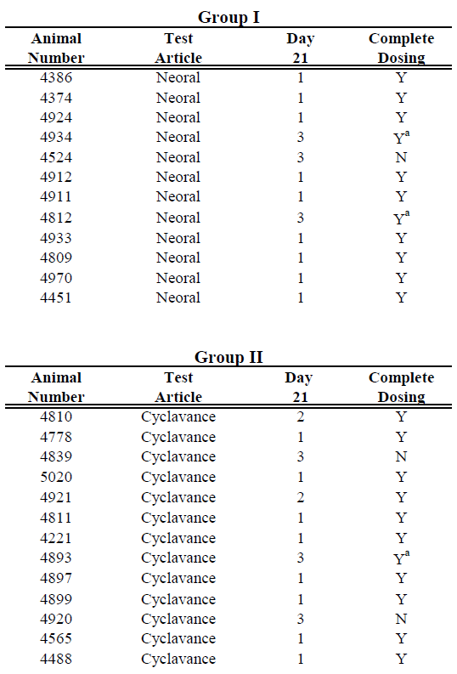
1 - Immediate Prehension - food and test article taken into the mouth within two seconds.
2 - Delayed Prehension - food and test article taken into the mouth after two seconds
3 - No Prehension - test article and food mixture remaining after one minute
Y - Yes
Ya - Yes; consumed after one minute

Table S3: Acceptance in Phase II (Perod 2)- Individual Animal Data
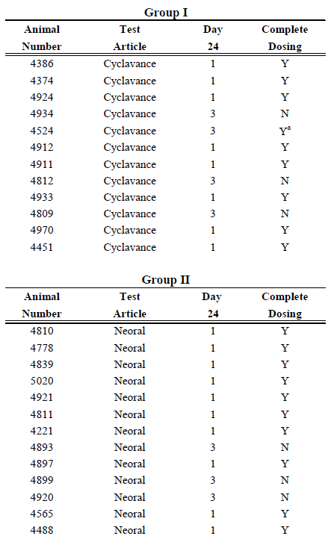
1 - Immediate Prehension - food and test article taken into the mouth within two seconds.
2 - Delayed Prehension - food and test article taken into the mouth after two seconds
3 - No Prehension - test article and food mixture remaining after one minute
Y - Yes
Ya - Yes; consumed after one minute

Table S3: Acceptance in Phase II (Perod 2)- Individual Animal Data (continued)
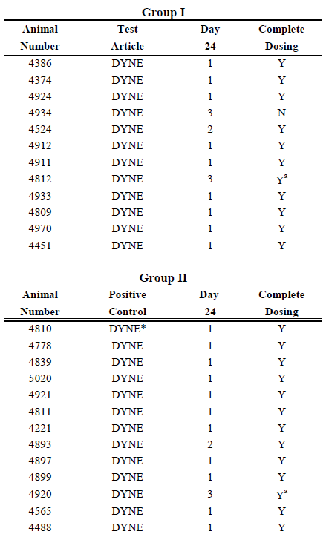
* DYNE - Dyne High Calorie Liquid Diet Supplement

1 - Immediate Prehension - food and test article taken into the mouth within two seconds.
2 - Delayed Prehension - food and test article taken into the mouth after two seconds
3 - No Prehension - test article and food mixture remaining after one minute
Y - Yes
Ya - Yes; consumed after one minute

Table S3: Acceptance in Phase II (Perod 2)- Individual Animal Data (continued)
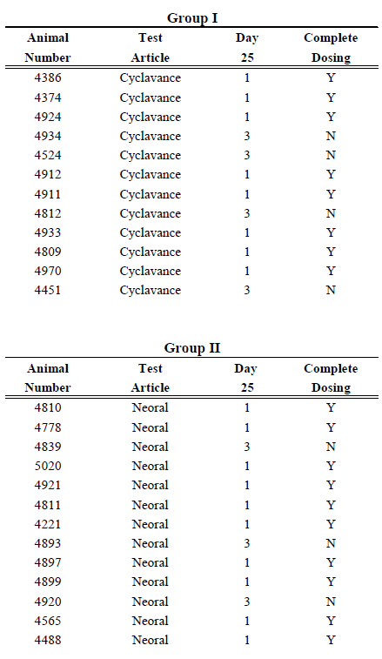
1 - Immediate Prehension - food and test article taken into the mouth within two seconds.
2 - Delayed Prehension - food and test article taken into the mouth after two seconds
3 - No Prehension - test article and food mixture remaining after one minute
Y - Yes
Ya - Yes; consumed after one minute

Table S3: Acceptance in Phase II (Perod 2)- Individual Animal Data (continued)
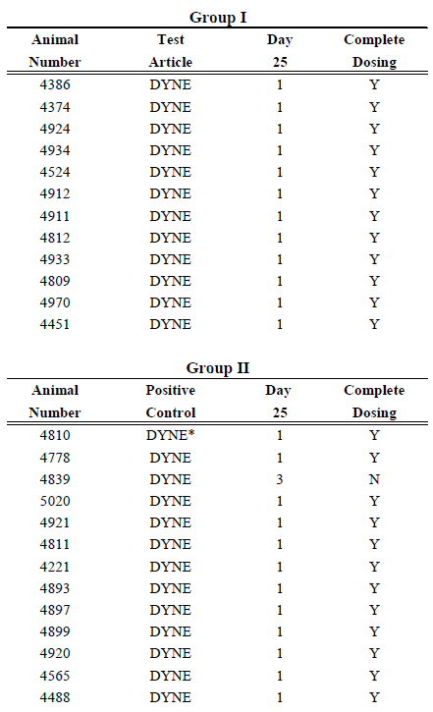
* DYNE - Dyne High Calorie Liquid Diet Supplement

1 - Immediate Prehension - food and test article taken into the mouth within two seconds.
2 - Delayed Prehension - food and test article taken into the mouth after two seconds
3 - No Prehension - test article and food mixture remaining after one minute
Y - Yes
Ya - Yes; consumed after one minute
Table S3: Acceptance in Phase II (Perod 2)- Individual Animal Data (continued)
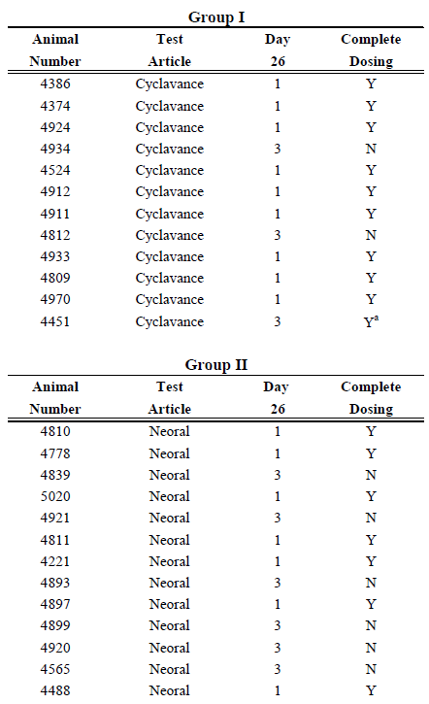
1 - Immediate Prehension - food and test article taken into the mouth within two seconds.
2 - Delayed Prehension - food and test article taken into the mouth after two seconds
3 - No Prehension - test article and food mixture remaining after one minute
Y - Yes
Ya - Yes; consumed after one minute
Table S3: Acceptance in Phase II (Perod 2)- Individual Animal Data (continued)
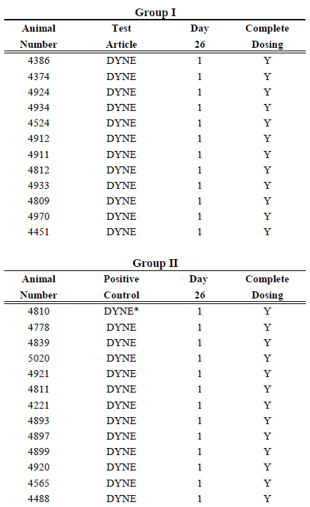
* DYNE - Dyne High Calorie Liquid Diet Supplement

1 - Immediate Prehension - food and test article taken into the mouth within two seconds.
2 - Delayed Prehension - food and test article taken into the mouth after two seconds
3 - No Prehension - test article and food mixture remaining after one minute
Y - Yes
Ya - Yes; consumed after one minute
Table S4: Individual Animal Body weights
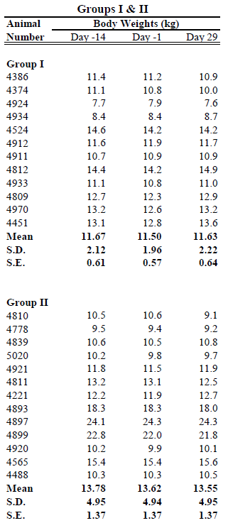
S.D. - Standard Deviation; S.E. - Standard Error

Table S5: Physical Examination Data
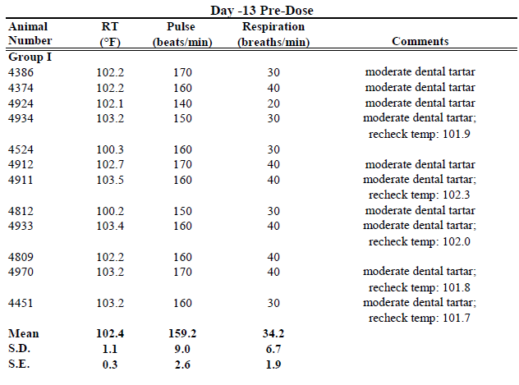
Note: Higher temperatures for some animals were believed to be due to excitement. Temperatures were rechecked, as noted, when dogs were calmer.
Note: The following items were examined for normal or abnormal: general appearance; body condition; behaviour; cardiovascular/pulmonary; ears, eyes and mouth; skin and hair; and study suitability. All parameters were marked normal unless otherwise noted.
RT - Rectal Temperature; min - minute; S.D. - Standard Deviation; S.E. - Standard Error

Table S5: Physical Examination Data (continued)
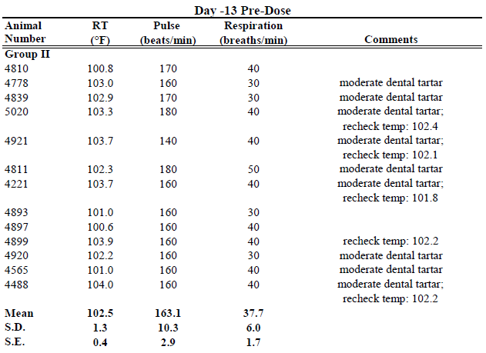
Note: Higher temperatures for some animals were believed to be due to excitement. Temperatures were rechecked, as noted, when dogs were calmer.
Note: The following items were examined for normal or abnormal: general appearance; body condition; behaviour; cardiovascular/pulmonary; ears, eyes and mouth; skin and hair; and study suitability. All parameters were marked normal unless otherwise noted.
RT - Rectal Temperature; min - minute; S.D. - Standard Deviation; S.E. - Standard Error

Table S5: Physical Examination Data (continued)
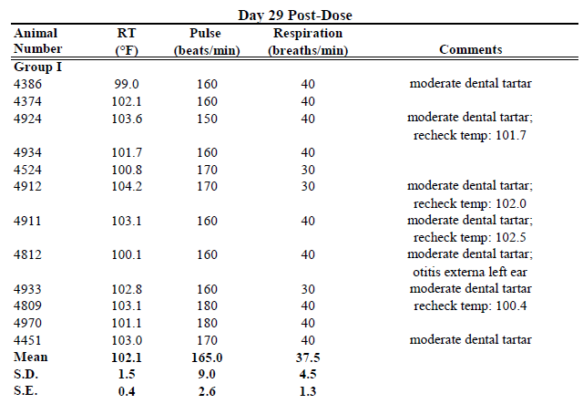

Note: Higher temperatures for some animals were believed to be due to excitement. Temperatures were rechecked, as noted, when dogs were calmer.
Note: The following items were examined for normal or abnormal: general appearance; body condition; behaviour; cardiovascular/pulmonary; ears, eyes and mouth; skin and hair; and study suitability. All parameters were marked normal unless otherwise noted.
RT - Rectal Temperature; min - minute; S.D. - Standard Deviation; S.E. - Standard Error

Table S5: Physical Examination Data (continued)
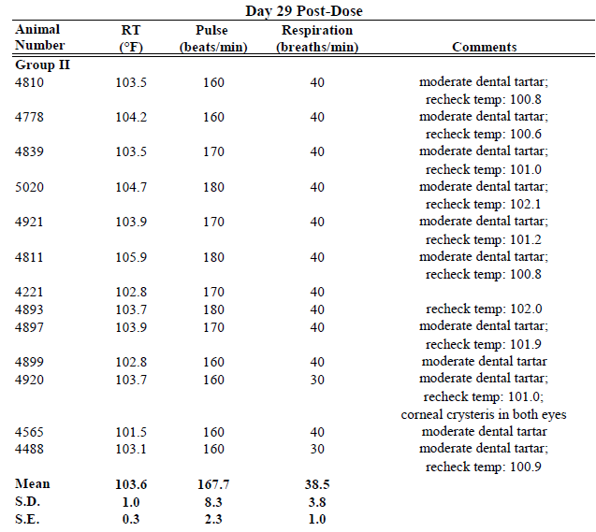

Note: Higher temperatures for some animals were believed to be due to excitement. Temperatures were rechecked, as noted, when dogs were calmer.
Note: The following items were examined for normal or abnormal: general appearance; body condition; behaviour; cardiovascular/pulmonary; ears, eyes and mouth; skin and hair; and study suitability. All parameters were marked normal unless otherwise noted.
RT - Rectal Temperature; min - minute; S.D. - Standard Deviation; S.E. - Standard Error

Table S6: Hematology Data
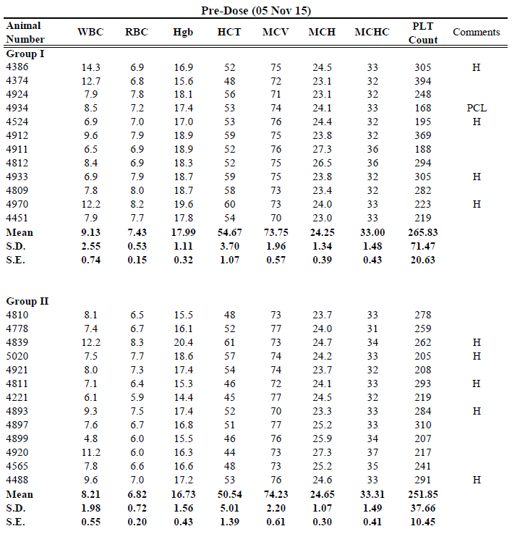
H - Hemolysis 1+ - No significant interference
PCL - Low platelet count reflects the minimum number due to platelet clumping.
S.D. - Standard Deviation, S.E. - Standard Error

Table S6: Hematology Data (continued)

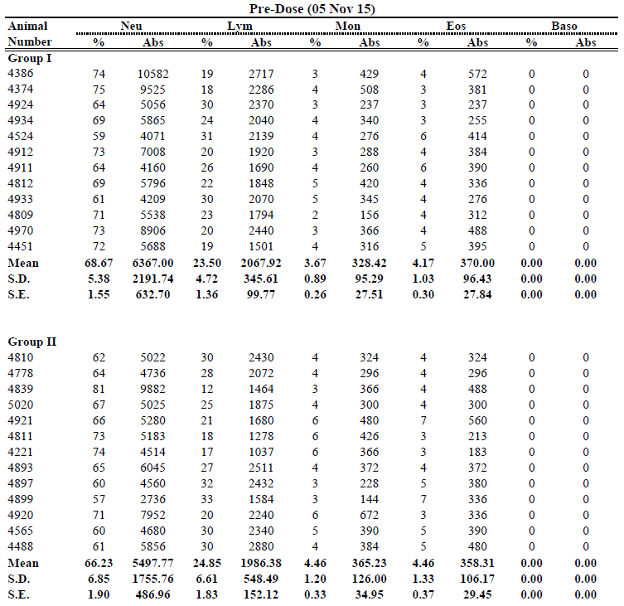

Table S6: Hematology Data (continued)

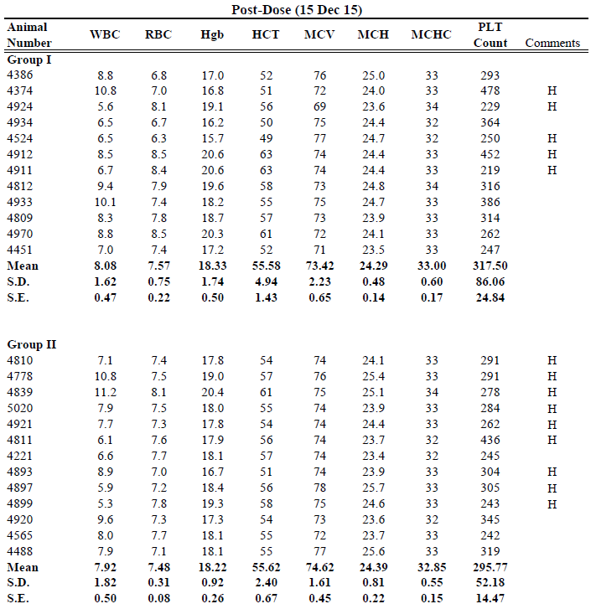
H - Hemolysis 1+ - No significant interference
PCL - Low platelet count reflects the minimum number due to platelet clumping.
S.D. - Standard Deviation, S.E. - Standard Error

Table S6: Hematology Data (continued)
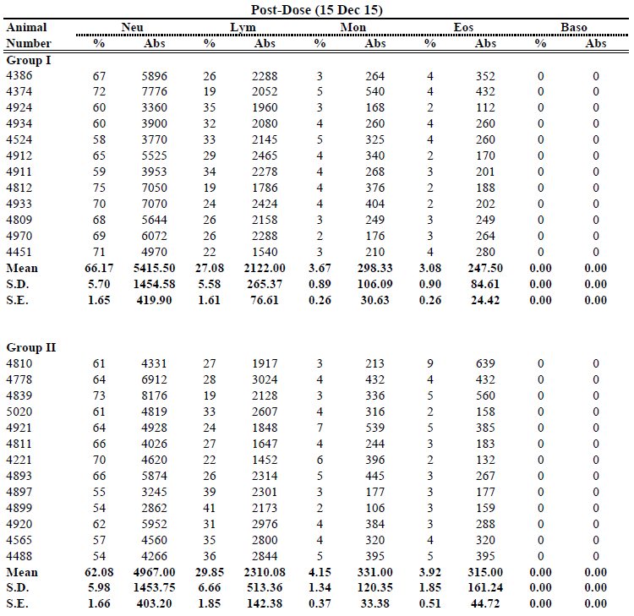

Tabls S7: Serum Chemistry Data
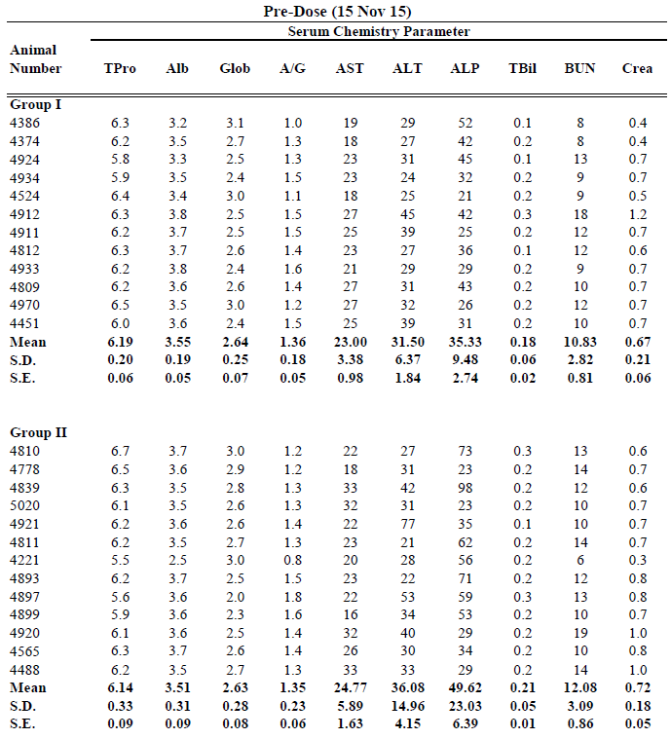

Table S7: Serum Chemistry Data (continued)

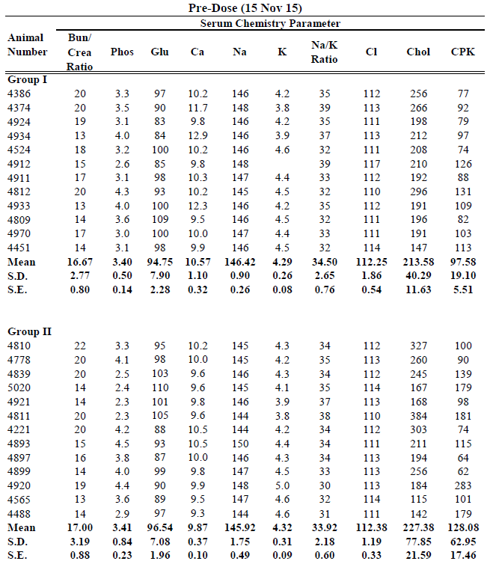

Table S7: Serum Chemistry Data (continued)
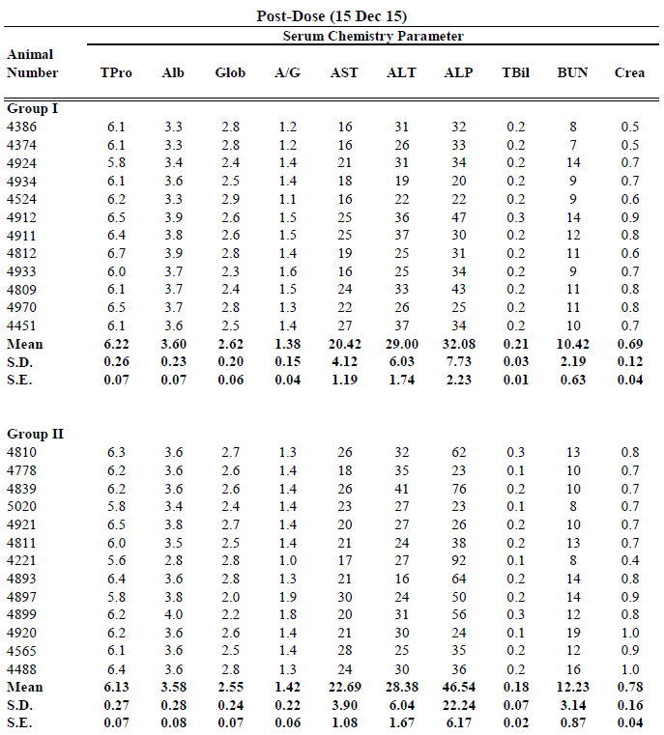

Table S7: Serum Chemistry Data (continued)
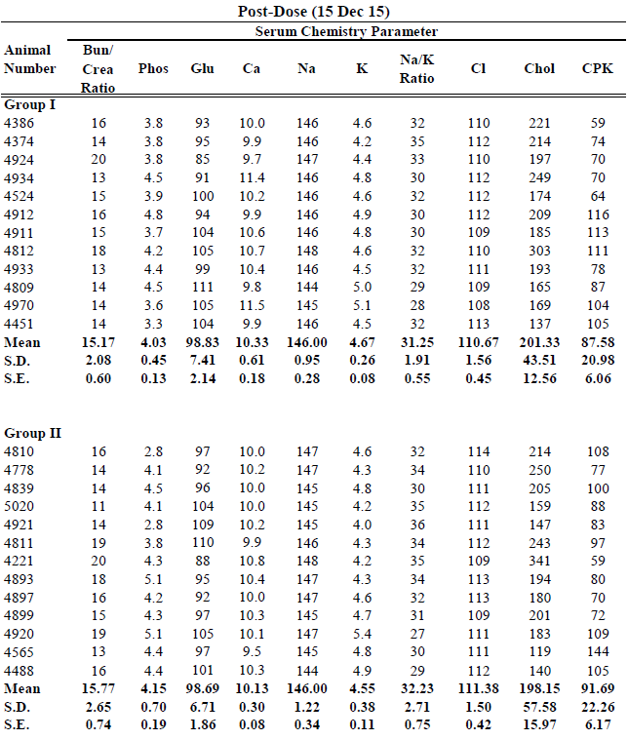

Units of Hematology and Serum Chemistry Parameters
White Blood Cell Count (WBC) | 103/μL
Erythrocyte Count (RBC) | 106/μL
Hemoglobin (Hgb) | g/dL
Hematocrit (Hct) | %
Mean Corpuscular Volume (MCV) | fL
Mean Corpuscular Hemoglobin (MCH) | pg
Mean Corpuscular Hemoglobin Concentration (MCHC) | g/dL
Platelets (Plt) | 103/μL
Neutrophils (% Neut) | %
Lymphocytes (% Lymph) | %
Monocytes (% Mono) | %
Eosinophils (% Eosin) | %
Basophils (% Baso) | %
Total Protein (Tpro) | g/dL
Albumin (Alb) | g/dL
Globulin (Glob) | g/dL
Albumin/Globulin Ratio (A/G)
Aspartate Aminotransferase (AST) | U/L
Alanine Aminotransferase (ALT) | U/L
Alkaline Phosphatase (ALP) | U/L
Total Bilirubin (TBil) | mg/dL
Urea Nitrogen (BUN) | mg/dL
Creatinine (Crea) | mg/dL
BUN/Creatinine Ratio (BUN/Crea)
Phosphorus (Phos) | mg/dL
Glucose (Glu) | mg/dL
Calcium (Ca) | mg/dL
Sodium (Na) | mmol/L
Potassium (K) | mmol/L
Sodium Potassium Ratio (Na/K)
Chloride (Cl) | mmol/L
Cholesterol (Chol) | mg/dL
Creatine phosphokinase (CPK) | U/L

