Additional file 1
Table S1, The indexing scheme.

Sample | Condition | i7 Sequence | i5 Sequence
1 | Fresh | TAAGGCGA | CTCTCTAT
2 | Fresh | CGTACTAG | TATCCTCT
3 | RT | AGGCAGAA | AGAGTAGA
4 | RT | TCCTGAGC | GTAAGGAG
5 | Lysis | GGACTCCT | ACTGCATA
6 | Lysis | TAGGCATG | AAGGAGTA
7 | EDTA | GCTACGCT | CTCTCTAT
8 | EDTA | CGAGGCTG | TATCCTCT
9 | 4C | AAGAGGCA | AGAGTAGA
10 | 4C | GTAGAGGA | GTAAGGAG
11 | -20C | TAAGGCGA | ACTGCATA
12 | -20C | CGTACTAG | AAGGAGTA
13 | -80C | AGGCAGAA | CTAAGCCT
14 | -80C | TCCTGAGC | GCGTAAGA
15 | HY | CTCTCTAC | CTAAGCCT
16 | HY | CAGAGAGG | GCGTAAGA

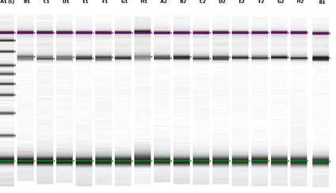
B

A

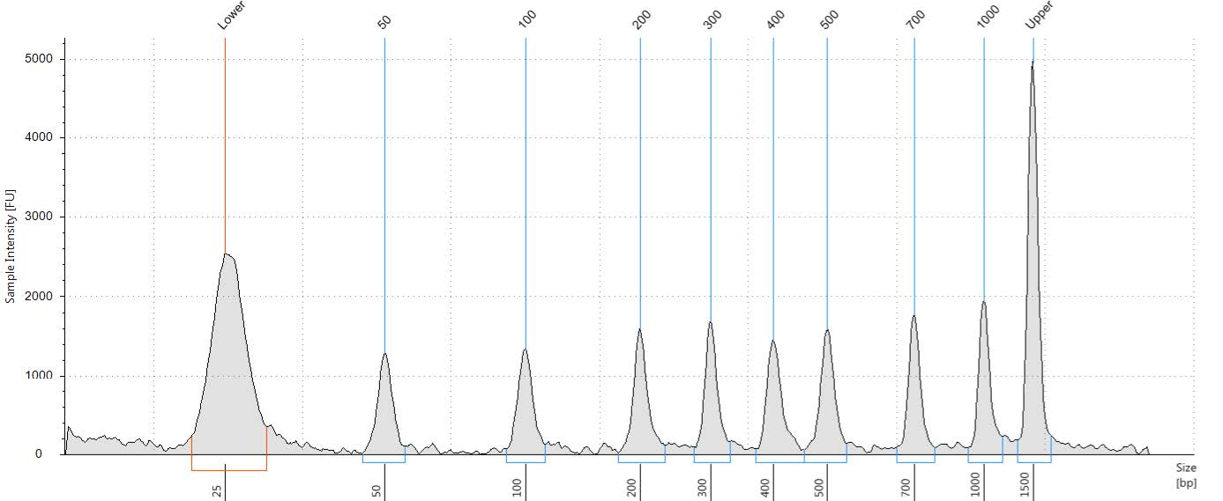

Figure S1, Tapestation 2200 images using D1000 Tapes and D1000 reagents.
A, Indexed samples were found to be in the expected size range (600-650 bp). B, Sizes corresponding to the bands detected in the ladder in the first lane of panel A.

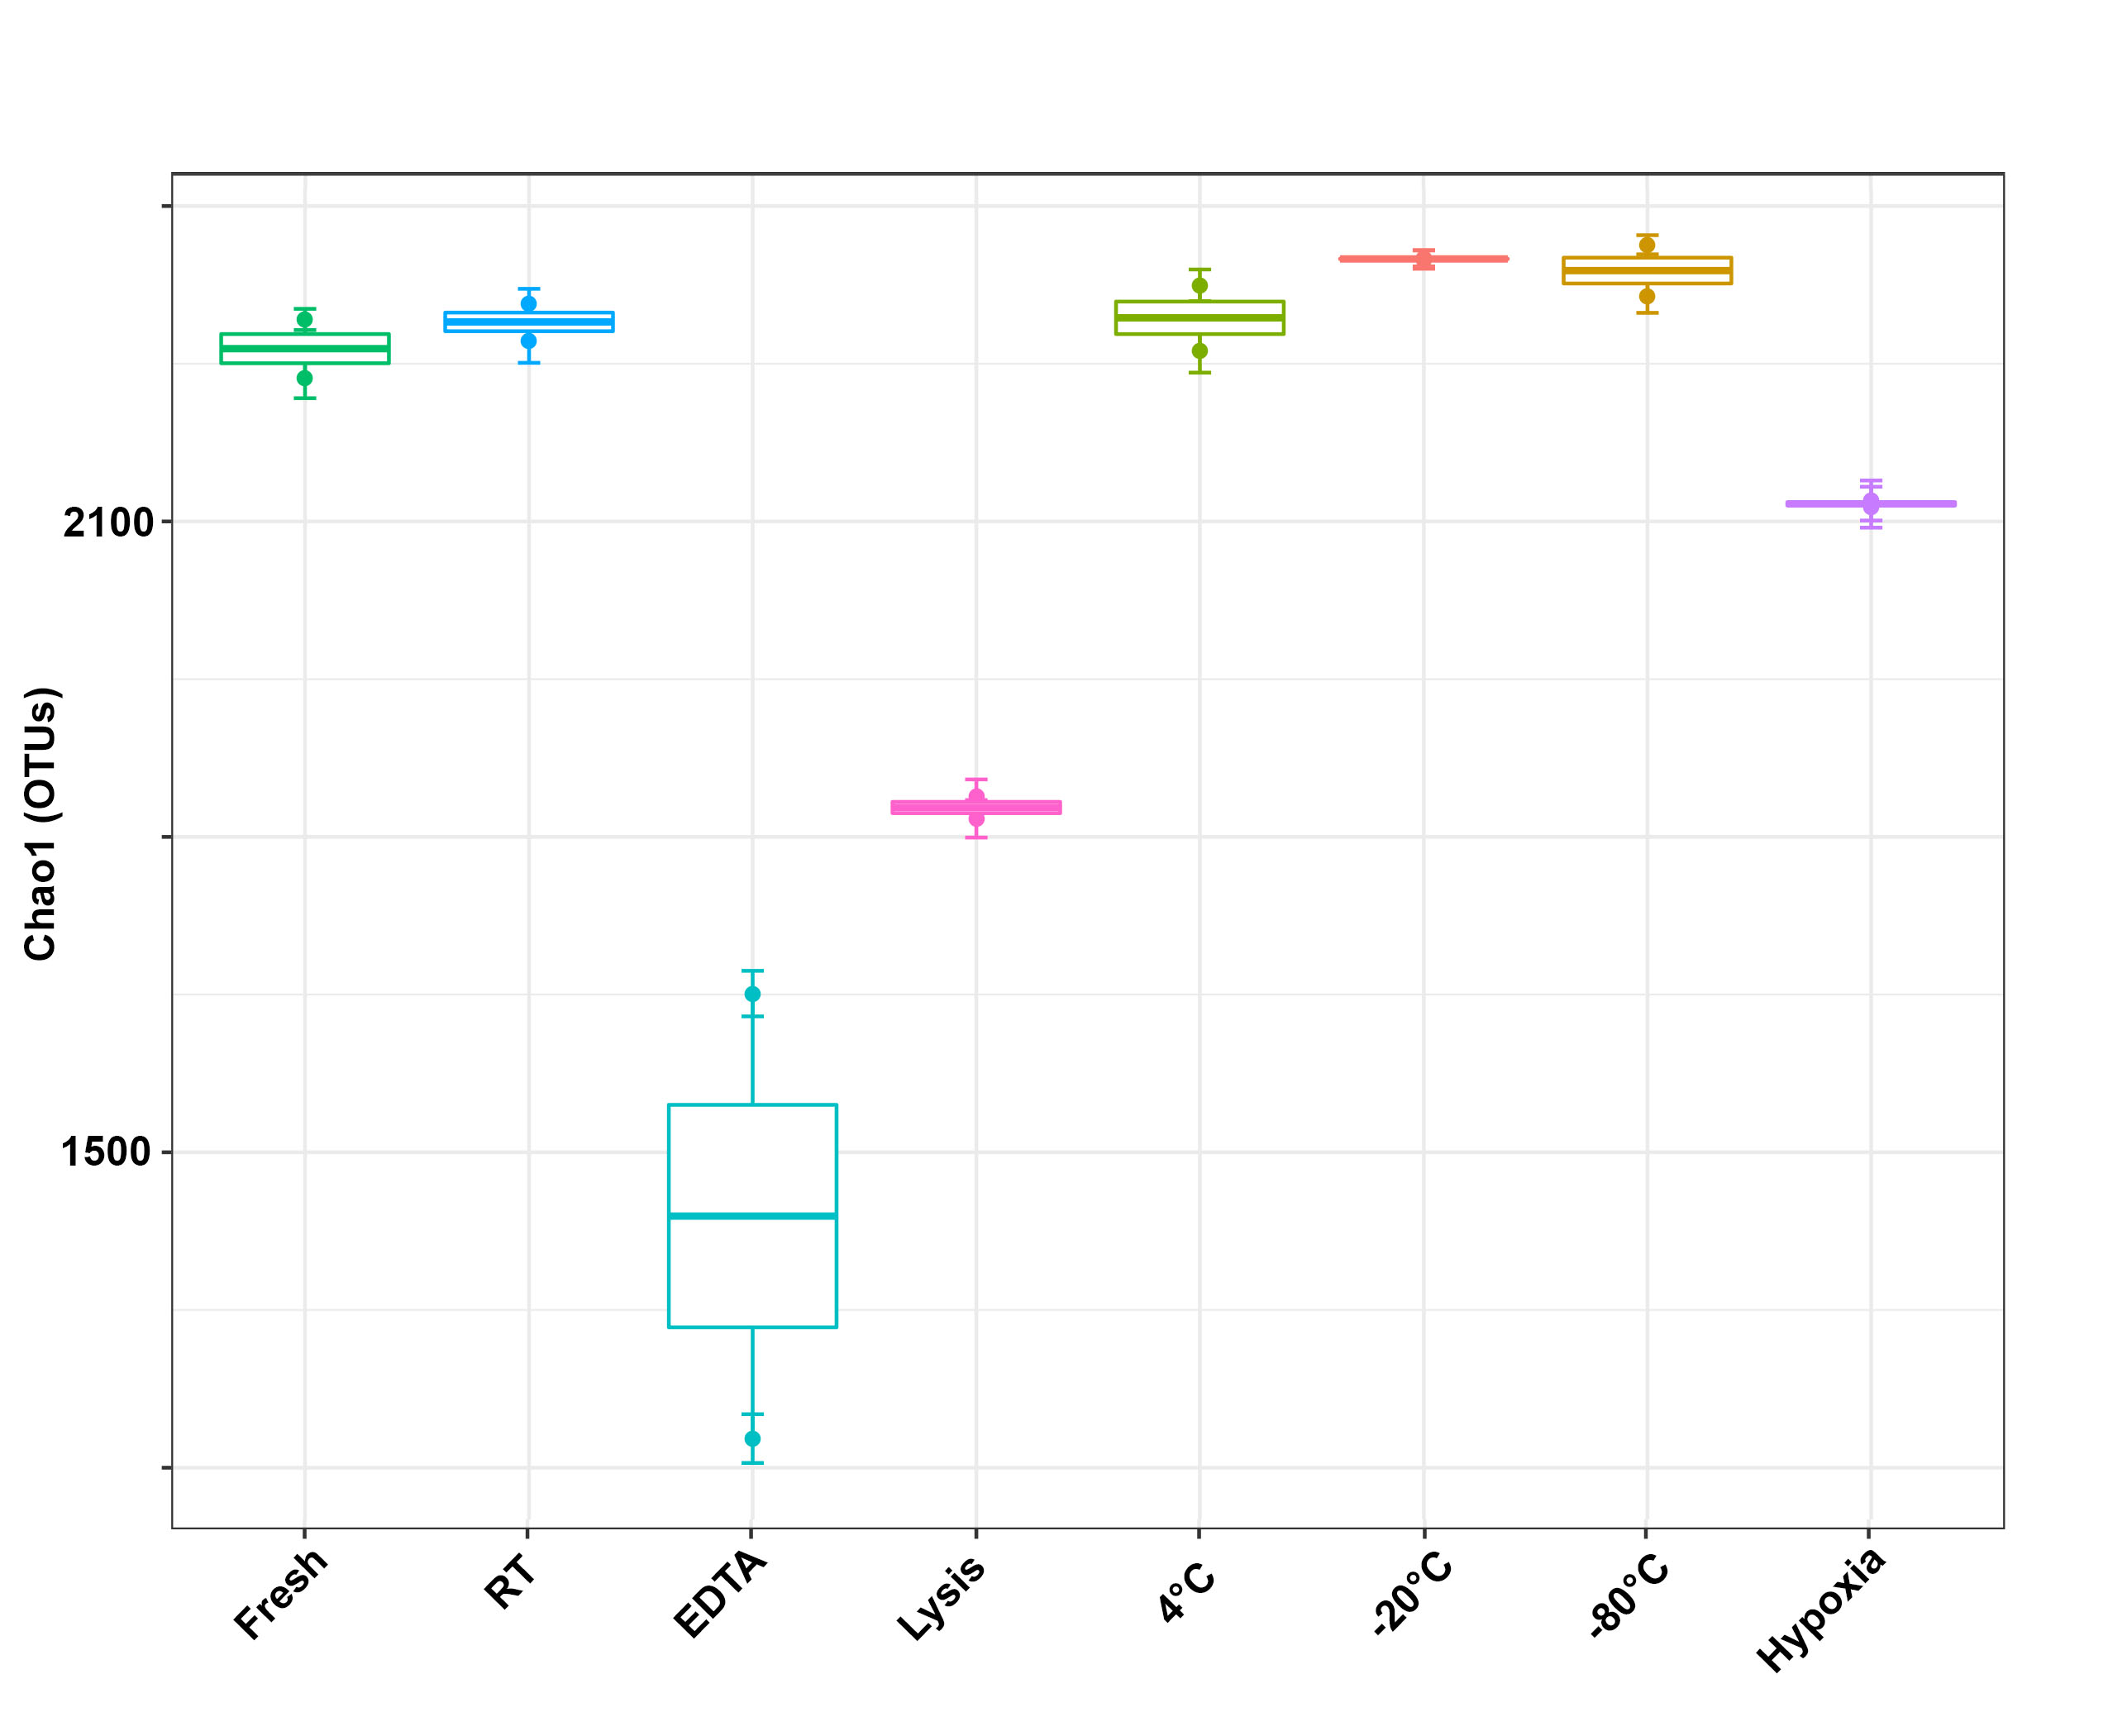

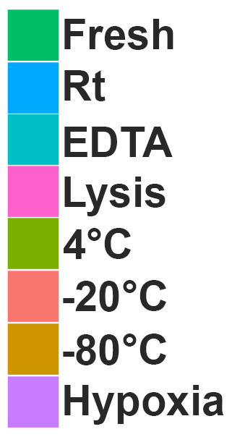

Figure S2, Detected alpha diversity in fecal matter following incubation under 8 different storage conditions. Chao1 richness estimator between storage conditions and individual samples.

