Fig. S1. Full genome genetic distance comparisons between HIV-1 subtype A sub-subtypes according to our classification proposal. X-axis scale lines indicate genetic distance thresholds allowing, in our alignment and model conditions, for group, subtype and sub-subtype identification.

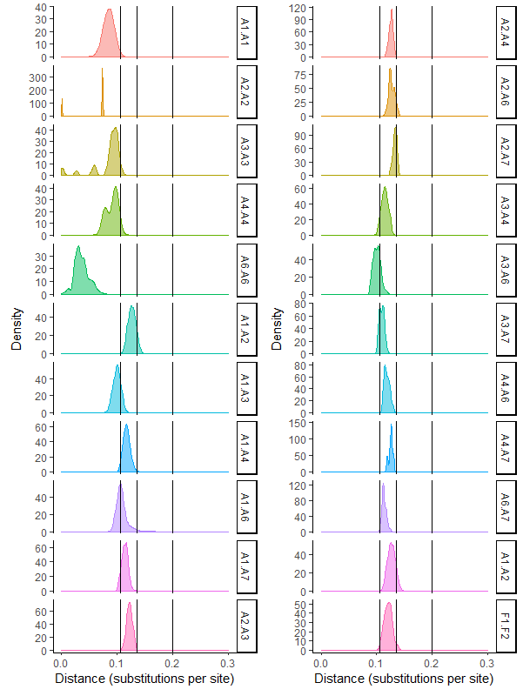

Fig. S2. Phylogenetic tree of sub-type A obtained with pol gene. Sequences from A1, A2, A3, A4 and A6 clades have been collapsed for readability. One pol sequence was identified in the A7 clade in addition to the two full genome sequences and is highlighted by an arrow. The tree has been obtained with PhyML 3.0, using GTR-G nucleotide substitution model and branch support obtained by bootstrap method is given for each node. Several sequences, depicted in black, clustered outside the defined clades but cannot be retained in the classification proposal because of poor branch support values or absence of available full genome sequences.

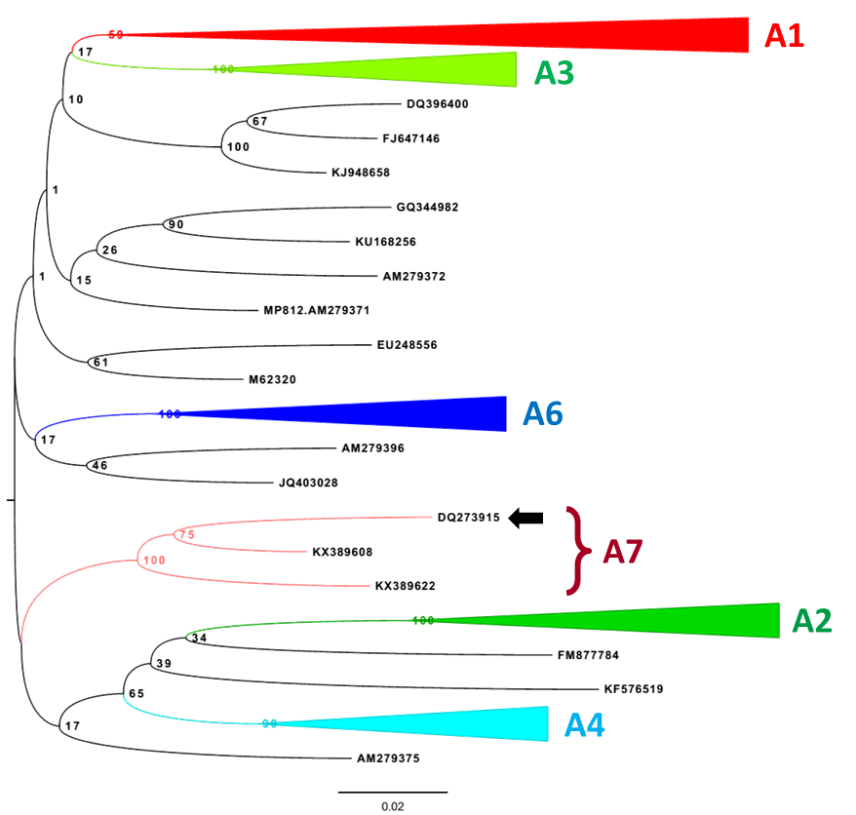

Fig. S3. Phylogenetic tree of sub-type A obtained with gag gene. Sequences from A1, A2, A3, A4 and A6 clades have been collapsed for readability. One pol sequence was identified in the A7 clade in addition to the two full genome sequences and is highlighted by an arrow. The tree has been obtained with PhyML 3.0, using GTR-G nucleotide substitution model and branch support obtained by bootstrap method is given for each node. Several sequences, depicted in black, clustered outside the previously defined clades but cannot be retained in the classification proposal because of poor branch support values or absence of available full genome sequences.

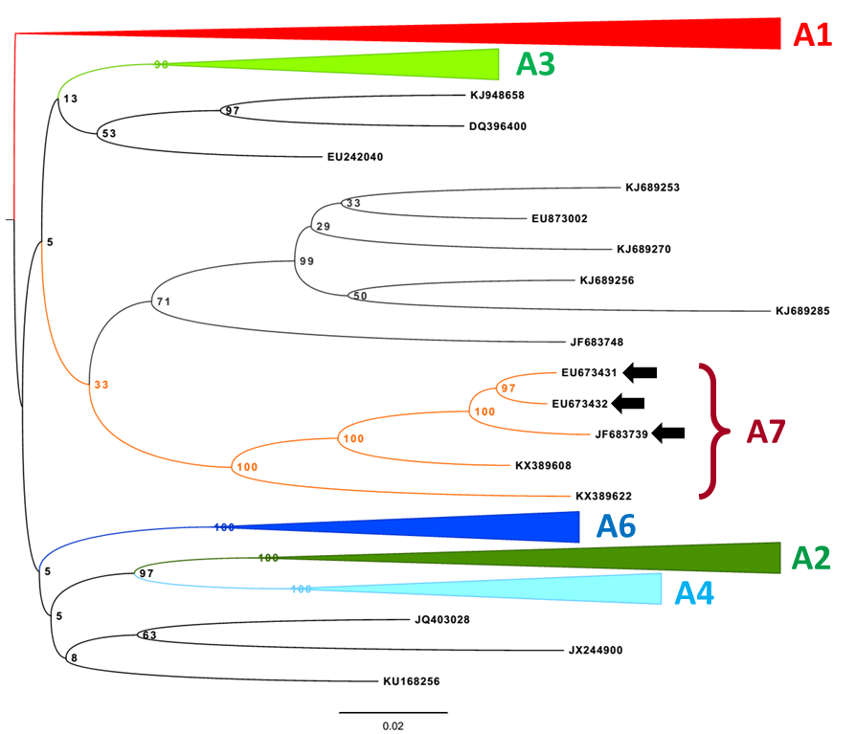

Fig. S4. Genetic distance comparisons between HIV-1 subtype D sub-subtypes according to our new classification proposal. X-axis scale lines indicate genetic distance thresholds allowing, in our alignment and model conditions, for group, subtype and sub-subtype identification.

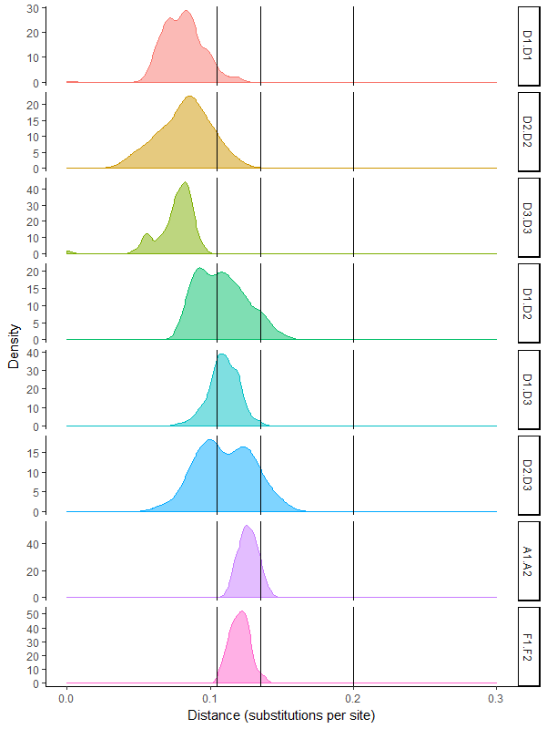

Fig. S5. Genetic distance comparisons between HIV-1 groups, subtypes and sub-subtypes using pol sequences. X-axis scale lines indicate genetic distance thresholds allowing, in our alignment and model conditions, for group, subtype and sub-subtype identification. Genetic distance ranges compatible with intra-sub-subtype, inter-sub-subtype, inter-subtype and inter-group comparisons are indicated by the numbers 1, 2, 3 and 4, respectively.

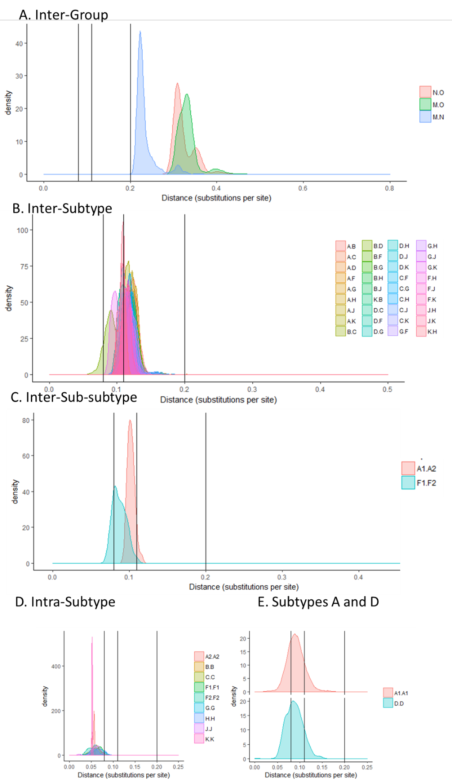
Fig. S6. Subtypes A (A) and D (B) pol sequences maximum likelihood phylogenetic trees. Names of all sub-subtypes are indicated according to the new classification proposal.
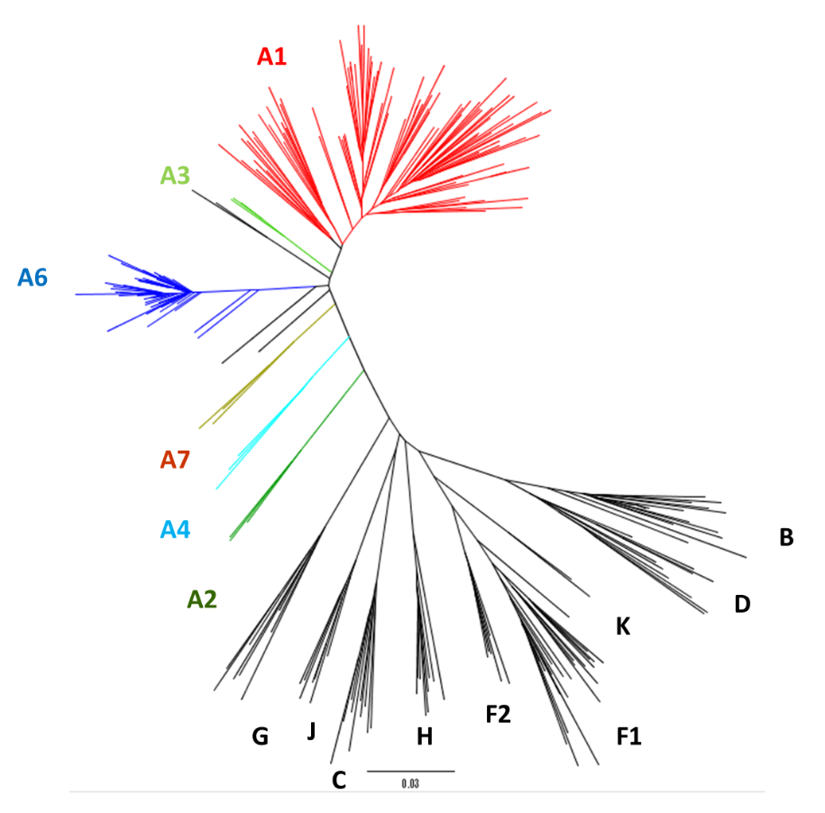
A.
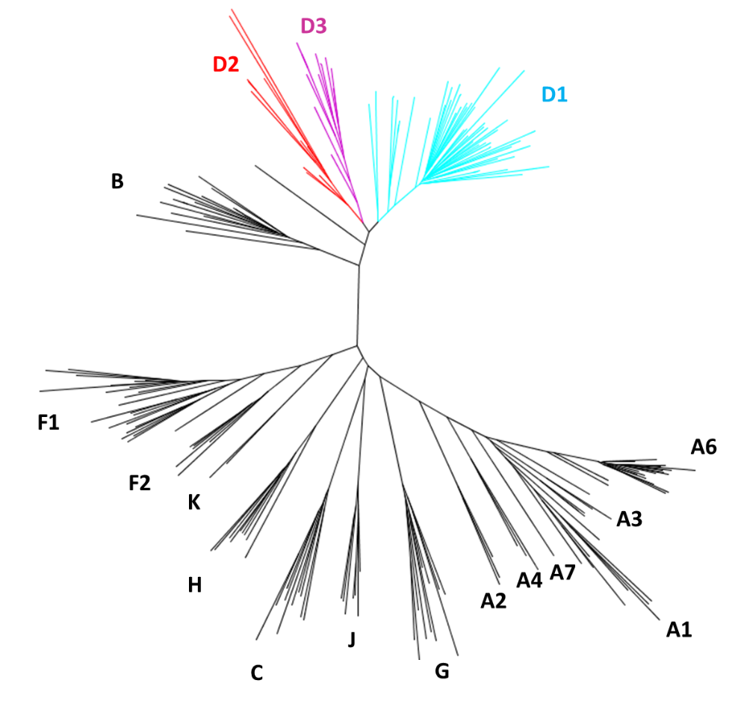
B.

Fig. S7. Pol gene genetic distance comparisons between HIV-1 subtype A sub-subtypes according to our classification proposal. X-axis scale lines indicate genetic distance thresholds allowing, in our alignment and model conditions, for group, subtype and sub-subtype identification.

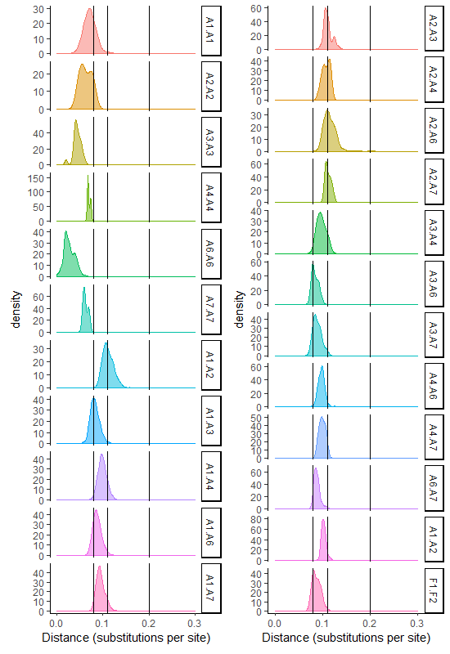
Fig. S8. Pol gene genetic distance comparisons between HIV-1 subtype D sub-subtypes according to our classification proposal. X-axis scale lines indicate genetic distance thresholds allowing, in our alignment and model conditions, for group, subtype and sub-subtype identification.

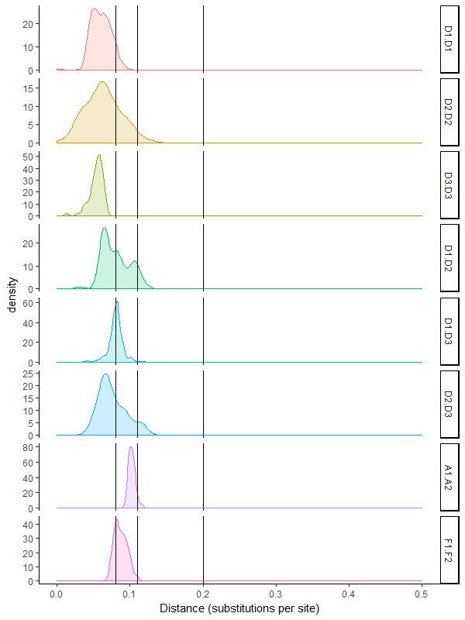

Table S1. Full genome sequence used for our analysis and the corresponding clade in our classification proposal.

Subtype A

Accession number | Clade | Country | Years
AB098332 | A1 | UG | 1992
AB098333 | A1 | UG | 1992
AB253421 | A1 | RW | 1992
AB287377 | A1 | RW | 1992
AB287378 | A1 | RW | 1993
AB485632 | A1 | UG | -
AF004885 | A1 | KE | 1994
AF069669 | A1 | SE | 1995
AF069670 | A1 | SE | 1994
AF069671 | A1 | SE | 1994
AF069673 | A1 | SE | 1995
AF107771 | A1 | SE | 1995
AF361872 | A1 | TZ | 1997
AF361873 | A1 | TZ | 1997
AF457052 | A1 | KE | 2000
AF457053 | A1 | KE | 2000
AF457055 | A1 | KE | 2000
AF457063 | A1 | KE | 1999
AF457065 | A1 | KE | 1999
AF457066 | A1 | KE | 2000
AF457067 | A1 | KE | 2000
AF457068 | A1 | KE | 2000
AF457069 | A1 | KE | 2000
AF457070 | A1 | KE | 2000
AF457075 | A1 | KE | 1999
AF457077 | A1 | KE | 2000
AF457079 | A1 | KE | 2000
AF457080 | A1 | KE | 2000
AF457081 | A1 | KE | 2000
AF457083 | A1 | KE | 2000
AF457084 | A1 | KE | 2000
AF457086 | A1 | KE | 2000
AF457089 | A1 | KE | 2000
AF484478 | A1 | UG | 1999
AF484493 | A1 | UG | 1999
AF484507 | A1 | UG | 1998
AF484508 | A1 | UG | 1998
AF484509 | A1 | UG | 1998
AF484512 | A1 | UG | 1998
AF539405 | A1 | KE | 1986
AY253305 | A1 | TZ | 2001
AY253314 | A1 | TZ | 2001
AY322184 | A1 | KE | 1986
AY322185 | A1 | KE | 1997
AY322190 | A1 | KE | 1997
AY322193 | A1 | KE | 1997
AY713406 | A1 | RW | 1993
AY713407 | A1 | UG | 1992
DQ676873 | A1 | AU | 2004
EU110085 | A1 | KE | 2001
EU110087 | A1 | KE | 2001
EU110088 | A1 | KE | 2001
EU110092 | A1 | KE | 2002
EU110094 | A1 | KE | 2002
FJ388893 | A1 | CY | 2005
FJ388894 | A1 | CY | 2005
FJ388903 | A1 | CY | 2005
FJ388909 | A1 | CY | 2005
FJ388925 | A1 | CY | 2005
FJ388932 | A1 | CY | 2005
FJ388938 | A1 | CY | 2005
FJ388942 | A1 | CY | 2005
FJ623475 | A1 | KE | 2006
FJ623476 | A1 | KE | 2006
FJ623477 | A1 | KE | 2006
FJ623478 | A1 | KE | 2006
FJ623479 | A1 | KE | 2006
FJ623480 | A1 | KE | 2006
FJ623481 | A1 | KE | 2006
FJ623482 | A1 | KE | 2006
FJ623483 | A1 | KE | 2006
FJ623485 | A1 | KE | 2006
FJ623486 | A1 | KE | 2006
FJ623487 | A1 | KE | 2006
FJ623488 | A1 | KE | 2006
FJ670519 | A1 | ES | 2005
JF683748 | A1 | CY | 2007
JF683759 | A1 | CY | 2007
JF683760 | A1 | CY | 2007
JF683761 | A1 | CY | 2007
JF683767 | A1 | CY | 2008
JF683779 | A1 | CY | 2008
JF683782 | A1 | CY | 2008
JF683783 | A1 | CY | 2008
JX140650 | A1 | ES | 2005
JX140651 | A1 | ES | 2006
JX236669 | A1 | UG | 2007
JX236671 | A1 | UG | 2007
JX236676 | A1 | UG | 2007
KF716472 | A1 | RW | 2011
KF716474 | A1 | KE | 2011
KF716475 | A1 | KE | 2011
KF716478 | A1 | UG | 2009
KF716486 | A1 | UG | 2011
KF716499 | A1 | RW | 2003
KF859745 | A1 | UG | 2011
KP109490 | A1 | UG | 2009
KP109528 | A1 | RW | 2007
KP718918 | A1 | CM | 2007
KP718928 | A1 | CM | 2008
KT022360 | A1 | KE | 2004
KT022361 | A1 | KE | 2004
KT022363 | A1 | KE | 2004
KT022364 | A1 | KE | 2004
KT022365 | A1 | KE | 2004
KT022367 | A1 | KE | 2004
KT022368 | A1 | KE | 2004
KT022369 | A1 | KE | 2004
KT022370 | A1 | KE | 2005
KT022372 | A1 | KE | 2005
KT022373 | A1 | KE | 2005
KT022374 | A1 | KE | 2005
KT022375 | A1 | KE | 2005
KT022376 | A1 | KE | 2005
KT022377 | A1 | KE | 2005
KT022378 | A1 | KE | 2006
KT022380 | A1 | KE | 2006
KT022381 | A1 | KE | 2006
KT022382 | A1 | KE | 2006
KT022383 | A1 | KE | 2006
KT022384 | A1 | KE | 2006
KT152839 | A1 | IN | 2009
KT152840 | A1 | IN | 1997
KT152841 | A1 | IN | 1999
KT152842 | A1 | IN | 1999
KT152843 | A1 | IN | 1999
KT152846 | A1 | IN | 2000
KT183312 | A1 | ZA | 2004
KU168305 | A1 | CM | 2003
KX228810 | A1 | UG | 2010
KX228815 | A1 | TZ | 2005
U51190 | A1 | UG | 1992
AF286237 | A2 | CY | 1994
AF286238 | A2 | CD | 1997
GU201516 | A2 | CM | 2001
AY521629 | A3 | SN | 2001
AY521630 | A3 | SN | 1996
AY521631 | A3 | SN | 2001
DQ396400 | A3 | ZA | 2004
JQ403028 | A3 | CH | 2003
KJ948658 | A3 | ZA | 2000
KU168256 | A3 | CD | 2002
M62320 | A3 | UG | 1985
AM000053 | A4 | CD | 1997
AM000054 | A4 | CD | 1997
AM000055 | A4 | CD | 2002
AF193275 | A6 | BY | 1997
AF413987 | A6 | UA | 2000
AY500393 | A6 | RU | 2003
AY829203 | A6 | UZ | 2002
AY829205 | A6 | UZ | 2002
AY829206 | A6 | UZ | 2002
AY829208 | A6 | UZ | 2002
AY829209 | A6 | UZ | 2002
AY829210 | A6 | UZ | 2002
AY829212 | A6 | UZ | 2002
DQ207944 | A6 | GE | 1999
DQ823356 | A6 | UA | 2001
DQ823357 | A6 | UA | 2001
DQ823358 | A6 | UA | 2001
DQ823359 | A6 | UA | 2001
DQ823360 | A6 | UA | 2001
DQ823361 | A6 | UA | 2001
DQ823365 | A6 | UA | 2001
DQ823366 | A6 | UA | 2001
DQ823367 | A6 | UA | 2001
EF545108 | A6 | RU | 2000
EF589039 | A6 | KZ | 2002
EF589040 | A6 | KZ | 2002
EF589041 | A6 | KZ | 2002
EF589042 | A6 | KZ | 2002
EF589043 | A6 | KZ | 2002
EF589044 | A6 | KZ | 2002
EU861977 | A6 | IT | 2002
FJ388892 | A6 | CY | 2005
FJ388906 | A6 | CY | 2005
FJ388950 | A6 | CY | 2006
FJ388951 | A6 | CY | 2006
FJ864679 | A6 | RU | 2008
JF683763 | A6 | CY | 2007
JF683780 | A6 | CY | 2008
JF683798 | A6 | CY | 2009
JQ292891 | A6 | RU | 2007
JQ292892 | A6 | RU | 2002
JQ292893 | A6 | RU | 2008
JQ292894 | A6 | RU | 2008
JQ292895 | A6 | RU | 2005
JQ292896 | A6 | RU | 2006
JQ292897 | A6 | RU | 2006
JQ292898 | A6 | RU | 2006
JQ292899 | A6 | RU | 2006
JQ292900 | A6 | RU | 2006
JX500694 | A6 | RU | 2011
JX500695 | A6 | RU | 2010
JX500696 | A6 | RU | 2010
KF716491 | A6 | RU | 2008
KF716492 | A6 | RU | 2008
KT983615 | A6 | BY | 2013
KX389608 | A7 | NG | 2010
KX389622 | A7 | NG | 2009

Subtype B

Accession number | Clade | Country | Year
X01762 | B | FR | 1983
U71182 | B | CN | -
U69593 | B | US | 1990
U69591 | B | US | 1990
U69590 | B | US | 1990
U69589 | B | US | 1990
U69588 | B | US | 1985
U69586 | B | US | 1985
U69585 | B | US | 1985
U69584 | B | US | 1985
U63632 | B | US | 1986
U43141 | B | DE | 1986
U43096 | B | DE | 1986
U39362 | B | US | 1989
U34604 | B | NL | 1986
U34603 | B | NL | 1986
U26942 | B | FR | 1985
U26546 | B | US | 1988
U23487 | B | GB | -
U21135 | B | US | 1990
AF049495 | B | US | -
AY779557 | B | CA | 1998
AY779559 | B | CA | 1992
AY779560 | B | CA | 1994
AY779561 | B | CA | 1992
AY779562 | B | CA | 1993
AY779563 | B | CA | 1996
FJ469752 | B | US | -
M17449 | B | US | 1984
NC_001802 | B | FR | 1983
U23487 | B | GB | -
M93259 | B | US | 1986
M93258 | B | US | 1986
M38429 | B | US | 1986
M26727 | B | GA | 1988
M17451 | B | US | 1983
M17449 | B | US | 1984
M15654 | B | FR | 1983
L31963 | B | FR | 1983
L02317 | B | US | 1987
KJ948660 | B | ZA | 2002
KJ948657 | B | ZA | 2000
KJ849820 | B | BR | 2010
KJ849818 | B | BR | 2010
KJ849817 | B | BR | 2010
KJ849815 | B | BR | 2010
KJ849814 | B | BR | 2010
KJ849812 | B | BR | 2010
KJ849811 | B | BR | 2010
KJ849808 | B | BR | 2010
KJ849807 | B | BR | 2010
KJ849805 | B | BR | 2010
KJ849804 | B | BR | 2010
KJ849803 | B | BR | 2010
KJ849801 | B | BR | 2010
KJ849799 | B | BR | 2010
KJ849796 | B | BR | 2010
KJ849790 | B | BR | 2010
KJ849786 | B | BR | 2010
KJ849785 | B | BR | 2010
KJ849784 | B | BR | 2010
KJ849780 | B | BR | 2010
KJ849767 | B | BR | 2010
KJ769147 | B | TH | 2006
KJ140267 | B | KR | 1992
KJ140266 | B | KR | 1992
KJ140265 | B | KR | 2002
KJ140264 | B | KR | 2002
KJ140263 | B | KR | 2007
KJ140262 | B | KR | 1993
KJ140261 | B | KR | 1992
KJ140260 | B | KR | 2003
KJ140258 | B | KR | 1992
KJ140257 | B | KR | 1992
KJ140256 | B | KR | 1992
KJ140255 | B | KR | 1992
KJ140254 | B | KR | 2002
KJ140253 | B | KR | 1993
KJ140252 | B | KR | 1992
KJ140251 | B | KR | 1992
KJ140250 | B | KR | 1995
KJ140249 | B | KR | 2002
KJ140248 | B | KR | 1992
KJ140247 | B | KR | 1992
KJ019215 | B | GB | 1994
KF716494 | B | FR | 2009
KF561443 | B | KR | 1993
KF561442 | B | KR | 1991
KF561441 | B | KR | 2012
KF561440 | B | KR | 2012
KF526318 | B | US | 2011
KF526312 | B | US | 2011
KF526298 | B | US | 2011
KF526287 | B | US | 2011
KF526280 | B | US | 2011
KF526279 | B | US | 2011
KF526276 | B | US | 2011
KF526270 | B | US | 2011
KF526265 | B | US | 2011
KF526236 | B | US | 2011
KF526231 | B | US | 2011
KF526204 | B | US | 2011
KF526203 | B | US | 2011
KF526202 | B | US | 2011
KF526201 | B | US | 2011
KF526192 | B | US | 2011
KF526179 | B | US | 2011
KF526176 | B | US | 2011
KF526174 | B | US | 2011
KF526120 | B | US | 2010
KF384814 | B | US | 2011
KF384813 | B | US | 2011
KF384811 | B | US | 2011
KF384810 | B | US | 2011
KF384809 | B | US | 2011
KF384808 | B | US | 2011
KF384807 | B | US | 2011
KF384806 | B | US | 2011
KF384805 | B | US | 2011
KF384804 | B | US | 2011
KF384803 | B | US | 2011
KF384802 | B | US | 2011
KF384801 | B | US | 2011
KF384800 | B | US | 2011
KF384799 | B | US | 2011
KF384798 | B | US | 2011
KC935959 | B | US | 2009
KC935958 | B | US | 2009
KC899011 | B | CN | 2009
KC797229 | B | CH | 2008
KC797225 | B | CH | 2008
KC797224 | B | CH | 2008
KC797223 | B | CH | 2008
KC797178 | B | CH | 2000
KC797177 | B | CH | 2000
KC797175 | B | CH | 2000
KC797174 | B | CH | 2000
KC797171 | B | CH | 2000
KC596069 | B | PL | -
KC596067 | B | DE | -
KC596066 | B | CN | 2009
KC473846 | B | US | 2003
KC473843 | B | ES | 2010
KC473842 | B | ES | 2010
KC473841 | B | ES | 2009
KC473835 | B | US | 2011
KC473834 | B | US | 2011
KC473833 | B | US | 2011
KC473832 | B | US | 2011
KC473831 | B | US | 2011
KC473830 | B | US | 2010
KC473829 | B | US | 2010
KC473828 | B | US | 2010
KC473827 | B | US | 2010
KC473826 | B | US | 2010
KC473825 | B | US | 2010
KC473824 | B | US | 2009
K03455 | B | FR | 1983
K02083 | B | FR | 1983
K02013 | B | FR | 1983
K02007 | B | US | 1983
JX974235 | B | US | 2008
JX960599 | B | CN | 2009
JX960598 | B | CN | 2009
JX960597 | B | CN | 2009
JX863924 | B | US | 2009
JX863923 | B | US | 2009
JX863922 | B | US | 2007
JX863921 | B | US | 2007
JX863919 | B | US | 2005
JX503073 | B | FR | 1985
JX500709 | B | RU | 2009
JX500708 | B | RU | 2011
JX500707 | B | RU | 2010
JX447165 | B | TH | 2007
JX447161 | B | TH | 2007
JX447158 | B | TH | 2007
JX447157 | B | TH | 2007
JX446805 | B | TH | 2006
JX446801 | B | TH | 2006
JX446797 | B | TH | 2006
JX446795 | B | TH | 2006
JX140659 | B | ES | 2010
JX140658 | B | CN | 2010
JX140657 | B | US | 2009
JX140656 | B | ES | 2009
JX140655 | B | ES | 2008
JX140654 | B | FR | 2008
JX140653 | B | ES | 2008
JX140652 | B | FR | 2005
JQ416162 | B | DE | 2005
JQ416161 | B | DE | 2004
JQ416159 | B | DE | 2004
JQ403107 | B | US | 2004
JQ403105 | B | US | 2002
JQ403060 | B | US | 2007
JQ403059 | B | US | 2007
JQ403056 | B | US | 2007
JQ403055 | B | DE | 2008
JQ403049 | B | DE | 2005
JQ403048 | B | DE | 2003
JQ403045 | B | CH | 2003
JQ403042 | B | CH | 2004
JQ403040 | B | FR | 1985
JQ403039 | B | DE | 2004
JQ403038 | B | DE | 2004
JQ403037 | B | DE | 2004
JQ403036 | B | US | 2008
JQ403035 | B | US | 2008
JQ403033 | B | US | 2008
JQ403029 | B | CH | 2002
JQ403026 | B | CH | 2001
JQ403025 | B | CH | 2001
JQ403024 | B | CH | 2001
JQ403023 | B | CH | 2000
JQ403022 | B | CH | 2000
JQ403021 | B | CH | 2002
JQ403019 | B | CH | 2002
JQ341411 | B | KR | 2007
JQ316135 | B | KR | 2003
JQ316134 | B | KR | 2005
JQ316133 | B | KR | 2004
JQ316132 | B | KR | 2003
JQ316131 | B | KR | 2003
JQ316130 | B | KR | 2004
JQ316129 | B | KR | 1999
JQ316128 | B | KR | 2003
JQ316127 | B | KR | 2003
JQ316126 | B | KR | 2004
JN944946 | B | US | 2000
JN944942 | B | US | 2006
JN944941 | B | US | 2006
JN944940 | B | US | 2006
JN944939 | B | US | 2006
JN944938 | B | US | 2000
JN944936 | B | US | 2001
JN944930 | B | US | 2000
JN944928 | B | US | 1991
JN944918 | B | US | 2000
JN944912 | B | US | 2001
JN944909 | B | US | 2006
JN944907 | B | US | 2006
JN944905 | B | US | 2006
JN944897 | B | US | 2006
JN860769 | B | TH | 2008
JN692480 | B | BR | 2006
JN692479 | B | BR | 2006
JN692476 | B | BR | 2005
JN692475 | B | BR | 2005
JN692474 | B | BR | 2005
JN692473 | B | BR | 2005
JN692472 | B | BR | 2005
JN692471 | B | BR | 2005
JN692470 | B | BR | 2002
JN692468 | B | BR | 2005
JN692467 | B | BR | 2005
JN692466 | B | BR | 2005
JN692465 | B | BR | 2005
JN692464 | B | BR | 2005
JN692463 | B | BR | 2005
JN692462 | B | BR | 2005
JN692461 | B | BR | 2005
JN692460 | B | BR | 2005
JN692458 | B | BR | 2004
JN692457 | B | BR | 2004
JN692455 | B | BR | 2004
JN692453 | B | BR | 2004
JN692452 | B | BR | 2004
JN692451 | B | BR | 2004
JN692450 | B | BR | 2004
JN692447 | B | BR | 2003
JN692446 | B | BR | 2003
JN692445 | B | BR | 2003
JN692444 | B | BR | 2002
JN692443 | B | BR | 2002
JN692439 | B | BR | 2002
JN692436 | B | BR | 2002
JN692435 | B | BR | 2002
JN692433 | B | BR | 2002
JN692432 | B | BR | 2002
JN692431 | B | BR | 2002
JN397365 | B | US | 2010
JN397364 | B | US | 2010
JN397363 | B | US | 2011
JN397362 | B | US | 2011
JN251906 | B | PY | 2003
JN251901 | B | PY | 2002
JN251896 | B | PY | 2002
JN248354 | B | TH | 2005
JN248353 | B | TH | 2005
JN248348 | B | TH | 2005
JN248347 | B | TH | 2005
JN248346 | B | TH | 2005
JN248345 | B | TH | 2005
JN248344 | B | TH | 2005
JN248343 | B | TH | 2005
JN248337 | B | TH | 2004
JN248335 | B | TH | 2004
JN248333 | B | TH | 2004
JN248329 | B | TH | 2004
JN248321 | B | TH | 2004
JN235965 | B | UY | 1999
JN235959 | B | UY | 1999
JN235958 | B | UY | 2002
JN024572 | B | US | 2005
JN024571 | B | US | 2005
JN024559 | B | US | 2005
JN024557 | B | US | 2005
JN024554 | B | US | 2005
JN024544 | B | US | 2005
JN024538 | B | US | 2005
JN024535 | B | US | 2005
JN024534 | B | US | 2005
JN024532 | B | US | 2005
JN024528 | B | US | 2005
JN024542 | B | US | 2005
JN024525 | B | US | 2005
JN024522 | B | US | 2005
JN024512 | B | US | 2004
JN024509 | B | US | 2005
JN024506 | B | US | 2005
JN024502 | B | US | 1996
JN024500 | B | US | 1996
JN024499 | B | US | 1996
JN024497 | B | US | 2004
JN024495 | B | US | 2005
JN024491 | B | US | 2005
JN024468 | B | US | 2005
JN024458 | B | US | 2005
JN024457 | B | US | 2005
JN024455 | B | US | 2005
JN024454 | B | US | 2005
JN024452 | B | US | 2005
JN024445 | B | US | 2005
JN024435 | B | US | 1996
JN024432 | B | US | 1996
JN024430 | B | US | 1996
JN024428 | B | US | 1996
JN024426 | B | US | 1996
JN024424 | B | US | 1996
JN024422 | B | US | 1996
JN024420 | B | US | 2005
JN024412 | B | US | 2005
JN024399 | B | US | 2005
JN024376 | B | US | 2005
JN024366 | B | US | 2005
JN024350 | B | US | 2005
JN024345 | B | US | 2005
JN024331 | B | US | 1996
JN024329 | B | US | 1995
JN024315 | B | US | 1995
JN024306 | B | US | 1995
JN024301 | B | US | 1995
JN024275 | B | US | 1995
JN024290 | B | US | 1995
JN024274 | B | US | 1995
JN024254 | B | US | 2004
JN024236 | B | US | 2004
JN024222 | B | US | 2004
JN024204 | B | US | 2004
JN024200 | B | US | 2005
JN024196 | B | US | 2005
JN024193 | B | US | 2005
JN024191 | B | US | 2005
JN024189 | B | US | 2005
JN024186 | B | US | 2005
JN024181 | B | US | 2005
JN024179 | B | US | 2005
JN024176 | B | US | 2005
JN024166 | B | US | 2005
JN024165 | B | US | 2005
JN024164 | B | US | 2005
JN024163 | B | US | 2005
JN024161 | B | US | 2005
JN024160 | B | US | 2005
JN024158 | B | US | 2005
JN024157 | B | US | 2005
JN024156 | B | US | 2005
JN024146 | B | US | 2005
JN024145 | B | US | 2005
JN024144 | B | US | 2005
JN024143 | B | US | 2005
JN024142 | B | US | 2005
JN024141 | B | US | 2005
JN024140 | B | US | 2005
JN024139 | B | US | 2005
JN024138 | B | US | 2005
JN024137 | B | US | 2005
JN024136 | B | US | 2005
JN024123 | B | US | 2005
JN024101 | B | US | 2004
JF932500 | B | CN | 2007
JF932499 | B | CN | 2007
JF932498 | B | CN | 2008
JF932497 | B | CN | 2009
JF932496 | B | CN | 1998
JF932495 | B | CN | 1998
JF932494 | B | CN | 2009
JF932493 | B | CN | 2007
JF932492 | B | CN | 2003
JF932491 | B | CN | 2007
JF932490 | B | CN | 2007
JF932489 | B | CN | 2007
JF932488 | B | CN | 2007
JF932487 | B | CN | 2007
JF932486 | B | CN | 2007
JF932485 | B | CN | 2007
JF932484 | B | CN | 2007
JF932483 | B | CN | 2007
JF932482 | B | CN | 2006
JF932481 | B | CN | 2008
JF932480 | B | CN | 2008
JF932479 | B | CN | 2008
JF932478 | B | CN | 2008
JF932477 | B | CN | 2007
JF932476 | B | CN | 2007
JF932475 | B | CN | 2007
JF932474 | B | CN | 2007
JF932473 | B | CN | 2007
JF932472 | B | CN | 2007
JF932471 | B | CN | 2007
JF932470 | B | CN | 2007
JF932469 | B | CN | 2007
JF932468 | B | CN | 2007
JF689897 | B | US | 2008
JF689896 | B | US | 2008
JF689895 | B | US | 2008
JF689894 | B | US | 2008
JF689892 | B | US | 2007
JF689890 | B | US | 2007
JF689889 | B | US | 2007
JF689887 | B | US | 2007
JF689886 | B | US | 2007
JF689885 | B | US | 2007
JF689884 | B | US | 2007
JF689883 | B | US | 2007
JF689879 | B | US | 2007
JF689877 | B | US | 2007
JF689876 | B | US | 2006
JF689875 | B | US | 2006
JF689874 | B | US | 2006
JF689873 | B | US | 2006
JF689872 | B | US | 2006
JF689871 | B | US | 2006
JF689870 | B | US | 2006
JF689868 | B | US | 2006
JF689867 | B | US | 2006
JF689866 | B | US | 2006
JF689865 | B | US | 2006
JF689864 | B | US | 2006
JF689863 | B | US | 2006
JF689862 | B | US | 2006
JF689860 | B | US | 2005
JF689859 | B | US | 2005
JF689857 | B | US | 2005
JF689856 | B | US | 2005
JF689854 | B | US | 2005
JF689852 | B | US | 2005
JF683809 | B | CY | 2009
JF683808 | B | CY | 2009
JF683807 | B | CY | 2009
JF683805 | B | CY | 2009
JF683804 | B | CY | 2009
JF683801 | B | CY | 2009
JF683797 | B | CY | 2009
JF683796 | B | CY | 2009
JF683794 | B | CY | 2009
JF683793 | B | CY | 2009
JF683791 | B | CY | 2009
JF683790 | B | CY | 2009
JF683788 | B | CY | 2009
JF683787 | B | CY | 2009
JF683785 | B | CY | 2008
JF683784 | B | CY | 2008
JF683781 | B | CY | 2008
JF683778 | B | CY | 2008
JF683775 | B | CY | 2008
JF683773 | B | CY | 2008
JF683769 | B | CY | 2008
JF683765 | B | CY | 2007
JF683764 | B | CY | 2007
JF683756 | B | CY | 2007
JF683754 | B | CY | 2007
JF683753 | B | CY | 2007
JF683751 | B | CY | 2007
JF683749 | B | CY | 2007
JF683747 | B | CY | 2007
JF683746 | B | CY | 2007
JF683743 | B | CY | 2007
JF683742 | B | CY | 2007
JF683741 | B | CY | 2007
JF683738 | B | CY | 2007
JF320629 | B | US | 2006
JF320628 | B | US | 2006
JF320627 | B | US | 2006
JF320626 | B | US | 2006
JF320624 | B | US | 2006
JF320622 | B | US | 2006
JF320621 | B | US | 2006
JF320620 | B | US | 2006
JF320619 | B | US | 2006
JF320617 | B | US | 2006
JF320616 | B | US | 2006
JF320615 | B | US | 2006
JF320613 | B | US | 2006
JF320577 | B | US | 2007
JF320564 | B | US | 2006
JF320562 | B | US | 2007
JF320536 | B | US | 2007
JF320535 | B | US | 2007
JF320534 | B | US | 2007
JF320533 | B | US | 2007
JF320532 | B | US | 2007
JF320531 | B | US | 2007
JF320530 | B | US | 2007
JF320529 | B | US | 2006
JF320526 | B | US | 2006
JF320519 | B | US | 2006
JF320518 | B | US | 2006
JF320516 | B | US | 2006
JF320515 | B | US | 2006
JF320492 | B | US | 2005
JF320491 | B | US | 2005
JF320490 | B | US | 2005
JF320489 | B | US | 2005
JF320488 | B | US | 2005
JF320487 | B | US | 2005
JF320486 | B | US | 2005
JF320485 | B | US | 2005
JF320484 | B | US | 2005
JF320483 | B | US | 2005
JF320482 | B | US | 2005
JF320478 | B | US | 2005
JF320477 | B | US | 2005
JF320470 | B | US | 2007
JF320469 | B | US | 2007
JF320468 | B | US | 2007
JF320467 | B | US | 2007
JF320466 | B | US | 2007
JF320465 | B | US | 2007
JF320464 | B | US | 2007
JF320463 | B | US | 2007
JF320462 | B | US | 2007
JF320461 | B | US | 2007
JF320429 | B | CA | 2006
JF320422 | B | CA | 2007
JF320411 | B | CA | 2006
JF320374 | B | US | 2006
JF320366 | B | US | 2006
JF320365 | B | US | 2006
JF320364 | B | US | 2006
JF320363 | B | US | 2006
JF320361 | B | US | 2005
JF320356 | B | US | 2006
JF320271 | B | US | 2006
JF320269 | B | US | 2006
JF320268 | B | US | 2006
JF320267 | B | US | 2006
JF320263 | B | US | 2006
JF320257 | B | US | 2006
JF320247 | B | US | 2006
JF320244 | B | PE | 2006
JF320242 | B | PE | 2006
JF320241 | B | PE | 2006
JF320225 | B | PE | 2007
JF320223 | B | PE | 2006
JF320220 | B | PE | 2007
JF320219 | B | PE | 2006
JF320218 | B | PE | 2006
JF320215 | B | PE | 2006
JF320214 | B | PE | 2006
JF320209 | B | PE | 2006
JF320207 | B | US | 2007
JF320205 | B | US | 2007
JF320203 | B | PE | 2006
JF320202 | B | US | 2007
JF320201 | B | PE | 2006
JF320199 | B | PE | 2007
JF320198 | B | PE | 2007
JF320197 | B | US | 2007
JF320196 | B | PE | 2006
JF320195 | B | PE | 2007
JF320193 | B | PE | 2006
JF320192 | B | US | 2005
JF320191 | B | PE | 2007
JF320189 | B | PE | 2007
JF320187 | B | PE | 2006
JF320186 | B | PE | 2006
JF320185 | B | US | 2005
JF320183 | B | PE | 2006
JF320182 | B | US | 2007
JF320181 | B | US | 2007
JF320179 | B | US | 2007
JF320171 | B | US | 2006
JF320169 | B | US | 2006
JF320160 | B | US | 2006
JF320158 | B | US | 2007
JF320157 | B | US | 2007
JF320156 | B | US | 2007
JF320155 | B | US | 2007
JF320154 | B | US | 2006
JF320153 | B | US | 2006
JF320152 | B | US | 2006
JF320151 | B | US | 2006
JF320150 | B | US | 2007
JF320149 | B | US | 2006
JF320148 | B | US | 2006
JF320147 | B | US | 2006
JF320146 | B | US | 2006
JF320145 | B | US | 2006
JF320144 | B | US | 2006
JF320120 | B | US | 2006
JF320097 | B | US | 2006
JF320082 | B | US | 2006
JF320081 | B | US | 2006
JF320071 | B | US | 2006
JF320070 | B | US | 2007
JF320069 | B | US | 2007
JF320068 | B | US | 2006
JF320066 | B | US | 2005
JF320065 | B | US | 2006
JF320064 | B | US | 2006
JF320062 | B | US | 2006
JF320061 | B | US | 2005
JF320060 | B | US | 2006
JF320059 | B | US | 2005
JF320058 | B | US | 2006
JF320056 | B | US | 2006
JF320055 | B | US | 2006
JF320054 | B | US | 2005
JF320053 | B | US | 2006
JF320052 | B | US | 2007
JF320051 | B | US | 2006
JF320049 | B | US | 2006
JF320048 | B | US | 2006
JF320047 | B | US | 2006
JF320045 | B | US | 2007
JF320044 | B | US | 2006
JF320036 | B | US | 2006
JF320028 | B | PE | 2007
JF320027 | B | PE | 2007
JF320026 | B | PE | 2007
JF320025 | B | PE | 2007
JF320024 | B | PE | 2007
JF320023 | B | PE | 2007
JF320022 | B | PE | 2007
JF320021 | B | PE | 2007
JF320020 | B | PE | 2007
JF320019 | B | PE | 2007
JF320018 | B | PE | 2007
JF320017 | B | PE | 2007
JF320012 | B | PE | 2007
JF320008 | B | PE | 2006
JF320003 | B | US | 2006
HQ215556 | B | CN | 2009
HQ215554 | B | CN | 2008
HM586212 | B | GB | 2005
HM586204 | B | GB | 2005
HM586202 | B | GB | 2005
HM586200 | B | GB | 2004
HM586198 | B | GB | 2004
HM586193 | B | GB | 2004
HM586187 | B | GB | 2003
HM469983 | B | ES | 1989
HM469981 | B | ES | 1989
HM469980 | B | ES | 1989
HM469979 | B | ES | 1989
HM469978 | B | ES | 1989
HM469977 | B | ES | 1989
HM469976 | B | ES | 1989
HM469975 | B | ES | 1989
HM469972 | B | ES | 1989
GU733713 | B | US | 2009
GU647198 | B | CN | 1999
GU647197 | B | CN | 1999
GU647196 | B | CN | 1999
GU362886 | B | ES | 2008
GU362885 | B | ES | 2009
GU362881 | B | ES | 2009
GU177863 | B | CN | 1999
GQ386795 | B | ES | 1989
GQ386794 | B | ES | 1989
GQ386791 | B | ES | 1989
GQ386778 | B | ES | 1989
GQ386775 | B | ES | 1989
GQ372990 | B | ES | 2008
GQ372988 | B | ES | 2008
FJ853622 | B | ES | 2008
FJ853620 | B | ES | 2008
FJ694790 | B | DK | 2007
FJ670531 | B | ES | 2008
FJ670525 | B | ES | 2008
FJ670524 | B | ES | 2008
FJ647145 | B | ZA | 1985
FJ496179 | B | US | 2000
FJ496177 | B | US | 2000
FJ496175 | B | US | 2000
FJ496172 | B | US | 2000
FJ496171 | B | US | 2000
FJ496169 | B | US | 2000
FJ496167 | B | US | 2000
FJ496166 | B | US | 1990
FJ496164 | B | US | 1990
FJ496162 | B | US | 1990
FJ496159 | B | US | 1990
FJ496157 | B | US | 2001
FJ496156 | B | US | 2001
FJ496155 | B | US | 2001
FJ496154 | B | US | 2001
FJ496153 | B | US | 2001
FJ496152 | B | US | 2001
FJ496151 | B | US | 2001
FJ496150 | B | US | 1991
FJ496149 | B | US | 1991
FJ496148 | B | US | 1991
FJ496147 | B | US | 1991
FJ496146 | B | US | 1991
FJ496145 | B | US | 1991
FJ496082 | B | US | 2005
FJ496081 | B | US | 2005
FJ496079 | B | US | 2002
FJ496078 | B | US | 2002
FJ496076 | B | US | 2002
FJ496007 | B | US | 2006
FJ496006 | B | US | 2006
FJ496005 | B | US | 2006
FJ496004 | B | US | 2006
FJ496003 | B | US | 2006
FJ496002 | B | US | 2006
FJ496001 | B | US | 2006
FJ496000 | B | US | 2006
FJ495943 | B | US | 2006
FJ495942 | B | US | 2006
FJ495941 | B | US | 2006
FJ495940 | B | US | 2006
FJ495939 | B | US | 2006
FJ495937 | B | US | 2006
FJ495826 | B | US | 2006
FJ495825 | B | US | 2006
FJ495824 | B | US | 2006
FJ495823 | B | US | 2006
FJ495822 | B | US | 2006
FJ495821 | B | US | 2006
FJ495820 | B | US | 2006
FJ495819 | B | US | 2006
FJ495818 | B | US | 2006
FJ469772 | B | US | 2004
FJ469771 | B | US | -
FJ469770 | B | US | 2003
FJ469769 | B | US | -
FJ469768 | B | US | -
FJ469767 | B | US | -
FJ469766 | B | US | -
FJ469765 | B | US | 2003
FJ469764 | B | US | 2003
FJ469763 | B | US | -
FJ469762 | B | US | 2002
FJ469761 | B | US | -
FJ469760 | B | US | 2002
FJ469759 | B | US | 2003
FJ469758 | B | US | 2002
FJ469757 | B | US | 2002
FJ469756 | B | US | -
FJ469755 | B | US | 2003
FJ469754 | B | US | 2002
FJ469753 | B | US | 2003
FJ469752 | B | US | -
FJ469751 | B | US | 2002
FJ469750 | B | US | -
FJ469749 | B | US | 2002
FJ469748 | B | US | 2002
FJ469747 | B | US | 2005
FJ469746 | B | US | 2005
FJ469745 | B | US | 2004
FJ469744 | B | US | -
FJ469743 | B | US | 2003
FJ469742 | B | US | 2003
FJ469741 | B | US | 2002
FJ469740 | B | US | 2003
FJ469739 | B | US | 2003
FJ469738 | B | US | 2001
FJ469737 | B | US | 2002
FJ469735 | B | US | 2002
FJ469734 | B | US | 2002
FJ469733 | B | US | 2004
FJ469732 | B | US | 2004
FJ469731 | B | US | 2003
FJ469730 | B | US | 2002
FJ469729 | B | US | -
FJ469727 | B | US | -
FJ469726 | B | US | -
FJ469725 | B | US | -
FJ469724 | B | US | 2005
FJ469723 | B | US | 2006
FJ469722 | B | US | 2004
FJ469721 | B | US | 2007
FJ469720 | B | US | -
FJ469719 | B | US | -
FJ469718 | B | US | 2005
FJ469717 | B | US | 2005
FJ469716 | B | US | 2007
FJ469715 | B | US | -
FJ469714 | B | US | 2006
FJ469713 | B | US | 2007
FJ469712 | B | US | -
FJ469711 | B | US | -
FJ469710 | B | US | 2006
FJ469708 | B | US | 2006
FJ469707 | B | US | 2007
FJ469706 | B | US | 2005
FJ469705 | B | US | -
FJ469704 | B | US | -
FJ469703 | B | US | 2005
FJ469702 | B | US | -
FJ469701 | B | US | 2003
FJ469700 | B | US | 2006
FJ469699 | B | US | -
FJ469698 | B | US | 2004
FJ469697 | B | US | 2004
FJ469696 | B | US | 2006
FJ469695 | B | US | 2004
FJ469694 | B | US | -
FJ469692 | B | US | -
FJ469691 | B | US | 2006
FJ469690 | B | US | -
FJ469689 | B | US | 2007
FJ469688 | B | US | 2002
FJ469687 | B | US | 2002
FJ469686 | B | US | 2003
FJ469685 | B | US | -
FJ469684 | B | US | 2004
FJ469683 | B | US | 2005
FJ469682 | B | US | 2005
FJ460501 | B | HK | 2006
FJ460500 | B | HK | 2006
FJ460499 | B | HK | 2006
FJ388964 | B | CY | 2005
FJ388963 | B | CY | 2005
FJ388962 | B | CY | 2005
FJ388960 | B | CY | 2005
FJ388959 | B | CY | 2005
FJ388958 | B | CY | 2005
FJ388957 | B | CY | 2005
FJ388955 | B | CY | 2006
FJ388947 | B | CY | 2006
FJ388940 | B | CY | 2005
FJ388936 | B | CY | 2005
FJ388935 | B | CY | 2005
FJ388934 | B | CY | 2005
FJ388933 | B | CY | 2005
FJ388931 | B | CY | 2005
FJ388930 | B | CY | 2005
FJ388927 | B | CY | 2005
FJ388924 | B | CY | 2005
FJ388920 | B | CY | 2005
FJ388919 | B | CY | 2005
FJ388916 | B | CY | 2005
FJ388915 | B | CY | 2005
FJ388914 | B | CY | 2005
FJ388912 | B | CY | 2005
FJ388911 | B | CY | 2005
FJ388905 | B | CY | 2005
FJ388904 | B | CY | 2005
FJ388899 | B | CY | 2005
FJ388898 | B | CY | 2005
FJ388895 | B | CY | 2005
FJ388890 | B | CY | 2005
FJ195091 | B | BR | 2005
FJ195090 | B | BR | 2004
FJ195089 | B | BR | 2005
FJ195088 | B | BR | 2005
FJ195086 | B | BR | 2004
FB707281 | B | FR | 1983
EU839610 | B | TT | 2001
EU839609 | B | TT | 2000
EU839608 | B | TT | 2001
EU839607 | B | TT | 2000
EU839606 | B | TT | 2000
EU839605 | B | JM | 2005
EU839604 | B | HT | 2005
EU839603 | B | HT | 2005
EU839602 | B | HT | 2005
EU839601 | B | HT | 2005
EU839600 | B | HT | 2005
EU839598 | B | DO | 2005
EU839597 | B | DO | 2005
EU839596 | B | DO | 2005
EU786680 | B | ES | 2007
EU786679 | B | ES | 2007
EU786678 | B | ES | 2007
EU786675 | B | ES | 2006
EU786674 | B | ES | 2006
EU786672 | B | ES | 2005
EU547186 | B | US | 2004
EF637057 | B | BR | 2003
EF637056 | B | BR | 2003
EF637054 | B | BR | 2003
EF637053 | B | BR | 2003
EF637051 | B | BR | 2003
EF637050 | B | BR | 2003
EF637049 | B | BR | 2003
EF637048 | B | BR | 2003
EF637047 | B | BR | 2003
EF637046 | B | BR | 2003
EF514712 | B | DK | 2001
EF514711 | B | DK | 2001
EF514710 | B | DK | 2001
EF514709 | B | DK | 2001
EF514708 | B | DK | 2001
EF514707 | B | DK | 2001
EF514706 | B | DK | 2001
EF514705 | B | DK | 2001
EF514704 | B | DK | 2001
EF514703 | B | DK | 2004
EF514702 | B | DK | 2004
EF514701 | B | DK | 2004
EF514700 | B | DK | 2004
EF514699 | B | DK | 2004
EF514698 | B | DK | 2004
EF514697 | B | DK | 2004
EF363127 | B | US | 2004
EF363126 | B | US | 2004
EF363125 | B | US | 2004
EF363124 | B | US | 2004
EF363123 | B | US | 2000
EF178358 | B | AU | 2004
EF178354 | B | AU | 2004
EF175209 | B | US | 1998
EF057102 | B | CN | 2001
DQ990880 | B | CN | 2005
DQ886037 | B | US | 2005
DQ854716 | B | ES | 1989
DQ854715 | B | ES | 1989
DQ854714 | B | ES | 1989
DQ853463 | B | US | 1998
DQ853461 | B | US | 1998
DQ853460 | B | US | 1998
DQ853459 | B | US | 1998
DQ853455 | B | US | 1998
DQ853454 | B | US | 2000
DQ853453 | B | US | 2000
DQ853452 | B | US | 2000
DQ853451 | B | US | 2000
DQ853450 | B | US | 2000
DQ853449 | B | US | 2000
DQ853448 | B | US | 2002
DQ853447 | B | US | 2002
DQ853446 | B | US | 2002
DQ853445 | B | US | 2002
DQ853444 | B | US | 2002
DQ853443 | B | US | 2002
DQ853442 | B | US | 2002
DQ853441 | B | US | 2002
DQ853440 | B | US | 2002
DQ853439 | B | US | 2002
DQ853438 | B | US | 2000
DQ853437 | B | US | 2000
DQ853436 | B | US | 2000
DQ837381 | B | KR | 2005
DQ823364 | B | UA | 2001
DQ823363 | B | UA | 2001
DQ823362 | B | UA | 2001
DQ676886 | B | AU | 2003
DQ676883 | B | AU | 2002
DQ676880 | B | AU | 2003
DQ676878 | B | AU | 2003
DQ676874 | B | AU | 2002
DQ676871 | B | AU | 2004
DQ672623 | B | IT | 2005
DQ487191 | B | US | 1996
DQ487190 | B | US | 1993
DQ487189 | B | US | 1995
DQ487188 | B | US | 1993
DQ396398 | B | ZA | 2003
DQ383752 | B | AR | 2004
DQ383751 | B | AR | 2004
DQ383750 | B | AR | 2004
DQ383749 | B | AR | 2003
DQ383748 | B | AR | 2003
DQ383746 | B | AR | 2002
DQ358810 | B | BR | 2002
DQ358809 | B | BR | 2002
DQ358808 | B | BR | 2002
DQ358805 | B | BR | 2002
DQ354119 | B | TH | 1996
DQ354118 | B | TH | 1996
DQ354116 | B | TH | 1996
DQ354114 | B | TH | 1996
DQ354112 | B | TH | 1996
DQ295196 | B | KR | 2004
DQ295195 | B | KR | 2004
DQ295194 | B | KR | 2004
DQ295193 | B | KR | 2004
DQ295192 | B | KR | 2004
DQ207943 | B | GE | 1998
DQ207942 | B | GE | 2003
DQ207940 | B | GE | 2003
DQ007903 | B | CN | 2002
DQ007902 | B | CN | 2002
DQ007901 | B | CN | 2002
D86069 | B | FR | 1983
D86068 | B | FR | 1983
D10112 | B | GB | 1983
BD298114 | B | FR | 1983
BD238372 | B | FR | 1985
AY970950 | B | NL | 1996
AY970949 | B | NL | 1996
AY970948 | B | NL | 1996
AY970947 | B | NL | 1986
AY970946 | B | NL | 1986
AY945711 | B | TH | 1999
AY945710 | B | TH | 2000
AY839827 | B | KR | 2004
AY835781 | B | US | 1983
AY835780 | B | US | 1986
AY835779 | B | US | 1984
AY835778 | B | US | 1986
AY835777 | B | US | 1983
AY835776 | B | US | 1993
AY835775 | B | US | 1986
AY835774 | B | US | 1986
AY835773 | B | US | 1994
AY835772 | B | US | 1997
AY835771 | B | US | 1986
AY835770 | B | US | 1983
AY835769 | B | US | 1985
AY835768 | B | US | 1995
AY835767 | B | US | 1993
AY835766 | B | US | 1989
AY835765 | B | US | 1984
AY835763 | B | US | 1988
AY835762 | B | US | 1984
AY835761 | B | US | 1991
AY835760 | B | US | 1987
AY835759 | B | US | 1982
AY835758 | B | US | 1987
AY835756 | B | US | 1986
AY835755 | B | US | 1985
AY835754 | B | US | 1983
AY835753 | B | US | 1996
AY835752 | B | US | 1992
AY835750 | B | US | 1989
AY835749 | B | US | 1986
AY835748 | B | US | 1983
AY819715 | B | RU | 2004
AY818644 | B | AU | 2004
AY795905 | B | YE | 2002
AY795904 | B | YE | 2002
AY781127 | B | UY | 2001
AY781126 | B | UY | 2001
AY779564 | B | CA | 1996
AY779563 | B | CA | 1996
AY779562 | B | CA | 1993
AY779561 | B | CA | 1992
AY779560 | B | CA | 1994
AY779559 | B | CA | 1992
AY779558 | B | CA | 1999
AY779557 | B | CA | 1998
AY779555 | B | CA | 1998
AY779554 | B | CA | 1998
AY779553 | B | CA | 1997
AY779552 | B | CA | 2000
AY779551 | B | CA | 1999
AY779550 | B | CA | 1998
AY751407 | B | RU | 2004
AY751406 | B | RU | 2004
AY713412 | B | US | 1990
AY713411 | B | FR | 1992
AY713410 | B | US | 1994
AY713409 | B | US | 1985
AY713408 | B | TH | 1996
AY682547 | B | RU | 2004
AY586543 | B | CU | 1999
AY586542 | B | CU | 1999
AY561240 | B | CO | 2001
AY561238 | B | CO | 2001
AY561237 | B | CO | 2001
AY561236 | B | CO | 2001
AY560110 | B | US | 1998
AY560109 | B | US | 1998
AY560108 | B | US | 1998
AY560107 | B | US | 1998
AY423387 | B | NL | 2000
AY423386 | B | NL | 2000
AY423385 | B | NL | 2000
AY423384 | B | NL | 2000
AY423383 | B | NL | 2000
AY423382 | B | NL | 2000
AY423381 | B | NL | 1999
AY352275 | B | US | 1984
AY332237 | B | US | 1996
AY332236 | B | US | 1997
AY331297 | B | US | 1999
AY331296 | B | US | 1999
AY331295 | B | US | 1998
AY331294 | B | US | 1998
AY331293 | B | US | 1996
AY331292 | B | US | 1996
AY331291 | B | US | 1996
AY331290 | B | US | 1997
AY331289 | B | US | 1997
AY331288 | B | US | 1997
AY331287 | B | US | 1997
AY331286 | B | US | 1997
AY331285 | B | US | 1997
AY331284 | B | US | 1997
AY331283 | B | US | 1997
AY331282 | B | US | 1997
AY314063 | B | CA | 1996
AY314044 | B | CA | 1996
AY308762 | B | US | 1996
AY308761 | B | US | 1996
AY308760 | B | US | 1996
AY180905 | B | CN | 2001
AY173956 | B | BR | 1989
AY173955 | B | US | 1990
AY173954 | B | US | 1990
AY173952 | B | US | 1990
AY173951 | B | TH | 1990
AY037282 | B | AR | 1999
AY037270 | B | BO | 1999
AY037269 | B | AR | 2000
AY037268 | B | AR | 1998
AX078307 | B | FR | 1983
AX032749 | B | FR | 1985
AJ271445 | B | GB | 1986
AJ006287 | B | ES | 1989
AF538307 | B | AU | 1995
AF538306 | B | AU | 1995
AF538305 | B | AU | 1995
AF538304 | B | AU | 1995
AF538303 | B | AU | 1999
AF538302 | B | AU | 1999
AF286365 | B | US | 1988
AF256204 | B | ES | 1989
AF224507 | B | KR | 1997
AF086817 | B | TW | 1994
AF070521 | B | FR | 1985
AF069140 | B | US | 1991
AF042106 | B | AU | 1993
AF042105 | B | AU | 1996
AF042104 | B | AU | 1996
AF042103 | B | AU | 1995
AF042102 | B | AU | 1993
AF042101 | B | AU | 1987
AF042100 | B | AU | 1986
AF004394 | B | US | 1986
AF003887 | B | FR | 1985
AB731670 | B | JP | 2011
AB731668 | B | JP | 2009
AB731667 | B | JP | 2009
AB731664 | B | JP | 2008
AB731663 | B | JP | 2008
AB485642 | B | BR | 1990
AB485641 | B | BR | 1990
AB485639 | B | US | 1991
AB485638 | B | US | 1991
AB480698 | B | JP | 1998
AB480697 | B | JP | 2004
AB480695 | B | JP | 2004
AB480694 | B | JP | 2004
AB480693 | B | JP | 2004
AB480692 | B | JP | 2004
AB428562 | B | JP | 2006
AB428561 | B | JP | 2006
AB428560 | B | JP | 2005
AB428559 | B | JP | 2004
AB428558 | B | JP | 2003
AB428557 | B | JP | 2005
AB428556 | B | JP | 2005
AB428555 | B | JP | 2003
AB428554 | B | JP | 2002
AB428553 | B | JP | 2002
AB428552 | B | JP | 2001
AB428551 | B | JP | 2000
AB289590 | B | JP | 2001
AB289588 | B | JP | 2000
AB289587 | B | JP | 2000
AB287372 | B | JP | 2000
AB287370 | B | JP | 1999
AB287368 | B | JP | 2005
AB287366 | B | JP | 2005
AB287364 | B | JP | 2005
AB287363 | B | JP | 2005
AB286955 | B | JP | 2004
AB253432 | B | US | 1985
AB221125 | B | JP | 2004
AB097870 | B | MM | 1999
AB078005 | B | US | 1997
A07867 | B | FR | 1983
A04321 | B | FR | 1983

Subtype C

Accession number | Clade | Country | years
EU786681 | C | ES | 2008
AY713417 | C | ET | 2002
AB485643 | C | DJ | -
AB485644 | C | DJ | -
AY255823 | C | IL | 1999
KF526218 | C | US | 2011
U46016 | C | ET | 1986
AF286233 | C | IL | 1998
AY255825 | C | IL | 1999
AY255826 | C | IL | 1999
FJ388952 | C | CY | 2006
JF683776 | C | CY | 2008
JF683777 | C | CY | 2008
KC156217 | C | MW | 2008
AY901969 | C | ZA | 2003
JX140663 | C | BR | 2007
AY563170 | C | AR | 2001
AF286228 | C | BR | 1998
U52953 | C | BR | 1992
AY563169 | C | UY | 2001
AY727525 | C | BR | 2004
AY727524 | C | BR | 2004
AY727523 | C | BR | 2004
AY727522 | C | BR | 2004
AY945738 | C | KE | 1991
GQ999983 | C | ZA | 2005
FJ496185 | C | ZM | 2003
AY703910 | C | ZA | 2004
FJ388901 | C | CY | 2005
KC870038 | C | CN | 2010
KC156210 | C | IN | 2009
AB023804 | C | IN | 1993
AY713414 | C | IN | 1994
AY967806 | C | CN | 1998
AB097871 | C | MM | 1999
AF067155 | C | IN | 1995
AF067159 | C | IN | 1994
AF067154 | C | IN | 1993
KC898980 | C | CN | 2006
KF835522 | C | CN | 2007
KF250404 | C | CN | 2009
KC898995 | C | CN | 2009
KC898996 | C | CN | 2009
KF250403 | C | CN | 2009
AF286232 | C | IN | 1998
AF286231 | C | IN | 1998
EF694032 | C | IN | -
EF694033 | C | IN | -
KF835515 | C | CN | 2007
AY049709 | C | IN | 1999
KF766539 | C | IN | 2004
KF766540 | C | IN | 2005
KF766541 | C | IN | 2005
AF110968 | C | BW | 1996
AF443095 | C | BW | 2000
AF110976 | C | BW | 1996
AF110978 | C | BW | 1996
AF110977 | C | BW | 1996
AF457054 | C | KE | 2000
AB485645 | C | ZM | 1989
AY713415 | C | SO | 1989
AY228556 | C | ZA | 1999
AY228557 | C | ZA | 2001
AY253310 | C | TZ | 2001
AF286224 | C | ZM | 1996
AY734550 | C | TZ | 2002
AY043173 | C | ZA | 1998
AY043175 | C | ZA | 1999
AY463234 | C | ZA | 2000
AY463227 | C | ZA | 2000
DQ275645 | C | ZA | 2003
KC156125 | C | ZA | 2007
AY838565 | C | ZA | 2000
AY878055 | C | ZA | 2004
DQ056406 | C | ZA | 2004
GQ999974 | C | ZA | 2005
DQ351216 | C | ZA | 2003
DQ093588 | C | ZA | 2004
AY463222 | C | ZA | 2000
DQ275646 | C | ZA | 2003
DQ396378 | C | ZA | 2003
AY878059 | C | ZA | 2004
DQ396368 | C | ZA | 2003
DQ011170 | C | ZA | 2004
AY772693 | C | ZA | 2003
DQ164110 | C | ZA | 2004
AY463224 | C | ZA | 2000
EU293447 | C | ZA | 1999
AY463226 | C | ZA | 2000
AY463231 | C | ZA | 2000
AY772696 | C | ZA | 2003
DQ351218 | C | ZA | 2002
DQ396394 | C | ZA | 2004
DQ275642 | C | ZA | 2003
DQ275643 | C | ZA | 2003
DQ351219 | C | ZA | 2003
DQ396371 | C | ZA | 2003
AY772690 | C | ZA | 2003
DQ396376 | C | ZA | 2003
AY901968 | C | ZA | 2003
DQ164116 | C | ZA | 2004
DQ275651 | C | ZA | 2003
DQ351221 | C | ZA | 2004
DQ164114 | C | ZA | 2004
AY878071 | C | ZA | 2004
DQ164104 | C | ZA | 2003
DQ164111 | C | ZA | 2004
AF286227 | C | ZA | 1997
AY463219 | C | ZA | 2000
AY901977 | C | ZA | 2004
DQ396370 | C | ZA | 2003
GQ999980 | C | ZA | 2005
AY463218 | C | ZA | 2000
AY463228 | C | ZA | 2000
DQ164113 | C | ZA | 2003
DQ011172 | C | ZA | 2004
AY463221 | C | ZA | 2000
AY878072 | C | ZA | 2004
AY463217 | C | ZA | 2000
GQ999984 | C | ZA | 2005
DQ011174 | C | ZA | 2004
DQ093587 | C | ZA | 2004
DQ369977 | C | ZA | 2003
DQ396383 | C | ZA | 2004
DQ351222 | C | ZA | 2002
DQ351223 | C | ZA | 2003
AY463220 | C | ZA | 2000
AY463223 | C | ZA | 2001
DQ093591 | C | ZA | 2003
DQ369983 | C | ZA | 2005
DQ369984 | C | ZA | 2003
DQ396369 | C | ZA | 2003
AY878058 | C | ZA | 2004
DQ369979 | C | ZA | 2003
DQ056409 | C | ZA | 2004
DQ351227 | C | ZA | 2003
DQ093593 | C | ZA | 2003
DQ275654 | C | ZA | 2003
DQ164112 | C | ZA | 2004
AY463237 | C | ZA | 2001
DQ093596 | C | ZA | 2003
DQ978981 | C | ZA | 2003
AY901978 | C | ZA | 2004
DQ164109 | C | ZA | 2004
DQ396375 | C | ZA | 2003
DQ369978 | C | ZA | 2003
DQ351220 | C | ZA | 2002
DQ369976 | C | ZA | 2003
AY043174 | C | ZA | 1999
DQ351228 | C | ZA | 2003
AY118165 | C | ZA | 1997
AY158534 | C | ZA | 1998
DQ056415 | C | ZA | 2004
DQ396388 | C | ZA | 2003
AF110959 | C | BW | 1996
AF110960 | C | BW | 1996
AF110961 | C | BW | 1996
AY158535 | C | ZA | 1998
AF443084 | C | BW | 1999
AF443099 | C | BW | 2000
DQ164129 | C | ZA | 2004
AY901973 | C | ZA | 2004
DQ093590 | C | ZA | 2004
AY878065 | C | ZA | 2003
DQ445631 | C | ZA | 2004
DQ396364 | C | ZA | 2003
AY901970 | C | ZA | 2003
AY901979 | C | ZA | 2004
DQ396385 | C | ZA | 2003
DQ369989 | C | ZA | 2003
AY901971 | C | ZA | 2003
DQ164106 | C | ZA | 2003
AF110973 | C | BW | 1996
AF110974 | C | BW | 1996
AF110975 | C | BW | 1996
AF443102 | C | BW | 2000
DQ093604 | C | ZA | 2004
AF443109 | C | BW | 2000
DQ396384 | C | ZA | 2003
DQ369987 | C | ZA | 2003
AF443085 | C | BW | 1999
AF443113 | C | BW | 2000
DQ396391 | C | ZA | 2003
DQ011173 | C | ZA | 2004
GQ999985 | C | ZA | 2005
GQ999981 | C | ZA | 2005
DQ093601 | C | ZA | 2003
DQ275658 | C | ZA | 2003
DQ369990 | C | ZA | 2003
DQ396372 | C | ZA | 2005
AY878056 | C | ZA | 2003
DQ396374 | C | ZA | 2003
AF286223 | C | IN | 1994
AY444801 | C | US | 1998
EF514713 | C | DK | 2001
AF286234 | C | TZ | 1998
AF443089 | C | BW | 2000
AY463230 | C | ZA | 2000
DQ351225 | C | ZA | 2003
DQ275659 | C | ZA | 2004
AY878054 | C | ZA | 2004
AY901965 | C | ZA | 2003
DQ396395 | C | ZA | 2003
AY901976 | C | ZA | 2004
JX140668 | C | ZA | 2009
DQ396367 | C | ZA | 2003
DQ275653 | C | ZA | 2003
EU293448 | C | ZA | 1999
DQ369981 | C | ZA | 2003
DQ056412 | C | ZA | 2004
GQ999978 | C | ZA | 2005
DQ011176 | C | ZA | 2003
DQ275657 | C | ZA | 2003
DQ369988 | C | ZA | 2003
GQ999990 | C | ZA | 2005
DQ093592 | C | ZA | 2003
KC156130 | C | ZA | 2007
AY772699 | C | ZA | 2004
AY878057 | C | ZA | 2003
AY901975 | C | ZA | 2003
AY585266 | C | ZA | 2000
DQ351226 | C | ZA | 2003
AY901967 | C | ZA | 2003
DQ445633 | C | ZA | 2003
AY901981 | C | ZA | 2003
AY772692 | C | ZA | 2003
GQ999982 | C | ZA | 2005
DQ369992 | C | ZA | 2005
AY772695 | C | ZA | 2003
DQ351233 | C | ZA | 2003
AY878063 | C | ZA | 2003
DQ396382 | C | ZA | 2004
DQ164115 | C | ZA | 2004
DQ093600 | C | ZA | 2004
AF411966 | C | ZA | 1999
DQ275661 | C | ZA | 2003
DQ056408 | C | ZA | 2003
DQ164105 | C | ZA | 2004
DQ093599 | C | ZA | 2004
DQ011166 | C | ZA | 2004
AY703908 | C | ZA | 2003
DQ011169 | C | ZA | 2003
DQ396396 | C | ZA | 2004
GQ999987 | C | ZA | 2005
AY463225 | C | ZA | 2000
DQ164107 | C | ZA | 2004
AY901980 | C | ZA | 2004
DQ396373 | C | ZA | 2003
GQ999973 | C | ZA | 2004
DQ164108 | C | ZA | 2003
DQ275644 | C | ZA | 2003
DQ396377 | C | ZA | 2003
DQ275652 | C | ZA | 2003
AY878068 | C | ZA | 2003
DQ093594 | C | ZA | 2004
DQ369982 | C | ZA | 2005
AY463229 | C | ZA | 2000
DQ093597 | C | ZA | 2003
AY585265 | C | ZA | 2000
AY838568 | C | ZA | 2000
DQ164117 | C | ZA | 2004
DQ275647 | C | ZA | 2002
DQ275648 | C | ZA | 2002
DQ351231 | C | ZA | 2003
DQ396390 | C | ZA | 2003
AY901966 | C | ZA | 2003
DQ164122 | C | ZA | 2004
DQ445635 | C | ZA | 2003
DQ396381 | C | ZA | 2004
DQ093586 | C | ZA | 2004
DQ011175 | C | ZA | 2003
AF443082 | C | BW | 1998
DQ164118 | C | ZA | 2004
AY118166 | C | ZA | 1997
DQ056413 | C | ZA | 2004
EU293445 | C | ZA | 1999
DQ396397 | C | ZA | 2004
DQ275656 | C | ZA | 2003
DQ369997 | C | ZA | 2004
DQ369986 | C | ZA | 2003
DQ011165 | C | ZA | 2003
DQ056418 | C | ZA | 2004
AY772694 | C | ZA | 2003
GQ999977 | C | ZA | 2005
DQ011179 | C | ZA | 2004
DQ445637 | C | ZA | 2004
GQ999975 | C | ZA | 2004
AY795906 | C | YE | 2002
AY255824 | C | IL | 1999
AY713416 | C | SN | 1990
AY463233 | C | ZA | 2000
AF110969 | C | BW | 1996
AF110970 | C | BW | 1996
AF110971 | C | BW | 1996
AF443074 | C | BW | 1996
AF443077 | C | BW | 1998
AF443103 | C | BW | 2000
JN188292 | C | ZA | 1990
AF443088 | C | BW | 2000
AF443097 | C | BW | 2000
AF443100 | C | BW | 2000
FJ496195 | C | ZM | 2003
AY162225 | C | ZA | 1998
AY703911 | C | ZA | 2004
DQ011171 | C | ZA | 2004
AB254148 | C | ZM | 2002
AF443094 | C | BW | 2000
AF443096 | C | BW | 2000
DQ056416 | C | ZA | 2004
AF443086 | C | BW | 1999
AB254141 | C | ZM | 2002
AB254146 | C | ZM | 2002
AB254147 | C | ZM | 2002
AF286225 | C | ZM | 1996
DQ164127 | C | ZA | 2004
DQ351217 | C | ZA | 2004
AY253308 | C | TZ | 2001
AF286235 | C | TZ | 1998
AF361874 | C | TZ | 1997
AY253320 | C | TZ | 2001
AF443079 | C | BW | 1998
AF443104 | C | BW | 2000
DQ369996 | C | ZA | 2003
AF110962 | C | BW | 1996
AF110964 | C | BW | 1996
AF110966 | C | BW | 1996
AF110965 | C | BW | 1996
AY805330 | C | ZM | -
EU293444 | C | ZA | 1999
DQ093589 | C | ZA | 2003
AY158533 | C | ZA | 1998
AY838567 | C | ZA | 2000
DQ275649 | C | ZA | 2003
DQ396366 | C | ZA | 2004
DQ011177 | C | ZA | 2004
DQ275650 | C | ZA | 2003
AY713413 | C | MW | 1993
DQ351237 | C | ZA | 2003
DQ396380 | C | ZA | 2003
AY253313 | C | TZ | 2001
AY253304 | C | TZ | 2001
AY253312 | C | TZ | 2001
AF443080 | C | BW | 1998
AY162224 | C | ZA | 1998
KC156212 | C | MW | 2007
AY463236 | C | ZA | 2000
AY772700 | C | ZA | 2003
AF411967 | C | ZA | 1999
AY162223 | C | ZA | 1998
AY253321 | C | TZ | 2001
AF110972 | C | BW | 1996
AY463232 | C | ZA | 2000
DQ396365 | C | ZA | 2003
DQ093595 | C | ZA | 2004
DQ275664 | C | ZA | 2003
DQ369985 | C | ZA | 2003
DQ369991 | C | ZA | 2005
GQ999991 | C | ZA | 2005
AF361875 | C | TZ | 1997
AF443112 | C | BW | 2000
AY444800 | C | US | 1998
AF443081 | C | BW | 1998
DQ369993 | C | ZA | 2004
AY253322 | C | TZ | 2001
DQ207941 | C | GE | 2003
AY734556 | C | TZ | 2002
AY043176 | C | ZA | 1998
EU293446 | C | ZA | 1999
DQ351229 | C | ZA | 2003
AY878060 | C | ZA | 2003
AF290027 | C | BW | 1996
AF290028 | C | BW | 1996
AF290029 | C | BW | 1996
AF443093 | C | BW | 2000
AF443110 | C | BW | 2000
GQ999972 | C | ZA | 2005
DQ011167 | C | ZA | 2004
DQ351234 | C | ZA | 2003
JX974246 | C | ZA | 2007
KC156126 | C | ZA | 2007
KC156115 | C | ZA | 2007
AY878062 | C | ZA | 2004
AF443078 | C | BW | 1998
DQ056404 | C | ZA | 2003
AY703909 | C | ZA | 2004
DQ056405 | C | ZA | 2004
DQ396387 | C | ZA | 2004
AF443101 | C | BW | 2000
DQ396386 | C | ZA | 2003
DQ011180 | C | ZA | 2004
EU884500 | C | ES | 2007
JX140662 | C | ES | 2007
KF527172 | C | MW | 2008
KF527173 | C | MW | 2008
DQ445634 | C | ZA | 2003
DQ396393 | C | ZA | 2004
KC156127 | C | ZA | 2007
KC156128 | C | ZA | 2008
AF443107 | C | BW | 2000
AF443076 | C | BW | 1998
AF443090 | C | BW | 2000
DQ445632 | C | ZA | 2003
EU293450 | C | ZA | 1999
KC156215 | C | MW | 2008
AF443098 | C | BW | 2000
DQ093598 | C | ZA | 2004
DQ369994 | C | ZA | 2005
KC156114 | C | MW | 2007
AY878061 | C | ZA | 2003
AY901974 | C | ZA | 2004
DQ396389 | C | ZA | 2003
DQ164119 | C | ZA | 2004
DQ275660 | C | ZA | 2003
DQ396392 | C | ZA | 2003
DQ011178 | C | ZA | 2004
DQ275655 | C | ZA | 2003
AF443111 | C | BW | 2000
EU293449 | C | ZA | 1999
AY838566 | C | ZA | 2000
AF443083 | C | BW | 1999
AF443105 | C | BW | 2000
AF443108 | C | BW | 2000
KF716466 | C | ZM | 2009
AY253317 | C | TZ | 2001
KC156219 | C | MW | 2008
DQ056411 | C | ZA | 2003
AY878070 | C | ZA | 2003
DQ351230 | C | ZA | 2003
JX140666 | C | ZA | 2008
AY878064 | C | ZA | 2003
DQ396399 | C | ZA | 2003
KC156116 | C | ZA | 2008
KC156129 | C | ZA | 2007
GQ999989 | C | ZA | 2005
DQ351224 | C | ZA | 2003
GQ999976 | C | ZA | 2005
KC156120 | C | MW | 2007
KC156119 | C | MW | 2007
DQ093607 | C | ZA | 2003
KC156221 | C | ZA | 2008
AF443092 | C | BW | 2000
KF716467 | C | ZM | 2011
AY253303 | C | TZ | 2001
AB254149 | C | ZM | 2002
EU786673 | C | ES | 2006
FJ670521 | C | ES | 2005
AY734558 | C | TZ | 2002
AB254155 | C | ZM | 2002
AY734560 | C | TZ | 2002
AF443087 | C | BW | 1999
AF110980 | C | BW | 1996
AF443091 | C | BW | 2000
AY772691 | C | ZA | 2003
DQ351235 | C | ZA | 2002
DQ093602 | C | ZA | 2004
DQ093605 | C | ZA | 2004
AF443075 | C | BW | 1996
FJ388913 | C | CY | 2005
JX140669 | C | ZA | 2010
GQ999979 | C | ZA | 2005
AY734551 | C | TZ | 2002
KC156214 | C | MW | 2009
KC156122 | C | MW | 2007
KC156213 | C | MW | 2007
GQ999986 | C | ZA | 2005
AF443114 | C | BW | 2000
DQ164126 | C | ZA | 2004
DQ369995 | C | ZA | 2002
DQ056410 | C | ZA | 2003
AY901972 | C | ZA | 2003
JX140667 | C | ZA | 2009
DQ351232 | C | ZA | 2004
KC156220 | C | TZ | 2008
DQ164121 | C | ZA | 2004
KC156211 | C | MW | 2007
DQ369980 | C | ZA | 2003
AF443115 | C | BW | 2000
FJ496209 | C | ZM | 2003
DQ093585 | C | ZA | 2004
DQ056417 | C | ZA | 2004
EF469243 | C | IN | 2003
KC156218 | C | MW | 2008
AB254142 | C | ZM | 2002
AY734559 | C | TZ | 2002
AY772698 | C | ZA | 2004
JF683770 | C | CY | 2008
AY253307 | C | TZ | 2001
JF683755 | C | CY | 2007

Subtype D

Accession number | Clade | Country | years
AY773339 | D2 | ZA | 1985
AY773340 | D2 | ZA | 1985
DQ054367 | D1 | KR | 2004
AY773341 | D2 | ZA | 1986
JX140670 | D3 | CM | 2010
FJ388945 | D3 | CY | 2006
KJ787684 | D2 | BR | 2010
AY322189 | D1 | KE | 1997
KF716476 | D1 | KE | 2011
KF716480 | D1 | UG | 2011
JX236672 | D1 | UG | 2008
JQ403079 | D1 | US | 2007
KF716479 | D1 | UG | 2010
KF716502 | D1 | UG | 2007
JX236679 | D1 | UG | 2007
AF484519 | D1 | UG | 1999
AF484486 | D | UG | 1999
AF484505 | D1 | UG | 1998
AF484485 | D1 | UG | 1999
AF484498 | D1 | UG | 1999
AF484518 | D1 | UG | 1999
AF484495 | D1 | UG | 1999
AF484502 | D1 | UG | 1998
AF484511 | D1 | UG | 1998
AF484490 | D1 | UG | 1999
AY304496 | D1 | UG | 1999
AF484487 | D1 | UG | 1999
AY795903 | D1 | YE | 2001
AF484477 | D1 | UG | 1999
AF484499 | D1 | UG | 1999
AF457090 | D1 | KE | 2001
JX236668 | D1 | UG | 2005
AF484513 | D1 | UG | 1998
JX236670 | D1 | UG | 2007
AF484489 | D1 | UG | 1999
AF484506 | D1 | UG | 1998
AY713418 | D1 | UG | 1993
U88824 | D1 | UG | 1994
AF484483 | D1 | UG | 1999
AF484515 | D1 | UG | 1999
AF484497 | D1 | UG | 1999
AF484516 | D1 | UG | 1998
AF484494 | D1 | UG | 1999
AF484481 | D1 | UG | 1999
AF484480 | D1 | UG | 1999
AB485650 | D1 | UG | 1991
JX236673 | D1 | UG | 2007
AF484514 | D1 | UG | 1998
AJ320484 | D1 | UG | 1992
AF484504 | D1 | UG | 1998
AY253311 | D1 | TZ | 2001
AB485648 | D1 | SN | 1990
KJ787683 | D2 | BR | 2010
U88822 | D3 | CD | 1984
A34828 | D2 | CD | 1983
M22639 | D2 | CD | 1985
A07108 | D2 | CD | 1983
AY773338 | D2 | ZA | 1984
EF633445 | D2 | ZA | 1990
AY371157 | D3 | CM | 2001
AY371156 | D3 | CM | 2001
AY371155 | D3 | CM | 2001
AJ519489 | D3 | TD | 1999
AJ488927 | D3 | TD | 1999
AJ488926 | D3 | TD | 1999
AY795907 | D3 | YE | 2002

Subtype F

Accession number | Clade | Country | years
AJ249236 | F | CM | 1995
AJ249237 | F | CM | 1995
AF377956 | F | CM | 1997
AY371158 | F | CM | 2002
JX140673 | F | CM | 2010
JX140672 | F | CM | 2010
DQ189088 | F | AR | 2002
AY173958 | F | BR | 1989
AY173957 | F | BR | 1989
FJ771006 | F | BR | 2002
AF005494 | F | BR | 1993
AF077336 | F | BE | 1993
AF075703 | F | FI | 1993
FJ771010 | F | BR | 2007
JX140671 | F | ES | 2011
JF683771 | F | CY | 2008
AJ249238 | F | FR | 1996
AB485658 | F | RO | 1996
DQ979023 | F | ES | -
DQ979024 | F | ES | -
FJ670516 | F | ES | 2002
DQ979025 | F | ES | -
FJ900267 | F | AO | 2006
FJ900268 | F | AO | 2006
FJ900266 | F | AO | 2006
KJ849782 | F | BR | 2010
EU446022 | F | DE | -
KJ849791 | F | BR | 2010
GQ290462 | F | RU | 2008

Subtype G

Accession number | Clade | Country | years
AY586547 | G | CU | 1999
AY586548 | G | CU | 1999
AY586549 | G | CU | 1999
AB485662 | G | KE | 1993
AF061641 | G | KE | 1993
AY772535 | G | CM | 1996
GU362882 | G | ES | 2009
AF423760 | G | ES | 2000
AF450098 | G | ES | 1999
AY612637 | G | PT | -
FR846410 | G | PT | -
FJ670530 | G | ES | 2008
FR846408 | G | PT | -
FJ670520 | G | ES | 2005
FR846409 | G | PT | -
FJ389364 | G | CM | 2004
AF061642 | G | SE | 1993
FJ389366 | G | CM | 2004
U88826 | G | NG | 1992
AY371121 | G | CM | 2001
AB231893 | G | GH | 2003
FJ389367 | G | CM | 2001
JN248584 | G | NG | 2009
KJ948662 | G | ZA | 2001
AF084936 | G | BE | 1996
JN248593 | G | NG | 2009
JN106043 | G | CN | 2008
DQ168573 | G | NG | 2001
DQ168579 | G | NG | 2001
DQ168576 | G | NG | 2001
DQ168575 | G | NG | 2001
JN248586 | G | NG | 2009
EU786670 | G | ES | 2005
FJ389363 | G | CM | 2004
JN248591 | G | NG | 2009
JN248582 | G | NG | 2008
FJ389365 | G | CM | 2004
KF716477 | G | KE | 2009
JX140676 | G | CM | 2010

Subtype H
Accession number | Clade | Country | years
AF190127 | H | BE | 1993
AF005496 | H | CF | 1990
AF190128 | H | BE | 1993
FJ711703 | H | GB | 2000

Subtype J
Accession number | Clade | Country | years
AF082395 | J | SE | 1994
AF082394 | J | SE | 1993
GU237072 | J | CM | 2004

Subtype K
AC number | Clade | Country | years
AJ249235 | K | CD | 1997
AJ249239 | K | CM | 1996

Table S2. Full genome genetic distance distributions observed within each corresponding clade. Genetic distances are expressed in substitution/100 nucleotides.

Clade | Mean | Standard deviation | Median | Q25 | Q75
Group M | 15.3 | 2.3 | 16.0 | 15.1 | 16.7
Group N | 6.9 | 0.8 | 7.0 | 6.5 | 7.4
Group O | 12.0 | 2.9 | 11.4 | 10.0 | 14.5
Group P | 4.8 | 2.0 | 5.6 | 5.5 | 6.0
Subtype A | 9.2 | 1.7 | 9.5 | 8.0 | 10.8
Subtype B/D | 12.7 | 1.1 | 12.7 | 12.1 | 13.4
Subtype C | 8.4 | 0.6 | 8.4 | 7.9 | 9.1
Subtype D | 9.4 | 1.9 | 9.3 | 8.0 | 10.9
Subtype F | 9.3 | 2.0 | 9.3 | 8.3 | 10.5
Subtype G | 8.8 | 1.4 | 8.9 | 7.9 | 9.7
Subtype H | 8.6 | 0.9 | 8.8 | 8.5 | 9.2
Subtype J | 5.9 | 2.7 | 7.3 | 5.0 | 7.4
Subtype K | 8.3 | ND | 8.3 | ND | ND
Sub-subtype A1 | 8.3 | 1.0 | 8.4 | 7.7 | 9.1
Sub-subtype A2 | 5.8 | 3.0 | 7.2 | 7.1 | 7.3
Sub-subtype A3 | 8.2 | 2.6 | 9.3 | 8.5 | 9.7
Sub-subtype A4 | 9.1 | 0.9 | 9.3 | 8.6 | 9.6
Sub-subtype A6 | 3.5 | 1.2 | 3.3 | 2.7 | 4.2
Sub-subtype A7 | 8.5 | ND | 8.5 | ND | ND
Subtype B | 8.4 | 1.3 | 8.4 | 8.0 | 9.6
Sub-subtype D1 | 8.1 | 1.3 | 8.1 | 7.1 | 8.9
Sub-subtype D2 | 8.1 | 1.8 | 8.3 | 7.0 | 9.2
Sub-subtype D3 | 7.5 | 1.4 | 7.9 | 7.1 | 8.3
Sub-subtype F1 | 8.5 | 1.4 | 8.6 | 7.8 | 9.4
Sub-subtype F2 | 8.1 | 1.1 | 8.3 | 7.4 | 8.9

Table S3. Net genetic divergence between each identified sub-subtypes. The “net genetic divergence” between each identified sub-subtypes within corresponding subtypes, which also takes into account the within-sub-subtype diversity, was calculated as follow: if d_{x,y} is the average genetic divergence between two sub-subtypes, x and y, and d_{x} and d_{y} are the genetic diversities within populations x and y, respectively, net divergence, D_{x,y}, is given by the expression D_{x,y} = d_{x,y} - (d_{x} + d_{y})/2.

Previously described sub-subtypes
d_{A1} | d_{A2} | d_{A1,A2} | D_{A1,A2}
9.6 | 7.3 | 12.7 | 4.25

d_{B} | d_{D} | d_{B,D} | D_{B,D}
8.8 | 9.5 | 12.7 | 3.55

d_{F1} | d_{F2} | d_{F1,F2} | D_{F1,F2}
8.9 | 8.8 | 12.7 | 3.85

A sub-subtypes candidates
d_{A1} | d_{A3} | d_{A1,A3} | D_{A1,A3}
8.3 | 8.2 | 9.9 | 1.65

d_{A1} | d_{A4} | d_{A1,A4} | D_{A1,A4}
8.3 | 9.1 | 11.7 | 3

d_{A1} | d_{A6} | d_{A1,A6} | D_{A1,A6}
8.3 | 3.5 | 10.8 | 4.9

d_{A1} | d_{A7} | d_{A1,A7} | D_{A1,A7}
8.3 | 8.5 | 11.4 | 3

d_{A2} | d_{A3} | d_{A2,A3} | D_{A2,A3}
5.8 | 8.2 | 12.2 | 5.2

d_{A2} | d_{A4} | d_{A2,A4} | D_{A2,A4}
5.8 | 9.1 | 12.5 | 5.05

d_{A2} | d_{A6} | d_{A2,A6} | D_{A2,A6}
5.8 | 3.5 | 12.7 | 8.05

d_{A2} | d_{A7} | d_{A2,A7} | D_{A2,A7}
5.8 | 8.5 | 13.3 | 6.15

d_{A3} | d_{A4} | d_{A3,A4} | D_{A3,A4}
8.2 | 9.1 | 11.5 | 2.85

d_{A3} | d_{A6} | d_{A3,A6} | D_{A3,A6}
8.2 | 3.5 | 10 | 4.15

d_{A3} | d_{A7} | d_{A3,A7} | D_{A3,A7}
8.2 | 8.5 | 10.9 | 2.55

D sub-subtypes candidates
d_{A4} | d_{A6} | d_{A4,A6} | D_{A4,A6}
9.1 | 3.5 | 11.8 | 5.5

d_{A4} | d_{A7} | d_{A4,A7} | D_{A4,A7}
9.1 | 8.5 | 12.5 | 3.7

d_{A4} | d_{A7} | d_{A4,A7} | D_{A4,A7}
9.1 | 8.5 | 12.5 | 3.7

d_{D1} | d_{D2} | d_{D1,D2} | D_{D1,D2}
8.1 | 8.1 | 10.8 | 2.7

d_{D1} | d_{D3} | d_{D1,D3} | D_{D1,D3}
8.1 | 7.5 | 10.9 | 3.1

d_{D2} | d_{D3} | d_{D2,D3} | D_{D2,D3}
8.1 | 7.5 | 11 | 3.2

