Additional file
Table S1 Taxa and ID of the selected species
Species name | GenBank accession number | Order | Family
Amborella trichopoda | AJ506156.2 | Amborellales | Amborellaceae
Arabidopsis thaliana | AP000423.1 | Brassicales | Brassicaceae
Averrhoa carambola | KU569488.1 | Oxalidales | Oxalidaceae
Buxus microphylla | EF380351.1 | Buxales | Buxaceae
Camellia sinensis | KC143082.1 | Ericales | Theaceae
Cucumis sativus | DQ119058.1 | Cucurbitales | Cucurbitaceae
Daucus carota | DQ898156.1 | Apiales | Apiaceae
Euonymus schensianus | NC_036019.1 | Celastrales | Celastraceae
Glycine soja | NC_022868.1 | Fabales | Fabaceae
Gossypium raimondii | NC_016668.1 | Malvales | Malvaceae
Helianthus annuus | KU306406.1 | Asterales | Asteraceae
Hippophae rhamnoides | NC_035548.1 | Rosales | Elaeagnaceae
Iris sanguinea | NC_029227.1 | Asparagales | Iridaceae
Malus doumeri | KX499861.1 | Rosales | Rosaceae
Morus notabilis | NC_027110.1 | Rosales | Moraceae
Nandina domestica | NC_008336.1 | Ranunculales | Berberidaceae
Nicotiana tabacum | Z00044.2 | Solanales | Solanaceae
Oryza sativa | NC_031333.1 | Poales | Poaceae
Paeonia obovate | NC_026076.1 | Saxifragales | Paeoniaceae
Panax ginseng | AY582139.1 | Apiales | Araliaceae
Platanus occidentalis | NC_008335.1 | Proteales | Platanaceae
Populus trichocarpa | EF489041.1 | Malpighiales | Salicaceae
Ranunculus macranthus | NC_008796.1 | Ranunculales | Ranunculaceae
Salix babylonica | MF189167.1 | Malpighiales | Salicaceae
Solanum lycopersicum | NC_007898.3 | Solanales | Solanaceae
Spinacia oleracea | AJ400848.1 | Caryophyllales | Amaranthaceae
Theobroma cacao | HQ336404.2 | Malvales | Malvaceae
Triticum aestivum | KC912694.1 | Poales | Poaceae
Vitis vinifera | NC_007957.1 | Vitales | Vitaceae
Zea mays | X86563.2 | Poales | Poaceae
All the classifications are based on the Angiosperm Phylogeny Group (APG) IV 2016.

Table S2 The related information of primers
Target gene | Product Length (bp) | Forward (F) primer sequence | Reverse (R) primer sequence | Product Tm F/R (℃)
accD | 181 | TGCCTACATTGCATTTGCGGGTAAA | CAGAGGAAAGAAAGCATGGAGCTGAA | 62.1/61.6
matK | 768 | AGGCAACATGACTTCCTATACCCACTT | CTTGAGGAAGCATAGGATGCCCTGAAA | 62.2/63.2

Table S3 Taxa and ID of the selected Fagales
Species name | GenBank accession number | Family | Genus
Annamocarya sinensis | KX703001.1 | Juglandaceae | Annamocarya
Betula nana | NC_033978.1 | Betulaceae | Betula
Betula pendula | LT855378.1 | Betulaceae | Betula
Carpinus putoensis | KX695124.1 | Betulaceae | Carpinus
Carpinus tientaiensis | NC_034910.1 | Betulaceae | Carpinus
Castanea mollissima | KY951992.1 | Fagaceae | Castanea
Castanea pumila | KM360048.1 | Fagaceae | Castanea
Castanopsis echinocarpa | NC_023801.1 | Fagaceae | Castanopsis
Corylus chinensis | KX814336.2 | Betulaceae | Corylus
Juglans cathayensis | NC_033893.1 | Juglandaceae | Juglans
Juglans regia | MF167463.1 | Juglandaceae | Juglans
Juglans sigillata | KX424843.1 | Juglandaceae | Juglans
Lithocarpus balansae | KP299291.1 | Fagaceae | Lithocarpus
Morella rubra | NC_035006.1 | Myricaceae | Morella
Ostrya rehderiana | NC_028349.1 | Betulaceae | Ostrya
Ostrya trichocarpa | NC_034295.1 | Betulaceae | Ostrya
Quercus aquifolioides | NC_026913.1 | Fagaceae | Quercus
Quercus rubra | JX970937.1 | Fagaceae | Quercus
Quercus spinose | NC_026907.1 | Fagaceae | Quercus
Trigonobalanus doichangensis | NC_023959.1 | Fagaceae | Trigonobalanus
All the classifications are based on the Angiosperm Phylogeny Group (APG) IV 2016.

Table S4 Codon usage frequency and RSCU value of the B. platyphylla chloroplast genome
Codon | AA | Count | RSCU | Codon | AA | Count | RSCU
AAA | Lys | 1,054 | 1.48 | GAA | Glu | 1,027 | 1.49
AAC | Asn | 308 | 0.47 | GAC | Asp | 213 | 0.39
AAG | Lys | 367 | 0.52 | GAG | Glu | 352 | 0.51
AAU | Asn | 1,007 | 1.53 | GAU | Asp | 866 | 1.61
ACA | Thr | 395 | 1.21 | GCA | Ala | 394 | 1.14
ACC | Thr | 227 | 0.7 | GCC | Ala | 210 | 0.61
ACG | Thr | 143 | 0.44 | GCG | Ala | 155 | 0.45
ACU | Thr | 537 | 1.65 | GCU | Ala | 627 | 1.81
AGA | Arg | 491 | 1.87 | GGA | Gly | 723 | 1.63
AGC | Ser | 116 | 0.35 | GGC | Gly | 179 | 0.4
AGG | Arg | 173 | 0.66 | GGG | Gly | 277 | 0.63
AGU | Ser | 397 | 1.21 | GGU | Gly | 592 | 1.34
AUA | Ile | 769 | 0.98 | GUA | Val | 550 | 1.55
AUC | Ile | 448 | 0.57 | GUC | Val | 176 | 0.5
AUG | Met | 603 | 1 | GUG | Val | 185 | 0.52
AUU | Ile | 1,142 | 1.45 | GUU | Val | 509 | 1.43
CAA | Gln | 716 | 1.54 | UAA | * | 50 | 1.79
CAC | His | 135 | 0.43 | UAC | Tyr | 203 | 0.41
CAG | Gln | 212 | 0.46 | UAG | * | 19 | 0.68
CAU | His | 487 | 1.57 | UAU | Tyr | 794 | 1.59
CCA | Pro | 311 | 1.14 | UCA | Ser | 409 | 1.25
CCC | Pro | 207 | 0.76 | UCC | Ser | 302 | 0.92
CCG | Pro | 152 | 0.56 | UCG | Ser | 185 | 0.56
CCU | Pro | 425 | 1.55 | UCU | Ser | 562 | 1.71
CGA | Arg | 354 | 1.35 | UGA | * | 15 | 0.54
CGC | Arg | 104 | 0.4 | UGC | Cys | 85 | 0.56
CGG | Arg | 112 | 0.43 | UGG | Trp | 449 | 1
CGU | Arg | 338 | 1.29 | UGU | Cys | 219 | 1.44
CUA | Leu | 384 | 0.84 | UUA | Leu | 861 | 1.87
CUC | Leu | 175 | 0.38 | UUC | Phe | 523 | 0.71
CUG | Leu | 177 | 0.39 | UUG | Leu | 578 | 1.26
CUU | Leu | 583 | 1.27 | UUU | Phe | 960 | 1.29
* is stop codon.
Here we used RNA sequences without editing to compute the codon usage and RSCU values.

Table S5 Simple sequence repeats within the Betula platyphylla chloroplast genome
No. | SSR type | Size | Region | Start | End
1 | (A)10 | 10 | LSC | 210 | 219
2 | (TA)5 | 10 | LSC | 1,777 | 1,786
3 | (AAT)4 | 12 | LSC | 3,047 | 3,058
4 | (ATT)5 | 15 | LSC | 4,692 | 4,706
5-6 | (AT)5tttttatttctttattatttattatttctaatttatttagaaataataaataacacaaataagtta(T)11 | 87 | LSC | 7,050 | 7,136
7-8 | (A)14gagaaagttgtttaaaatt(A)11 | 44 | LSC | 7,399 | 7,442
9 | (A)16 | 16 | LSC | 7,922 | 7,937
10 | (A)10 | 10 | LSC | 8,271 | 8,280
11 | (T)11 | 11 | LSC | 8,599 | 8,609
12 | (TCTT)3 | 12 | LSC | 9,036 | 9,047
13 | (AT)5 | 10 | LSC | 9,247 | 9,256
14 | (T)10 | 10 | LSC | 9,475 | 9,484
15 | (A)10 | 10 | LSC | 9,638 | 9,647
16 | (A)11 | 11 | LSC | 10,129 | 10,139
17 | (TTA)4 | 12 | LSC | 10,782 | 10,793
18 | (AAT)4 | 12 | LSC | 10,926 | 10,937
19 | (AT)6 | 12 | LSC | 11,368 | 11,379
20-21 | (T)10c(A)11 | 22 | LSC | 13,029 | 13,050
22 | (T)10 | 10 | LSC | 13,745 | 13,754
23 | (TA)5 | 10 | LSC | 14,441 | 14,450
24 | (CTC)4 | 12 | LSC | 15,739 | 15,750
25 | (T)10 | 10 | LSC | 16,004 | 16,013
26-28 | (T)12aaagaggaggtaccctgaaat(ATAA)3ttgttccgatggaaccttcttttctacctctaacggatattagccgttcatacatgattcaagccattaatttct(TTCTA)3 | 135 | LSC | 18,051 | 18,185
29 | (T)10 | 10 | LSC | 20,176 | 20,185
30 | (T)11 | 11 | LSC | 20,304 | 20,314
31 | (T)12 | 12 | LSC | 20,842 | 20,853
32 | (AT)5 | 10 | LSC | 21,683 | 21,692
33-34 | (C)10(A)10 | 20 | LSC | 24,370 | 24,389
35 | (T)10 | 10 | LSC | 24,786 | 24,795
36 | (T)10 | 10 | LSC | 28,087 | 28,096
37 | (AATA)3 | 12 | LSC | 33,268 | 33,279
38 | (A)10 | 10 | LSC | 33,692 | 33,701
39 | (A)11 | 11 | LSC | 34,471 | 34,481
40 | (AT)5 | 10 | LSC | 35,027 | 35,036
41-42 | (TTAT)3atttatttatattatttatattatttttattttatattattataataatataattataatga(ATT)4 | 86 | LSC | 35,437 | 35,522
43-44 | (TCTA)3tctgtatatatac(AGAT)3 | 37 | LSC | 39,565 | 39,601
45 | (TTAAG)4 | 20 | LSC | 40,702 | 40,721
46 | (A)10 | 10 | LSC | 46,523 | 46,532
47-48 | (A)11t(A)10 | 22 | LSC | 48,883 | 48,904
49 | (T)11 | 11 | LSC | 49,064 | 49,074
50 | (A)10 | 10 | LSC | 51,496 | 51,505
51 | (T)10 | 10 | LSC | 52,386 | 52,395
52 | (A)10 | 10 | LSC | 52,746 | 52,755
53 | (T)12 | 12 | LSC | 54,632 | 54,643
54-57 | (TAT)4ta(ATT)4aattattaaatttattattaaa(TAT)5taaatat(TAA)4 | 82 | LSC | 55,519 | 55,600
58 | (AACAA)3 | 15 | LSC | 56,993 | 57,007
59 | (T)10 | 10 | LSC | 58,862 | 58,871
60 | (ATT)4 | 12 | LSC | 63,444 | 63,455
61 | (TA)5 | 10 | LSC | 64,035 | 64,044
62 | (T)10 | 10 | LSC | 65,373 | 65,382
63 | (TC)5 | 10 | LSC | 65,836 | 65,845
64-66 | (A)10tttttaattttgattaaatactaaaatacatcgagtaaggttcgattagtaaagaatttgcatgatatctgatcaattgatcaatagaa(AT)7tattggtattttgtgattgtgtcctccagaaaaaaagggggggtccagtga(TTCT)3 | 176 | LSC | 68,285 | 68,460
67 | (GAAA)3 | 12 | LSC | 69,930 | 69,941
68 | (T)10 | 10 | LSC | 72,488 | 72,497
69 | (TA)6 | 12 | LSC | 72,848 | 72,859
70 | (A)10 | 10 | LSC | 73,343 | 73,352
71 | (A)11 | 11 | LSC | 75,670 | 75,680
72 | (AT)8 | 16 | LSC | 76,304 | 76,319
73 | (A)11 | 11 | LSC | 77,131 | 77,141
74 | (T)10 | 10 | LSC | 82,884 | 82,893
75-76 | (T)10ctttctttatatataatatata(T)10 | 42 | LSC | 85,616 | 85,657
77 | (T)10 | 10 | LSC | 86,131 | 86,140
78 | (GCAAT)3 | 15 | IR | 104,676 | 104,690
79 | (AGGT)3 | 12 | IR | 111,143 | 111,154
80 | (AG)5 | 10 | IR | 113,033 | 113,042
81 | (ATT)4 | 12 | SSC | 116,295 | 116,306
82 | (AAAT)3 | 12 | SSC | 117,812 | 117,823
83 | (T)11 | 11 | SSC | 118,063 | 118,073
84 | (AAAT)3 | 12 | SSC | 118,614 | 118,625
85 | (TA)5 | 10 | SSC | 119,126 | 119,135
86 | (TA)5 | 10 | SSC | 119,282 | 119,291
87-88 | (T)11cc(T)14 | 27 | SSC | 119,683 | 119,709
89 | (TAT)4 | 12 | SSC | 121,359 | 121,370
90-91 | (A)10tagaatatattttttcgagcagggggatttttgtcggt(A)10 | 58 | SSC | 122,958 | 123,015
92 | (TTGA)3 | 12 | SSC | 123,570 | 123,581
93-94 | (TA)5tttttatatattttttttta(T)10 | 40 | SSC | 125,026 | 125,065
95 | (T)10 | 10 | SSC | 126,456 | 126,465
96-97 | (TCT)4gtttatttatgcgcaactctttaattcttcttatacatcgaagacgagactcaataattttactgcaa(AT)7 | 94 | SSC | 127,122 | 127,215
98-99 | (AT)5ttcttgatcag(TAA)5 | 36 | SSC | 129,536 | 129,571
100 | (T)10 | 10 | SSC | 130,829 | 130,838
101-102 | (T)10aattttaa(T)11 | 29 | SSC | 132,772 | 132,800
103 | (CT)5 | 10 | IR | 136,874 | 136,883
104 | (CTAC)3 | 12 | IR | 138,760 | 138,771
105 | (CATTG)3 | 15 | IR | 145,225 | 145,239

Table S6 Candidate polymorphic SSRs and primers
SSR No. | Forward primer | Tm(℃) | Reverse primer | Tm(℃)
54-57 | TGTCACGTTTCAAGATTCATCCAC | 57.7 | GAGAAGGTCTACGGTTCGAGTCC | 59.7
The SSR number is in accordance with Supplementary Table 5.

Figure S1 Amino acid composition of protein-coding gene in the B. platyphylla chloroplast genome.
Figure S2 Genome coverage distribution curve of RNA-Seq.
Window length: 100 nt; step size: 50 nt.

Figure S3 Gene body coverage distribution curve of RNA-Seq.
All genes and sequencing depth have been normalized.
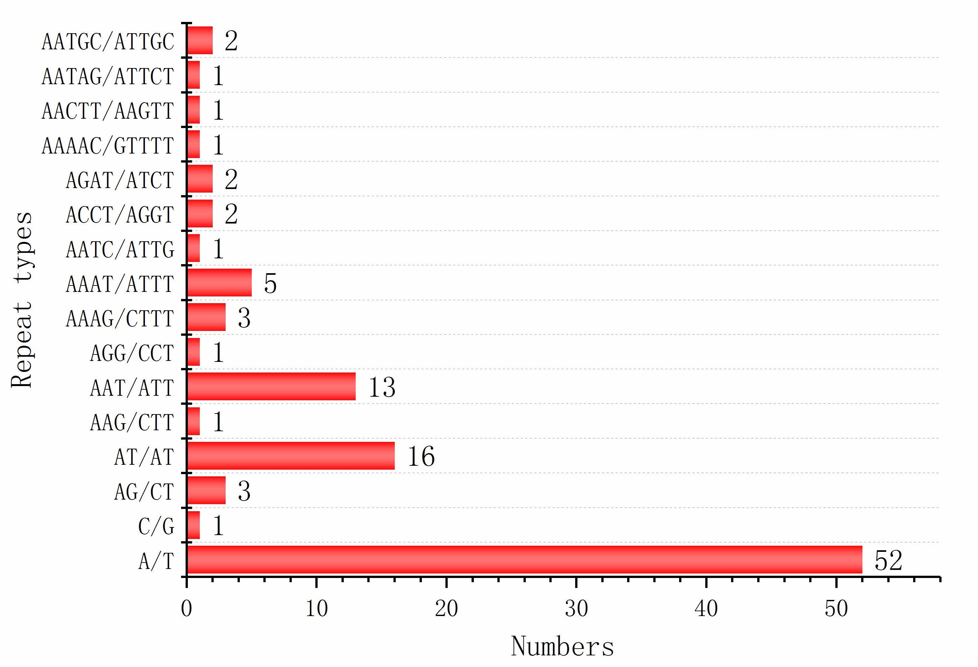
Figure S4 Number of classified SSR repeat types (considering sequence complementary).

Note S1
All these 49 conserved chloroplast proteins are atpA, atpB, atpE, atpF, atpH, ndhB, ndhC, ndhE, ndhF, ndhH, ndhI, ndhJ, petA, petB, petD, petG, psaA, psaB, psaJ, psbA, psbC, psbD, psbE, psbF, psbH, psbJ, psbK, psbN, rpl16, rpl2, rpl20, rpl23, rpl33, rpoA, rpoB, rpoC1, rpoC2, rps11, rps12, rps14, rps15, rps19, rps2, rps3, rps4, rps7, rps8, ycf2, ycf3.

