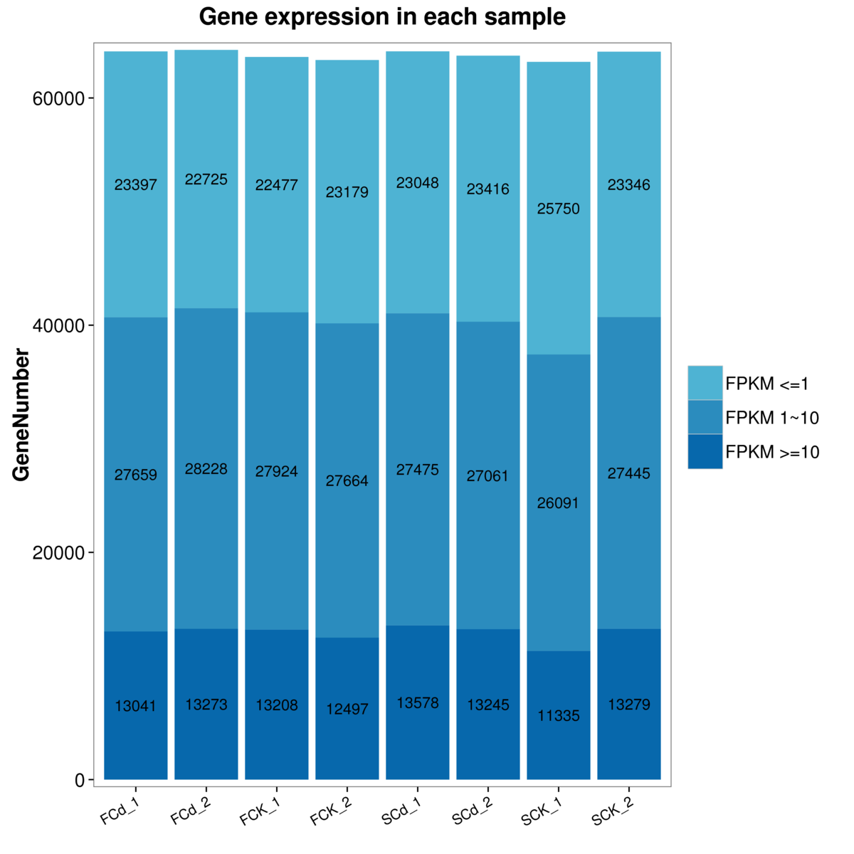

**Additional file 5: Figure S1.** **The gene expression distribution (FPKM) in eight samples.** X axis represents the sample name. Y axis represents the gene amount. The dark color means the moderate and high expression level which FPKM value ≥ 10, while the light color means the low expression level which FPKM value <10.