Figure Legends
Fig. 1 | The 4-section questionnaire adapted and modified from Gambetta-Tessini et al. (2016).

Fig. 1. The 4-section questionnaire adapted and modified from Gambetta-Tessini et al. (2016).

Please tick ✔ as appropriate for answers with selection boxes provided.
Socio-demographic background and practice profile

- Your gender
  - Male
  - Female

- Age*
  - ≤30
  - 31-40
  - 41-50
  - ≥51

- How long have you been practicing dentistry?*
  - Less than 5 years
  - 5 to 10 years
  - 11 to 20 years
  - 21 to 30 years
  - More than 30 years

- What is the type of your practice? (if you have more than one job, please indicate the type of practice in which you spent most of your working time.)*
  - Solo private practice
  - Group private practice
  - Non-government organization
  - Government
  - Hospital
  - Others, please specify_____________________

- Was there adequate training in dental school regarding management for hypomineralized teeth?
  - Yes
  - No

- Did you obtain any additional qualification(s), which is/are relevant to the dental profession?*
  - Yes, please specify: (you may tick ✔ more than one box below.)
    - Post-graduate Certificate
    - Post-graduate Diploma
    - Master’s degree
    - Doctoral degree
    - Fellowship
    - Membership
    - Others, please specify: _____________________________
  - No

- Are you a dental therapist, general practitioner, specialty trainee or specialist?#
  - Dental therapist
  - General practitioner
  - Postgraduate Student under speciality training, please specify your field below.
  - Trainee, please specify your field below.
  - Specialist, please specify your field below.
    - Community Dentistry
    - Endodontics
    - Family Dentistry
    - Oral and Maxillofacial Surgery
    - Orthodontics
    - Paediatric Dentistry
    - Periodontology
    - Prosthodontics

MIH Images

The following questions relate to these images.*
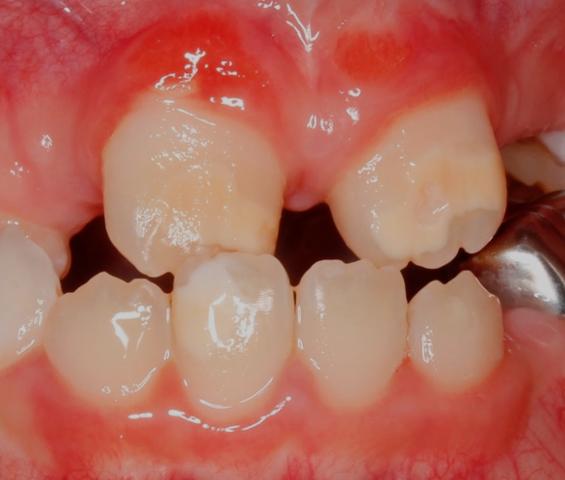
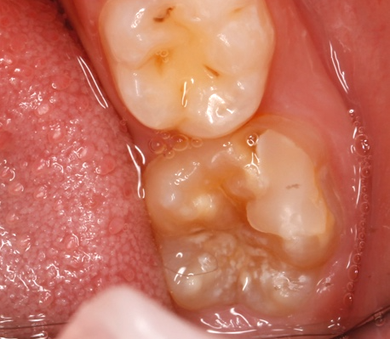
Images of Hypomineralized First Permanent Molars and Incisors
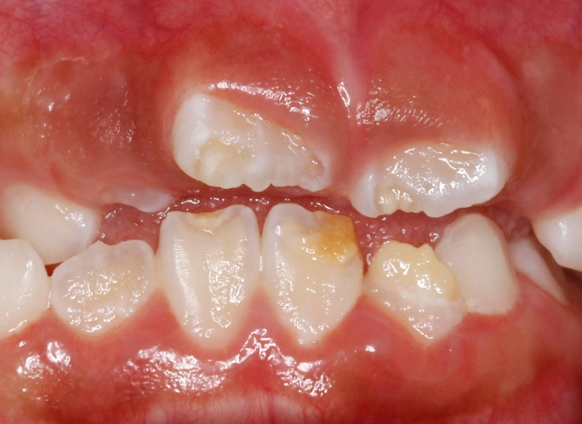
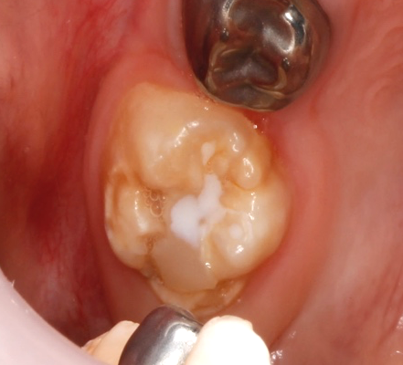
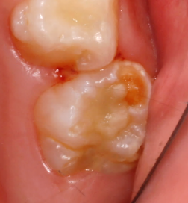

Knowledge
1. Have you been aware that MIH is a developmental defect that differs from fluorosis and hypoplasia?
- Yes
- No

2. How prevalent do you think MIH might be in your community? (One option chosen)
- <5%
- 5 – 10 %
- 10 – 20 %
- >20%
- Not sure

3. Do you think they are involved in the aetiology of MIH? (you may tick ✔ more than one box below.)
- Genetic factors
- Environmental contaminants
- Acute medical conditions affecting mother or child
- Chronic medical conditions affecting mother or child
- Antibiotics or medications
- Fluoride exposure

4. During what time/period do you think this insult occurs?
- During pregnancy
- 1st year of life
- 3rd year of life
- Pregnancy to 1st year of life
- Pregnancy to 3rd year of life

5. Do you think the pattern of caries related to MIH is different from the classical caries pattern?
- Yes
- No
- Not sure

Perception, clinical experience, continuing education

1. Do you encounter teeth with MIH in your practice?
- Yes
- No
2. What is the most frequent type/ defect seen in your practice?
- White demarcated
- Yellow/ brown demarcations
- Post-eruptive breakdown
- None

3. In what other permanent teeth have you encountered MIH-like defects? (you may tick ✔ more than one box below.)
- Premolars
- Second permanent molars
- Canines
- None

4. Do you notice these defects in the primary dentition?
- Yes
- No
5. Do you feel the incidence has increased in the period of your practice?
- Yes
- No
6. Would you refer a child who has signs of MIH to a paediatric dental specialist for treatment?
- Yes or when possible
- No
7. Do you think MIH represents a clinical problem that could come next to dental caries in public health?
- Yes
- No

8. What type of preventive treatment do you often use to treat these teeth? (you may tick ✔ more than one box below.)#
- Fluoride varnish
- Silver diamine fluoride solution
- Tooth mousse
- Fissure sealant
- Others: (please specify) ___________________

9. What type of treatment you often use to treat MIH? (you may tick ✔ more than one box below.)*
- Microabrasion
- Resin infiltration
- Glass ionomer
- Composite
- Amalgam
- Preformed crowns
- Extraction

10. How confident do you feel when diagnosing MIH teeth?#
- Very confident
- Confident
- Unconfident
- Very unconfident

11. How confident do you feel in managing MIH teeth?#
- Very confident
- Confident
- Doubtful
- Unconfident

- Are you receiving any information on MIH?
  - Yes
  - No

- Would you like further training regarding tooth hypomineralization? (you may tick ✔ more than one box below.)#
- Diagnosis
- Aetiology
- Treatment
- No training
Thank you for your collaboration with this project.

*Questions modified from the original questionnaire
#Questions added to the original questionnaire

