**PERSONS IN CONGREGATE SETTINGS**

**Assess with ICF job aid/Form**



**Cough**

**No cough; but has other TB S&S**

**No cough and No to other TB S&S**

**Refer to clinician to assess for extra pulmonary TB Disease**

**Screen for TB after 3 months**

**TB Suspect**

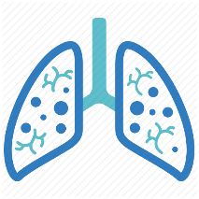

**TB disease excluded**

**Extra pulmonary Disease not excluded**

**Investigate to exclude TB; X-ray, US, lung biopsy**

X-ray

**Presumptive TB Case. Follow MOH TB Diagnostic algorithm**

NB: Persons in congregate settings should be encouraged to have HIV testing at TB screening