PCA ANALYIS KNOWLEDGE IUDs & IMPLANTs

- Importance of components:

PC1 PC2 PC3 PC4
Standard deviation 1.7924 0.6277 0.4943 0.3857
Proportion of Variance 0.8032 0.0985 0.0611 0.0372
Cumulative Proportion 0.8032 0.9017 0.9628 1.00000

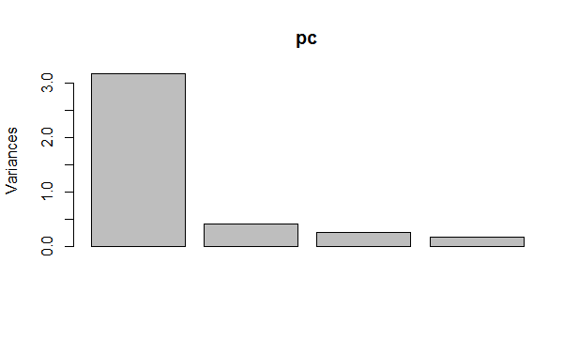
- PCA plot
- Biplot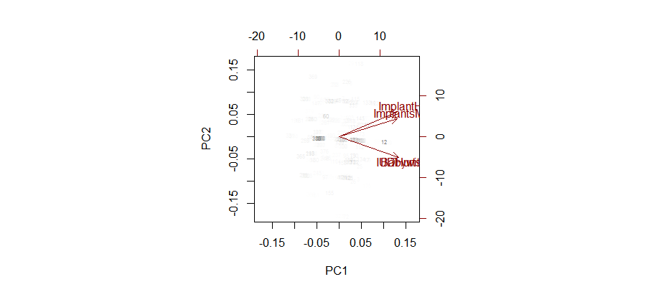

- Standard deviation of each of the four PCs, and their rotation (or loadings)
Standard deviations (1, .., p=4):
[1] 1.7924399 0.6277049 0.4943176 0.3857405

Rotation (n x k) = (4 x 4):
PC1 PC2 PC3 PC4
sydata$F2score 0.4873118 -0.5893082 -0.63406702 -0.1149001
sydata$F3score 0.4963921 -0.4200423 0.74435180 0.1519859
sydata$F5score 0.5092234 0.4784105 0.07563808 -0.7114027
sydata$F6score 0.5067678 0.4973969 -0.19539266 0.6764647

- Total knowledge score plotted against PC1

