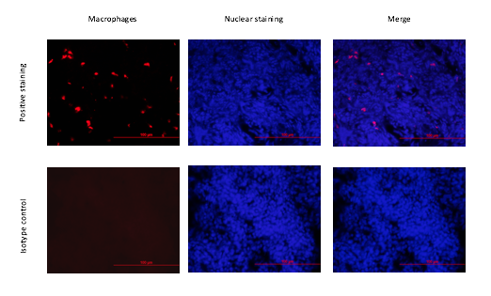

Additional file: Figure S1: Specificity of avian macrophage staining. Representative images of lung sections that were stained with anti-chicken macrophage antibody (KUL-01) or isotype control. The sections were also stained with nuclear staining (DAPI).

