Additional file 1: Table S1- Food and Nutrient content of the test beverages along with the fixed content breakfast
 | Skim milk (SM) | Apple juice (AJ) | Whole milk (WM)
Ingredient
Skim milk (ml) | 240 | - | -
Apple juice (ml) | - | 240 | -
Whole milk (ml) | - | - | 240
Iranian whole wheat bread (g) | 65 | 65 | 65
Walnut (g) | 12 | 12 | 12
Low fat cheese (g) | 15 | 15 | 15
Nutrients
Energy (Kcal) | 383.2 | 411.44 | 447.7
Protein (g) | 19.28 | 11.276 | 18.96
Fat (g) | 13.22 | 13.022 | 20.93
Carbohydrates (g) | 49.09 | 65.195 | 48.59
Fiber (g) | 1.04 | 1.016 | 1.04
Glycemic index | 40.17 | 42.5 | 40.17
Glycemic load | 19.70 | 27.70 | 19.70

Additional file 1: Figure S1- Mean ± SE subjective visual analogue scale (VAS) values for the overall appetite in male participants after intake of skim milk (●), apple juice (■) and whole milk (▲) adjusted for age, BMI and rolling method. Significant differences between the intervention periods are shown with asterisks. Standard errors are appeared by vertical bars.

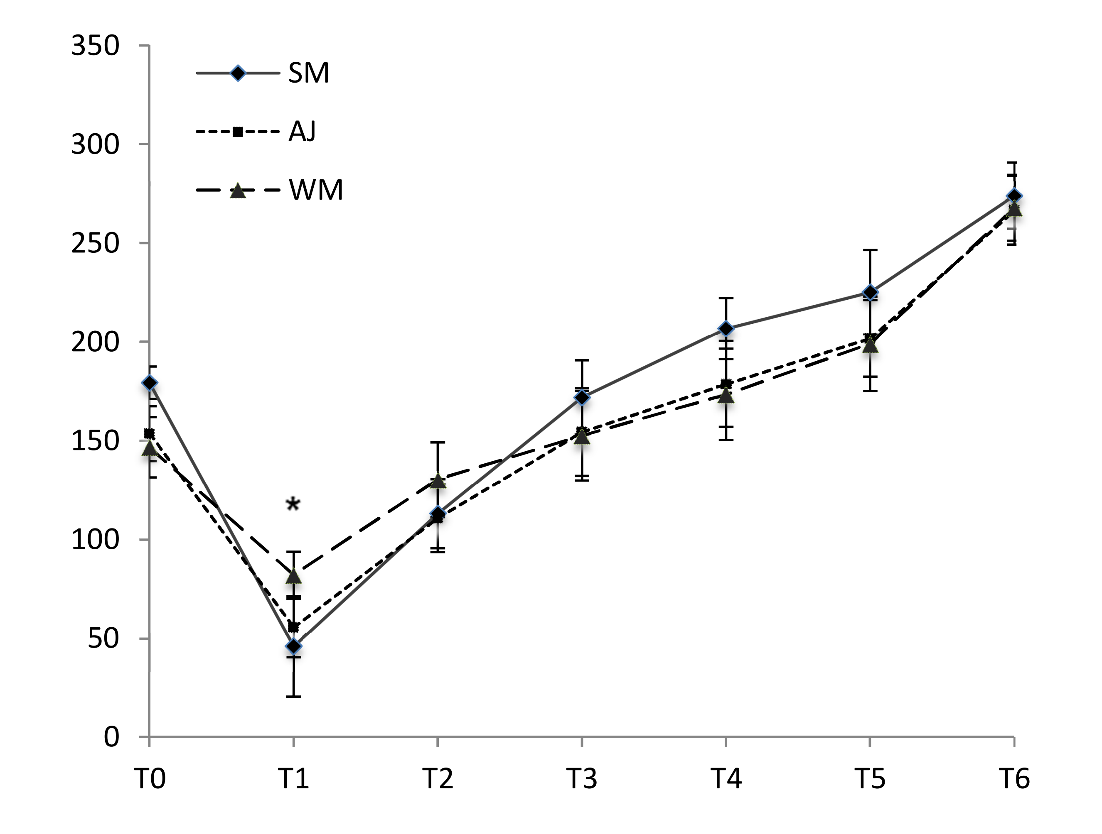

Additional file 1: Figure S2- Mean ± SE subjective visual analogue scale (VAS) values for desire to eat, fullness, hunger and prospective consumption in male participants after ingestion of skim milk (●), apple juice (■) and whole milk (▲) adjusted for age, BMI and rolling method. Significant differences between the intervention periods are shown with asterisks. Standard errors are appeared by vertical bars.

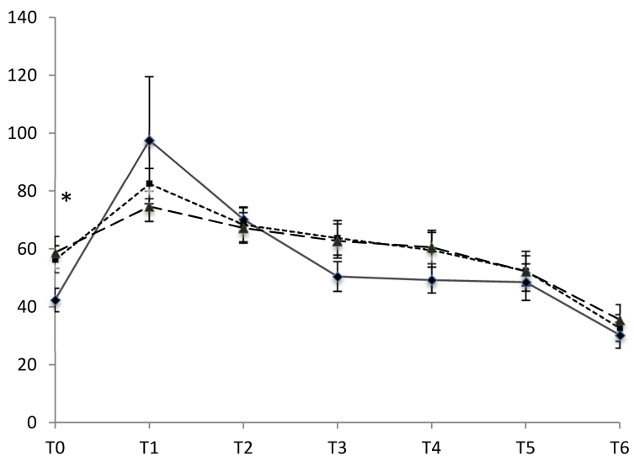
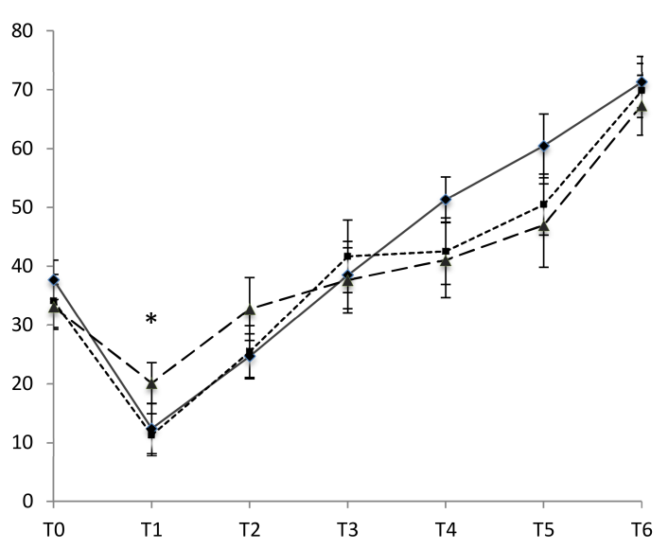
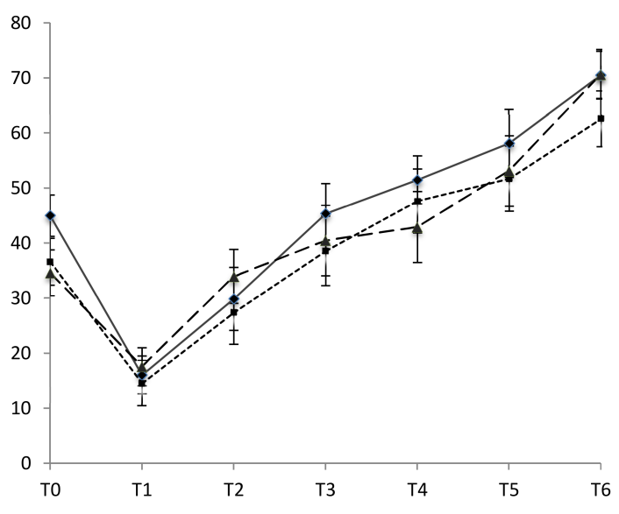
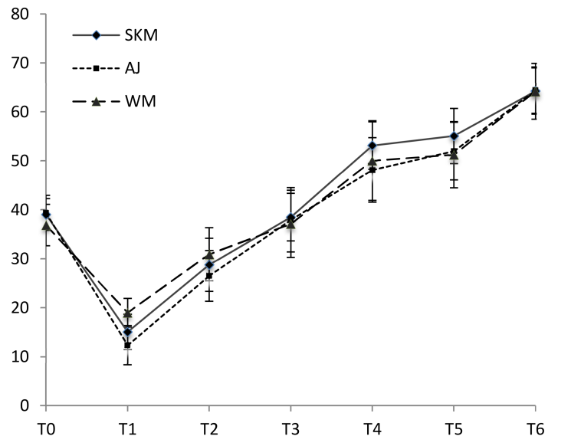
Hunger (mm)

Desire to eat (mm)

Prospective consumption (mm)
Fullness (mm)

Additional file 1: Figure S3- Mean ± SE subjective visual analogue scale (VAS) values for the overall appetite in female participants after intake of skim milk (●), apple juice (■) and whole milk (▲) adjusted for age, BMI and rolling method. Significant differences between the intervention periods are shown with asterisks. Standard errors are appeared by vertical bars.
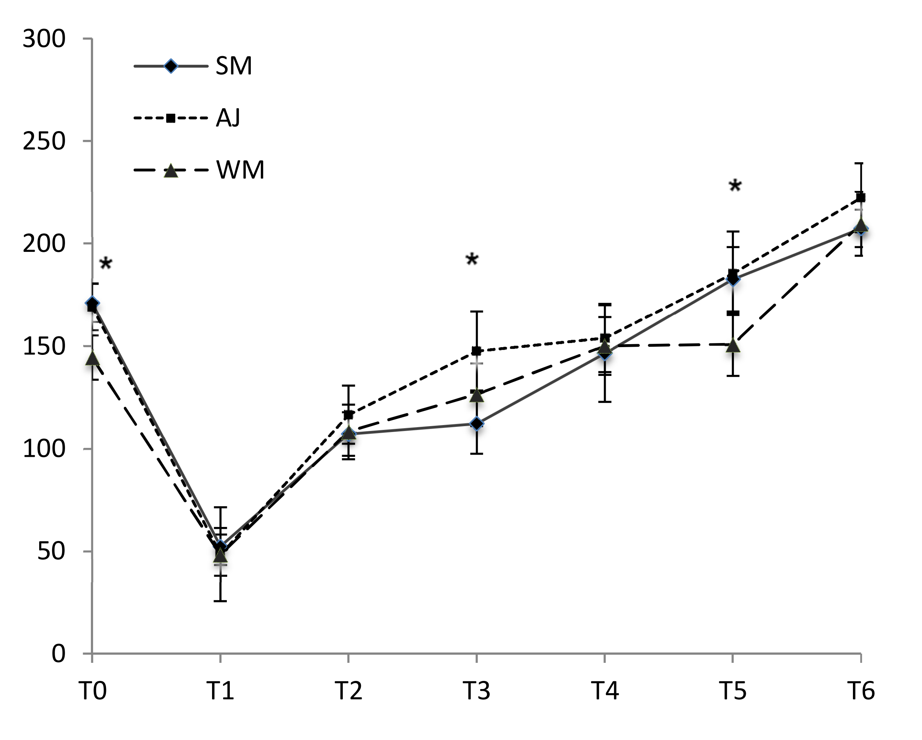

Additional file 1: Figure S4- Mean ± SE subjective visual analogue scale (VAS) values for desire to eat, fullness, hunger and prospective consumption in female participants after ingestion of skim milk (●), apple juice (■) and whole milk (▲) adjusted for age, BMI and rolling method. Significant differences between the intervention periods are shown with asterisks. Standard errors are appeared by vertical bars.

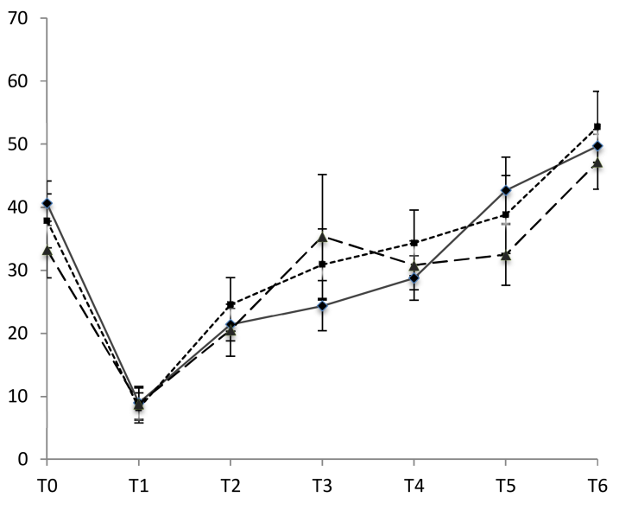
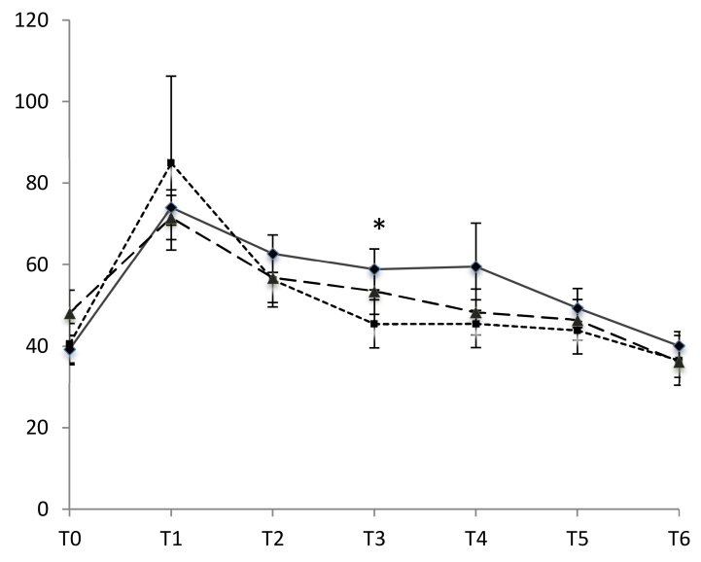
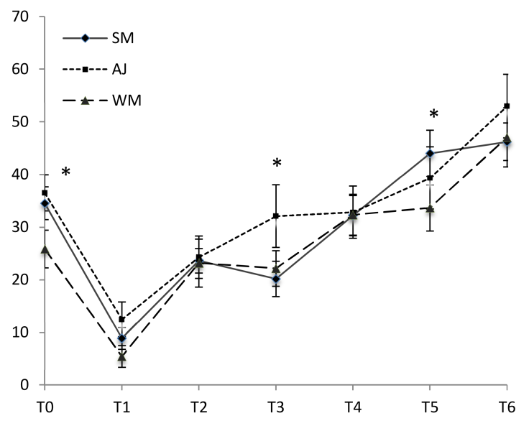
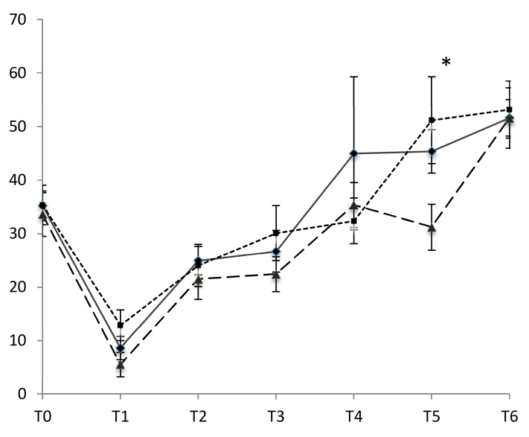
Hunger (mm)

Fullness (mm)
Prospective consumption (mm)
Desire to eat (mm)

