Additional file 1

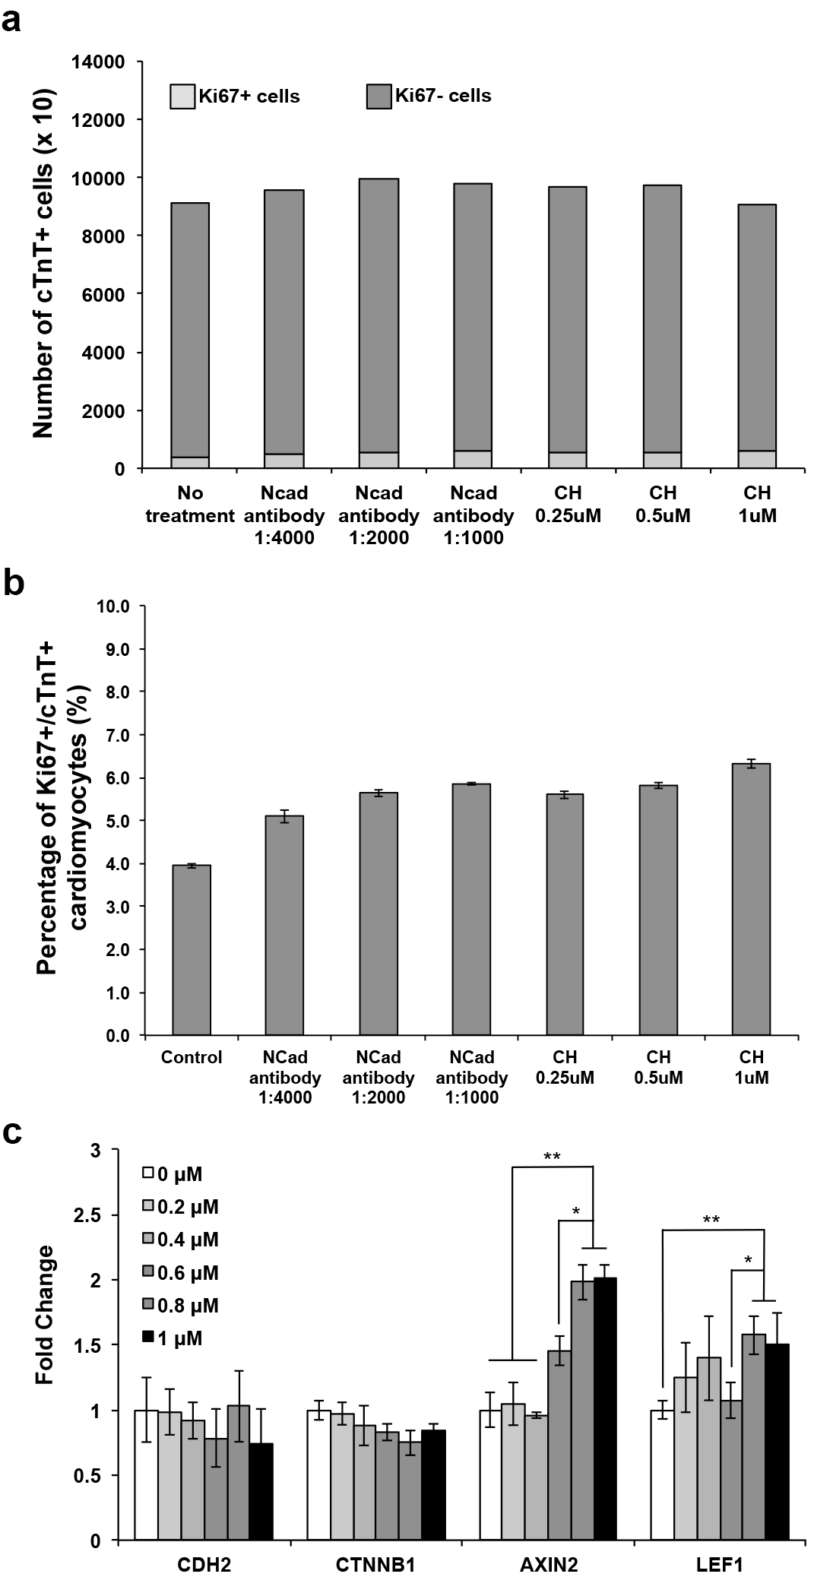

Figure S1: Up-regulation of Wnt signaling leads to proliferation of human ES derived cardiomyocytes. (A-B) Graphical quantification of the proportion of Ki67+ cardiomyocytes in different concentrations of N-cadherin antibody (1:4,000, 1:2,000 and 1:1,000) and CHIR99021 (0.25 µM, 0.5 µM and 1 µM) as compared to untreated cardiomyocytes (control). Note that the optimal concentrations of N-cadherin antibody (1:1,000) and CHIR99021 (1µM) treatments lead to ~50 % and ~60 % increase in Ki67 positive cardiomyocytes, respectively. (C) Expression levels of Wnt signaling genes of matured cardiomyocytes treated with different concentrations of CHIR99021. While CDH2 and CTNNB1 expression levels do not change significantly, AXIN2 and LEF1, both downstream Wnt signaling effectors, were up-regulated with increasing concentrations of CHIR99021. Error bars indicated s.d, n = 3 replicates. * P < 0.05 and ** P < 0.01 for Kruskal-Wallis one-way analysis of variance compared to control.

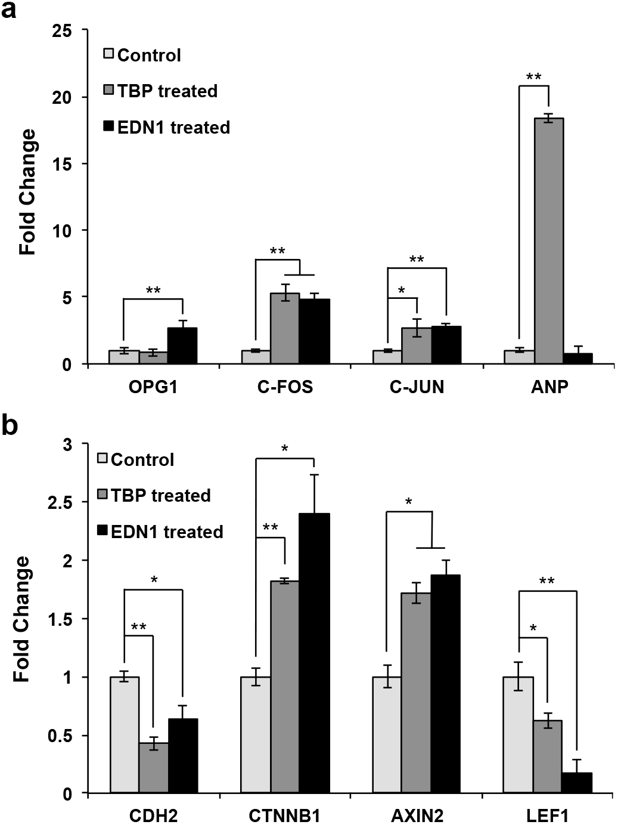

Figure S2: Expression levels of Wnt signaling genes are affected in a cardiac hypertrophy model. (A) Quantitative PCR analysis of mRNA isolated from cardiomyocytes of an injury model of cardiac hypertrophy. ES cell derived cardiomyocytes treated with Endothelin-1 (EDN1) and Tert-Butyl Peroxide (TBP) showed up-regulation of hypertrophy associated genes OPG1, C-FOS, C-JUN and ANP, relative to untreated control cardiomyocytes. Error bars indicated s.d, n = 3 replicates. * P < 0.05 and ** P < 0.01 for Kruskal-Wallis one-way analysis of variance compared to control. (B) Quantitative PCR analysis of CDH2, CTNNB1, AXIN2 and LEF1 transcript expression levels in cardiac hypertrophy model induced with either TBP or EDN1. Error bars indicated s.d, n = 3 replicates. * P < 0.05 and ** P < 0.01 for Kruskal-Wallis one-way analysis of variance compared to control.

Table S1: Lists of human and murine primer sequences used in this study.

Gene | Forward Primer | Reverse Primer
CDK1 | TGGATCTGAAGAAATACTTGGATTCTA | CAATCCCCTGTAGGATTTGG
CDK2 | AAAGCCAGAAACAAGTTGACG | GTACTGGGCACACCCTCAGT
CDK4 | GTGCAGTCGGTGGTACCTG | TTCGCTTGTGTGGGTTAAAA
CDK6 | TGATCAACTAGGAAAAATCTTGGA | GGCAACATCTCTAGGCCAGT
CCNA2 | GGTACTGAAGTCCGGGAACC | GAAGATCCTTAAGGGGTGCAA
CCNB1 | ACATGGTGCACTTTCCTCCT | AGGTAATGTTGTAGAGTTGGTGTCC
CCNB2 | TGGAAAAGTTGGCTCCAAAG | TCAGAAAAAGCTTGGCAGAGA
CCND1 | GCTGTGCATCTACACCGACA | TTGAGCTTGTTCACCAGGAG
CCND2 | GGACATCCAACCCTACATGC | CGCACTTCTGTTCCTCACAG
CCNE1 | GGCCAAAATCGACAGGAC | GGGTCTGCACAGACTGCAT
CCNE2 | GCCATTGATTCATTAGAGTTCCA | CTGTCCCACTCCAAACCTG
AXIN2 | GCTGACGGATGATTCCATGT | ACTGCCCACACGATAAGGAG
LEF1 | CAGTCGACACTTCCATGTCC | GAGGGATGCCAGTTGTGTG
ACTINB | CCAACCGCGAGAAGATGA | CCAGAGGCGTACAGGGATAG
FZD1 | cggcaagaccctcaactc | ccttgtttgctgttggtgag
FZD2 | caccccaccaggagtactga | acaagtgctcaaaggcgaat
FZD3 | acagcaaagtgagcagctacc | ctgtaactgcagggcgtgta
FZD4 | ttcacaccgctcatccagta | tgcacattggcacataaaca
FZD5 | accccaggggagagaaac | tgcaaattgggggaagtaag
FZD6 | cgtctatgagcaagtgaacagg | aattctggtcgagcttttgc
FZD7 | gccagcttgtgcctaatagaa | agccgggagaaactcacag
FZD8 | tgctctgcttcgtgtcca | aagcgctccatgtcgataa
GSK3A | gtctcctacatctgttctcgctact | cagccagctgaccaaacat
GSK3B | cccagaaccacctcctttg | ttgctgccgtccttgtct
WNT1 | cgctggaactgtcccact | aacgccgtttctcgacag
WNT2 | tttggcagggtcctactcc | cctggtgatggcaaatacaa
WNT3 | ctcgctggctacccaattt | gagcccagagatgtgtactgc
WNT4 | gcagagccctcatgaacct | cacccgcatgtgtgtcag
WNT6 | cagttccagttccgcttcc | gaacacgaaggccgtctc
WNT7A | cttcgggaaggagctcaaa | gcaatgatggcgtaggtga
WNT8A | ccacaacaggctgagaagtg | tgctacagttcttggtgatgatg
CDH2 | CCCAAGACAAAGAGACCCAG | GCCACTGTGCTTACTGAATTG
CTNNB1 | GTTCAGTTGCTTGTTCGTGC | GTTGTGAACATCCCGAGCTAG
JUN | ccaaaggatagtgcgatgttt | ctgtccctctccactgcaac
PITX2 | ccttacggaagcccgagt | ccgaagccattcttgcata
OPG1 | GCTAACCTCACCTTCGAG | TGATTGGACCTGGTTACC
C-FOS | CACTCCAAGCGGAGACAGAC | AGGTCATCAGGGATCTTGCAG
C-JUN | TCCAAGTGCCGAAAAAGGAAG | CGAGTTCTGAGCTTTCAAGGT
ANP | CAGGATGGACAGGATTGGA | TGTCCTCCCTGGCTGTTATC
Cdk1 | gaacttcgacatccaaatatagtcag | ccatggacaggaactcaaaga
Cdk2 | cacagccgtggatatctgg | catggtgctgggtacacact
Cdk4 | agagctcttagccgagcgta | ttcagccacgggttcatatc
Ccna2 | cttggctgcaccaacagtaa | caaactcagttctcccaaaaaca
Ccnb1 | gcgctgaaaattcttgacaac | ttcttagccaggtgctgcat
Ccnb2 | caaccgtaccaagttcatcg | gagggatcgtgctgatcttc
Ccnd2 | gctgtgcatttacaccgaca | acactaccagttcccactcca
Ccne2 | gccatcgactctttagaatttca | tgtcatcccattccaaacct
Wnt1 | acagtagtggccgatggtg | cttggaatccgtcaacaggt
Wnt2 | cagagatcacagcctctttgg | gcgtaaacaaaggccgatt
Wnt6 | gtgcaactgcacaacaacg | ggaacggaggcagcttct
Axin2 | gagagtgagcggcagagc | cggctgactcgttctcct
Lef1 | tcctgaaatccccaccttct | tgggataaacaggctgacct
Gapdh | cctgcttcaccaccttcttg | tgtccgtcgtggatctgac

