Additional Information

Onboard experiment investigating metal leaching of fresh hydrothermal sulfide cores into seawater

Shigeshi Fuchida^{1,*}, Jun-ichiro Ishibashi², Kazuhiko Shimada², Tatsuo Nozaki^{3,4,5,6}, Hideaki Kumagai³, Masanobu Kawachi⁷, Yoshitaka Matsushita⁸, Hiroshi Koshikawa¹

¹Marine Environment Section, Center for Regional Environmental Research, National Institute for Environmental Studies (NIES), 16-2 Onogawa, Tsukuba, Ibaragi 305-8506, Japan

²Department of Earth and Planetary Sciences, Faculty of Science, Kyushu University, 744 Motooka, Nishi-ku, Fukuoka 819-0395, Japan

³Research and Development (R&D) Center for Submarine Resources, Japan Agency for Marine-Earth Science and Technology (JAMSTEC), 2-15 Natsushima-cho, Yokosuka, Kanagawa 237-0061, Japan

⁴Frontier Research Center for Energy and Resources, The University of Tokyo, 7-3-1 Hongo, Bunkyo-ku, Tokyo 113-8656, Japan

⁵Department of Planetology, Kobe University, 1-1 Rokkodai-cho, Nada-ku, Kobe, Hyogo 657-8501, Japan

⁶Ocean Resources Research Center for Next Generation, Chiba Institute of Technology, 2-17-1 Tsudanuma, Narashino, Chiba 275-0016, Japan

⁷Biodiversity Resource Conservation Office, Center for Environmental Biology and Ecosystem Studies, National Institute for Environmental Studies (NIES), 16-2 Onogawa, Tsukuba, Ibaragi 305-8506, Japan

⁸Research Network and Facility Services Division, the National Institute for Materials Science (NIMS), 1-2-1 Sengen, Tsukuba, Ibaragi 305-0047, Japan
CKL-1 (C9026A 7X-CC)
C9026A
(oxic) | Time (h) | pH | Fe (μM) | Cu (μM) | Zn (μM) | Pb (μM) |  | (anoxic) | Time (h) | pH | Fe (μM) | Cu (μM) | Zn (μM) | Pb (μM)
5°C | 1 | 8.0 | *- | - | 17 | 3.2 |  | 5°C | 1 | 8.0 | - | - | 8.1 | 3.7
 | 4 | 8.2 | - | - | 17 | 1.8 |  |  | 4 | 8.1 | - | - | 12 | 2.2
 | 10 | 8.6 | - | - | 7.4 | 1.3 |  |  | 10 | 8.2 | - | - | 9.3 | 1.2
 | 18 | 8.9 | - | - | 1.8 | 0.93 |  |  | 18 | 8.6 | - | - | 4.2 | 1.3
 | 30 | 9.0 | - | - | 1.1 | 0.74 |  |  | 30 | 8.9 | - | - | 1.8 | 1.1
20°C | 1 | 8.0 | - | - | 15 | 3.7 |  | 20°C | 1 | 8.0 | - | - | 5.8 | 3.1
 | 4 | 8.3 | - | - | 11 | 2.3 |  |  | 4 | 8.0 | - | - | 9.3 | 3.0
 | 10 | 8.5 | - | - | 6.3 | 1.8 |  |  | 10 | 8.2 | - | - | 8.2 | 2.0
 | 18 | 8.7 | - | - | 4.0 | 1.6 |  |  | 18 | 8.3 | - | - | 5.8 | 1.9
 | 30 | 8.8 | - | - | 2.1 | 1.5 |  |  | 30 | 8.7 | - | - | 1.8 | 1.5
CKL-2 (C9027B 1X-CC)
(oxic) | Time (h) | pH | Fe (μM) | Cu (μM) | Zn (μM) | Pb (μM) |  | (anoxic) | Time (h) | pH | Fe (μM) | Cu (μM) | Zn (μM) | Pb (μM)
5°C | 1 | 7.7 | - | - | 38 | 6.0 |  | 5°C | 1 | 7.7 | - | - | 25 | 1.9
 | 4 | 7.7 | - | - | 54 | 3.9 |  |  | 4 | 7.7 | - | - | 26 | 2.0
 | 10 | 8.1 | - | - | 50 | 1.8 |  |  | 10 | 7.8 | - | - | 40 | 3.1
 | 18 | 8.4 | - | - | 20 | 1.4 |  |  | 18 | 7.7 | - | - | 50 | 2.4
 | 30 | 8.6 | - | - | 5.0 | 1.3 |  |  | 30 | 7.8 | - | - | 52 | 1.8
20°C | 1 | 7.6 | - | - | 47 | 10 |  | 20°C | 1 | 7.7 | - | - | 7.9 | 0.76
 | 4 | 7.6 | - | - | 57 | 5.1 |  |  | 4 | 7.7 | - | - | 13 | 1.3
 | 10 | 8.3 | - | - | 17 | 2.3 |  |  | 10 | 7.7 | - | - | 43 | 4.1
 | 18 | 8.6 | - | - | 7.8 | 2.0 |  |  | 18 | 7.6 | - | - | 63 | 4.5
 | 30 | 8.2 | - | - | 18 | 3.0 |  |  | 30 | 7.8 | - | - | 54 | 4.1
Table S1. pH and concentrations of Fe, Cu, Zn and Pb in seawater from powdered core samples at different temperature and redox conditions.
Table S1. (continued)
CKL-3 (C9028A 7S-CC)
(oxic) | Time (h) | pH | Fe (μM) | Cu (μM) | Zn (μM) | Pb (μM) |  | (anoxic) | Time (h) | pH | Fe (μM) | Cu (μM) | Zn (μM) | Pb (μM)
5°C | 1 | 7.5 | - | - | 8.7 | 3.5 |  | 5°C | 1 | 7.8 | - | - | 2.7 | 1.2
 | 4 | 7.5 | - | - | 13 | 3.6 |  |  | 4 | 7.7 | - | - | 4.4 | 1.8
 | 10 | 7.3 | - | - | 21 | 3.7 |  |  | 10 | 7.7 | - | - | 7.2 | 3.3
 | 18 | 7.2 | - | - | 32 | 3.7 |  |  | 18 | 7.6 | - | - | 10 | 2.9
 | 30 | 6.7 | - | - | 47 | 3.8 |  |  | 30 | 7.4 | - | - | 15 | 3.4
20°C | 1 | 7.3 | - | - | 8.2 | 4.2 |  | 20°C | 1 | 7.9 | - | - | 1.0 | 0.55
 | 4 | 7.3 | - | - | 19 | 4.3 |  |  | 4 | 7.5 | - | - | 6.9 | 4.5
 | 10 | 7.1 | - | 0.38 | 44 | 4.8 |  |  | 10 | 7.5 | - | - | 13 | 6.6
 | 18 | 6.5 | - | 0.91 | 96 | 12 |  |  | 18 | 7.4 | - | - | 17 | 6.7
 | 30 | 4.5 | 130 | 23 | 190 | 130 |  |  | 30 | 7.2 | - | - | 21 | 5.9
CKL-4 (C9028A 1H-7)
(oxic) | Time (h) | pH | Fe (μM) | Cu (μM) | Zn (μM) | Pb (μM) |  | (anoxic) | Time (h) | pH | Fe (μM) | Cu (μM) | Zn (μM) | Pb (μM)
5°C | 1 | 7.4 | - | - | 93 | 9.7 |  | 5°C | 1 | 7.5 | - | - | 62 | 17
 | 4 | 7.5 | - | - | 110 | 6.3 |  |  | 4 | 7.6 | - | - | 67 | 7.3
 | 10 | 7.5 | - | - | 130 | 2.7 |  |  | 10 | 7.6 | - | - | 76 | 3.7
 | 18 | 7.3 | - | - | 200 | 3.3 |  |  | 18 | 7.5 | - | - | 90 | 2.6
 | 30 | 7.2 | - | - | 310 | 5.2 |  |  | 30 | 7.4 | - | - | 120 | 3.2
20°C | 1 | 7.3 | - | - | 100 | 14 |  | 20°C | 1 | 7.5 | - | - | 69 | 14
 | 4 | 7.4 | - | - | 130 | 12 |  |  | 4 | 7.6 | - | - | 80 | 7.5
 | 10 | 7.3 | - | - | 190 | 6.6 |  |  | 10 | 7.4 | - | - | 85 | 6.4
 | 18 | 7.0 | - | - | 340 | 12 |  |  | 18 | 7.4 | - | - | 110 | 7.1
 | 30 | 6.9 | - | - | 610 | 21 |  |  | 30 | 7.1 | - | - | 140 | 11
*-: below limit of quantification
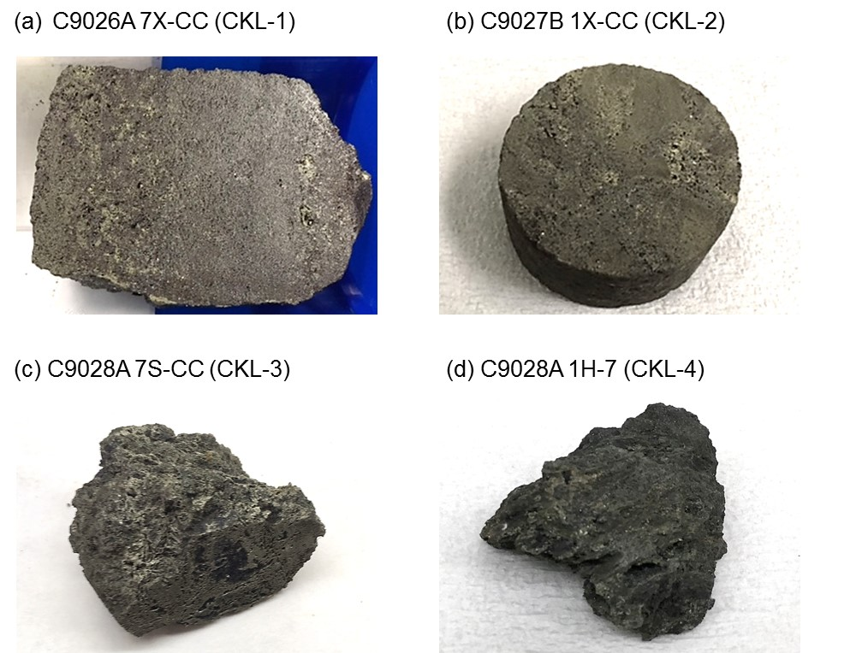
Figure S1 Photographs of hydrothermal mineral cores for onboard leaching experiment: (a) C9026A 7X-CC (CKL-1), (b) C9027B 1X-CC (CKL-2), (c) C9028A 7S-CC (CKL-3), and (d) C9028A 1H-7 (CKL-4).

(a)
(b)
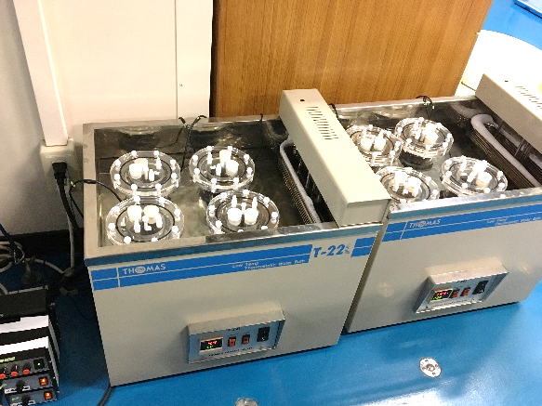

Figure S2. Images of onboard leaching experiment: (a) an operation in the anaerobic chamber and (b) sample reactions in the water baths.

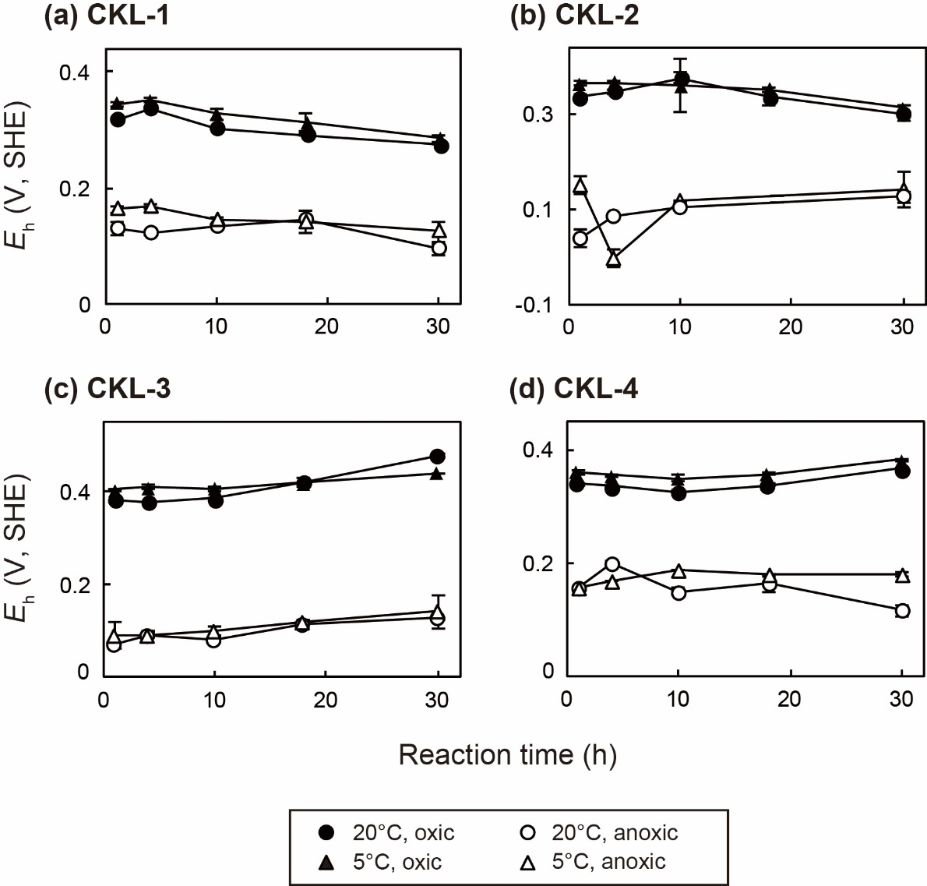
Figure S3. Changes in E_{h} (V, SHE) for (a) CKL-1, (b) CKL-2, (c) CKL-3, and (d) CKL-4 solutions under different redox and temperature conditions. Plots show mean values of duplicates, and error bars indicate range of duplicate (difference between the max and min values).

