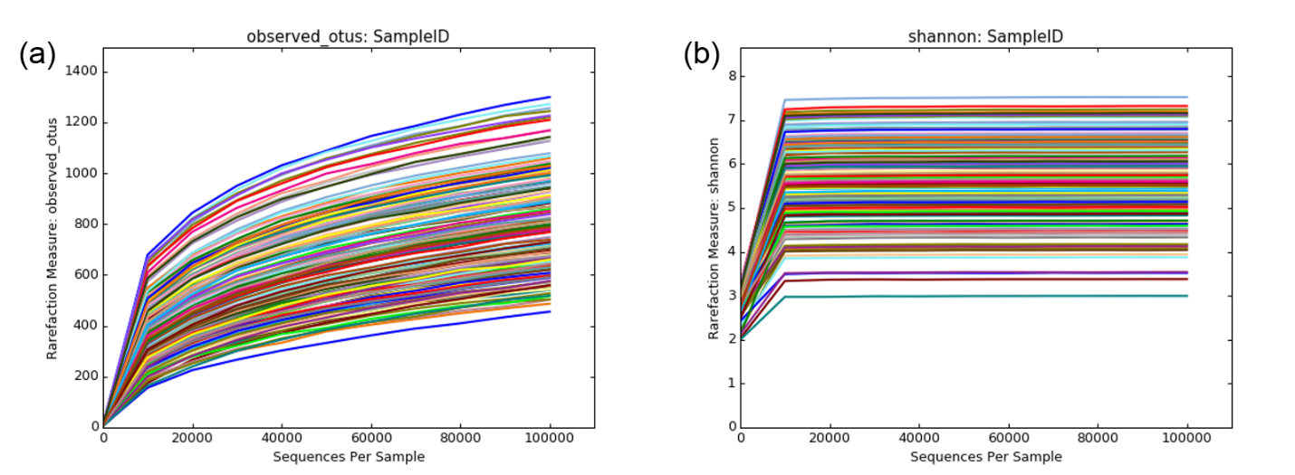
Figure S1: Rarefaction curves showing the number of reads per sample against observed operational taxonomic unit (OTU) or Shannon diversity indices of each dust sample.

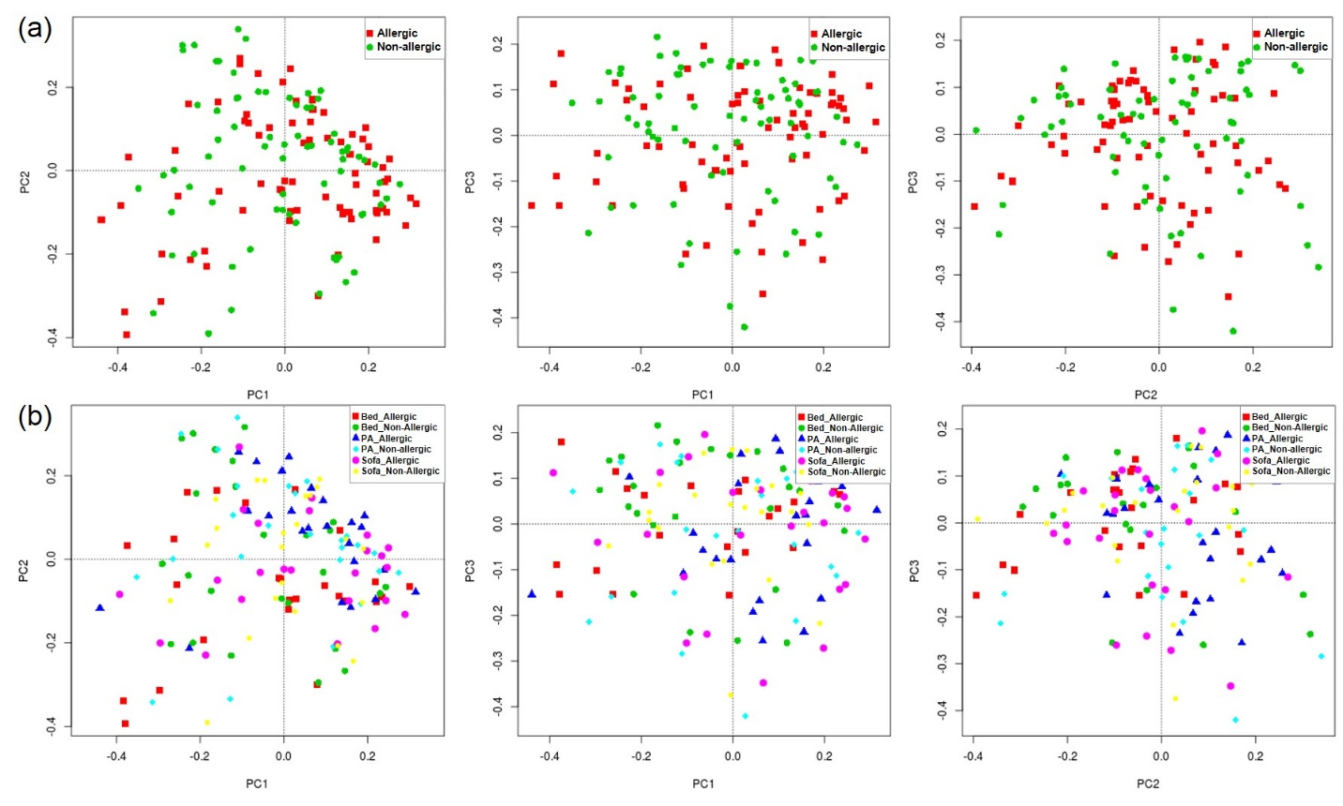
Figure S2: Principal coordinates plots of house dust samples of allergic and non-allergic subjects based on Bray-Curtis dissimilarities. The axes shown were rotated to PC1-10.03%, PC2-8.05%, PC3-5.69%. There was no distinct clusters of house dust samples of allergic and non-allergic subjects (a). There was also no distinct clusters of bed, play area (PA), and sofa dust samples of allergic and non-allergic subjects (b).
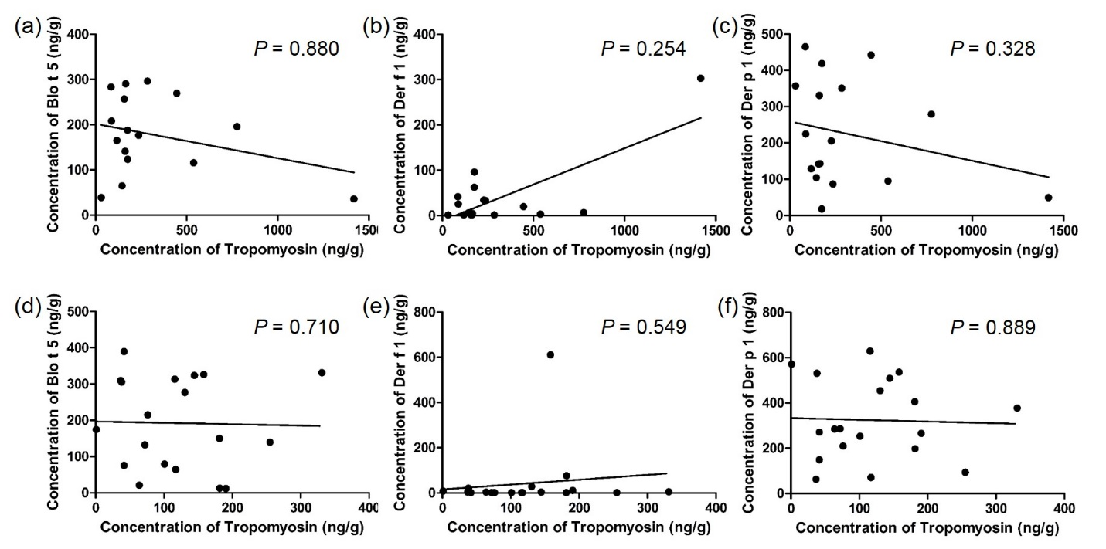
Figure S3: Correlation analysis of the concentrations of tropomyosin and house dust mites of dust samples from Sofa of allergic subjects and non-allergic subjects. There was no significant correlation between concentration of tropomyosin and Blo t 5, Der f 1, or Der p 1 in the sofa dust samples of allergic subjects (a-c) and non-allergic subjects (d-f) using Spearman’s rank-order correlation analysis.

