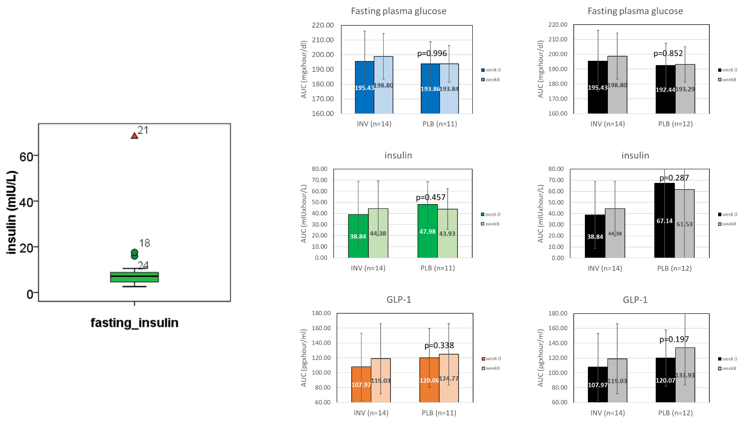
[A]
[C]
[B]

Additional Fig. S2 Subject number 21 had an extreme value from the boxplot test and was excluded from the primary analysis (panel A). The primary outcomes after subject number 21 was excluded are shown in panel B. A reanalysis of the primary outcomes which included subject number 21 in the analysis did not change the statistical significance of the pre-post values, fasting plasma glucose, insulin level or GLP-1 in the control group (panel C). The paired t-test was used to determine the differences of the pre-post values.

