Figure S1. The flow diagram for inclusion of patients.

Distal metastasis（n=5）

No standard treatment（n=43）

Osteosarcoma from January 2000 to February 2015
（N=1133）
Proximal Fibula（n=39）
Proximal Tibia（n=214）

Exclusion（n=11）
Exclusion（n=68）
Distal metastasis（n=5）
No standard treatment（n=6）

Figure S2. An example of chemotherapy protocol

Neo-adjuvant Chemotherapy
MTX
MTX
DDP
ADM
IFO、
Surgery
1
2
3
4

Adjuvant Chemotherapy
MTX
DDP
ADM
IFO、
1
2
3
4
MTX
DDP
ADM
IFO、
MTX
DDP
ADM
IFO、
5
6
7
8
9

Figure S3. An example of measuring tumor volumes (TVS) and extraosseous tumor volumes (ETVS).
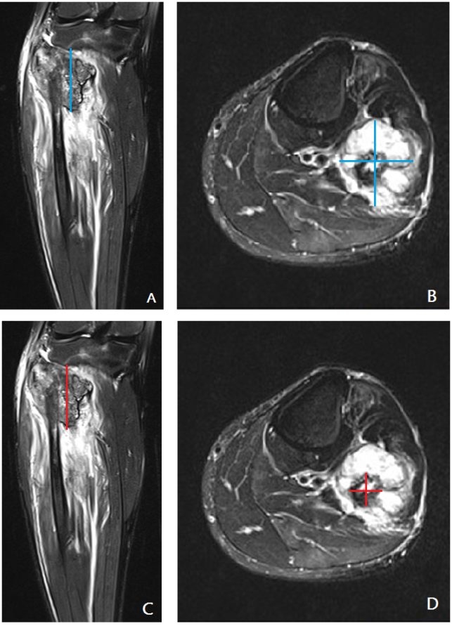
A. Measurement of tumor length from coronary section. B. Measurement of tumor width and depth from transverse section. C. Measurement of intraosseous tumor length from coronary section. D. Measurement of intraosseous tumor width and depth from transverse section.

