ONLINE-ONLY ADDITIONAL MATERIAL
Additional Tables
Table S1 Inclusion and exclusion criteria
Inclusion criteria
- Diagnosis of type 2 diabetes
- Age ≥ 18 yearsª
- Initiating a second-line therapy (add-on or switching) after a first-line oral treatment with monotherapy, dual therapy, or triple therapy^{b}
- Provision of written informed consent
Exclusion criteria
- Type 1 diabetes
- Pregnancy
- Initiation of dual therapy after having previously received two different lines of monotherapy (e.g. initiation of a combination of a sulfonylurea and a DPP-4 inhibitor after successive metformin monotherapy and sulfonylurea monotherapy)
- Current treatment with chemotherapy or oral or intravenous steroids
- Undergoing dialysis or received a renal transplant
- First-line treatment with insulin or another injectable agent
- First-line treatment with herbal remedies or natural medicines alone
- Participation in an interventional trial
- Condition or circumstance that, in the opinion of the investigator, could significantly compromise the 3-year follow-up (e.g. life-threatening comorbidities, tourist, non-native language speaker or lack of understanding of the local language in countries where interpreter services are not reliably available, psychiatric disturbances, dementia, alcohol or drug abuse)
- Unwilling to sign the informed consent form
ª ≥ 20 years in Japan. ^{b}In Japan, only patients using an oral monotherapy as first-line treatment were included.
DDP-4 dipeptidyl peptidase-4

Table S2 Comparisons between patients for whom either HbA_{1c} or total cholesterol data are unreported, and those with complete HbA_{1c} and total cholesterol data
 | Patients with either HbA_{1c} or TC data unreported  (n = 7,358) | Patients with complete dataª  (n = 6,656) | P value^{b}
Any microvascular disease, n (%) | 992 (13.5) | 1,615 (24.3) | < 0.001
Unreported | 14 | 1
Any macrovascular disease, n (%) | 895 (12.2) | 856 (12.9) | 0.228
Unreported | 25 | 10
Sex, n (%) |  |  | < 0.001
Male | 3,653 (49.7) | 3,842 (57.7)
Female | 3,703 (50.3) | 2,814 (42.3)
Unreported | 2 | 0
Age, years, mean (SD) | 57.0 (12.1) | 57.2 (12.0) | 0.460
Unreported | 0 | 0
Time in formal education, n (%) |  |  | 0.039
No formal education | 245 (3.6) | 193 (2.9)
Primary (1–6 years) | 1,104 (16.2) | 1,011 (15.2)
Secondary (7–13 years) | 3,333 (48.9) | 3,310 (49.7)
Higher (> 13 years) | 2,138 (31.3) | 2,142 (32.2)
Unreported | 538 | 0
Diabetes duration, years, mean (SD) | 5.7 (5.4) | 5.6 (5.1) | 0.064
Unreported | 176 | 0
HbA_{1c}, %, mean (SD) | 8.3 (1.6) | 8.4 (1.7) | 0.173
Unreported | 3,207 | 0
BMI, kg/m², mean (SD) | 28.8 (5.9) | 29.1 (5.8) | 0.004
Unreported | 754 | 0
Tobacco smoking, n (%) |  |  | < 0.001
Nonsmoker | 5,346 (74.5) | 4,390 (66.0)
Ex-smoker | 981 (13.7) | 1,180 (17.7)
Current smoker | 849 (11.8) | 1,086 (16.3)
Unreported | 182 | 0
SBP, mmHg, mean (SD) | 131.7 (16.2) | 132.6 (16.8) | < 0.001
Unreported | 435 | 0
Total cholesterol, mean (SD) | 187.7 (49.4) | 187.1 (46.7) | 0.759
Unreported | 6,771 | 0
History of hypoglycemia^{c} | 327 (4.7) | 317 (4.8) | 0.834
Unreported | 381 | 0
Comedication, n (%)
ACEi or ARB | 2,406 (32.7) | 2,705 (40.6) | < 0.001
Diuretic | 862 (11.7) | 798 (12.0) | 0.616
β-blocker | 932 (12.7) | 947 (14.2) | 0.006
Statin | 2505 (34.0) | 3311 (49.7) | < 0.001
ASA | 960 (13.0) | 1,292 (19.4) | < 0.001
Unreported | 0 | 0
ACEi angiotensin-converting enzyme inhibitor, ARB angiotensin receptor blocker, ASA acetylsalicylic acid, BMI body mass index, HbA_{1c} glycated hemoglobin, SBP systolic blood pressure, SD standard deviation, TC total cholesterol
ª Patients with reported data for all variables included in the hierarchical logistic model
^{b} P values calculated for continuous variables using Student’s t-test, and for categorical variables using the χ² or Fisher’s exact test, as appropriate
^{c} Minor hypoglycemic event in the previous month or major hypoglycemic event in the previous year
Table S3 Number and proportion of patients with microvascular and macrovascular complications according to country (unadjusted)
Region | Country | N | Microvascular, n (%) | Macrovascular, n (%)
Africa | Algeria | 293 | 70 (23.9) | 19 (6.5)
 | South Africa | 519 | 48 (9.2) | 55 (10.6)
Americas | Argentina | 299 | 30 (10.0) | 35 (11.7)
 | Brazil | 437 | 84 (19.2) | 52 (11.9)
 | Canada | 386 | 57 (14.8) | 42 (10.9)
 | Colombia | 206 | 44 (21.4) | 32 (15.5)
 | Costa Rica | 127 | 7 (5.5) | 10 (7.9)
 | Mexico | 455 | 78 (17.1) | 51 (11.2)
 | Panama | 92 | 2 (2.2) | 10 (10.9)
South-East Asia | India | 3,139 | 498 (15.9) | 98 (3.1)
 | Indonesia | 221 | 58 (26.2) | 37 (16.7)
Europe | Austria | 209 | 56 (26.8) | 50 (23.9)
 | Czech Republic | 454 | 106 (23.3) | 102 (22.5)
 | Denmark | 41 | 2 (5.4) | 4 (11.8)
 | France | 264 | 27 (10.6) | 64 (25.6)
 | Italy | 361 | 96 (26.6) | 76 (21.1)
 | Netherlands | 162 | 40 (24.7) | 33 (20.4)
 | Norway | 79 | 14 (19.4) | 13 (20.3)
 | Poland | 324 | 43 (13.3) | 90 (27.8)
 | Russia | 588 | 239 (40.6) | 326 (55.4)
 | Spain | 225 | 36 (16.0) | 36 (16.0)
 | Sweden | 236 | 45 (19.1) | 35 (15.4)
 | Turkey | 536 | 108 (20.1) | 86 (16.0)
Eastern Mediterranean | Bahrain | 70 | 16 (22.9) | 9 (12.9)
 | Egypt | 583 | 124 (21.3) | 55 (9.4)
 | Jordan | 271 | 28 (10.3) | 33 (12.2)
 | Kuwait | 51 | 16 (31.4) | 6 (11.8)
 | Lebanon | 348 | 49 (14.1) | 40 (11.5)
 | Oman | 31 | 10 (32.3) | 1 (3.2)
 | Saudi Arabia | 519 | 105 (20.2) | 51 (9.8)
 | Tunisia | 214 | 41 (19.2) | 18 (8.4)
 | UAE | 95 | 10 (10.5) | 5 (5.3)
Western Pacific | Australia | 167 | 52 (31.1) | 24 (14.4)
 | China | 1,293 | 156 (12.1) | 134 (10.4)
 | Japan | 1869 | 476 (25.5) | 209 (11.2)
 | Malaysia | 334 | 88 (26.3) | 30 (9.0)
 | South Korea | 236 | 23 (9.7) | 28 (11.9)
 | Taiwan | 258 | 23 (8.9) | 28 (10.9)
Percentages were calculated for all patients with data available; unreported data were excluded
UAE United Arab Emirates

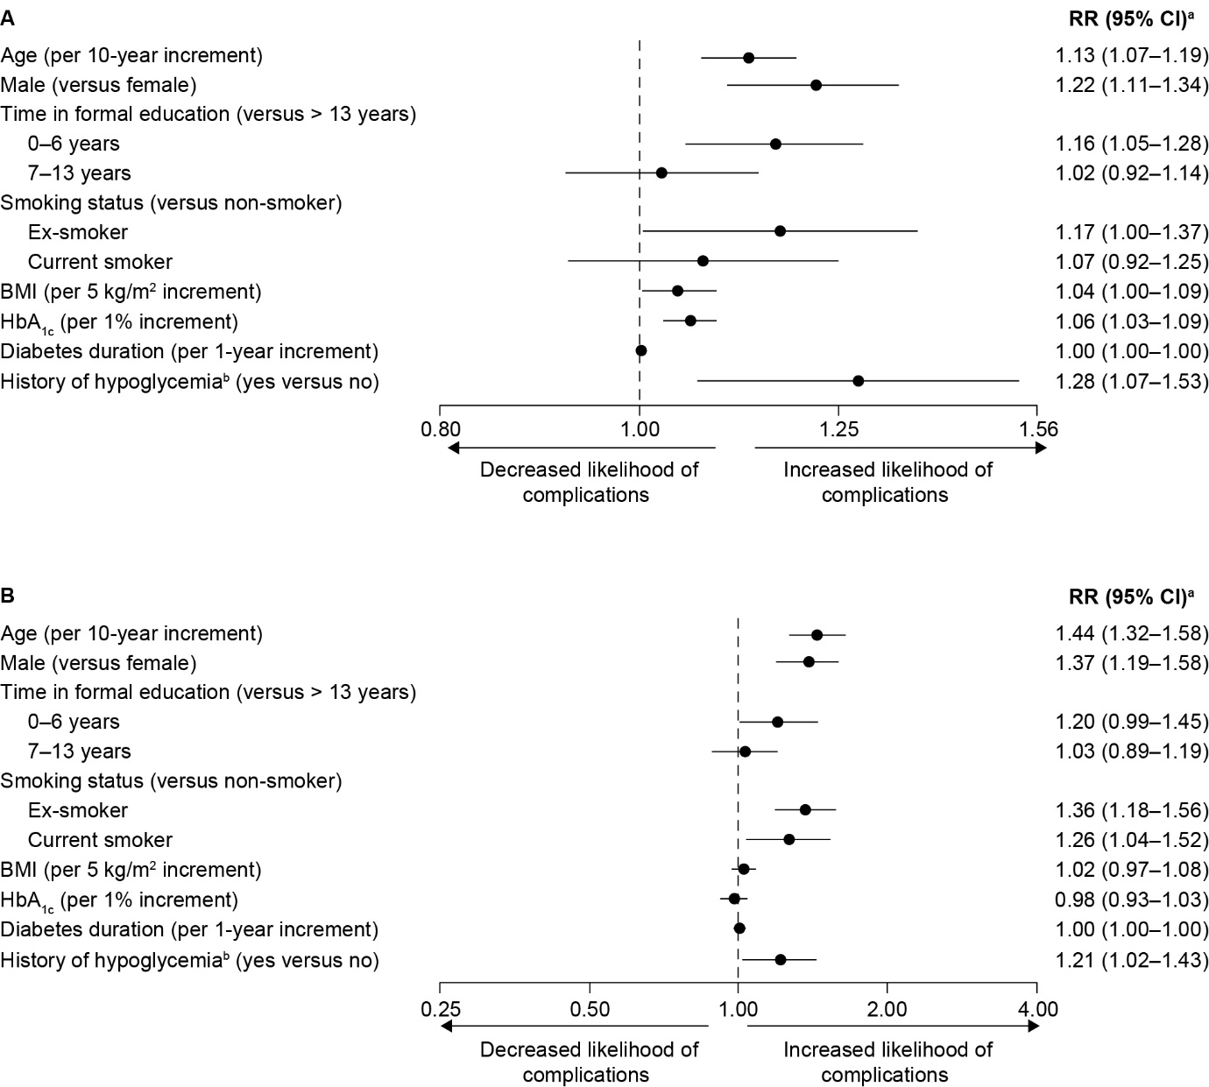
Figure S1. Sensitivity analysis including only patients with complete data to assess factors associated with (A) microvascular and (B) macrovascular complications. ªRRs adjusted for all variables in the figure with the addition of SBP, total, cholesterol levels and comedication use, using a modified Poisson model with cluster-based sandwich variance estimator as described in the Methods. RRs for the associations between complication prevalence and SBP, total cholesterol levels, and comedication use are not reported due to reverse-causality. ^{b}Minor hypoglycemic event in the previous month or major hypoglycemic event in the previous year. BMI body mass index, CI confidence interval, HbA_{1c} glycated hemoglobin, OR odds ratio

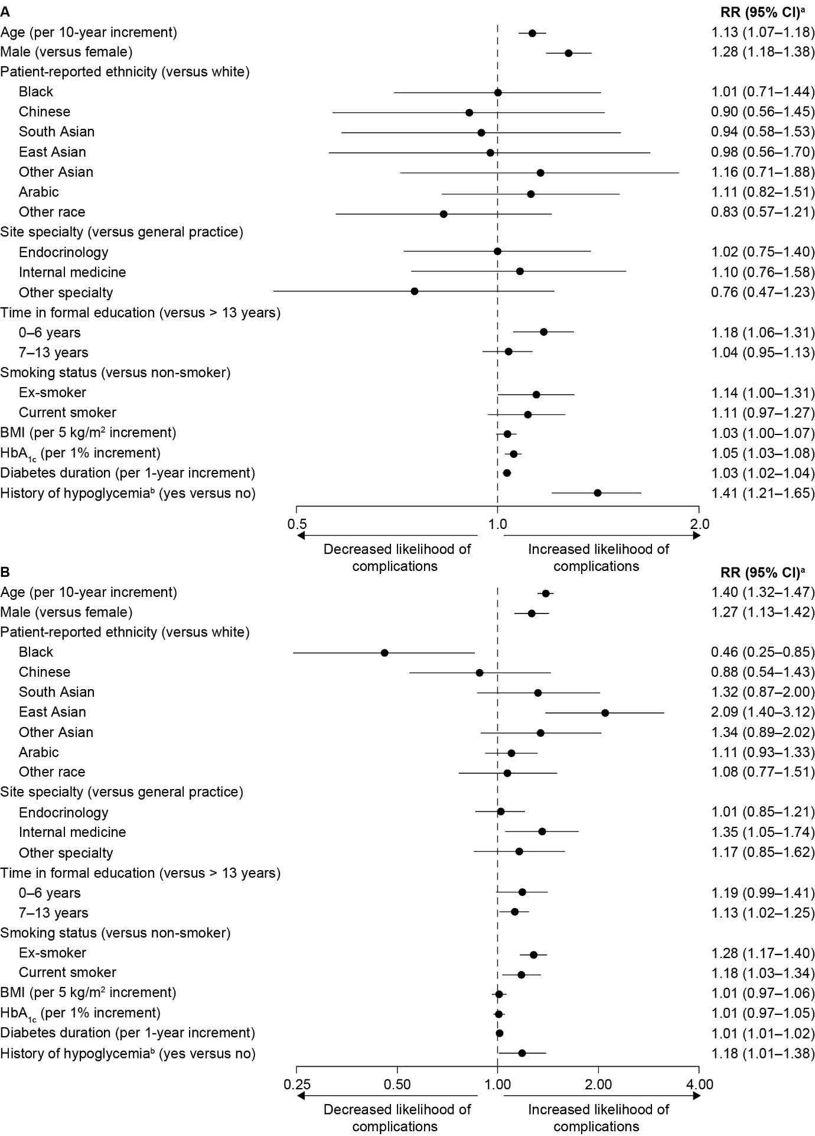
Figure S2. Sensitivity analysis with additional variables for site specialty and patient-reported ethnicity to assess factors associated with (A) microvascular and (B) macrovascular complications. ªRRs adjusted for all variables in the figure with the addition of SBP, total, cholesterol levels and comedication use, using a modified Poisson model with cluster-based sandwich variance estimator as described in the Methods. RRs for the associations between complication prevalence and SBP, total cholesterol levels, and comedication use are not reported due to reverse-causality. ^{b}Minor hypoglycemic event in the previous month or major hypoglycemic event in the previous year. BMI body mass index, CI confidence interval, HbA_{1c} glycated hemoglobin, OR odds ratio

