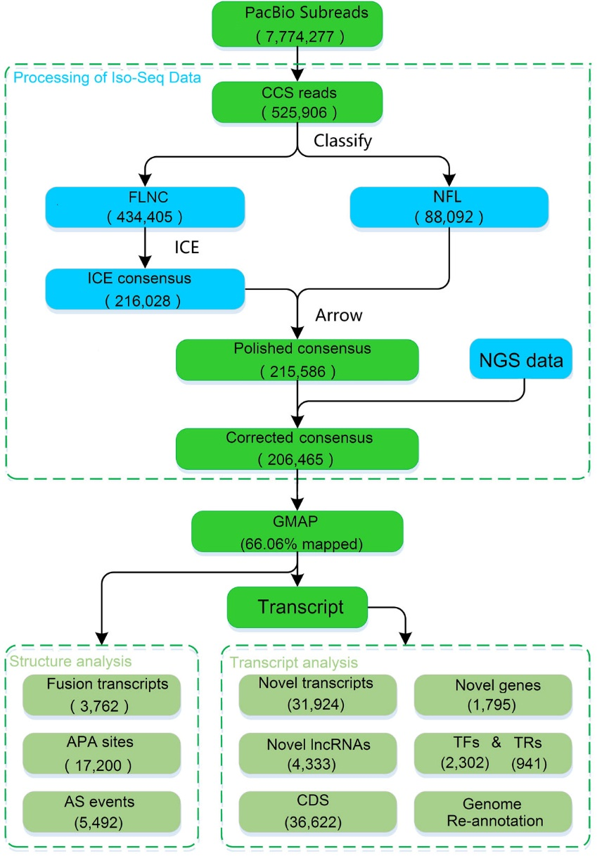
Figure S1 Flow chart of Bioinformation analysis.

