Additional file 3:
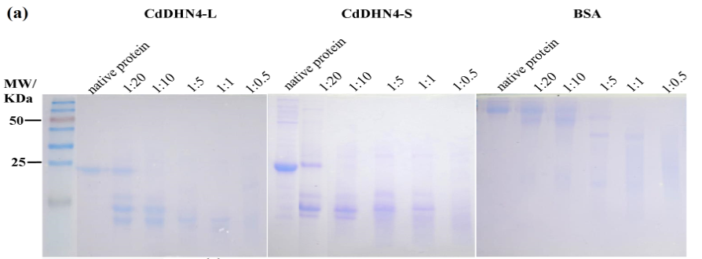

(b)
Additional file 3 (a) Limited proteolysis of BSA, CdDHN4-L and CdDHN4-S with trypsin. The ratio of proteinase concentration (mg mL⁻¹) was varied from 1:20 (dehydrin protein: trypsin) to 1:0.5 relative to substrate concentration at 0.5 mg mL⁻¹. Incubation was carried out for 30 s, stopped by adding SDS-PAGE loading buffer, and heating at 100℃ for 10 min.
(b)BSA, CdDHN4-L and CdDHN4-S were treated with proteinase K. The ratio of proteinase concentration (mg mL⁻¹) was varied from 1:1000 (dehydrin protein: proteinase K) to 1: 50 relative to substrate concentration at 0.5 mg mL⁻¹. Incubation was carried out for 30 s, stopped by adding SDS-PAGE loading buffer, and heating at 100℃ for 10 min.

