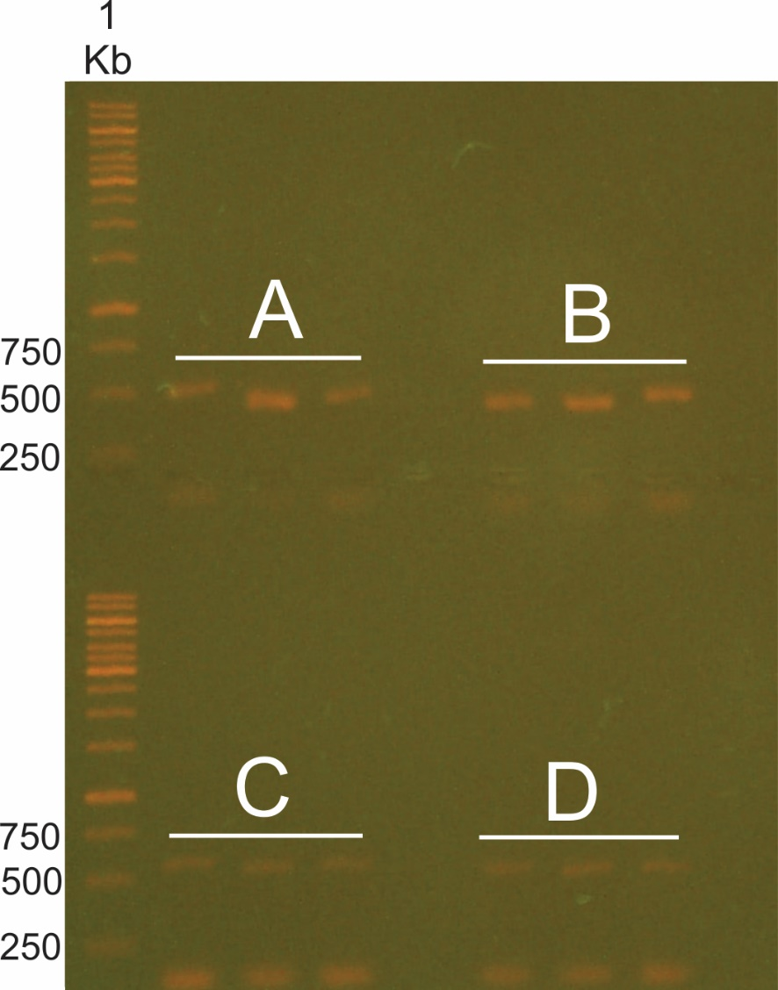

Figure S2. Extraction of the metagenomic DNA in triplicates experimental. (A) First biological sample - CCN51. (B) First biological sample - Catongo. (C) Second biological sample - CCN51 and (D) Second biological sample - Catongo.

