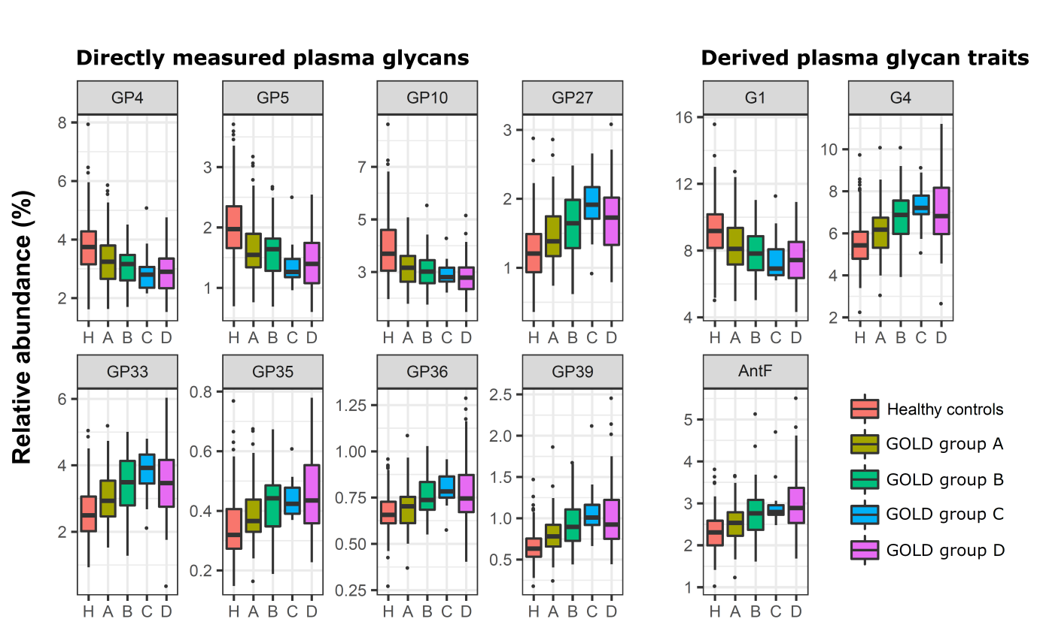
Additional file 4: Figure S1 Differences in abundance of plasma protein glycan traits between COPD subjects classified into ABCD groups and healthy controls. Differences are shown as box plots, resulting from case-control meta-analysis, performed on both herein studied cohorts. Each box represents the 25th to 75th percentile. The upper whisker extends from 75th percentile to the values within 1.5 x IQR (where IQR is the inter-quartile range, or distance between the first and third quartiles). The lower whisker extends from 25th percentile to the values within 1.5 x IQR. Data beyond the end of the whiskers are called "outlying" points and are plotted individually. AntF – antennary fucosylation; G1 – monogalactosylation; G4 – tetragalactosylation; GP – plasma glycan peak.

