**Additional file 1**

**Additional file S1**

Table: List of external COI sequences used in this study. The sequence in bold corresponds to type-locality of *P. rubiginosus*, caught in MatoGrosso, Brazil compared to *P. sp4* in De Thoisy et al (2014).

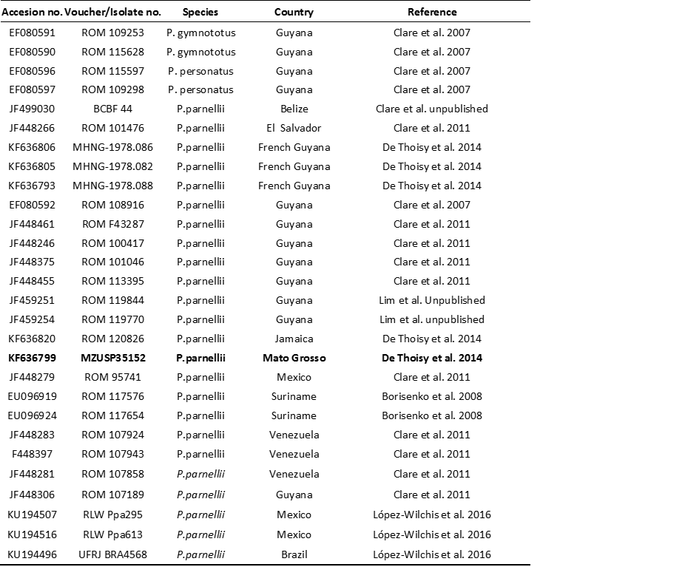

Additional file S2

Table: Characteristics of microsatellite markers.



**Additional file S3**

Graphical representation of assignation probabilities for *Pteronotus* A and *Pteronotus* B sampled. Each individual (x axis) is represented by a vertical bar divided in two parts according to its assignation probability (y axis) in each of the two clusters.

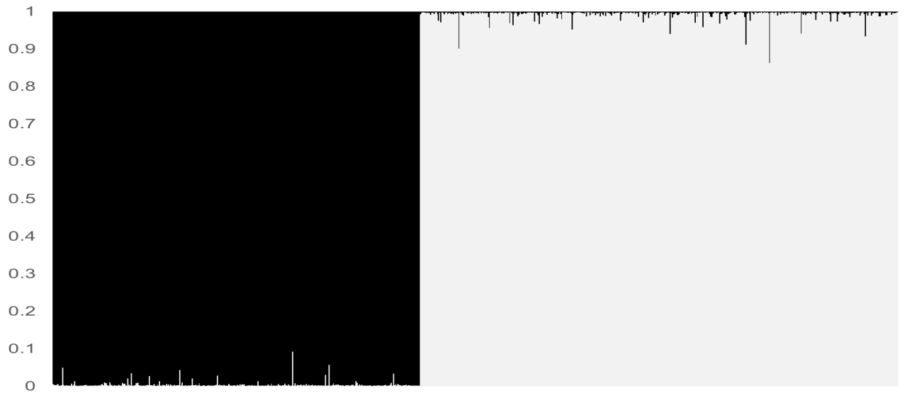

**Additional file S4**

Table: Pairwise *Fst* values between caves for each species and both sexes.

|  |  |  |  |
| --- | --- | --- | --- |
| **Females A** | | | |
|  | **PA** | **SC** | **MG** |
| **MA** | 0.095 | -0.018 | 0.009 |
| **PA** |  | 0.016 | 0.025 |
| **SC** |  |  | -0.004 |
| **Females B** | | | |
| **MA** | -0.001 | -0.003 | -0.002 |
| **PA** |  | -0.006 | -0.004 |
| **SC** |  |  | -0.010 |
| **Males A** | | | |
| **MA** | 0.006 | 0.000 | -0.008 |
| **PA** |  | **0.005\*** | -0.011 |
| **SC** |  |  | -0.007 |
| **Males B** | | | |
| **MA** | 0.002 | 0.003 | -0.002 |
| **PA** |  | -0.001 | 0.000 |
| **SC** |  |  | 0.000 |

**Additional file S5**

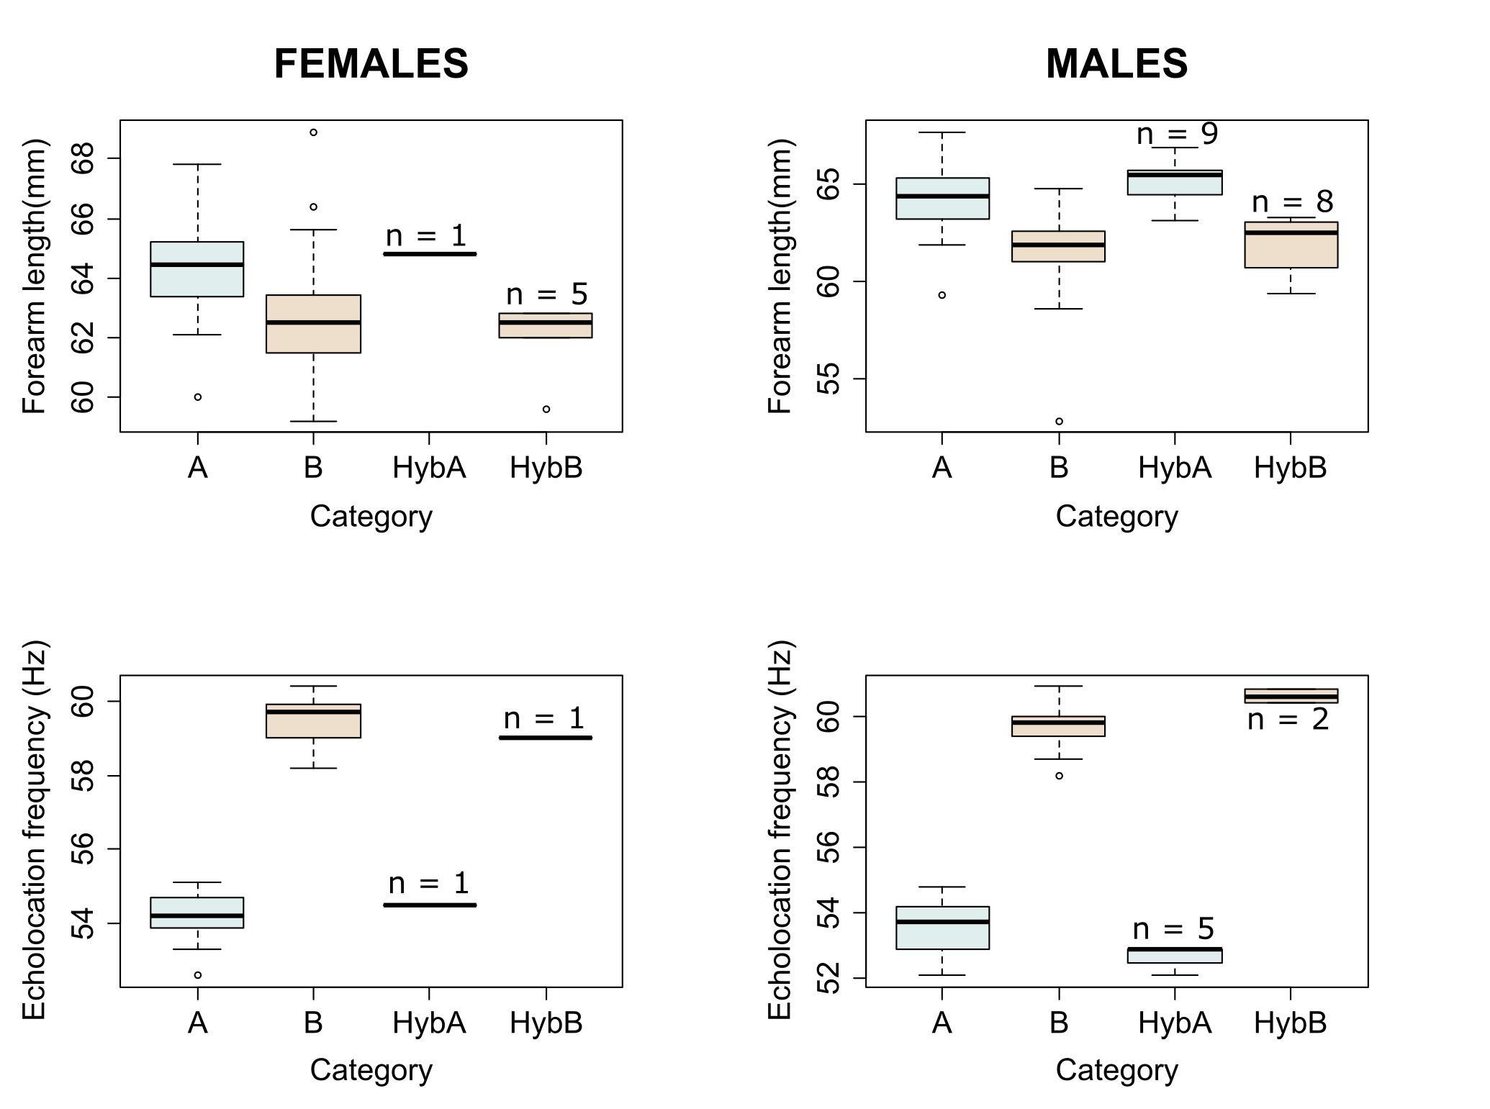

Figure: Forearm length (mm) and echolocation frequency (kHz) depending on the genetic status of individuals according to the relaxed approach (A = *Pteronotus* A, B = *Pteronotus* B, HybA = hybrids mostly assigned to cluster A by STRUCTURE, Hyb B = hybrids mostly assigned to cluster B by STRUCTURE). The number of individuals available for hybrid classes is indicated on the graph.

Globally, hybrids presented features similar to the the features observed in the cluster to which they had the higher assignment probability. The low number of individuals did not allow us to test reliably differences between pure individuals and hybrids.

**Additional file S6**

Table: Life cycle of *Pteronotus* A and B. PRE = Pregnant, LAC = Lactating females, PLAC = Post-lactating females, NS = No status (non pregnant, non-lactating, non post-lactating females, and non breeding males). n(A): number of *Pteronotus A* (number of adult females in parentheses); n(B): number of *Pteronotus B* (number of adult females in parentheses); n: total number of *Pteronotus*.

|  |  |  |  |  |  |  |  |  |  |  |  |
| --- | --- | --- | --- | --- | --- | --- | --- | --- | --- | --- | --- |
|  | ***Pteronotus A*** | | | | **n(A)** | ***Pteronotus B*** | | | | **n(B)** | **n** |
| **Status** | **PRE** | **LAC** | **PLA** | **NS** |  | **PRE** | **LAC** | **PLA** | **NS** |  |  |
| July | 2 | - | - | 117 | 119(24) | 27 | 15 | - | 95 | 137(74) | 256 |
| August | - | - | - | 1 | 1(0) | - | - | 2 | 5 | 7(3) | 8 |
| September | - | - | - | 121 | 121(24) | - | - | 12 | 89 | 101(29) | 222 |
| October | - | 1 | - | 83 | 84(24) | - | - | 19 | 159 | 178(71) | 262 |
| **Total** | **2** | **1** | **0** | **322** | **325(72)** | **27** | **15** | **33** | **348** | **423(177)** | **748** |